STEREO/WAVES CMAD
Version: 2022-10-05

1 introduction
  - Purpose
The STEREO Mission-level Science Objectives are to:
- Understand the causes and mechanisms of CME initiation
- Characterize the propagation of CMEs through the heliosphere
- Discover the mechanisms and sites of energetic particle acceleration in the low corona and the interplanetary medium
- Develop a 3-dimensional, time-dependent model of the ambient solar wind

NASA selected four instrument investigations to meet these science objectives: SECCHI, IMPACT, PLASTIC, and WAVES. The STEREO/WAVES (hereafter S/WAVES) investigation was selected to measure and triangulate interplanetary radio bursts associated with CMEs and flares and to measure the in situ electromagnetic properties of shocks and turbulence.

The S/WAVES instrument consists of several subsystems: a set of 3 monopole electric antennas and preamplifiers, the Low Frequency/High Frequency/Fixed Frequency Receiver (LFR/HFR/FFR), the Time Domain Sampler (TDS) and Low Rate Science (LRS) system, and Data Processing Unit (DPU) and power supply. The instrument is described fully in Bougeret et al. (2008), Bale et al. (2008) and Cecconi et al (2008).

While the LFR/HFR/FFR receiver system is a single piece of hardware, it is useful to consider the systems separately. The LFR measures voltage spectra from the S/WAVES antennas in three 2-octave bands (Bands A, B, and C) ranging from 2.5 to 160 kHz using a digital spectral processing architecture. Each band produces 16 log-spaced measurements with Δf/f ~ 8.7%. Band A covers 2.5-10 kHz, Band B covers 10-40 kHz, and Band C covers 40-160 kHz. Bands B and C each have two input channels and product auto- and (complex) cross-spectra. Band A produces only auto-spectra on a single channel. Different antenna configurations (monopoles, dipoles) can be assigned to the receiver input channels (see Bougeret et al., 2008).

The HFR is a two channel superheterodyne ‘sweeping’ receiver system that covers the frequency range 125 kHz to 16.025 MHz in 50 kHz steps. The HFR measurement is heterodyned to lower frequencies and processed by the LFR hardware, as described above.

The Fixed Frequency Receiver (FFR) is a single channel receiver operating at 30.025 or 32.025 MHz and at high cadence (64 samples per second). The FFR was designed to provide comparative measurements with the Nancay Radioheliograph instrument; however an error in testing during development led to a large reduction in FFR sensitivity and the data has not been (to date) exploited.

The Time Domain Sampler (TDS) is a snapshot waveform sampler designed to study plasma waves and spacecraft-dust interactions. TDS samples simultaneously in 4 channels at programmable sample speeds up to 250,000 samples per second. Channel inputs are programmable and selectable from monopole and dipole (diffential) voltage signals. TDS waveform data are produced in voltage units (uncorrected for antenna length and geometry) and uncorrected for system response. A transfer function is shown in Figure 15 of Bougeret et al. (2008). TDS also produces a ‘Langmuir Wave Statistics (LWS) data stream, which is an accumulation of statistics generated onboard from the TDS waveform measurements. A ‘Low Rate Science’ (LRS) system digitizes data from eight analog channels (a combination of AC and DC coupled monopole and dipole S/WAVES electric field sensors). 32 second long time series bursts of these eight analog low-rate science values are acquired at 64 Sa/s and sent to telemetry periodically. These samples are also provided in housekeeping telemetry once per minute. In the same once per minute housekeeping stream, the peak values observed in the TDS burst stream are also produced and referred to as TDSmax data. TDS samples made at, for example, 250,000 Sa/s on each of four channels are scanned in real-time to obtain the peak value in each period (nominally once per minute). The peaks are determined by retaining the largest value of an absolute value comparison of each in-coming sample.

  - Contents
This document serves to describe the processes, software, and calibrations used to produce science quality data from the STEREO/WAVES instrument. In Sections 3-6 below, we describe the data products from most basic (Level 0) to most processed (Level 3). We also describe the calibrations and processing and analysis software.

Table of contents

1. introduction
1.1 Purpose
1.2 Contents

2. Overview of Data Levels
2.0 Description of Level 0
2.1 Description of Level 1
2.2 Description of Level 2
2.3 Description of Level 3

3. Housekeeping Data

4. Data status
4.1 Data Calibration
4.2 Validation
4.3 References

5. Processing programs
5.1 Introduction
5.2 STEREO/WAVES Daily Summary Plot description
5.3 Sources and file names
5.4 Data format

6. Archives

Appendix
1. Data plots

2. Overview of Data Levels
2.0 Description of Level-0

Level-0 data is essentially telemetry data produced by the S/WAVES instrument and sent to the STEREO spacecraft command and handling system (C&DH). That telemetry data is in the form of fixed-length CCSDS compatible telemetry packets. The packets are stored in the STEREO spacecraft C&DH systems until they can be sent to the ground in a DSN contact.

The STEREO ground system (operated by the STEREO APL mission operations center) processes the received packets into level-0 telemetry files which are cleaned and sorted into time order. The level-0 files are formatted as PTP (Payload Telemetry Files) files which are simply container files for a 24-hour day-aligned collection of S/WAVES data packets. The ground system produces new versions of these files as data are acquired from space. About one month after acquisition, the ground system produces a final or definitive level-0 data product.

A typical level-0 file-name looks like “swaves_ahead_2021_109_1_02.ptp” or “swaves_ahead_2021_109_1_07.fin”. Starting on the left, “swaves” indicates that the file is a S/WAVES level-0 telemetry file. Next, “ahead” indicates that the data comes from the STEREO Ahead spacecraft. Next, the “2021” indicates the year and the “109” indicates the day of year – in this case corresponding to 19 April 2021. Next, the “1” indicates the type of the file – this is always “1” for S/WAVES. The next value ‘02” or “07” indicates the version sequence number – in general, higher numbers are more recent and include the most recent set of received data. Finally, the “ptp” indicates an intermediate file and the “.fin” indicates that this is a final version of the file.

There are other mechanisms by which S/WAVES telemetry data can be obtained – for example using real-time telemetry but the PTP files described here are what is used for essentially all normal S/WAVES data processing.

2.1 Description of Level-1

The TMlib software (explained in Section 5) accesses the raw Level 0 telemetry data, and creates a virtual Level 1 set of decommutated, decoded and calibrated data for access by S/WAVES data users, for processing, plotting, and analyzing. Since no intermediate data product is produced, this is a virtual data product.

2.2 Description of Level-2

The modified data products from TMlib accessing can be called Level 2. Various relevant products are created in locations around the world.

At the University of Minnesota, the Level 2 data files are:
a. stereo-a_swaves_hfr-lfr_average_yyyymmdd_v##.sav
b. stereo-a_swaves_hfr_average_yyyymmdd_v##.txt
c. stereo-a_swaves_lfr_average_yyyymmdd_v##.txt
d. stereo-a_swaves_tds_tdsmax_yyyymmdd_v##.txt
e. stereo-b_swaves_hfr-lfr_average_yyyymmdd_v##.sav
f. stereo-b_swaves_hfr_average_yyyymmdd_v##.txt
g. stereo-b_swaves_lfr_average_yyyymmdd_v##.txt
h. stereo-b_swaves_tds_tdsmax_yyyymmdd_v##.txt

And the Level 2 data plots are:
i. stereo_swaves_daily-summary_color_yyyymmdd_v##.pdf
j. stereo_swaves_daily-summary_color_yyyymmdd_v##.png
k. stereo_swaves_daily-summary_color_yyyymmdd_v##.ps
l. stereo_swaves_daily-summary_color-status_yyyymmdd_v##.pdf
m. stereo_swaves_daily-summary_color-status_yyyymmdd_v##.png
n. stereo_swaves_daily-summary_color-status_yyyymmdd_v##.ps
o. stereo_swaves_daily-summary_gray_yyyymmdd_v##.pdf
p. stereo_swaves_daily-summary_gray_yyyymmdd_v##.png
q. stereo_swaves_daily-summary_gray_yyyymmdd_v##.ps
r. stereo_swaves_daily-summary_gray-status_yyyymmdd_v##.pdf
s. stereo_swaves_daily-summary_gray-status_yyyymmdd_v##.png
t. stereo_swaves_daily-summary_gray-status_yyyymmdd_v##.ps

In the file names, _hfr is high frequency, _lfr is low frequency, _hfr-lfr are both frequency ranges combined, -a and -b are the 2 STEREO spacecraft, v## is a version number, color and gray depict how the data are displayed, and -status includes the data parameter scales. The .sav file extension indicates an IDL save file, while the .txt files are in ASCII format. Files with .pdf, .png and .ps file extensions are graphics files. The file formats are described in more detail in Section 5.4.

These Level 2 products are all available at ftp://ftp.space.umn.edu/STEREO/data/level-3/STEREO/ and also at https://stereo-ssc.nascom.nasa.gov/data/ins_data/swaves/. All of the daily files are in folders organized by spacecraft (or Both), product, and year.

The background determination is created using the IDL histogram procedure. Daily data for each frequency is placed in a histogram column. The total value of all the data in each of the histogram columns is calculated, then summation started from each bottom bin is worked until it reaches the bin where the sum equals or exceeds 3% of the total value. Then the spectrums are scanned to detect single frequencies that have higher data values than both frequencies above and below them. Then this frequency data is deleted and replaced with an interpolation using the data values just above and below that frequency.

2.3 Description of Level 3

Some products are essentially Level 3 data products. One of these Level 3 products is the combined dynamic spectra plots of S/WAVES STEREO A, Wind Waves, and S/WAVES STEREO B. An example of the 3 unit dynamic spectra plots is shown below for 20140305, with several solar radio Type III bursts, a Type III storm, and a small Type II burst. In the Appendix, there’s another S/WAVES-WIND/Waves dynamic spectra plot. Note the inset, which shows the locations of the 3 spacecraft.

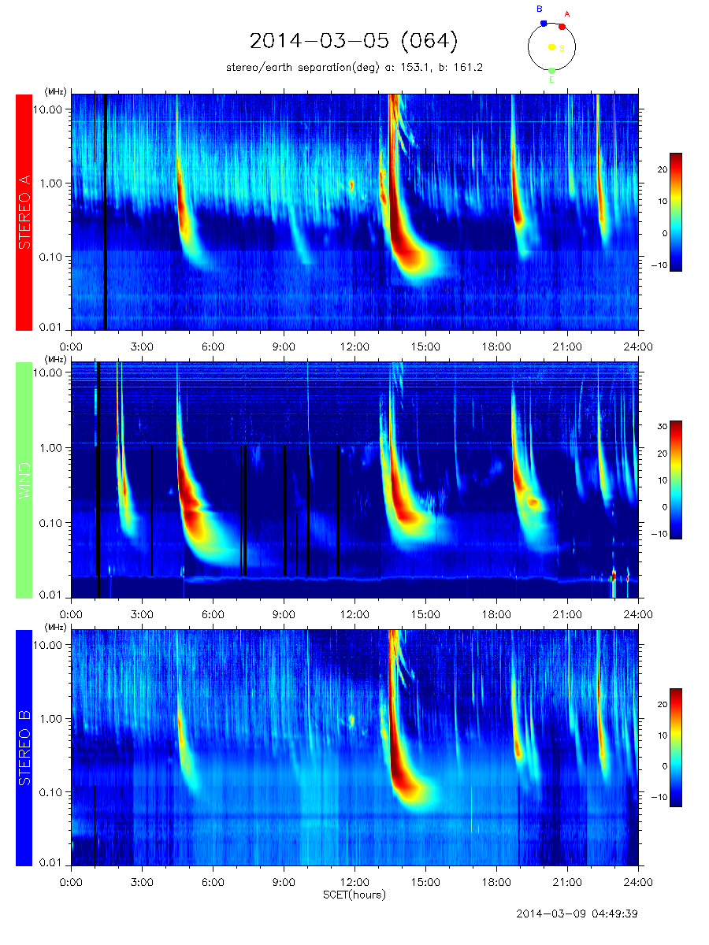

Another of the Level 3 products is the tables of dates and times when Type II bursts or Type IV bursts occur, detected by Wind and/or STEREO “Ahead & Behind”. These tables are available at
https://solar-radio.gsfc.nasa.gov/wind/data_products.html
or
https://stereo-ssc.nascom.nasa.gov/data/ins_data/swaves/bursts/

A 2 month table of the 2014 data is shown here:

These tables were produced first by Mike Kaiser, and most recently by Mike Reiner, both at GSFC. The annual tables contain the start date and time, the stop date and time, the frequency range, and Comments indicating the sources (STEREO-A = Ahead, Wind, and/or STEREO-B = Behind) , and the structure (F-H, complex, weak, intermittent, etc.), and links to dynamic spectrum examples like the plot shown above for 2014-03-05 (064).

3. Housekeeping Data

S/WAVES produces a single housekeeping (HK) packet each minute. This packet includes a variety of analog and digital HK values as well as some low-rate science.

Most of the HK values are related to instrument operational status, Instrument operational modes or analog housekeeping values such as power supply voltages or temperatures.

Included in the HK data are Low Rate Science (one sample per minute) values. The Low Rate Science’ (LRS) system digitizes data from eight analog channels (a combination of AC and DC coupled monopole and dipole S/WAVES electric field sensors).

In the same once per minute housekeeping stream, the peak values observed in the TDS burst stream are also produced and referred to as TDSmax data. TDS samples made at, for example, 250,000 Sa/s on each of four channels are scanned continuously in real-time to obtain the peak value in each HK period (nominally once per minute). The peaks are determined by retaining the largest value of an absolute value comparison of each in-coming sample over each minute.

4. Data status

4.1 Data Calibration -The LFR/HFR measurements were calibrated in the laboratory at Meudon using a system of attenuators and a signal generator. In-flight calibrations are performed for a few minutes every other day to verify and track the stability of the HFR/LFR electronics. Experience has shown the the receivers have been very stable as a function of time.

4.2 Validation – Flight HFR data have been validated by comparing the quiet-time radio spectrum to the expected signal from the galactic continuum (synchrotron) spectrum (Eastwood et al., 2009; Zaslavsky et al., 2011). A free parameter in this comparative work is the antenna stray capacitance; the value inferred by comparison with the galaxy agrees well with measurements made in the lab pre-flight (Bale et al., 2008).

4.3 References

Bougeret, J.L., Goetz, K., Kaiser, M.L., Bale, S.D., Kellogg, P.J., Maksimovic, M., et al. 2008: Space Science Reviews 136, 487. Doi:10.1007/s11214-007-9298-8.
Bale, S.D., Ullrich, R., Goetz, K., Alster, N., Cecconi, B., Dekkali, M., et al. 2008: Space Science Reviews, 136, 529. Doi:10.1007/s11214-007-9251-x.
Cecconi, B., Bonnin, X., Hoang, S., Maksimovic, M., Bale, S.D., Bougeret, J.-L., et al. 2008: Space Science Reviews, 136, 549. Doi:10.1007/s11214-007-9255-6.
Eastwood, J.P., Bale, S.D., Maksimovic, M., Zouganelis, I., Goetz, K., Kaiser, M.L., et al.: 2009, Radio Science 44, RS4012. Doi:10.1029/2009RS004146.
Zaslavsky, A., Meyer-Vernet, N., Hoang, S., Maksimovic, M., and Bale, S.D.: 2011, Radio Science 46, RS2008. Doi:10.1029/2010RS004464.

5. Processing programs

5.1 Introduction
The University of Minnesota obtains Level 0 S/WAVES data files, and the data is processed using Tmlib level 1 data generation, Shell scripts and Python scripts on a Mac computer, and IDL, producing Level 2 data files and data plots.

All S/WAVES level-0 data processing starts with a FIELDS specific telemetry access software package called Tmlib. Tmlib provides decommutation for all raw S/WAVES telemetry data – including the level-0 telemetry files described above.

Tmlib is a client-server telemetry access software package which breaks out the contents of all packed PTP S/WAVES Level 0 data into directly useful telemetry values. The normal use is that an end user prepares an IDL program to obtain a certain type of S/WAVES data. Such a program becomes a Tmlib client. Directed to a Tmlib server, the program attaches one or more Level 0 PTP files and can access data items of interest. Tmlib handles the bit-twiddling aspects of providing access to the data. In addition to providing raw de-commutated telemetry data, Tmlib can also provide calibrated data.

Using Tmlib, a number of software packages have been developed for the conversion of raw data (provided by Tmlib) into a variety of ASCII data files (e.g. one minute averages).

Using Tmlib, a number of software packages have been developed for the conversion of raw data (provided by Tmlib) into a variety of data plots (e.g. daily summary plots).

In addition to Tmlib itself, a number of sub-system specific software suites have been developed for the conversion of raw data (provided by Tmlib) into more sophisticated physical units.

A set of IDL routines exists to query Tmlib and produce data objects within the IDL SPEDAS environment. SPEDAS is available here: https://spedas.org/blog/ While the S/WAVES specific IDL routines are not part of the current SPEDAS distribution, they are available here: http://stereo.space.umn.edu/distribution/.

5.2 STEREO/WAVES Daily Summary Plot description

Each daily summary plot (DSP) is intended to cover one 24-hour day. The day starts on or after 00:00:00 of spacecraft UTC.

The top-most line gives the date including the day-of year (where 1 January is DOY 001).

Text in the top left corner shows the name of the source level-0 telemetry file from which this STEREO-Ahead-WAVES DSP was produced (the two STEREO spacecraft provide separate level-0 telemetry files). In some cases, we include statistical information on the completeness of the recovered telemetry. Below that, we sometimes include a place-holder for the probe-sun-earth angle but this value was seldom available when the processing was done.

Text in the bottom left corner shows the name of the source level-0 telemetry file from which this STEREO-Behind-WAVES DSP was produced. Above that, we sometimes include a place-holder for the probe-sun-earth (PSE) angle.

Text in the top right corner shows the STEREO-Ahead-WAVES instrument up-time measured in days, the current version of the STEREO-Ahead-WAVES flight software version (e.g. “V412”) and the current default operating mode (e.g. “d26”).

Text in the bottom right corner shows the STEREO-Behind-WAVES instrument up-time measured in days, the current version of the STEREO-Behind-WAVES flight software version and the current default operating mode.

Below that, a line of text in the bottom right corner gives the name of the DSP file, its production date, Tmlib telemetry access software version and the version of the DSP production software.

The main body or central part of the graphic shows the dual spectrograms of the STEREO-Ahead-WAVES data on the top half and the STEREO-Behind-Waves data on the bottom half. These are plotted with time in hours going from left to right on the x-axis and the highest frequency for both Ahead and Behind in the center – running horizontally.

The top-half of the main body or central part of the graphic shows a spectrogram of the STEREO-Ahead-WAVES data plotted with the frequency starting with 2.5kHz on the top and increasing to 16MHz in about the middle of the page.

The bottom-half of the main body or central part of the graphic shows a spectrogram of the STEREO-Behind-WAVES data plotted with the frequency starting with 16MHz along the center decreasing to 2.5kHz at the bottom.

Displaying the spectra from the two instruments with Ahead and Behind spectra inverted puts the highest frequency for both along the center allows for quick comparison of solar activity.

The color or gray scale spectrograms are displayed with an amplitude scale in dBs shown to the far right.

At the right hand edge of the spectrograms, the plots include tic-marks indicating the electron plasma density corresponding to the frequencies shown.

Another type of DSP graphic has the same type of Ahead and Behind spectrogram data in the center but includes "status" information for the STEREO-Ahead-WAVES instrument on the top and similar "status" information for STEREO-Behind-WAVES on the bottom. These status lines are generally engineering states. They allow the science user to determine that particular changes in instrument data are due to commanded mode changes or are natural.

In general the status lines show the instrument operating modes as a function of time during the 24-hour daily period of the DSP. On the far left, there is some text showing the specific receiver or subsystem - reading from top to bottom for STEREO-Ahead, we have "LFR A", "LFR B", "LFR C", "HFR 1", "HFR 2" and "TDS". For STEREO-Behind, the labels are reversed.

For each of the subsystems, there are two or three lines indicating the state. The current value for each subsystem state is shown at the start of the plot on the left hand side. During the day, as those values change (for example because of instrument time-tagged commands), the new values appear at times corresponding to those changes. On the far right of the status lines, we define the meanings for each status line. There are between one and four commandable states shown in each subsystem status line. For example, the right hand side for the top line for "LFR A" shows "Int/Auto". Looking to the far left, we can see the initial values for those two states (for example, “125ms/On”).

When status lines are present, the spectral data are also augmented with three lines of added science data.

One strip is labeled on the left as “TDSmax”. This graphically shows the peak value observed on one selected channel of the TDS. The plotted values are given in dBs. The selected channel number is shown on the far right. As described above, the TDS is also a burst capture system. Bursts are captured and selected for transmission to the ground based on their quality. As such, the returned bursts are erratically distributed in time. The TDSmax plot includes a row of small tic-marks above (or below for the Behind spacecraft) the plotted stripe to indicate the times when a selected burst is received.

Another strip is labeled on the left as “APM_Ey”. This graphically shows the DC voltage on the Ey antenna throughout the day.

5.3 Sources and file names – the first source is ftp://ftp.space.umn.edu/STEREO/data/level-3/STEREO/, where the directories are:

5.3.1. Ahead – which contains spacecraft, product, and annual folders, containing the following files for each day

a. stereo-a_swaves_hfr-lfr_average_yyyymmdd_v##.sav
b. stereo-a_swaves_hrf_average_yyyymmdd_v##.txt
c. stereo-a_swaves_lfr_average_yyyymmdd_v##.txt
d. stereo-a_swaves_tds_tdsmax_yyyymmddd_v##.txt

5.3.2. Behind – which contains spacecraft, product, and annual folders, containing the following files for each day

e. stereo-b_swaves_hfr-lfr_average_yyyymmdd_v##.sav
f. stereo-b_swaves_hfr_average_yyyymmdd_v##.txt
g. stereo-b_swaves_lfr_average_yyyymmdd_v##.txt
h. stereo-b_swaves_tds_tdsmax_yyyymmdd_v##.txt

5.3.3. Both – which contains product and annual folders, containing the following files for each day

i. stereo_swaves_daily-summary_color_yyyymmdd_v##.pdf
j. stereo_swaves_daily-summary_color_yyyymmdd_v##.png
k. stereo_swaves_daily-summary_color_yyyymmdd_v##.ps
l. stereo_swaves_daily-summary_color-status_yyyymmdd_v##.pdf
m. stereo_swaves_daily-summary_color-status_yyyymmdd_v##.png
n. stereo_swaves_daily-summary_color-status_yyyymmdd_v##.ps
o. stereo_swaves_daily-summary_gray_yyyymmdd_v##.pdf
p. stereo_swaves_daily-summary_gray_yyyymmdd_v##.png
q. stereo_swaves_daily-summary_gray_yyyymmdd_v##.ps
r. stereo_swaves_daily-summary_gray-status_yyyymmdd_v##.pdf
s. stereo_swaves_daily-summary_gray-status_yyyymmdd_v##.png
r. stereo_swaves_daily_summary_gray-status_yyyymmdd_v##.ps

So, there are the 4 average and tdsmax data files daily for each STEREO spacecraft, and 12 plots daily for the 2 STEREO spacecraft.

5.4 Data formats of the data in the files above is as follows:
5.4.1 STEREO/WAVES 1-minute average files

One minute averages of the STEREO/WAVES data from the low (lfr) and high (hfr)
frequency receivers are produced in daily files. For each spacecraft, there
are 3 files produced each day: (1) an ascii file of the lfr data (48 channels),
(2) an ascii file of the hfr data (319 channels), and (3) an IDL ‘sav’ file
that is the sum of lfr and hfr (367 channels) combined into one. The naming
convention for the files is:

stereo-a (or -b)_swaves_lfr_average_yyyymmdd_v##.txt for the lfr ascii data Ahead (Behind)
stereo-a (or -b)_swaves_hfr_average_yyyymmdd_v##.txt for the hfr ascii data Ahead (Behind)
stereo-a (or -b)_swaves_hfr-lfr_average_yyyymmdd_v_##.sav for the lfr+hfr IDL version

Each file contains (a) a list of the frequencies in the file (in kHz), (b) the
background value used in (currently) arbitrary decibel (dB) units, (c) the
2-dimensional (# of frequencies X 1440 minutes per day) array of averages in
dB above the average (i.e. value-average in dB). Missing data is indicated by
a value less than 0.

The specific format for the ascii files is:

(A) f9.1 for frequencies (so, 48f9.1 for lfr or 319f9.1 for hfr)
(B) f8.3 for backgrounds (so, 48f8.3 or 319 f8.3)
(C) f8.3 for the data with each frequency line preceded with an i4 value
indicating the start minute of the averaging bin (thus, (i4,48f8.3) repeated
1440 times for lfr and (i4,319f8.3) repeated 1440 times for hfr)

The IDL sav files are self-evident after the usual 'restore' command.

5.4.2 TDSmax file format

The TDSmax ASCII data files are produced each day with names of the format:

stereo-SC_swaves_tds_tdsmax_yyyymmdd_v##.txt

So for example:

stereo-a_swaves_tds_tdsmax_20210630_v03.txt
stereo-b_swaves_tds_tdsmax_20070329_v02.txt

There are five columns of numbers in each TDSmax line.

In column one, we have the time of the end of the acquisition period of the peak data from the four analog channels.
The acquisition period is nominally 60s in duration.
The time format is an integer giving the millisecond of the current day.

The next four columns are the peak values obtained from 100% duty cycle sampling of each of the four TDS analog data channels during the preceding minute (the HK period is pretty close to one minute). These peak values are obtained by the S/WAVES flight hardware. The peak values in these files are given as floating point numbers in dBs with an arbitrary reference. The range for these dB peaks is from about -100dBs to about +100dBs in signed-dBs. In volts, that ranges from about -200mV to +200mV.

The reason the values are signed-dBs (and can be negative) is that the sign of the peak values is actually retained. The peak detection is done using a comparison of the absolute values of the signed TDS time series values but the sign of the peak is maintained. When calculating the dB value of the peaks, we again retain the original sign of the peak and apply it to the normally positive dB value. We call those "signed dBs”.

6. Archives
The web sites ftp://ftp.space.umn.edu/STEREO/data/level-3/STEREO/, and https://stereo-ssc.nascom.nasa.gov/data/ins_data/swaves/ contain all of the University of Minnesota and GSFC S/WAVES Level 2 and 3 data, so they are archives for international scientists, including the following for Type II and Type IV bursts
https://solar-radio.gsfc.nasa.gov/wind/data_products.html
or
https://stereo-ssc.nascom.nasa.gov/data/ins_data/swaves/bursts/

Other data sources:
Files in CDF format
https://spdf.gsfc.nasa.gov/pub/data/stereo/combined/swaves/level2_cdf/
Data visualization
https://cdaweb.gsfc.nasa.gov/
Plasma Physics Data Center, CNES and INSU
http://cdpp.eu

Appendix

1. Data plots

University of Minnesota S/WAVES data plots are available at the first source of ftp://ftp.space.umn.edu/STEREO/data/level-3/STEREO/Both/SWAVES/, the second source is https://stereo-ssc.nascom.nasa.gov/data/ins_data/swaves/Both.

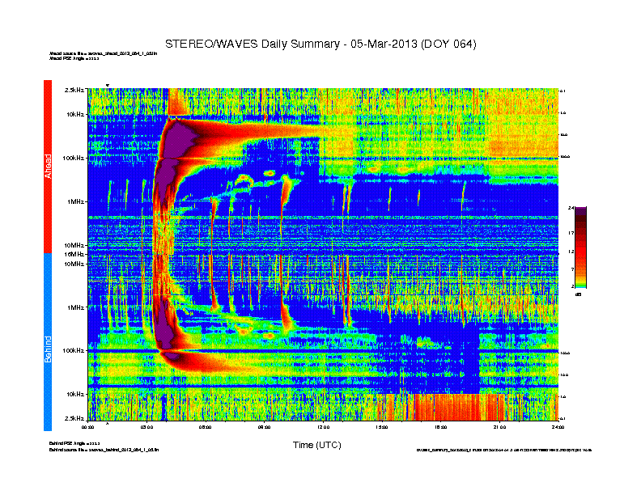
stereo_swaves_daily-summary_color_20130305_v01.png

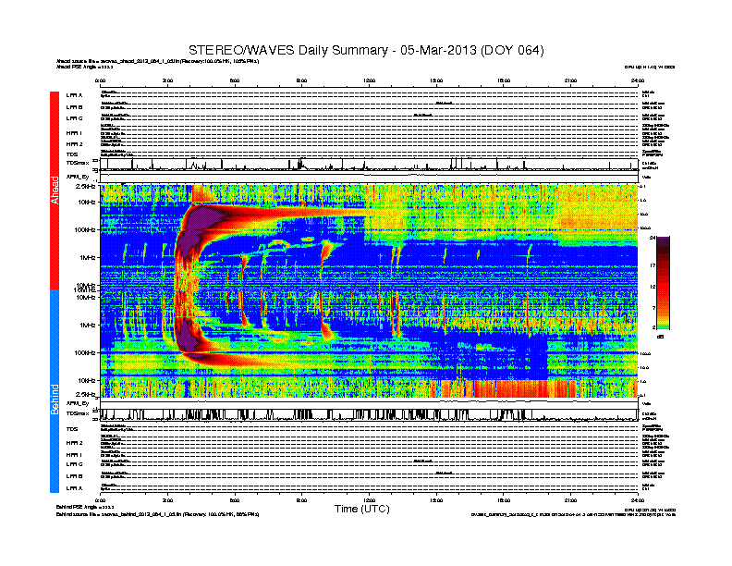
stereo_swaves_daily-summary_color-status_20130305_v01.png

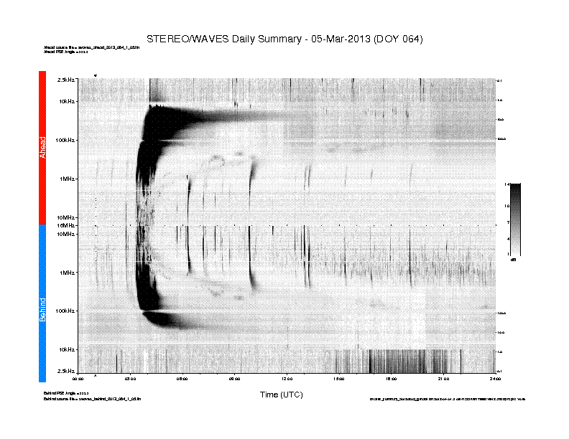
stereo_swaves_daily-summary_gray_20130305_v01.png

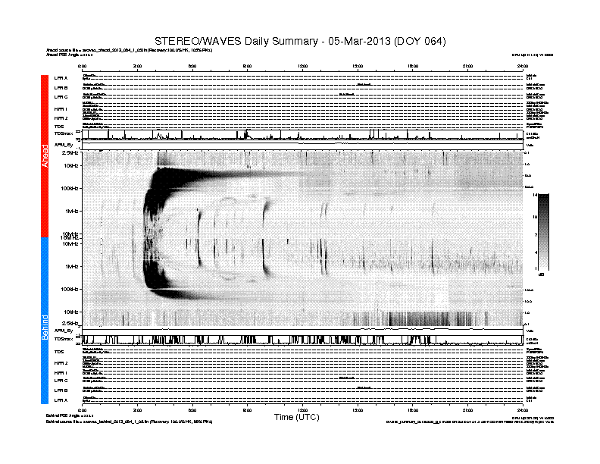
stereo_swaves_daily-summary_gray-status_20130305_v01.png

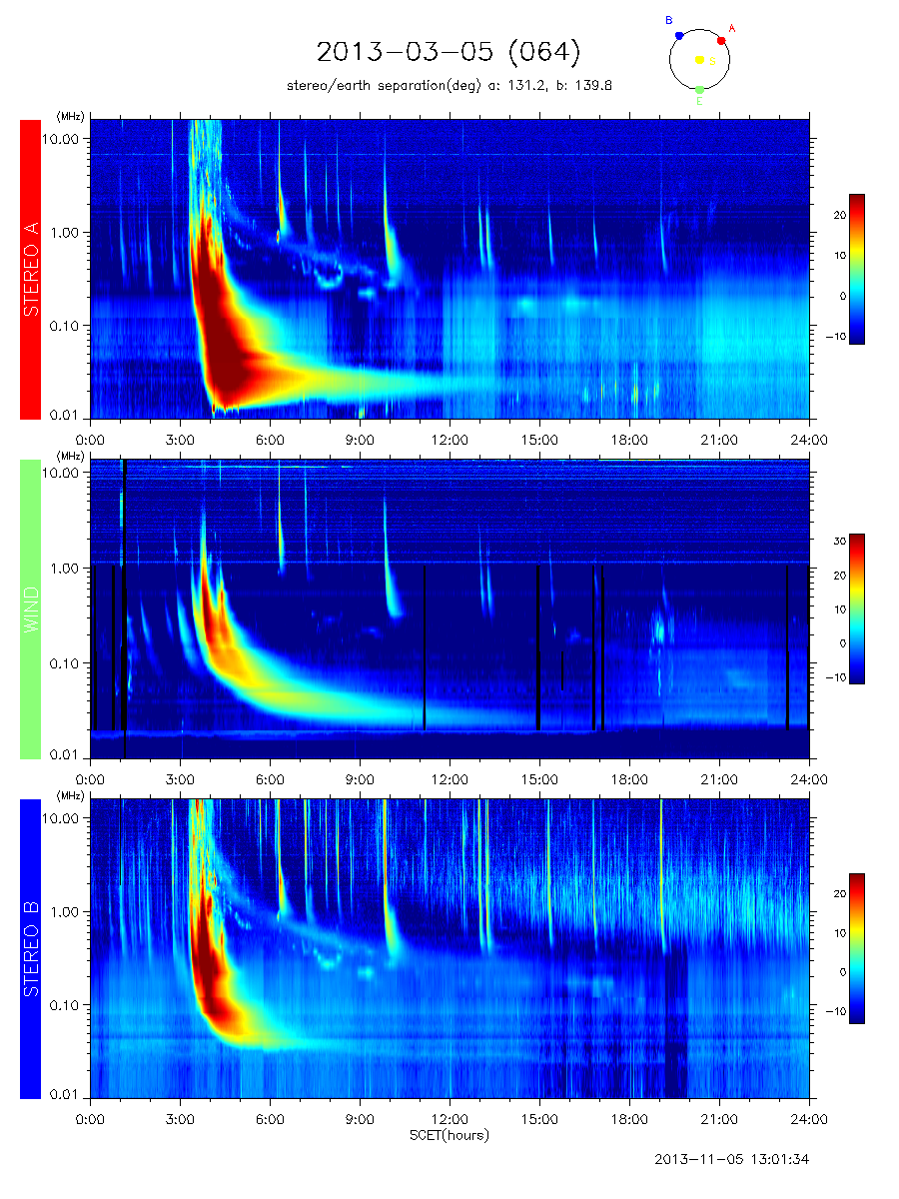
wind_stereo_20130305.png

