STEREO/SECCHI/COR2 Calibration and Measurement Algorithms Document (CMAD)
V1.0 / 30 June 2021 – First release
V1.1 / 06 December 2021 – Updated references
V1.2 / 15 October 2022 – Add P0 data description

Instrument Description & Measuring Concepts
Like the COR1, the SECCHI outer coronagraph, known as COR2, observes the weak coronal signal in visible light. It is an externally occulted Lyot coronagraph and derives its heritage from the highly successful LASCO C2 and C3 coronagraphs aboard SOHO (Brueckner et al., 1996). The externally occulted design shields the objective lens from direct sunlight, enabling a lower stray light level than COR1 thus achieving observations to further distances from the Sun. The COR2 field of view is 2.5 to 15 Rs.
The goal of COR2 is the study of the properties of coronal mass ejections (CMEs) via observations of the brightness of Thomson-scattered light from the solar K-corona. The primary requirement on the COR2 is to observe CMEs, in both total brightness B and linearly polarized brightness (pB), with a 15 arc second per pixel spatial resolution. To obtain pB images, a sequence of 3 linearly polarized images is taken. In order to minimize the smear caused by the CME motion during the polarization image sequence, the sequence of 3 images need to be acquired in a short time. A moderately fast CME moving at the speed of 750 km/s would traverse a COR2 pixel (15 arc sec) in 15 seconds. This was the time criterion that was established. CMEs moving faster than this can still be accommodated, by binning the image down (on the ground) until the motion is within one pixel.
Figure 1 shows the COR2 opto-mechanical layout. A key feature of the COR2 (and COR1) design is the existence of a rotating Polarcor linear polarizer in the optical path at all times. The normal operating mode of COR2 is to take two images in rapid succession, at linear polarization angles of 0° and 90° , every 15 minutes, and sum them on-chip, thus forming a total brightness image. Once an hour, COR2 obtains a full pB sequence; namely, three images in rapid succession, at linear polarization angles of 0°, 120°, and 240°. The total brightness $B$, polarized brightness $pB$, and angle of polarization $μ$, can be calculated from these three images using the procedure outlined in Billings (1966). When necessary to reduce cadence, the COR2 images are binned to half resolution (1024x1024). A complete description of the COR2 telescope is given in Howard et al. (2008). The design of the COR2 telescopes on STEREO-A and STEREO-B is identical except for slightly different occulter sizes reflecting the different perihelion distances of each spacecraft.
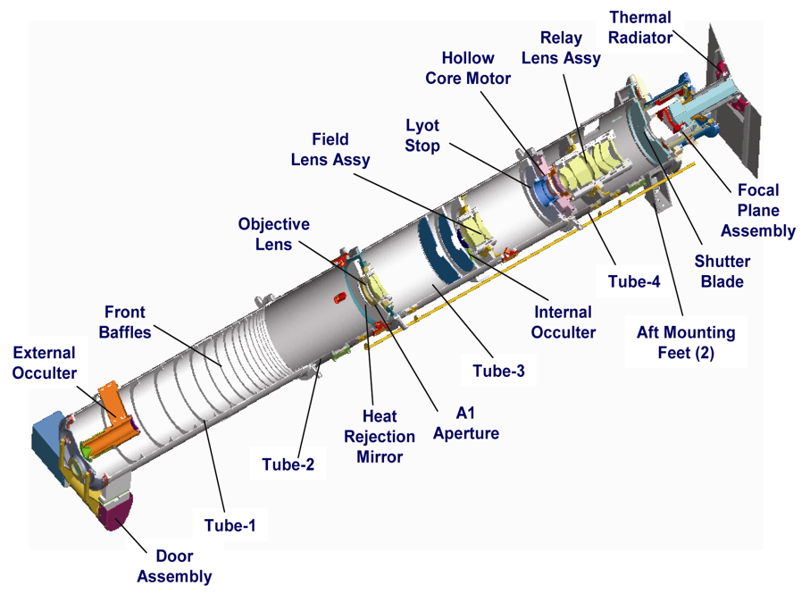
Figure 1 COR2 opto-mechanical layout
The COR2 images are used to automatically detect CMEs onboard and thus trigger the freezing of the event buffer. This circular buffer holds high cadence EUVI images for up to 3 hours before the event detection in the COR2 images. In addition, a low resolution, total brightness image is formed onboard every hour and transmitted through the space weather beacon channel. More details about the instrument operations are given in Howard et al. (2008). The various algorithms described in this document are listed below
Section 2 | Conversion from Level 0.5 to Level 1
Section 3 | Derivation of polarization parameters
Section 4 | Background determination

Purpose
This document describes the algorithms and physical basis to convert from raw COR2 Level 0.5 images to calibrated Level 1 images, and the subsequent derivation of the total brightness B, the polarized brightness pB, and the angle of polarization μ. The software to accomplish this task is described in [SECCHI_PREP]. The Level 0.5 data are stored in FITS format. The procedures to create the Level 0.5 files from the raw telemetry are described in [PIPELINE]. All calibration files are distributed as part of the SECCHI software package in SolarSoft.

Contents
Section A.2 describes the procedure used to convert COR1 images from raw Level 0 to calibrated Level 1, which is the basic step needed for all subsequent scientific analysis. Section A.3 describes how to use these calibrated images to derive the linear polarization properties of the coronal radiation. Section A.4 describes the procedure used for estimating the instrumental and F-corona background.

References

[PIPELINE] STEREO/SECCHI Level-0 to Level-0.5 FITS Pipeline CMAD, STEREO_SECCHI_Reduce_CMAD_20211206.pdf, Version 1.1, 06 December 2021
[SECCHI_PREP] STEREO/SECCHI Level-0.5 to Level-1 Calibration CMAD, STEREO_SECCHI_Prep_CMAD_20211206.pdf, Version 1.1, 06 December 2021
Billings, D. E., 1966, A Guide to the Solar Corona, New York: Academic Press.
Brueckner, G. E., Howard, R. A., Koomen, M. J., Korendyke, C. M., Michels, D. J.; Moses, J. D., Socker, D. G., Dere, K. P., Lamy, P. L., Llebaria, A., Bout, M. V.; Schwenn, R., Simnett, G. M., Bedford, D. K., Eyles, C. J., 1995, The Large Angle Spectroscopic Coronagraph (LASCO), Solar Phys., 162, 357–402.
Howard, R. A., Moses, J. D., Vourlidas, A., Newmark, J. S., Socker, D. G., Plunkett, S. P.; Korendyke, C. M., Cook, J. W., Hurley, A., Davila, J. M., Thompson, W. T., St Cyr, O. C.; Mentzell, E., Mehalick, K., Lemen, J. R., Wuelser, J. P., Duncan, D. W., Tarbell, T. D.; Wolfson, C. J., Moore, A. Harrison, R. A., Waltham, N. R., Lang, J., Davis, C. J.; Eyles, C. J., Mapson-Menard, H., Simnett, G. M., Halain, J. P., Defise, J. M., Mazy, E.; Rochus, P., Mercier, R., Ravet, M. F., Delmotte, F., Auchere, F., Delaboudiniere, J. P.; Bothmer, V., Deutsch, W., Wang, D., Rich, N., Cooper, S., Stephens, V., Maahs, G.; Baugh, R., McMullin, D., Carter, T., 2008, Sun Earth Connection Coronal and Heliospheric Investigation (SECCHI), Space Sci. Rev., 136, 67–115.

Conversion from Level 0.5 to Level 1

Product Description
The process of applying calibration to COR2 Level 0.5 data to produce Level 1 data consists of converting raw detector signals in data numbers (DN) into Mean Solar Brightness (MSB) units. MSB is defined as the average surface brightness of the solar disk in the wavelength range of the instrument, if the instrument (i.e. COR2) were to observe the Sun directly. Unless otherwise specified, the output image is the same size and format as the input image, with each input and output pixel in a one-to-one correspondence with each other.

Heritage
This procedure is essentially the same for all white-light solar coronagraphs and is described in more detail in Vourlidas et al. (2010).

Theoretical Description
The basic process of converting from raw DN to calibrated MSB can be described as follows:
$$MSB=\left(\frac{c}{V}\right) (\frac{DN-DN0}{ẟt}-B)$$
where $DN0$ is the detector bias, $ẟt$ is the exposure time, $B$ is an estimate of the instrumental background, $V$ is the instrumental vignetting function, and $c$ is the calibration factor. The parameters $DN0$ and $ẟt$ are determined onboard and come down in the telemetry. Options exist within SECCHI_PREP to omit any or all of the steps in the calibration process.

Error Analysis and Corrections

The raw COR2 images are dominated by scattered light only close to the occulter. This is demonstrated in Figure 2, which shows a horizontal trace from the center of a COR2-A image during ground calibration. The launch affected the occulter alignment in both COR2s resulting in an increased stray light around the occulter, which reduces significantly the signal-to-noise ratio in that area. For science studies, heights below 3 Rs should be avoided.
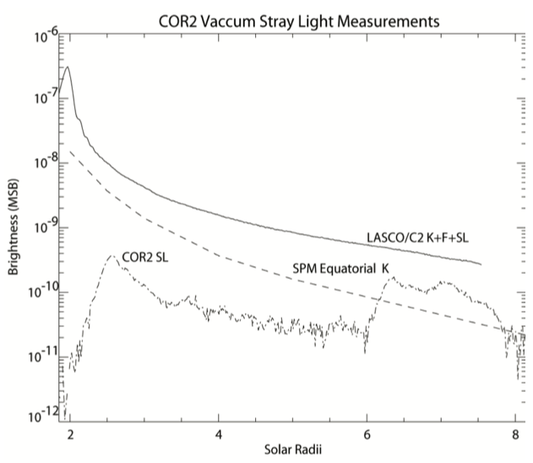
Figure 2. Comparison of the stray light levels in COR2 against the expected F and K coronal levels from LASCO/C2 and the Saito-Poland-Munro (1972) model.

To minimize saturation and maintain suffiicient signal-to-noise close to the occulter, the two s/c have been off-pointed from Sun center by 1 arcmin since July 2007. In addition, each COR2 image is now the sum of three 2-sec exposures, in each polarization, for an effective 6-sec exposure image. Since Aug 2019, COR2 is acquiring a single 36-sec exposure image per day to create a background for the 36-sec exposures sequences taken during support of the PSP perihelia. There is an indication that the COR2-A occulter is slowly drifting. An investigation is under way.

Calibration and Validation

Pre-flight/On-ground Calibration
Pre-flight measurements of the COR2 telescope were designed to verify the performance prior to delivery for integration into the SECCHI instrument suite (Table 1). These tests were performed at NRL’s Solar Coronagraph Optical Test Chamber (SCOTCH) facility (Morrill et al 2006) designed specifically for testing solar coronagraphs. Th
Table 1 Ground Calibration Tests for the COR2 Instrument Performance Characterization
Stimulus | Quantity | Data Products Affected
In-air | - Focus  - Polarization response  - Polarizer image motion  - Exposure time accuracy and repeatability  - Light leaks  - Vignetting  - Spectral Response | - Level 1 and derived products
In vacuum | - Plate scale  - Scattered light  - Resolution  - Photon curve  - Radiometric calibration  - Polarization response  - Signal-to-noise ratio | - Level 1 and derived products
For the purposes of calibrating observations taken during flight, the pre-flight measurements are superseded by in-flight calibration activities.

In-flight Calibration
The in-flight calibration of COR2 (A & B) is on-going. The current status is shown in Table 2. The radiometric calibration of COR2 is based on aperture photometry of ~800 stars of mag 8 and above, as the crossed the instruments’ FOVs. The resulting photometric calibration factors are:
- 1 DN/(s pixel) = 1.03x10⁻¹² MSB (COR2A)
- 1 DN/(s pixel) = 1.44x10⁻¹² MSB (COR2B)
Figure 3 The measured flux from the 2011 observations against the expected stellar brightness in COR2-A. The slope of the fit line gives the photometric calibration factor in units of (MSB)/(DN s-1 pixel-1). This plot includes the mean measured flux from 763 stars observed in the COR2-A data. On average, each star was observed 390 times during the year. The errors plotted are the standard deviation of the weighted observed flux.
These are 31% (COR2A) and 2% (COR2B) lower from ground calibration factors currently used in secchi_prep. Because of the relatively large discrepancy between the ground and in-flight photometry, the change has not been implemented until it is investigated thoroughly.
The ground-derived vignetting function was validated against star tracks. It was found that the COR2-B function was incorrect as it failed to correct the stellar brightnesses towards the edges of the COR2-B FOV. The COR2-A function was used as replacement, properly rotated. It was shown to flatten the stellar brightness across the COR2-B FOV. The new function was incorporated into the analysis software on 07-23-2014.
Stars are used for validating the pointing and geometric distortion of the instrument. Pointing is checked and corrections are applied during the pipeline processing using the test_pointing.pro and cor2_point_error.pro routines.
The geometric distortion model calculated on the ground was validated against stellar locations and found to be within the 1-pixel requirement.
Table 2 Current in-flight Calibration Status for the COR2 coronagraphs
Measurement | Quantity | Data Products Affected
Stellar measurements | Radiometric calibration | COR2-A/B Level 1
Stellar measurements | COR2-A/B pointing calibration, plate scale, roll angle, distortion | COR1-A/B Level 0, Level 1
Stellar measurements | Vignetting function | Level 1
Star monitoring | Monitoring radiometric calibration, pointing | Level 1

Validation
The principle method for validating the COR2 calibration is to compare the data with those from other coronagraphs.
Colaninno and Vourlidas (2009) compared observations of CMEs with simultaneous observations from the SOHO LASCO C2 and C3 coronagraphs. Events were chosen from early in the mission when the two STEREO spacecraft were still close to the Sun-Earth line. COR2 mass measurements were compared against the CME masses extracted from LASCO C2/C3 for three CMEs that occurred between February 9 and March 31, 2007, when the two STEREO spacecraft were below 2 degrees apart. Pre-event images were subtracted from all three telescopes to isolate the CME, and to ensure that the comparison of the radiometric calibrations was unaffected by any errors in the background determination. It was found that COR2-A/B and C2/C3 results were practically indistinguishable above 8 Rs (Fig.2 in Colaninno and Vourlidas). This test also demonstrated that the telescopes were well coaligned with each other.
Frazin et al. (2012) compare observations of the overall coronal structure on 16 April 2007 from the COR1 and COR2 telescopes on both STEREO spacecraft with those from LASCO C2 and MLSO Mk4. They found good agreement within the uncertainties for $pB$ measurements in bright streamer structures from all six telescopes. Difficulties with background subtraction was identified as the biggest problem with inter-telescope comparisons.

References

The COR2 pre-flight calibration activities are reported in COR2-RPT-03-0021 COR2-A and COR2-B Calibration Reports.
References from the scientific literature concerning in-flight calibration and validation are as follows:
Saito K., Poland A.~I., Munro R.~H., 1977, A study of the background corona near solar minimum, Solar Phys, 55, 121, 10.1007/BF00150879
Colaninno, R. C. & Vourlidas, A. First Determination of the True Mass of Coronal Mass Ejections: A Novel Approach to Using the Two STEREO Viewpoints. The Astrophysical Journal 698, 852–858 (2009).
Vourlidas, A. et al. 2012, Comprehensive Analysis Of Coronal Mass Ejection Mass And Energy Properties Over A Full Solar Cycle. ApJ 722, 1522–1538. Doi: 10.1088/0004-637X/722/2/1522
Frazin, Richard A., Vásquez, Alberto M., Thompson, William T., Hewett, Russell J., Lamy, Philippe, Llebaria, Antoine, Vourlidas, Angelos, Burkepile, Joan, 2012, Intercomparison of the LASCO-C2, SECCHI-COR1, SECCHI-COR2, and Mk4 Coronagraphs, Solar Phys., 280, 273–293.

Derivation of polarization parameters

Overview
The COR2 (and COR1) polarization analysis is based on the standard measurement approach of obtaining a sequence of images in three linear polarization angles, 0°, 120°, and 240°. This is called a pB sequence, which provides the following parameters
Table 3 COR2 Data products derived from the 3-image pB sequence
Quantity | Description
$$B$$ | Total brightness
$$pB$$ | Linearly polarized brightness
$$pB/B$$ | Fractional polarization
$$μ$$ | Angle of polarization

Heritage
The process of measuring the polarized brightness of the corona has long been developed as it is the only way to obtain visible coronal information from the ground. The process is thoroughly described in van der Hulst (1950) and Billings (1966). The LASCO C2 and C3 coronagraphs on SOHO (Brueckner et al., 1995) obtain a pB sequence by rotating a series of linear polarizers into the beam to derive the polarization parameters. The COR2 technique is essentially the same, but instead of rotating multiple polarizers in and out of the beam, a single polarizer remains in the beam at all times and rotates about its optical axis. This greatly simplifies the calibration process by removing the need to cross-calibrate the different polarizers.

Product Description
The process of deriving the polarization properties from COR2 data takes three images taken in rapid sequence, $I_{0}$, $I_{120}$, $I_{240}$, and returns three new images, $B$, $pB$, and $μ$, with the same size and format, so that the pixels in the derived images are in a one-to-one relationship with the original images. Each polarized image is the sum of three 2-sec exposures, resulting in a nominal 6-sec pB sequence, that is executed over 1 min.
The SECCHI pipeline reduces each polarization sequence into a total brightness (*_0B4c2A.fts) and a percent polarization (*_0p4c2A.fts) FITS files. The files are stored under the P0 directory. The total brightness images are not background-subtracted so they can be processed with the same routines as the regular total brightness imagers. The files are produced for each set of polarization sequence FITS files (pol_seq) via secchi_prep [SECCHI_PREP] via the following call:
Total Brightness: secchi_prep, pol_seq, header_out, image_out, /polariz, /calimg_off, /nocalfac, /pipeline
Percent Polarization: secchi_prep, pol_seq, header_out, image_out, /polariz, /percent, /calimg_off, /nocalfac, /pipeline

Theoretical Description
The theoretical basis is described in Billings (1996) and in [COR1 CMAD] so we do not have to repeat it here. The COR1 analysis routines (e.g., cor1_fitpol.pro) can be used for the COR2 polarization analysis by setting the keyword /COR2.

Error Analysis and Corrections
The statistical uncertainty issues discussed in [COR1 CMAD] also pertain for COR2. The background removal from the individual polarized images is not strictly necessary for COR2 but it is an available option in the analysis routines. Another source of error need to be considered for polarization analysis of fast moving features, if the feature crosses more than two pixels (the nominal resolution elemen) within the time it takes to execute a pB sequence (~one minute), the feature will not overlap in all three images of the sequence. This results in smearing and reduction of the derived polarization degree. The effect is more pronounced at the leading edge of the feature in question. One should keep in mind, an intrinsic limitation in the derived polarization estimates. Namely, each polarization measurement is the result of the line-of-sight integration through the object of interest and hence it represents an average polarization value, which is much more uncertain that the effect of smearing. In any case, features moving with speeds above 400 km/s, will move more than a COR2 resolution element during a pB sequence. Polarization analysis of fast CMEs needs to be undertaken carefully.
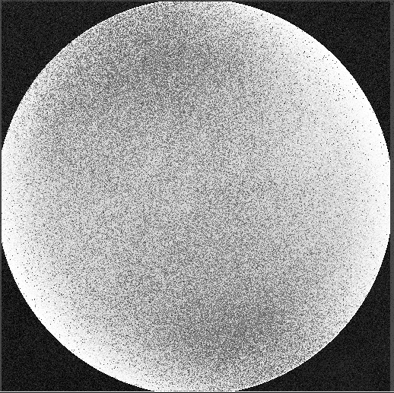 | 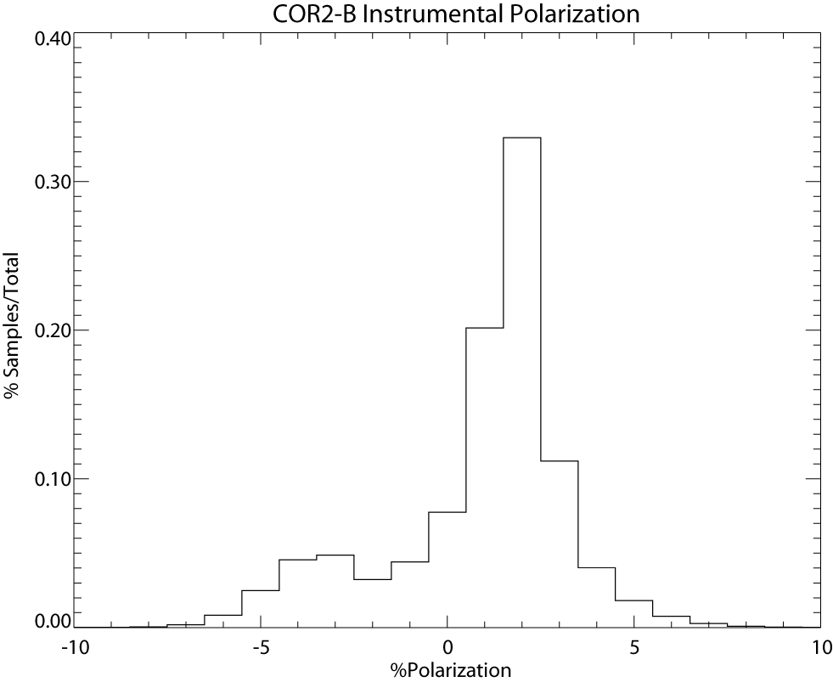
Figure 4 Left: Percent polarization (%P) image. The polarization is around 0% over most of the FOV. Right: Histogram of the values in the image to the right.

Calibration and Validation

Calibration
The polarization performance was measured using a calibrated visible light diffuse source (lightbox) and linear polarizer. The occulters were removed and the detector was at room temperature. The lightbox output is assumed unpolarized. Figure 4 (left) is the derived polarization (%P) image fro COR2-B. The polarization is 1-2% over most of the FOV (Figure 4, right). The polarization increases at the edges of the field to about 5%. However, the measurements are more uncertain in those areas due to vignetting effects from the entrance aperture (A0) cutoff. COR2-A has similar performance.

Validation
Validation of the proper functioning of the COR2 polarizers were determined during vacuum testing in the NRL facility. The instrument was exposed to both completely polarized and partially polarized light, and in both cases the correct level and direction of polarization were obtained.
In-flight validation of the COR2 polarization performance is pending.

References

[COR1_CMAD] STEREO/SECCHI/COR1 Calibration and Measurement Algorithms Document (CMAD), Version 1.0, 30 June 2021

Billings, D. E., 1966, A Guide to the Solar Corona, New York: Academic Press.
Brueckner, G. E., Howard, R. A., Koomen, M. J., Korendyke, C. M., Michels, D. J.; Moses, J. D., Socker, D. G., Dere, K. P., Lamy, P. L., Llebaria, A., Bout, M. V.; Schwenn, R., Simnett, G. M., Bedford, D. K., Eyles, C. J., 1995, The Large Angle Spectroscopic Coronagraph (LASCO), Solar Phys., 162, 357–402.
van de Hulst, H. C. The electron density of the solar corona. Bulletin of the Astronomical Institutes of the Netherlands 11, 135 (1950).

Background determination

Overview
Figure 5 Model equatorial brightness curves for K corona (Saito et al. 1977) and F corona (Koutchmy & Lamy 1985). The F corona dominates the observed signal for heliocentric distances larger than about 4 Rs. From Hayes et al. (2001)
Background determination and removal is an intrinsic analysis operation for all coronagraph data and has been described in several publications (e.g. Morrill et al. 2006; Thompson et al. 2010). The COR2 analysis is an adaptation of the procedures developed for LASCO. So, the following discussion draws heavily from Morrill et al. (2006).
The dominant component of the corona in the COR2 field of view (2-15 Rs) is the F (dust) corona (Figure 5). Since a quantitative model of the F-corona is not yet available, the most practical way to observe the details and changes in the K (electron) corona is the removal of the F-corona and stray light via an empirically-derived background model.

Heritage
The method described in this CMAD is based on procedures used for the SOHO/LASCO telescopes, optimized for COR2.

Product Description
Table 4 Types of background images applied to COR2 data to remove F-corona and instrumental stray light effects
Type | Cadence | Description
Daily median | Daily | “Median” image derived from the COR2 images in a day (for each type: double, polarizer angle)
Monthly minimum [default] | Every week | Running-“Minimum” image derived from +/- 13 days’ worth of daily median images
Background images are produced at the same resolution as the original images, with each pixel in a one-to-one relation with the raw images. Separate backgrounds are calculated for the total brightness (*dbTB*) and each polarizer angle (*p000*, *p120*, *p240*), so that the polarization signal within the background is also subtracted out.
From the three polarizer angles is calculated a total brightness background (*pTBr*) which is simply the average of the three polarized backgrounds. Hence, COR2 has two different backgrounds for total brightness images. The *dbTB* backgrounds should be applied to the Double images (total brightness images formed on board by summing two images taken at 0° and 90°). The *pTBr* backgrounds should be applied to total brightness images produced by averaging the pB sequence images. The reason for forming the backgrounds for these images from the polarization sequence backgrounds, instead of directly from the total brightness images, is to ensure that a consistent background is subtracted from all images.
Background images are generated without any calibration factors applied to them, so that they don’t need to be regenerated if the calibration factors change. Hence, the backgrounds are uncorrected for vignette or flat fielding, and the values are not converted into MSB.

Theoretical Description
This method for the empirically generated backgrounds follows the LASCO flow. First, a daily median image is calculated by finding the median value for each pixel for all images on that date. Then the minimum of all daily images for 2 weeks (13 days) on either side of the desired date is computed giving the background image for the mid-point of a given week. This computation is performed every week. To obtain the background image for a given date, the background images just prior to and after the desired date were used in a linear interpolation to the desired date.

Error Analysis and Corrections

It should be noted that these background images may still have a residual K- coronal contribution to them. A background K-signal or a persistent streamer that is present for more than 27 days will not be removed by this simple procedure. For example during the solar minimum period, the equatorial streamer was persistent for many rotations. Such structures can generate artifacts in an image that has had the background image applied and caution should be taken before using them (e.g. Stenborg & Howard (2017), and references therein). The interested reader is directed to Llebaria et al. (2020) for a more in-depth discussion of the nuisances of K and F corona separation.
In any case, images with empirically-subtracted backgrounds are usuall referred to as ‘quicklooks’ to signify they are unsuitable for quantitative analysis of brightness variations. They are still very useful (and used extensively) to measure kinematics, sizes and assess long-term evolution of coronal features.

Calibration and Validation

Calibration

COR2 background images are in raw counts (digital units (DNs)), with no calibrations applied, to preserve their utility as knowledge of the calibration changes with time. The SECCHI Data analysis guide provides more information on their use.

Validation
No detailed validation has been performed since the quicklook images are not to be used for precise photometry work. Previous work on LASCO and SECCHI background subtraction algorithms (e.g. Stenborg & Howard 2017) suggests that the daily median – monthly-min approach is accurate to about 1%.

References
Hayes, A. P., Vourlidas, A. & Howard, R. A. Deriving the electron density of the solar corona from the inversion of total brightness measurements. The Astrophysical Journal 548, 1081–1086 (2001).
Koutchmy, S. & Lamy, P. L. The F-corona and the Circum-Solar Dust Evidences and Properties [G. Nikolsky Memorial Lecture]. in Properties and Interactions of Interplanetary Dust 63–74 (Springer, Dordrecht, 1985). doi:10.1007/978-94-009-5464-9_14.
Llebaria, A., Lamy, P., Gilardy, H., Boclet, B. & Loirat, J. Restitution of the K and F Components of the Solar Corona from LASCO-C2 Images over 24 Years [1996--2019]. arXiv:2011.12920 [astro-ph] (2020).
Morrill, J. S. et al. Calibration of the Soho/Lasco C3 White Light Coronagraph. Sol Phys 233, 331–372 (2006).
Saito, K., Poland, A. I., & Munro, R. H. 1977, Sol. Phys., 55, 121
Stenborg, G. & Howard, R. A. A Heuristic Approach to Remove the Background Intensity on White-light Solar Images. I. STEREO/HI-1 Heliospheric Images. The Astrophysical Journal 839, 68 (2017).
Thompson, W. T., Wei, K., Burkepile, J. T., Davila, J. M. & St. Cyr, O. C. Background Subtraction for the SECCHI/COR1 Telescope Aboard STEREO. Sol Phys 262, 213–231 (2010).

