STEREO/PLASTIC CMAD
Version: 2021-03-29

Table of Contents
Table of Contents 1
I. Overview/Introduction 6
A. Introduction 6
B. Purpose 13
C. References 14
II. Overview of Data Levels 15
III. Description of Level 0 15
IV. Description of Level 1 15
A. Overview of CDF Files 15
B. Level 1 Software 16
C. Housekeeping Data 17
C.1. Analog Housekeeping 17
C.2. Digital Housekeeping 18
C.3. Spacecraft Housekeeping 21
D. Monitor Rate Data 21
D.1 Full Resolution Monitor Rates 22
D.2. Normal Resolution Mon. Rates: Science Mode 22
D.3. Normal Res. Mon. Rates: Engineering Mode 23
E. Matrix Rate Data 23
E.1. Solar Wind Proton and Alpha Data 24
E.1.1 Proton Moments 24
E.1.2 Proton/Alpha Reduced Distributions 25
E.2. Heavy Ion Data 26
F. Raw Event Data (PHA) 28
G. Memory Data 30
G.1. Classifier Data 30
G.2. ‘Trickle-Down’ Memory Data 31
V. Description of Level 2 31
A. Overview of CDF Files 31
B. SPLAT Software 31
B.1. Introduction 31
B.2. Installation 32
B.2.1. System Requirements 32
B.2.2. Folder Structure 32
B.2.3. Editing splat.sh start-up script 33
B.3. SPLAT Usage 34
B.3.1. SPLAT Crib-Sheets - DESCRIPTION OF CRIBS AND INPUT PARAMETERS 35

B.3.1.1. MOST COMMON INPUT PARAMETERS 35

B.3.1.2. pla_en_spec_crib 35

B.3.1.3. pla_en_spec_line_crib 37

B.3.1.4. pla_def_spec_crib 37

B.3.1.5. pla_pos_spec_crib 38

B.3.1.6. pla_obmom_crib 39

B.3.1.7. pla_mon_crib 40

B.3.1.8. pla_mon_full_crib 42

B.3.1.9. pla_hk_crib 42

B.3.1.10. pla_dig_hk_crib 43

B.3.1.11. pla_sc_hk_crib 43
B.3.2 Level 2 and Level 3 Processing Programs 43
B.4. Trouble Shooting 43
C. PHA_PLAY Software 44
C.1. Introduction 44
C.2. Input Parameters and Associated Output 44
C.2.1 Do you want to simulate the instrument’s bit shifting, etc.? (0=n0,1=yes) 44
C.2.2. Use “quad” style limits file? (0=no, 1=yes) 44
C.2.3. File name and path for limits file (ex. PLASTIC_Rate_Bins_20040811.txt) 45

C.2.3.1 Checking box definitions with plot_bins keword 45
C.2.4 File name and path for constants file (ex. ClassConstants_20_2000228.txt) 46
C.2.5 File name and path for esa lookup (ex. sweep_table_info_EM_060803.txt) 46
C.2.6. PAC 46
C.2.7. Directory in which to put plot files 46
C.2.8. Read cdf from maui if nfs mounted? (0=no, 1=yes) 46
C.2.9. Add year to cdf directory 46
C.2.10. If not reading from maui, directory in which to find cdfs 46
C.2.11. Which plot files do you want created? 46

C.2.11.1. classpoints 46

C.2.11.2 classbins 47

C.2.11.3 normbins 47

C.2.11.4 histograms 47

C.2.11.5 cumulative 48
C.2.12 For class points plots, do you want small circles or single points? 48
C.2.13. Which plots within the plot files do you want? 48
C.2.14 Do you want full-page classpoints plots? (0=no, 1=yes) 48
C.2.15 For full-page plot files, do you want the x-axis log or linear? (0=linear, 1=log) 48
C.2.16 For full-page plot files, do you want the y-axis log or linear? (0=linear, 1=log) 48
C.2.17 For full-page plot files, what limits to you want on the x-axis? 49
C.2.18 For full-page plot files, what limits to you want on the y-axis? 49
C.2.19 For full-page plot files, what limits do you want for the contour levels? 49
C.2.20. How do you want the histograms colored? 49
C.2.21 Do you want ascii output of raw pha data (and nm, nq) for each product you selected? (0=no, 1=yes) 49
C.2.22. Do you want ascii output of normalized counts? 49
C.2.23. For ascii output, over how many hours do you want it averaged? 50
C.2.24. For ascii, do you want normalized data in counts or counts/sec? 50
C.2.25. Do you want data summed over deflection before or after normalization? 50
C.2.26. For normalization, do you want events separated into primary and secondary buffer for error log? 50
C.2.27. Do you want the range of ESA steps combined into one data-set, or separate plots for each esa step? 50
C.2.28 Do you want to generate .tplot files? 51
C.2.29 If you want .tplot files, directory in which to save them 51
C.2.30 Which algorithm do you want to calculate mass and m/q? 51
C.2.31 Do you want full information on the number of cycles used in normalization to be printed? 51
C.2.32. List of specific file information 51

C.2.32.1. satellite 51

C.2.32.2. start year 51

C.2.32.3. start day-of-year 51

C.2.32.4. start_time 51

C.2.32.5. stop year 51

C.2.32.6. stop day-of-year 51

C.2.32.7. stop_time 52

C.2.32.8. esa step from which to take data 52

C.2.32.9. section 52

C.2.32.10. normalization interval 52

C.2.32.11. For normalization, number of ESAs to sum over 52

C.2.32.12. select PHA to include 52

C.2.32.13. Suffix for filename 52
C.3. Classification 53
C.3.1. Overview of Classification on the Instrument 53
C.3.2. Classification Algorithm in this Program 58

C.3.2.1. Calculate NQ 58

C.3.2.2. Calculate NM 59

C.3.2.3. Find Bindatword 60

C.3.2.4. Increment appropriate Rates 60
C.4. Normalization Algorithm 60
C.4.1. Normalization interval 61
C.4.2. Number of ESA steps to sum over 61
C.4.3. Summing over deflection before or after normalization 61
C.4.4. Select PHA to include 61
C.4.5. Explanation of S-Channel switch 61
C.5. Conversion to Counts/Sec 61
C.6. PHA Selection Scheme 62
D. Protons Data Derived from 1D Maxwellian 62
B.1 Data Format 63
E. Protons from on-board 66
C.1 Data Format 68
F. Alphas 69
D.1 Data Format 69
G. Iron Abundance and Kinetic Data 70
E.1 Data Format 71
H. Iron Charge State Data 71
F.1 Data Format 72
VI. Description of L3 72
A. He+ Phase Space Densities 72
A.1 File Format 73
A.2 Measurement range (V/Vsw) for He+ PUI 74
A.3 Comparison of STEREO PLASTIC PUI Spectra with ACE / SWICS 75
A.4 Long-term PUI Measurements 77
B. He+ Relative Fluxes, in four V/Vsw ranges 77
B.1 Data Format 79
B.2 Modification History 80
C. He+ SW Frame Velocity Count Distributions 81
C.1 Data Format 82
C.2 IMF Angles 83
C.3 SW Frame PUI Measurements 84
C.4. References 85
D. He++ Phase Space Densities 86
D1. Data Format 86
D.2 Measurement range (V/Vsw) for He+ PUI and He2+ 87
D.3 PLASTIC Inflight Calibration - Efficiency for Helium 88
E. Alfven Wave Lists 89
E.1. Data Format 89
F. Small Transients Lists 91
F.1 Data Format 92
F.2 References 93
G. Suprathermal Event Lists 94
G.1 Instrument Details 94
G.2 Suprathermal Event Definition 94
G.3 Event List Criteria 95
G.4 Data Format 96
G.5 References 99
Appendices 101
Appendix A: Apids with PLASTIC Data 101
Appendix B: Compression Algorithms 102
Appendix C: Analog Housekeeping Products 103
Appendix D: Classification Bins 105
Appendix E: PHA_PLAY: Sample PLASTIC_Rate_Bins File “Square” Format 107
Appendix F: PHA_PLAY: Sample PLASTIC_Rate_Bins File “Quad” Format 110
Appendix G: PHA_PLAY: Sample Constants File 113
Appendix H: PHA_PLAY: Sample Classpoints PlotFile 114
Appendix I: PHA_PLAY: Sample Classbins PlotFile 115
Appendix J: PHA_PLAY: Sample Normbins PlotFile 116
Appendix K: PHA_PLAY: Sample Histogram PlotFile 117
Appendix L: PHA_PLAY: Sample Cumulative Plot 118
Appendix M: PHA_PLAY: Sample Normalization Error File 119
Appendix N: PHA_PLAY: Sample Use of .tplot Files in SPLAT 121
Appendix O: Conversion of On-board Moments to Physical Units 122
Density 122
Velocity 127
Pressure and Temperature 128
Energy Flux Density and Heat Flux 130
Appendix P: READ_ME_PLASTIC_He_Efficiency_Rev15 133

- Overview/Introduction:

Introduction
The original (Level 1) STEREO Mission Science Objectives are to:

- Understand the causes and mechanisms of CME initiation.
- Characterize the propagation of CMEs through the heliosphere.
- Discover the mechanisms and sites of energetic particle acceleration in the low corona and the interplanetary medium.
- Develop a 3-dimensional, time-dependent model of the ambient solar wind.

To meet these objectives, there are four investigations on STEREO: SECCHI, IMPACT, PLASTIC and SWAVES. The STEREO/PLASTIC contribution is to investigate the spectra and composition of solar wind and heliospheric ions.

The Plasma and Supra-Thermal Ion Composition (PLASTIC) Investigation on STEREO measures solar wind and suprathermal ions in the energy-per-charge range of ~0.2 up to ~87 keV/e (in the normal E/Q sweep mode). PLASTIC is the primary sensor on STEREO for studying coronal - solar wind and solar wind - heliospheric processes. It was developed in a collaboration of the University of New Hampshire, the University of Bern, Kiel University, the Max Planck Institute (MPE), and NASA/GSFC.

PLASTIC incorporates three instrument subsections: The PLASTIC Solar Wind Sector (SWS) measures the distribution functions of solar wind protons (H⁺) and alphas (He⁺²), providing proton density (n), velocity (V_{sw}), kinetic temperature (T_{k}), and alpha to proton (He⁺² / H⁺) ratios with a time resolution up to about one minute to 1-hour. Charge states and anisotropy for minor ions may be obtained through pulse height analysis (pha). The SWS has two channels: the Small Channel (typically designated as ‘Schn’ or ‘Schannel’) and the Main Channel, with different geometrical factors. In order to measure ions out of the in-ecliptic, each channel has its own set of electrostatic deflectors.

The PLASTIC Wide-Angle Partition (WAP) measures distribution functions of suprathermal ions, including interplanetary shock-accelerated (IPS) particles, recurrent particle events associated with Co-rotating Interaction Regions (CIRs), and heliospheric pickup ions. Typical time resolution for selected ions is about 1-hour.

PLASTIC is mounted on the corner of the sunward facing deck. There are six isolator/dampers mounting feet for the sensor box, and a grounding strap. On Spacecraft A, there is also an external auxiliary radiator on the +Y panel, connected to the PLASTIC sensor by a strap. While a clear field of view (FOV) is maintained for the SWS, the WAP FOV suffers from spacecraft and other instrument intrusions. Because of the blockages the primary focus on the WAP science has been use of rates for on event identification, however pulse height data are available.

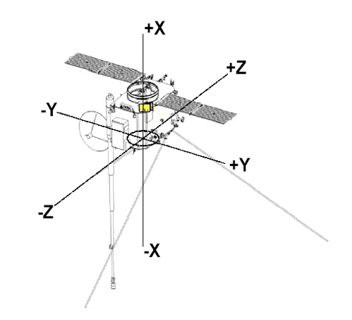 | 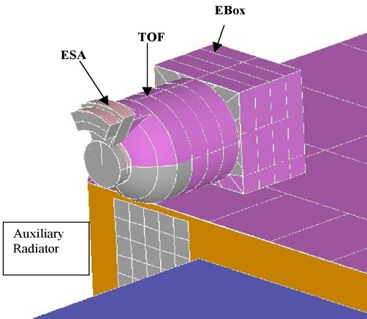
Spacecraft Coordinate System. PLASTIC is mounted on the sunward facing +X panel. On Spacecraft A, the external auxiliary radiator is mounted on the +Y panel. Prior to solar conjunction, the STA PLASTIC was mounted on the top (northward facing) side, and STB on the bottom (southward facing). The spacecraft ‘flipped’ at conjunction. | Close-up schematic of the corner mounting for the PLASTIC A, B, and placement of the auxiliary radiator (A).  Labeled are the Electrostatic Analyzer sections (SWS sections shows the two sets of electrostatic deflectors), the Time-of-flight (TOF) measurement system, and the Electronics Box (Ebox).

The Entrance System was designed and fabricated by the University of Bern. The Entrance System schematic and response are summarized in Galvin et al. (2008). The electrode configuration for the entrance system (Figure 3 of Galvin et al.) is shown below.
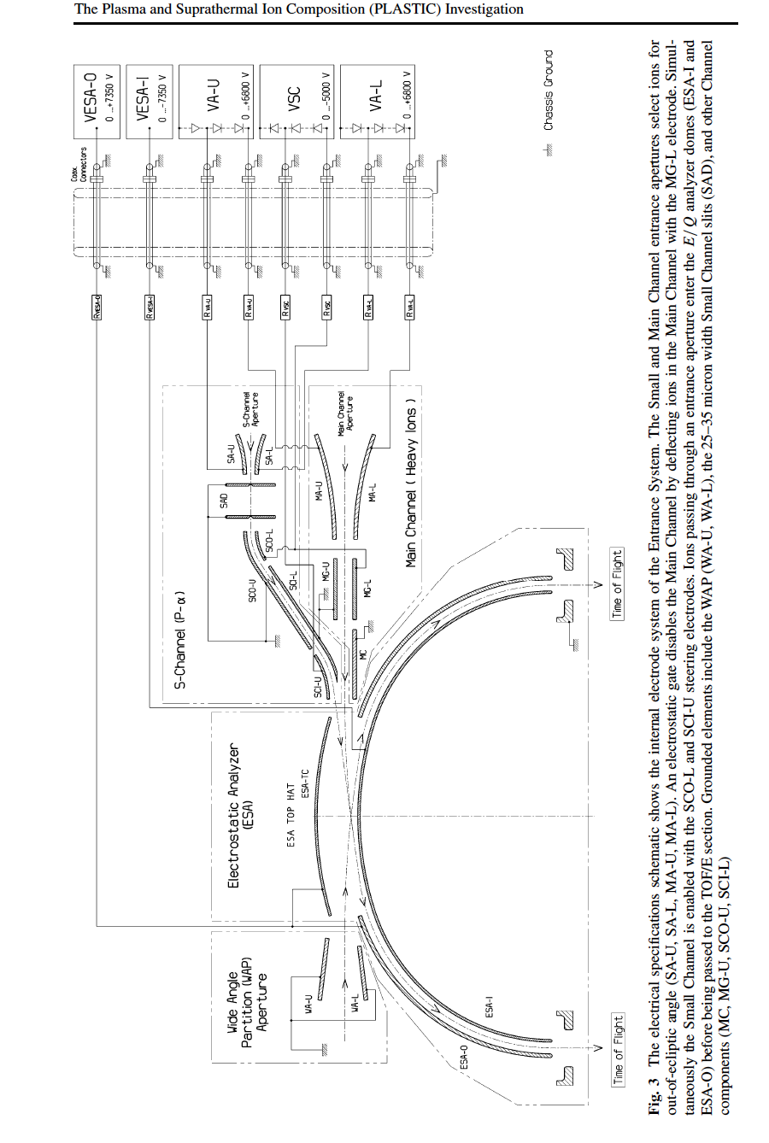

The Entrance System electrode applied voltages are set via DAC (Digital-to-Analog Converter) tables, known as the MACHO and SACHO tables for SWEEPING voltages:
MACHO = Instrument Main Channel Aperture Operation
SACHO = Instrument S-Channel Aperture Operation
These tables are commandable and have changed over the mission. The DAC values are read out into the telemetry in the “trickle down memory”, contained in apid 318.

Each DAC address table has 128 7-bit entries, corresponding to the 128 steps in an ESA (Electrostatic analyzer) sweep cadence. Each entry in the address table points to an entry in the MACHO or SACHO sweep table. There are 5 sweep tables, ESA, S-CH, S-CH TAP, DEFL-1 and DEFL-2. Each sweep table is broken in two (coarse and fine), but can be taken as a single table with 128 16-bit entries. Each sweep table entry is input to a set of DACs, producing a voltage on the corresponding structure in the entry system.

The DAC value is multiplicative (coarse*fine). The FM1 MACHO, SACHO values are shown below (original flight table).

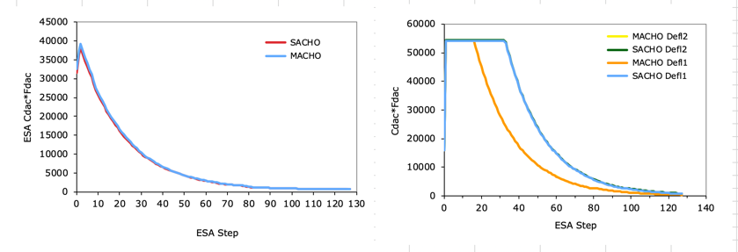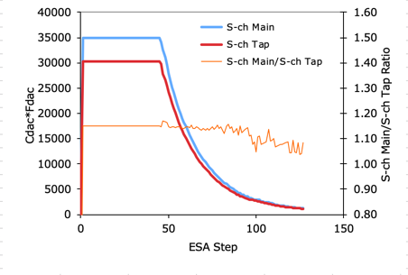
These DAC values in turn correspond to the applied voltages, as given below (pre-launch calibration by M. Popecki & J. Gaidos, UNH).

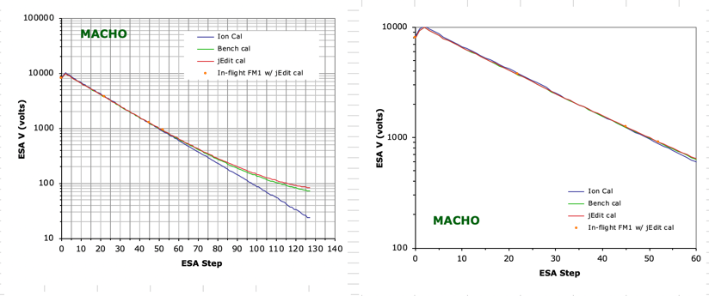 | 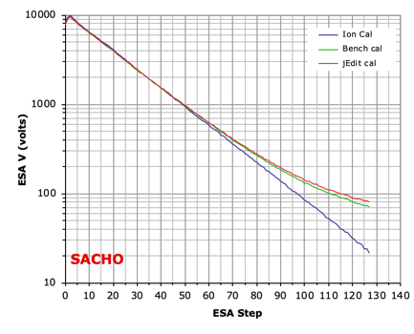
FM1 ESA voltages vs ESA step, for original flight MACHO Table DAC. | FM1 ESA voltages vs ESA step, for original flight SACHO Table DAC.

Whether the MACHO or the SACHO table is applied is determined by the fluence measured at a given deflection/esa setting. This depends on the solar wind fluence value. The switch to the SACHO table helps to prevent the saturation of electronics and controls the lifetime fluence on the MCP and SSD detectors. At the start of each 1-minute ESA sweep the small channel is 'off', and the main channel is open. Upon reaching a set (but commandable) count threshold, the main channel is electrostatically closed and the small channel is enabled. The ESA step where the switch from MACHO table voltages to SACHO table occurs is provided for each ESA cadence. This is often referred to the Schn-switch ESA step, and this information is contained within the data product.

The correspondence between electrode voltage setting and instrument response was determined via calibration with the accelerator facilities at the University of Bern. The entrance system electrode calibration is described by Blush et al. (2005), and references therein. The following description and calibration data for the Entrance System are taken from Blush et al.

“The PLASTIC Entrance System/Energy Analyzer (ESEA) is designed to select solar wind ions for out-of-ecliptic angle of incidence and solar wind and suprathermal ions for energy per charge (E/q). Ions are accepted through three apertures with different geometric factors (GF), each designed to distinguish different components of the solar wind and suprathermal ion populations. The two apertures located in the solar wind sector (SWS) are the proton-alpha channel (S-Channel) and the heavy ion channel (Main Channel), positioned one above the other. The SWS is centered on the Sun and spans a 45º in-ecliptic field of view (FOV) for up to ~20º out-of-ecliptic angle. The SWS thus accepts the main distribution of the solar wind. The remainder of the 360º in-ecliptic field of view (with the exclusion of spacecraft and instrument blockage) is spanned by the Wide-Angle Partition (WAP) with an out-of-ecliptic FOV ~6º.”

“Of key importance in calibration is the determination of the proportionality between applied electrode voltage and the … response, known as the analyzer and deflection constants,
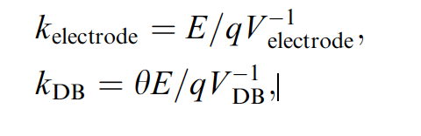
in units of (keV/e) kV⁻¹ and deg*(keV/e) kV⁻¹, respectively. The analyzer constant specifies the relation between an electrode voltage (V_{electrode}) and the measured ion E/q. The deflection constant specifies the relation between the deflector electrode voltage (V_{DB}) and the measured out-of-ecliptic (polar) incident angle.”

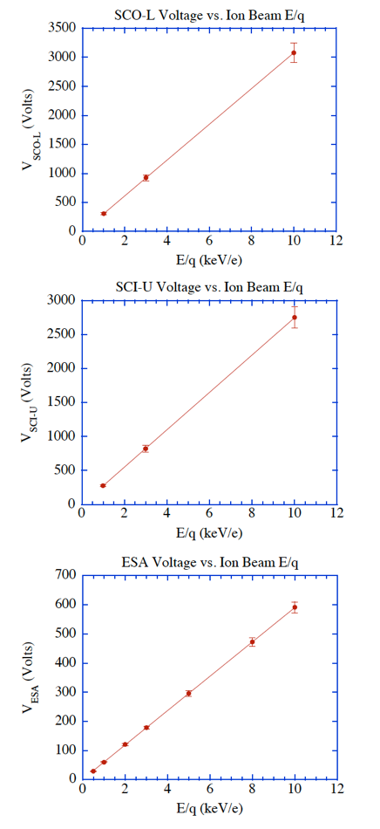 | 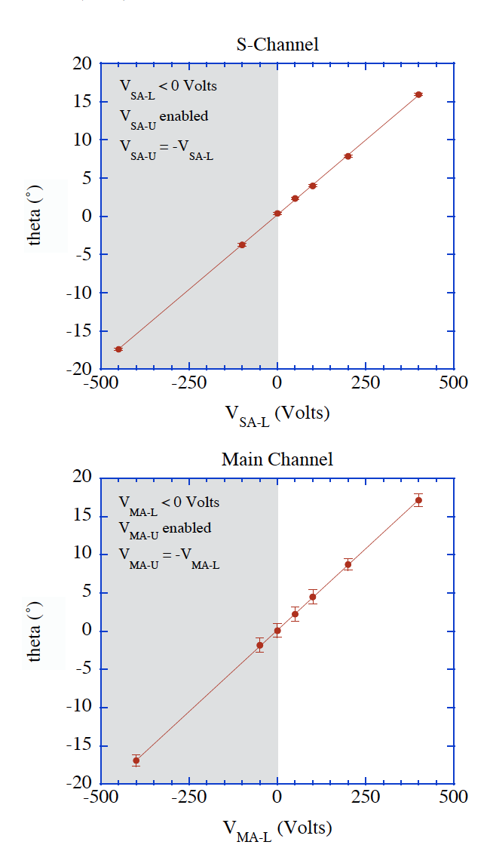
Taken from Figure 3 in Blush et al. FM2 ESEA electrode voltage tuning for various ion beam E/q, which provides the S-Channel steering electrode constants (SCO-L and SCI-U) and E/q analyzer constant (ESA). The error bars indicate the E/q resolution or bandwidth, given as the FWHM of transmission response of a voltage scan for constant ion beam energy. | Taken from Figure 4 of Blush et al. FM1 out-of-ecliptic angular acceptance and resolution showing the deflector electrode ability to deflect ions for collection through SChannel and Main Channel. The error bars indicate the angular resolution or bandwidth, given as the FWHM of transmission response of an angular beam scan. Note that only one deflector electrode is biased to a positive voltage at a time, while the other is biased to zero Volts (the plotted negative values for MA-L and SA-L electrode voltages correspond to the bias of the MA-L and SA-L electrode to the associated positive voltage values).

After launch, during the commissioning period, it was found that the suppression behavior in the Main Channel during SACHO table operations was not as expected. Beam analysis was performed using the engineering model PLASTIC unit at UNH and with the flight spare entrance system at the University of Bern and the in-flight effect was reproduced. The effects are attributed to insufficient fringe-field control in the aperture section of the Entrance System. (We refer to this as Main Channel ‘leakage’). When the SACHO tables are applied, there is a significant fraction of the solar wind entering through the Main apertures. In this case the voltage is to be taken from the SACHO table, but the response to those voltages from the Main channel. Extended analysis of in-flight performance of the small channel instrumental response in geometrical factor, E/Q, and polar and azimuth angular response were performed by Simunac, 2009. These calibrations are embedded in the SPLAT routines for proton bulk parameter analysis.

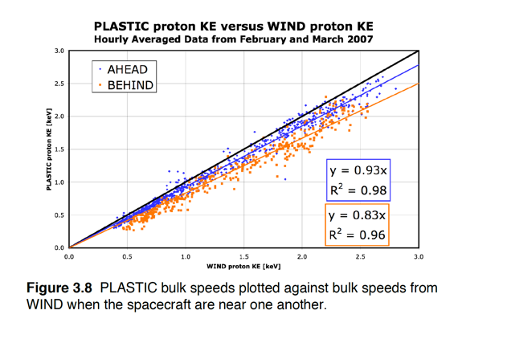 | 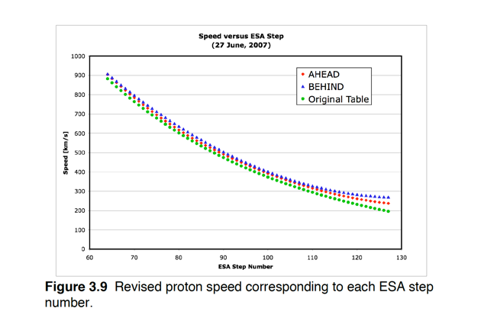
Post launch calibration by Simunac 2009. | Post launch calibration table for Schn used in Proton bulk analysis.

In summary, to determine from first principles the Entrance System values of the E/Q and Deflection Angle for a given ESA/Defl bin, one first extracts the MACHO and SACHO table values from housekeeping. Convert the DAC settings to voltages, and then convert through the appropriate analyzer constants from these voltages to E/Q or Deflection Angle. Then for a given instrument Entrance System Sweep, determine when the instrument has encountered the Schn-Switch, then apply the appropriate MACHO or SACHO table conversions. Note that Sweep calibration tables used in the pha_play and SPLAT routines use the default table load values. For suprathermal ion analysis, it is suggested that the housekeeping be checked to determine if there are non-standard table entries being employed.

The Detector Section or Time-of-flight (TOF) section of the instrument contains the detectors (Solid State Detectors and Microchannel Plates) that measure count rates, time-of-flight (TOF), and measured energy (E_{ssd}).

Pre-launch calibrations of the counting rates are provided in Galvin et al (2008) and post launch in Simunac (2009). These efficiencies depend on bias and gain.
Taken from Figure 2 of Daoudi et al., the interior of the PLASTIC entrance and detector sections.

The TOF and E_{ssd} are digital values that are provided within the PHA (pulse height analysis) word. The TOF is 0.25 ns/chn and the E_{ssd} is 2 keV/chn. (Classification parameters are provided within the pha_play program.)

The measured energy is provided by solid state detectors. Because some energy is lost with the SSD, there is a correspondence between incident energy and measured energy, that is dependent on species and speed. This has been determined for the PLASTIC detectors and provided in Daoudi et al. (2009), as

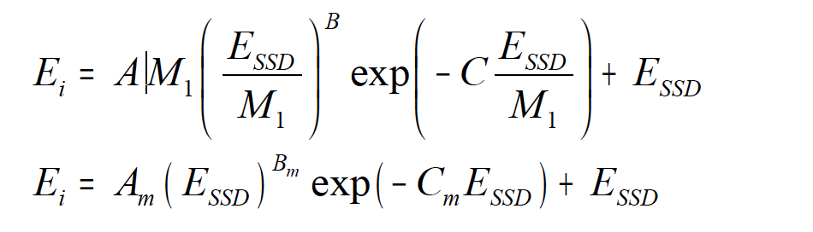

Using the measured SSD energy channel (ssde), the time-of-flight channel (tof), and the ESA step information (swpe), an on-board initial calculation of the composition of a given event is performed using a table look up:

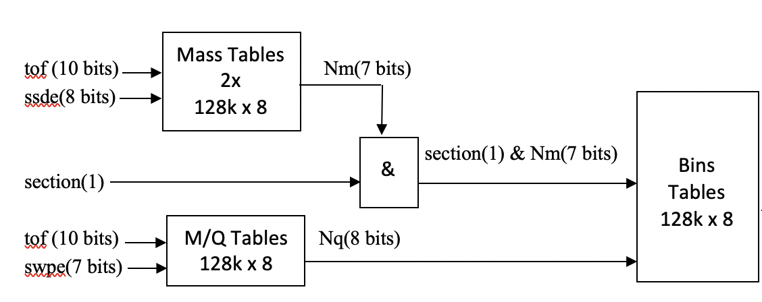
This onboard composition calculation is used to determine into which composition bin a given pha event belongs. The composition matrix rates are accumulated from these bins.

There are multiple pha logic requirements available. The trigger logic being used at a given time is provided in the housekeeping.

The azimuth position is determined using a resistive anode described in Galvin et al (2008). The calibration for the Main channel is given therein:

The azimuth flow angle determination in the Small Channel is compromised by the leakage effect described earlier. For this determination, we rely on rate averaging over position bins with a 5º width, which limits the precision of the E/W measurement.

The PLASTIC microprocessor was descoped by NASA. PLASTIC flight software, including the beacon data generation, is handled by the IMPACT Data Processing Unit, and was coded under direction of the NASA Project office. (The PLASTIC team was not involved in the actual coding.)

The data products directly provided by PLASTIC are described in a subsequent section (Level 1 data below) and consist of rates, pulse height analysis events, and instrument operation mode and status.

For further information on the instrument response, including analyzer constants, geometrical factors, detector efficiencies for all units, see the instrument paper (Galvin et al., 2008).

Purpose
This document describes the process used to convert from raw PLASTIC Level 0 data to higher level (Level 1, 2, 3) data products. The Level 0-3 data sets are stored at the STEREO Science Center in CDF format, and browse level image data are provided in *.png format.

In what follows, we provide an overview of the data levels that are generated. We also describe two s/w program routines provided to the SSC that are used to create Level 2 and some Level 3 products:

- The STEREO PLASTIC ANALYSIS TOOL (SPLAT) software is used for the retrieval of rates and housekeeping data from the Level 1 CDFs. The software is used to obtain rates and analog data as either raw data or as data converted into engineering or science units using embedded calibration data.

- The PHA_play software is used for the creation of composition products using the pha and associated priority rate data from Level 1 CDFs. The s/w composition analysis uses embedded calibration data to convert to science units.

References
Relevance | Title/Author | Publication Information
Instrument Paper, provides a complete context for hardware and data descriptions | The Plasma and Suprathermal Ion Composition (PLASTIC) Investigation on the STEREO Observatories, Galvin et al., 2008 | Space Science Reviews, doi: 10.1007/s11214-007-9296-x
Description of the calibration of the Entrance System, including FOV and GFs | Development and calibration of major components for the STEREO/PLASTIC (plasma and suprathermal ion composition) instrument, Blush et al. 2005 | Advances in Space Research, 36, 1544-1556, 2005
Pre-launch calibration Entrance System | STEREO PLASTIC calibration,  simulation and data analysis, Opitz, 2007 | PhD dissertation, U Bern
Post-launch Schannel calibration for E/Q, Deflection, and Density | Solar Wind Stream Interfaces: The Importance of Time, Longitude and Latitude Separation between Points of Observation, Chapter 3 & Appendix A,B, Simunac, 2009 | PhD dissertation, UNH
Species identification techniques using PHA: Solar Wind Iron (Fe) | Solar wind ion trends and signatures: STEREO PLASTIC  observations approaching solar minimum, Galvin et al., 2009 | Ann. Geophys., 27, 3909–3922, 2009, www.ann-geophys.net/27/3909/2009/
Species identification techniques using PHA: Solid State Detector E calibration by species | The STEREO/PLASTIC response to solar wind ions (Flight measurements and models), Daoudi et al., 2009 | Astrophys. Space Sci. Trans., 5, 1–13, 2009,  http://www.astrophys-space-sci-trans.net/5/1/2009/.
Data Access and Known Issues | Instrument Description and Data Portal | http://stereo.sr.unh.edu/data/PLASTIC_Resources/index.htm

Overview of Data Levels
Level 1 Data is the highest time resolution full data set for the PLASTIC instrument. The generation of the Level 1 data is only done once. Thus the Level 1 processing only includes processing steps which do not change. In particular, efficiencies are not applied to generate quantities in physical units because it is known that the efficiencies, and knowledge of the efficiencies change with time. Steps which are done in the Level 1 processing include decompressing rate data, and formatting each data product into useful arrays, including any header data that are needed for later analysis. Level 2 (key parameter data) consists of one-minute, 5-minute, 10-minute, hourly or 2-hour summary data sets containing the most frequently used quantities from PLASTIC, such as ion plasma moments and lower time-resolution of some key minor species (such as He+). Summary moment data include: solar wind density, velocity, and kinetic temperature. Level 3 data consists of higher-level data products which come about as the result of scientific analysis of the data. Due to its nature, Level 3 data may be limited in its timespan and scope. PLASTIC also produces a real-time data product (“Beacon Data”) which includes a subset of housekeeping to monitor the health of the instrument as well as proton data similar to the on-board moments. The contents of the Beacon data packet are specified in Appendix A.

Description of Level 0
Level 0 data is processed by APL and is kept by the Stereo Science Center. It is stored in daily files with names in form plastc_[ahead/behind]_[YYYY]_[DOY]_1_[XX].fin, where:
Ahead/behind indicates which spacecraft the data is for
YYYY = year
DOY = Day of year
XX = version
Each file contains raw CCSDS packets, put in sequential order. The definition for each APID can be found in IMPACT_CTMV32A.xls, with a summary provided in the Appendices.

Description of Level 1

Overview of CDF Files
All Level 1 data are stored in CDF (Common Data Format) files. See http://cdf.gsfc.nasa.gov/ for a description of CDF files, in general. Each day, for each spacecraft, we create four CDF files with the following filenames:
STx_L1_PLA_yyyymmdd_doy_Vzz.cdf
STx_L1_PLA_HK_yyyymmdd_doy_Vzz.cdf
STx_L1_PLA_SC_yyyymmdd_doy_Vzz.cdf
STx_L1_PLA_CL_yyyymmdd_doy_Vzz.cdf
In each filename, ‘x’ stands for ‘A’ or ‘B’ depending on the spacecraft; ‘yyyymmdd’ stands for the date; ‘doy’ stands for the three-digit day-of-year, and ‘zz’ gives the version number of the processing software. If you want easily to check if you have the most up-to-date files, you can look in the files ‘processing_dates_’ and ‘sphk_processing_dates_’ for each spacecraft. These files list the most recent processing date for the data from each day of year.

The first file, which begins ‘STx_L1_PLA_’, contains all our science data, including monitor rates, proton moments, proton/alpha distributions, heavy ion data, and pha events. The second file, which includes the ‘HK’ (housekeeping) abbreviation, contains the housekeeping data that comes from the instrument, including analog and digital housekeeping. The third file, which includes the ‘SC’ (spacecraft) abbreviation, contains the spacecraft housekeeping values that are pertinent for PLASTIC. The last file, which includes the ‘CL’ (classifier) abbreviation, contains memory dump information from the instrument. This includes reads of our classifier memory, as well as a continuous ‘trickle-down’ stream of data that reads all our memory and puts it in telemetry as space allows.

In each file, data records are linked to an ‘epoch’ variable that gives the time for each record in UTC. CDF epoch variables denote milliseconds since 01-Jan-0000 00:00:00.000. Specifics of the different epoch variables are listed below. Also, in each file, there are a ‘level0_file’ variable and a ‘processing_date’ variable which give the name of the level 0 file used to create this CDF, and the date on which this CDF was processed.

In the science CDF, there are also three variables used to indicate potentially bad data. This CDF contains three epoch variables: epoch1 for one-minute resolution data, epoch5_heavy for the heavy-ion data, and epoch5_mon for the science mode normal monitor rates (see below). For each of these variables, there is a corresponding error variable: error1, error5_heavy, error5_mon. If, for any record, the error variable has a value of 1, then the data in that record is suspect. Further analysis of the Level 0 data would be required to determine more details about why it is suspect.

Level 1 Software
The PLASTIC Level 1 software is written in IDL. The PLASTIC s/w is available through the Stereo Science Center’s distribution of Solar Soft. This level s/w was not written as public software, and it has hardcoded paths which make it unrunnable by others in its current form. However, it shows the process and algorithms for the Level 1 processing. The Level 1 software checks for any errors in the data including packets out of order, missing packets and time gaps; it decompresses rate data; it formats each data product into useful arrays, including any header data that would later be needed for analysis; and it separates data into separate files for housekeeping and science data.

Housekeeping Data

C.1. Analog Housekeeping
Analog housekeeping in contained in apid 200 packets in our level 0 telemetry. It is stored in CDFs with the prefix STx_L1_PLA_HK_, where ‘x’ is either ‘A’ or ‘B’, depending on the spacecraft. The PLASTIC housekeeping data are collected and sent from the instrument to the DPU once per minute, at the end of a data cycle. Because apid 200 includes data from the IMPACT instrument as well as from PLASTIC, apid 200 packets may be sent more often than once per minute. However, the PLASTIC portion of the data comes on a one-minute cadence.

The level 1 data include both the raw value, and a converted (engineering) value, where applicable. All analog housekeeping products are tied to the epoch_analog product, which contains the time for each record. Data products are:

device_code
block_id

lrnm_spare_raw lrnm_spare_eng
lvc_-12v_raw lvc_-12v_eng
lvc_-5v_raw lvc_-5v_eng
esa_vm_pos_raw esa_vm_pos_eng
dfl_1_vm_raw dfl_1_vm_eng
dfl_1_tap_raw dfl_1_tap_eng
dfl_2_vm_raw dfl_2_vm_eng
dfl_2_tap_raw dfl_2_tap_eng
lvc_+2.5v_b_raw lvc_+2.5v_b_eng
pac_cm_dc_raw pac_cm_dc_eng
lvc_+12v_raw lvc_+12v_eng
lrpm_spare_raw lrpm_spare_eng
lvc_+2.5v_a_raw lvc_+2.5v_a_eng
lvc_+5v_raw lvc_+5v_eng
adc_avdd_raw adc_avdd_eng
adc_dvdd_raw adc_dvdd_eng
pac_vm_raw pac_vm_eng
cal_vref_raw cal_vref_eng
pac_cm_ac_raw
mcp_vm_raw mcp_vm_eng
mcp_cm_dc_raw mcp_cm_dc_eng
mcp_cm_ac_raw
ssd_cm_dc_raw ssd_cm_dc_eng
s_ch_vm_raw s_ch_vm_eng
s_ch_vm_tap_raw s_ch_vm_tap_eng
s_ch_cm_dc_raw s_ch_cm_dc_eng
esa_vm_neg_raw esa_vm_neg_eng
esa_cm_dc_raw esa_cm_dc_eng
dfl_1_cm_dc_raw dfl_1_cm_dc_eng
dfl_2_cm_dc_raw dfl_2_cm_dc_eng
lvc_+2.5v_b_imon_raw lvc_+2.5v_b_imon_eng
lvc_+12v_imon_raw lvc_+12v_imon_eng
lvc_-12v_imon_raw lvc_-12v_imon_eng
lvc_+5v_imon_raw lvc_+5v_imon_eng
lvc_-5v_imon_raw lvc_-5v_imon_eng
lvc_+2.5v_a_imon_raw lvc_+2.5v_a_imon_eng
ssd_vm_raw ssd_vm_eng
plug_id_raw
adc_lu_flag_raw
dac_status_raw
adc_lu_ctr_raw
adc0_agnd_raw adc0_agnd_eng
adc1_agnd_raw adc1_agnd_eng
ra_e0_raw ra_e0_eng
ra_e1_raw ra_e1_eng
tac0_tsp_raw tac0_tsp_eng
tac2_tsp_raw tac2_tsp_eng
sb0_tsp_raw sb0_tsp_eng
sb1_tsp_raw sb1_tsp_eng
tof_hv0_tsp_raw tof_hv0_tsp_eng
tof_hv1_tsp_raw tof_hv1_tsp_eng
s_c_0_tsp_raw s_c_0_tsp_eng
s_c_1_tsp_raw s_c_1_tsp_eng
lvc0_tsp_raw lvc0_tsp_eng
lvc1_tsp_raw lvc1_tsp_eng
adc0_vref_raw adc0_vref_eng
adc1_vref_raw adc1_vref_eng
ssd_status_raw
ssd_v_pos_analog_raw ssd_v_pos_analog_eng
ssd_v_neg_analog_raw ssd_v_neg_analog_eng
ssd_hv_bias_raw ssd_hv_bias_eng
ssd_tc0_raw ssd_tc0_eng
ssd_tc1_raw ssd_tc1_eng
ssd_tc2_raw ssd_tc2_eng
ssd_v_pos_dig_raw ssd_v_pos_dig_eng

C.2. Digital Housekeeping
Digital housekeeping is contained in apid 313 packets in our level 0 telemetry. It is stored in CDFs with the prefix STx_L1_PLA_HK_, where ‘x’ is either ‘A’ or ‘B’, depending on the spacecraft. The PLASTIC housekeeping data are collected and sent down in telemetry once per minute, at the end of a data cycle. The level 1 data include raw values only. All digital housekeeping products are tied to the epoch_digital product, which contains the time for each record. Data products are:

dpu_sw_version
cmd_rcvd_cnt
cmd_exec_cnt
cmd_total_err_cnt
cmd_parity_err_cnt
cmd_frame_err_cnt
cmd_illegal_err_cnt
ic_status_reg
ic_ctl_reg
lbc_reset_ctl
lbc_mode_ctl
lbc_logic_ctl_a
lbc_logic_ctl_b
lbc_tac_pwr_ctl
lbc_reg_seq
lbc_event_ctl
lbc_rlim_ch
lbc_rlim_hi
lbc_rlim_lo
lbe_pos_ctrl
lbe_pos_disable0
lbe_pos_disable2
lbe_tac0_ctrl
lbe_tac0_dac
lbe_tac2_ctrl
lbe_tac2_dac
lbe_tac0_under_hi
lbe_tac0_under_lo
lbe_tac0_over_hi
lbe_tac0_over_lo
lbe_tac2_under_hi
lbe_tac2_under_lo
lbe_tac2_over_hi
lbe_tac2_over_lo
lbe_ssd_ctrl
lbe_ssd_cmd_h
lbe_ssd_cmd_l
lbe_ssd_dis
lbe_ssd_under_hi
lbe_ssd_under_lo
lbe_ssd_over_hi
lbe_ssd_over_lo
lbe_sel_ctrl
lbe_trig_mode
lbe_esa_step
lbe_defl_step
lbe_ssd_offset0
lbe_ssd_offset1
lbe_ssd_offset2
lbe_ssd_offset3
lbe_ssd_offset4
lbe_ssd_offset5
lbe_ssd_offset6
lbe_ssd_offset7
lbe_stim_enable
lbe_stim_freq_hi
lbe_stim_freq_lo
lbe_sel0_window
lbe_sel2_window
lbe_ssd_offset8
lbe_ssd_offset9
lbe_ssd_offset10
lbe_ssd_offset11
lbe_ssd_offset12
lbe_ssd_offset13
lbe_ssd_offset14
lbe_ssd_offset15
lbe_pos_ra
dacm_pac_mcp_ssd_ctl_mcp_limit
dacm_pac_limit
dacm_esa_ctl
dacm_s_ch_ctl
dacm_dfl_1_ctl
dacm_dfl_2_ctl
dacm_control
dacm_status
dacm_adc_lu_ctr
dacm_dfl_1_offset
dacm_dfl_2_offset
dacm_pac_coarse
dacm_pac_fine
dacm_pac_cm_fs_coarse
dacm_pac_cm_fs_fine
dacm_mcp_coarse
dacm_mcp_fine
dacm_mcp_cm_fs_coarse
dacm_mcp_cm_fs_fine
dacm_ssd_coarse
dacm_ssd_fine
dacm_esa_coarse
dacm_esa_fine
dacm_s_ch_coarse
dacm_s_ch_fine
dacm_s_ch_tap_coarse
dacm_s_ch_tap_fine
dacm_dfl_1_coarse
dacm_dfl_1_fine
dacm_dfl_1_dfine
dacm_dfl_2_coarse
dacm_dfl_2_fine
dacm_dfl_2_dfine
dacr_pac_mcp_ssd_ctl_mcp_limit
dacr_pac_limit
dacr_esa_ctl
dacr_s_ch_ctl
dacr_dfl_1_ctl
dacr_dfl_2_ctl
dacr_control
dacr_status
dacr_adc_lu_ctr
dacr_dfl_1_offset
dacr_dfl_2_offset
dacr_c_pac_coarse
dacr_c_pac_fine
dacr_c_pac_cm_fs_coarse
dacr_c_pac_cm_fs_fine
dacr_c_mcp_coarse
dacr_c_mcp_fine
dacr_c_mcp_cm_fs_coarse
dacr_c_mcp_cm_fs_fine
dacr_c_ssd_coarse
dacr_c_ssd_fine
dacr_c_esa_coarse
dacr_c_esa_fine
dacr_c_s_ch_coarse
dacr_c_s_ch_fine
dacr_c_s_ch_tap_coarse
dacr_c_s_ch_tap_fine
dacr_dfl_1_coarse
dacr_dfl_1_fine
dacr_dfl_1_dfine
dacr_dfl_2_coarse
dacr_dfl_2_fine
dac_dfl_2_dfine
sw_status1
sw_hv_ramp_status
sw_hv_enable_status
sw_hv_limit_status
sw_eepromchksum
hkp_sampletime
pac_discharge_status
pac_discharge_cnt
pac_discharge_conseccntr
pac_discharge_safe_att
analog_limit_status
analog_lim_pt1_status
analog_lim_pt1_id
analog_lim_pt1_red
analog_lim_pt2_status
analog_lim_pt2_id
analog_lim_pt2_red
analog_lim_pt3_status
analog_lim_pt3_id
analog_lim_pt3_red
analog_lim_pt4_status
analog_lim_pt4_id
analog_lim_pt4_red
analog_lim_pt5_status
analog_lim_pt5_id
analog_lim_pt5_red
analog_lim_pt6_status
analog_lim_pt6_id
analog_lim_pt6_red
analog_lim_pt7_status
analog_lim_pt7_id
analog_lim_pt7_red
analog_lim_pt8_status
analog_lim_pt8_id
analog_lim_pt8_red
analog_lim_pt9_status
analog_lim_pt9_id
analog_lim_pt9_red
analog_lim_pt10_status
analog_lim_pt10_id
analog_lim_pt10_red
analog_lim_pt11_status
analog_lim_pt11_id
analog_lim_pt11_red
analog_lim_pt12_status
analog_lim_pt12_id
analog_lim_pt12_red
analog_lim_pt13_status
analog_lim_pt13_id
analog_lim_pt13_red
analog_lim_pt14_status
analog_lim_pt14_id
analog_lim_pt14_red
analog_lim_pt15_status
analog_lim_pt15_id
analog_lim_pt15_re
opmode
sw_mode
proton_mode
active_supplyid
supply_coarse_rb
supply_fine_rb
swmaint_supplystat
swmaint_pac_coarse
swmaint_pac_fine

C.3. Spacecraft Housekeeping
Spacecraft housekeeping is contained in .csh (converted spacecraft housekeeping) files created by APL. It is stored in CDFs with the prefix STx_L1_PLA_SC_, where ‘x’ is either ‘A’ or ‘B’, depending on the spacecraft. The level 1 data include converted values only; APL does the conversions. All spacecraft housekeeping products are tied to the epoch product, which contains the time for each record. Data products are:
pl_ebox_tmp
pl_inst_msg_pwr_dwn_req
pl_pwr_cur
pl_pwr_tt
pl_surv_pwr_cur
pl_surv_pwr_tt
pl_tof_tmp

Monitor Rate Data
The monitor rates data consist of the raw rates from individual 16-bit counters and from checks for logical coincidences in the instrument. There are 32 rates. The data from the instrument to the DPU contain the rate data, the E/Q ESA step, and the deflection step information.

These are sent in a message to the DPU every deflection step (every 12.8 ms). From this, two types of data products are formed: “full resolution” rates and “normal” rates. In science mode, for one rate (selectable: default is start rate, sf0; however the ra_trig is most frequently used) we keep full angle and time resolution for half the 128 energy steps (full resolution). The first step to use is commandable, and the product then uses the subsequent 63 steps (total of 64 steps). For the full set of rates (normal resolution) we create a data product which sums the rates in energy, angle and time to get a smaller set. This summed product is sent out once every 5 cycles. Each set of 4 adjacent energies, and 4 adjacent deflector angles is summed, and the product is accumulated for 5 cycles (5 minutes). In Engineering mode, the “normal” rates come out every minute, and five additional rates are put into the telemetry at full resolution.

In both modes, the data is compressed from 16 bits to 8 bits. The data in the CDF is uncompressed back to 16 bits. If the 16-bit counters overflow, the DPU sends down a compressed value of ‘FF’x which decompresses to 507904. So, a value of 507904 in the CDF implies data overflow.

The 32 rates are:

SSD side Non-SSD side
s_valid w_no_pos
s_e_not_req w_mult_pos
s_e_req w_valid
s_no_pos sf2
s_mult_pos sfr2
s_no_e stp2
s_mult_e pos2_0
ra_sat_a pos2_1
ra_sat_b pos2_2
ra_sat_both pos2_3
ssd_sw pos3_0
ssd_st pos3_1
sf0 pos3_2
sfr0 pos3_3
stp0
ra_trig
pos1_0
pos1_1

All monitor rates products are contained in our level 0 telemetry and are stored in CDFs with the prefix STx_L1_PLA_ where ‘x’ is either ‘A’ or ‘B’, depending on the spacecraft. Full resolution monitor rates are contained in apid 317 while normal resolution monitor rates (both science and engineering mode) are contained in apid 316.

D.1 Full Resolution Monitor Rates
The full resolution monitor rates are listed in the CDF by their name and the ‘_full’ suffix. For example, there is a ‘s_valid_full’ product. All the full-resolution monitor rates are tied to the ‘epoch1’ variable because they come out every minute. The time given is the start of cycle time. There will be a record for each minute in the day for which we received any science data. All records that do not contain valid data for any particular product will have the ‘fill value’ of -1. It does not matter whether we are in science or engineering mode; valid data is simply entered into the CDF of whichever products we receive at any given time.

Each record has the dimensions 128 x 32 which represent the 128 esa steps and the 32 deflection steps.

The full resolution monitor rates are tied to the following variables (i.e. the same record number will give you the appropriate data for any given value):
‘epoch1’ gives time for record
‘cycle1’ gives cycle number for record (for synchronization)
‘s_chan1’ gives the step on which the s-channel switched for this record
(0 = didn’t switch)
‘error1’ if 1, there was a possible error with this cycle’s data

D.2. Normal Resolution Mon. Rates: Science Mode
The normal resolution monitor rates that are taken in science mode are listed in the CDF by their names and the ‘_norm_science’ suffix. For example, there is a ‘s_valid_norm_science’ product. All the normal resolution monitor rates taken in science mode are tied to the ‘epoch5_mon’ variable, because they come out every five minutes. The time given is the start time of the first cycle. There are two epoch5 variables (epoch5_mon and epoch5_heavy) because the monitor rates and the heavy ions are not necessarily synchronized.

Each record has the dimensions 32 x 8 which represent the 32 groups of 4 summed esa steps and the 8 groups of 4 summed deflection steps.

The normal resolution monitor rates taken in science mode are tied to the following variables (i.e. the same record number will give you the appropriate data for any given value):
‘epoch5_mon’ gives time for record – start of first cycle
‘cycle5_mon’ gives cycle number for record (for synchronization)
‘s_chan5_mon’ gives the step on which the s-channel switched for this
record (0 = didn’t switch)
‘error5_mon’ if 1, there was a possible error with this data

D.3. Normal Res. Mon. Rates: Engineering Mode
The normal resolution monitor rates that are taken in engineering mode are listed in the CDF by their names and the ‘_norm_eng’ suffix. For example, there is a ‘s_valid_norm_eng’ product. All the normal resolution monitor rates taken in engineering mode are tied to the ‘epoch1’ variable, because they come out every minute. The time given is the start of the cycle.

Each record has the dimensions 32 x 8 which represent the 32 groups of 4 summed esa steps and the 8 groups of 4 summed deflection steps.

The normal resolution monitor rates taken in engineering mode are tied to the following variables (i.e. the same record number will give you the appropriate data for any given value):
‘epoch1’ gives time for record – start of cycle
‘cycle1’ gives cycle number for record (for synchronization)
‘s_chan1’ gives the step on which the s-channel switched for this
record (0 = didn’t switch)
‘error1’ if 1, there was a possible error with this cycle’s data

Matrix Rate Data
The 16-bit accumulators from the classification board are sent to the DPU after every deflection cycle (435.6 ms). The contents of the accumulators are listed below.

Note that the naming convention for the matrix rates is based on a nominal compositional onboard calculation by the classification board using the digital values of the ESA step, TOF, and energy. These calculations do not take into account effects such as measurement resolutions and spill-over from adjacent species, as that would require a full pha analysis.

Table: Accumulated products on Classification board.

Name | Bin_dat type | Class bins | Pos. bins | Def. bins | Energy steps | # of sections | SECTION* | Total bins | bits/ item | Total Bytes
SW-all | Sw-all | 1 | 32 | 32 | 1 | 1 | 0 or 1 | 1024 | 16 | 2048
SW-H (Doubles) | sw H alpha | 1 | 32 | 32 | 1 | 1 | 0 or 1 | 1024 | 16 | 2048
SW- alpha (Doubles) | sw H alpha | 1 | 32 | 32 | 1 | 1 | 0 or 1 | 1024 | 16 | 2048
SW_alpha (Triples) | sw H alpha | 1 | 32 | 32 | 1 | 1 | 0 or 1 | 1024 | 16 | 2048
SW Z>2 | sw Z>2 | 15 | 16 | 8 | 1 | 1 | 0 or 1 | 1920 | 16 | 3840
Wide-angle, Triples | Supra  wide | 15 | 8 | 1 | 1 | 1 | 2 | 120 | 16 | 240
Wide-angle, Double | Supra no E | 7 | 8 | 1 | 1 | 2 | 2,3 | 112 | 16 | 224
SW_PHA_Priority_rates | SW Pha pri rates | 4 | 1 | 32 | 1 | 1 | 0 or 1 | 128 | 16 | 256
WAP_PHA_Priority_rates | WAP Pha pri rates | 2 | 1 | 1 | 1 | 2 | 2,3 | 4 | 16 | 8
PHA Data |  |  |  |  |  |  |  | 512 | 48 | 3072
Total |  |  |  |  |  |  |  |  |  | 15832
*0-SW-main channel,
1-SW-S channel,
2-WAPwSSD
3-WAP_no_SSD

E.1. Solar Wind Proton and Alpha Data
From the instrument, there are three arrays which contain the nominal solar wind proton and alpha classification rate data. The first array (SW-all) contains the proton and alpha data together, with only angular binning. The second (SW-H/alpha-Doubles) contains data classified using the time-of flight: there is a 32-azimuthal bin x 32-polar bin array for each of the two species. The third (SW_alpha_Triples) contains the alpha data classified using the both time-of-flight and energy measurement. So that the DPU does not have to store a whole array of data, the telemetered reduced distribution functions and part of the moments are based on the peak from the previous cycle. The data is compressed from 16 bits to 8 bits. The data in the CDF is uncompressed back to 16 bits.

E.1.1 Proton Moments
By command, we can choose which array, SW_all or SW_H, is used for the onboard calculation of proton moments. Default is SW_H. The moments are calculated using a commandable energy range. Default is ESA steps 39-127 (step 39 is nominally 15 keV). The moments calculation normally uses all odd position bins, but this is commandable and read out in housekeeping. For deflection, it uses deflection bins DP-3 to DP+4 where DP is the deflection peak from the previous cycle (i.e. the deflection bin in which the most counts were received).

Proton moments are contained in apid 325 packets in our level 0 telemetry. They are stored in CDFs with the prefix STx_L1_PLA_, where ‘x’ is either ‘A’ or ‘B’, depending on the spacecraft. The moments are collected and sent down in telemetry once per minute, when we are in science or proton mode. The level 1 data include raw values only. All moments products are tied to the epoch1 product, which contains the time for each record. The data are compressed to 16 bits. The data in the CDF is uncompressed.

The moments variables are:
‘density_main’ density for main channel
‘density_s’ density for s channel
‘velocity_main’ 3 element array: x,y,z
‘velocity_s’ 3 element array: x,y,z
‘heat_flux_main’ 3 element array: x,y,z
‘heat_flux_s’ 3 element array: x,y,z
‘temperature_main’ 6 element array: xx,xy,xz,yy,yz,zz
‘temperature_s’ 6 element array: xx,xy,xz,yy,yz,zz

The moments are tied to the following variables (i.e. the same record number will give you the appropriate data for any given value):
‘epoch1’ gives time for record – start of cycle
‘cycle1’ gives cycle number for record (for synchronization)
‘s_chan1’ gives the step on which the s-channel switched for this
record (0 = didn’t switch)
‘moment_meta’ 4 elements:[Emin, Emax, Schan conversion factor,
Array (0:SW-All, 1:SW-H)]
‘error1’ if 1, there was a possible error with this cycle’s data

E.1.2 Proton/Alpha Reduced Distributions
There are four distribution functions total, from the 4 SW proton and alpha arrays. If the proton peaks are EP (peak energy step) and DP (peak deflection bin) and the alpha peaks are EA (peak energy step) and DA (peak deflection bin), then the min and max energies and deflection angles to use are given in the following table. In order to sample all position bins (except position 0 which holds error cases), the position distribution sums across 3 or 4 position steps. Thus, the position bin 0 holds position steps 1-3 (ignoring position step 0); position bin 1 holds position steps 4-7; position bin 2 holds position steps 8-11, etc. Note in the following, we are using the energy (ESA) stepping sequence number, and the energies step from high energies to low energies. So the highest energy step would be EP=0, and the lowest energy step would be EP=128. Similarly EP+4 corresponds to a lower energy than EP, and EP-5 corresponds to a higher energy than EP.

Table. Bins to use to form the reduced proton and alpha distributions.
Source Array | Reduced Array | Class bin | E min | E max | E steps | POS min | POS max | POS summed | Pos bins | DEF min | DEF max | Def bins
SW-all | H_alpha | 0 | EP+4 | EP-15 | 20 | 1 | 31 | 3,4 | 8 | DP-3 | DP+4 | 8
SW-H(Doubles) | H+ Peak | 0 | EP+4 | EP-5 | 10 | 1 | 31 | 3,4 | 8 | DP-3 | DP+4 | 8
SW-alpha-(Doubles) | He++ Peak | 1 | EA+4 | EA-5 | 10 | 1 | 31 | 3,4 | 8 | DA-3 | DA+4 | 8
SW_alpha (Triples) | He++ TCR | 0 | EA+4 | EA-5 | 10 | 1 | 31 | 3,4 | 8 | DA-3 | DA+4 | 8

These products are contained in apid 324-7 packets in our level 0 telemetry. They are stored in CDFs with the prefix STx_L1_PLA_, where ‘x’ is either ‘A’ or ‘B’, depending on the spacecraft. They are collected and sent down in telemetry once per minute, when we are in science mode. In proton mode, we receive two of the four (SW-H Doubles and SW_alpha Triples). The level 1 data include raw values only. All these products are tied to the epoch1 product, which contains the time for each record. The data are compressed from 16 bits to 8 bits. The data in the CDF are uncompressed back to 16 bits.

The alpha/proton variables are:
‘h_alpha’ apid 324, SW-all array
4 dim array, 20 x 8 x 8
[EP+4:EP-15, SummedPos, DP-3:DP+4]
‘h+peak’ apid 325, SW-H Doubles
4 dim array, 10 x 8 x 8
[EP+4:EP-5, SummedPos, DP-3:DP+4]
‘he++peak’ apid 326, SW-alpha Doubles
4 dim array, 10 x 8 x 8
[EA+4:EA-5, SummedPos, DA-3:DA+4]
‘he++tcr’ apid 327, SW-alpha Triples
4 dim array, 10 x 8 x 8
[EA+4:EA-5, SummedPos, DA-3:DA+4]

The alpha/proton reduced distribution products are tied to the following variables (i.e. the same record number will give you the appropriate data for any given value):
‘epoch1’ gives time for record – start of cycle
‘cycle1’ gives cycle number for record (for synchronization)
‘s_chan1’ gives the step on which the s-channel switched for this record
(0 = didn’t switch)
‘proton_peak’ 4 elements:[ESA, position, deflection, array
(0=sw_all, 1=doubles)]
‘alpha_peak’ 4 elements:[ESA, position, deflection, array
(0=doubles, 1=triples)]
‘error1’ if 1, there was a possible error with this cycle’s data

E.2. Heavy Ion Data
The heavy ion data products are summed over several cycles as well as over some position and deflection bins. The following table gives the source arrays, and the summing that is done to create the final arrays. It is important to note that because the S-channel is switched based on real time count rate, the ESA step at which the S-channel switch occurs can be different between cycles which are summed together. In order to keep data clean, bins are only summed if the channel matches. That is, if the instrument was using the s-channel at esa step 82 on the first cycle, we only include step 82 of the following four cycles in the sum if they are also in the s-channel. In order to keep track of this, there are variables set up to indicate how many of the possible 5 (or 10, for Supra No E) cycles were summed at each esa step.

Table. Bins to be summed to form the heavy ion distributions.
Source Array | Classifier board array | Reduced Array | Sec. | Total Class bins | Summed Energy bins | Total Energy bins | Summed Pos. Bins | Total Pos. bins | Summed Def. Bins | Total Def. Bins | Summed Cycles | total bins
SW Z>2 | SW Z>2 | SW_Z>2 - H | 0 and 1 | 2 | 1 | 128 | 2 | 8 | 1 | 8 | 5 | 16384
SW Z>2 | SW Z>2 | SW_Z>2 - L | 0 and 1 | 13 | 1 | 128 | 2 | 8 | 8 | 1 | 5 | 13312
Wide-angle, Triples | Supra Wide | WAP-SSD_TCR | 2 | 15 | 1 | 128 | 2 | 4 | 1 | 1 | 5 | 7680
Wide-angle, Double | Supra No E | WAP-SSD_DCR | 2 | 7 | 1 | 128 | 2 | 4 | 1 | 1 | 5 | 3584
Wide-angle, Double | Supra No E | WAP-noSSD-DCR | 3 | 7 | 1 | 128 | 1 | 8 | 1 | 1 | 10 | 7168
SW_PHA_ Priority_ rates | SW PHA Rates | SW_Priority_ rates | 0 and 1 | 4 | 1 | 128 | 1 | 1 | 2 | 16 | 5 | 8192
WAP_PHA_ Priority_ rates | WAP PHA Rate | WAP_Priority-SSD | 2 | 2 | 1 | 128 | 1 | 1 | 1 | 1 | 5 | 256
WAP_PHA_ Priority_ rates | WAP PHA Rate | WAP_Priority-no-SSD | 3 | 2 | 1 | 128 | 1 | 1 | 1 | 1 | 5 | 256

The heavy ion products are contained in apid 31A-323 packets in our level 0 telemetry. They are stored in CDFs with the prefix STx_L1_PLA_, where ‘x’ is either ‘A’ or ‘B’, depending on the spacecraft. They are collected and sent down in telemetry once per five minutes, when we are in science mode. In proton mode, we receive three products (SW_Priority_rates, WAP_Priority_SSD, WAP_Priority_no_SSD). The level 1 data include raw values only. All these products are tied to the epoch5_heavy product, which contains the time for each record. The data are compressed from 16 bits to 8 bits. The data in the CDF is uncompressed back to 16 bits. If there is data overflow from the 16 bit counters, the counters simply roll over, and the data are not tagged as overflow in any way.

Apid 319 contains meta-data for the heavy ion products. There are no files that contain only this meta-data, rather, it is distributed within the appropriate file for each product.

The heavy ion variables are:
‘sw_z>2_h’ apids 31A and 31B
4 dim array, 128 x 8 x 8 x 2
[ESA, summed position, summed deflection, class]
‘sw_z>2_l’ apids 31C and 31D
3 dim array, 128 8 13
[ESA, summed position, class]

‘wap_ssd_tcr’ apid 31E, Wide-angle, Triples, Supra Wide
3 dim array, 128 x 4 x 15
[ESA, summed position, class]
‘wap_ssd_dcr’ apid 31F, Wide-angle, Doubles, Supra No E
3 dim array, 128 x 4 x 7
[ESA, summed position, class]
‘wap_no_ssd_dcr’ apid 320, Wide-angle, Doubles, Supra No E
3 dim array, 128 x 8 x 7
[ESA, position, class]
‘sw_priority’ apid 321, SW PHS rates
3 dim array, 128 x 16 x 4
[ESA, summed deflection, class]
‘wap_priority_ssd’ apid 322, WAP PHA rates
2 dim array, 128 x 2
[ ESA, class]
‘wap_priority_no_ssd’ apid 323, WAP PHA rates
2 dim array 128 x 2
[ESA, class]

The heavy ion products are tied to the following variables (i.e. the same record number will give you the appropriate data for any given value):
‘epoch5_heavy’ gives time for record – start of first cycle. See note
below about wap_no_ssd_dcr
‘cycle5_heavy’ gives cycle number for record (for synchronization)
‘s_chan5_heavy’ gives the step on which the s-channel switched for
this record (0 = didn’t switch)
‘heavy_ion_num_summed5’ 128 elem array for 5 min resolution products
num packets summed for each esa step
‘heavy_ion_num_summed10’ 128 elem array for wap_no_ssd_dcr
num packets summed for each esa step
‘error5_heavy’ if 1, there was a possible error with this cycle’s data

Note: The wap_no_ssd_dcr product has a 10-minute cadence. It is tied to the epoch5_heavy variable because the epoch for the 10-minute cadence matches every-other value for the 5 minute cadence. The data within the CDFs for wap_no_ssd_dcr will generally have only fill-values in every other record.
Note: During conjunction telemetry was reduced. Therefore, during that time, the heavy ion products were summed over larger time intervals.

Raw Event Data (PHA)
We collect a sample of raw events, which are used for high resolution science analysis, as well as instrument diagnostics. We want to maximize the number of minor ions collected, and also collect a selection of ions from the different sections of the instrument. Thus we have a prioritizing scheme for selecting the ions. The ions are tagged with their priority classification. This comes from the classification board. Then, a selection of these events is put into the telemetry.

On the classifier board, the data have already been sorted by priority. There are 6 priorities, 2 for the WAP section (WAP P0 and WAP P1) and 4 for the Solar Wind Section (SW P0, SW P1, SW P2, SW P3). The DPU is sent up to 512 PHA words for one energy step. These will be already divided as up to 32 WAP P0, 32 WAP P1, 64 SW P0, 64 SW P1 and 160 SW P2 and 160 SW P3. The DPU is responsible for down-selecting the data, but making sure we still emphasize the heavy ions in a full packet.

On average the DPU can send down 6 events per step. We handle the PHA data in sets of 2 E/Q steps. The DPU can send down 12 events every 2 steps. This data are divided into 6 priorities: 2 WAP priorities and 4 SW priorities. We specify, on average, how many of each priority we should collect every 2 steps, with the total adding up to 12. For example, the default is:

1 WAP P0 (H+ and He++)
1 WAP P1 (Heavies)
1 SW P0 (H+)
1 SW P1 (He++)
4 SW P2 (heavies)
4 SW P3 (heavies)

The DPU has a buffer of size 768*48 bits = 36864 bits. It is filled from the front with “primary” events – i.e. those specified above. The extra space is used to store extra “high priority” events on a first-come basis. In order to get events from all esa steps, the DPU alternates between starting a cycle on esa step 0 and starting on esa step 1.

PHA data are contained in apid 315 packets in our level 0 telemetry. They are stored in CDFs with the prefix STx_L1_PLA_, where ‘x’ is either ‘A’ or ‘B’, depending on the spacecraft. PHA data are collected throughout a cycle and sent down in telemetry once per minute, when we are in science or proton mode. The PHA data are tied to the epoch1 product, which contains the time for each record.

It is important to note that the PHA data are kept in the form they are in when they come out of the classifier board. This means that the deflection value given is based on the time when it arrives at the classifier board. Therefore, to get the physical deflection step during odd esa steps (when the deflectors are retracing), one must subtract the deflection given in the PHA data from 31. So, deflection step 0 on even ESA steps is the same as deflection step 31 on odd ESA steps. For all other products, the level 1 data corrects for this reversal, but the PHA is kept in its rawest form.

The PHA variables are:
‘pha’ 2 dim array, 768 x 9
1st dim is which event out of possible 768 then –
[ESA, Defl, Quadrant, WhichSSD, SSD energy, TOF, Pos in Q,
Instr Portion, Priority]
‘pha_start_esa’ for each cycle, where pha collection started
‘pha_missing’ error field, each bit represents a missing packet (out of 18 packets)

PHA data are tied to the following variables (i.e. the same record number will give you the appropriate data for any given value):
‘epoch1’ gives time for record – start of cycle
‘cycle1’ gives cycle number for record (for synchronization)
‘s_chan1’ gives the step on which the s-channel switched for this
record (0 = didn’t switch)
‘error1’ if 1, there was a possible error with this cycle’s data

Memory Data
All memory data products are simple readings of the instrument memory without processing by the DPU (beyond adding headers). Because the instrument sweeps deflection first in one direction and then in the opposite direction any sequence of deflection steps in the memory data is reversed on odd esa steps.

G.1. Classifier Data
When ‘Proton Mode’ is specified, by default, the DPU collects the following data from the classifier memory:

ESA step 0-63 Block Ids 0-7 every 5 cycles.

This data are sent down in compressed form in apid 328. In addition, we can change these parameters. We can specify:

The first ESA step to collect

The number of ESA steps to collect within the period

For each ESA step, the first BlockId to collect

For each ESA step, the number of successive blocks to collect

The number of cycles to skip between collection periods

Whether the data are sent compressed (apid 328) or uncompressed (apid 329)

Classifier data are contained in apids 328 and 329 packets in our level 0 telemetry. They are stored in CDFs with the prefix STx_L1_PLA_CL_, where ‘x’ is either ‘A’ or ‘B’, depending on the spacecraft. Classifier data are tied to the epoch_classifier product, which contains the time for each record.

The classifier memory variables are:
‘epoch_classifier’ gives time for record
‘block_id_classifier’ gives block number for data
‘esa_step’ gives esa step; if 8th bit set, in S-channel
‘classifier_data’ 128 element array of data

G.2. ‘Trickle-Down’ Memory Data
As space in telemetry allows, we receive a continual ‘trickle-down’ of the contents of memory. These data are contained in apid 318 in our level 0 telemetry. They are stored in CDFs with the prefix STx_L1_PLA_CL_, where ‘x’ is either ‘A’ or ‘B’, depending on the spacecraft. Classifier data are tied to the epoch_memory product, which contains the time for each record.

The trickle-down memory variables are:
‘epoch_memory’ gives time for record
‘device’ device code – see Logic Reference document for details
‘block_id_memory’ block id
‘memory_data’ 256 element array of data

Description of Level 2

Overview of CDF Files
All Level 2 data are stored in CDF (Common Data Format) files. See http://cdf.gsfc.nasa.gov/ for a description of CDF files, in general. Each day, for each spacecraft, we create one CDF file with the following filename:
STx_L2_PLA_MOM_yyyymmdd_doy_Vzz.cdf
In each filename, ‘x’ stands for ‘A’ or ‘B’ depending on the spacecraft; ‘yyyymmdd’ stands for the date; ‘doy’ stands for the three-digit day-of-year, and ‘zz’ gives the version number of the processing software. Files that begin STx_L2_PLA_MOM_ contain the level 2 moments products.

In each file, data records are linked to an ‘epoch’ variable that gives the time for each record in UTC. CDF epoch variables denote milliseconds since 01-Jan-0000 00:00:00.000. Specifics of the different epoch variables are listed below. Also, in each file, there are a ‘level1_file’ variable and a ‘processing_date’ variable which give the name of the level 1 file used to create this CDF, and the date on which this CDF was processed. There is also an ‘error’ flag used to indicate potentially bad data. If, for any record, the error variable has a value of 1, then the data in that record is suspect.

SPLAT Software

B.1. Introduction

SPLAT is a software package for the data-analysis of the STEREO PLASTIC instrument. It is distributed via the Stereo Science Center’s use of SolarSoft. Most programs within SPLAT should be run in the SolarSoft environment. SPLAT is used for the products that use the Plastic level 1 rates. It is written in IDL and uses the Berkeley TPLOT graphics package (by Davin Larson http://sprg.ssl.berkeley.edu/~davin/). This package provides the data extraction and processing routines which are initiated by the use of crib-sheets. Once the data are loaded in the IDL memory, tplot functions are used to plot the data. The crib-sheets provided are generic idl scripts that are used to load particular data products.

B.2. Installation

B.2.1. System Requirements

SPLAT has been developed in IDL6 in a Linux-Unix environment. SPLAT should work on any Unix and Unix based (MAC OSX) system. Porting to other platforms is not currently planned but is possible. Filenames & paths follow the UNIX naming convention.

B.2.2. Folder Structure

SPLAT is delivered as a zipped file (splat.zip). Unzip this file using an unzip utility or the following unix command:

unzip splat.zip

A folder, named splat, is installed in the current directory. Under this folder the following folders/files can be found:

- A README file with a quick-start description on how to get started with splat.

- A Doc folder that contains the splat manual and a set of html files that list all the procedures/functions and the relevant documentation as provided at the file header.

- A cal_data folder that contains some calibration files. Others are maintained in STEREO’s SolarSoft library.

- The folder splat_v1.4. All the processing routines are in this folder. In principle, there is no need to edit any of the files in this folder. The processing routines are written in a fairly transparent way, with a lot of comments which should allow anybody with some IDL programming experience to read them. In case a bug is found or an improvement is needed we would like to be informed so that we can include the corrections/improvements in a new version. The splat_v1.4 folder is comprised of three subfolders: splat_core that contains all the SPLAT data extraction and processing routines, splat_util that contains utility procedures/functions usable with SPLAT, and splat_tplot that contains all the tplot (graphics functionality) routines.

- The folder splat_user. This folder is each user's personal folder and contains: the splat.sh start-up script, a list of crib-sheets for the creation of different products and a number of subfolders for the better organization of SPLAT related tasks. The crib-sheets are IDL scripts that call the main processing routines for the creation of a particular product (i.e. energy spectrum, moments and etc.) Once these products are created, they are stored in memory and can be plotted using the TPLOT routines.

- In the Public subfolder of the splat_user folder, there are also routines that are used for the creation of some Level 2 and Level 3 data products. These routines are often hard-coded for use at UNH, but they show the algorithms and code used to create some of the Level 2 and Level 3 data products.

B.2.3. Editing splat.sh start-up script

Each user has to edit the splat.sh start-up script in the splat_user folder. The splat.sh script is a c-shell script setting environment variables for all software and data paths. In the example script included, it is assumed that both splat_user and splat_v1.4 directories are installed in the user's home directory under the directory splat. The user has to ensure that all software paths defined in this file are valid. Data paths need to be valid if they are to be used for the creation of a particular product. Here is a description of some of the environment variables that are set by the splat.sh script (only highlighted variables are the ones that need to be edited if the default setup is kept):

- SOFT: path of where the directory splat is installed. Here the user’s home directory is assumed.

- SPLAT: path to the splat directory.

- SPLAT_USER: path to the splat_user directory.

- IDL_PATH: It requires that the IDL_PATH environment variable is set (which is usually the case - typing the command: echo $IDL_PATH in the unix command line should return the idl path) and it updates the IDL_PATH to include the splat software.

- STA_PLA_L1DATA: path to plastic CDFs directory for spacecraft A.

- STB_PLA_L1DATA: path to plastic CDFs directory for spacecraft B.

- PLACAL: the path to the calibration files.

- SPLAT_TEMP: path to a temporary directory. This directory is used for splat “internal” purposes and because of this, the splat_temp path has to be valid. By default it points to the splat_user/tmp directory.

- OUT_DIR: Points to the directory where plots can be stored. This is not used extensively. Most of the time plots are saved locally.

- ERROR_LOG: if set to ‘on’ it writes a separate error log file in the splat_user/error_log folder for every idl session. The default setting is ‘off’

- IDL_STARTUP: runs the splat_startup script when idl is started.

B.3. SPLAT Usage

Once the start-up script splat.sh file is properly edited the user has to:

- execute the splat.sh using the following unix command: source splat.sh (the usage of the tcsh or csh is assumed). In each unix window (unix command line session) this shell should be executed only once
- if the user is running SPLAT in the SolarSoft environment, then the user must also source the SolarSoft startup script
- Start IDL
- From the IDL-prompt execute the SPLAT crib-sheets. For example in order to execute the crib-sheet for the creation of energy spectra, type in the IDL-prompt: @pla_en_spec_crib. Available crib-sheets are described in the next section.

Once the crib-sheet is executed tplot commands can be used to display the data. Here is a very basic list of tplot commands. These commands should be executed in the idl command line after data products are loaded.

- tplot_names: it lists the tplot variables that are loaded in the IDL memory. The name or the number of the tplot variable listed should be used in order to refer to a particular variable.

- tplot: Assuming that four tplot variables are loaded, these can be plotted using: tplot, [1,2,3,4]. Different order of the numbers can be used in order to change the order that the variables are plotted.

- ylim, zlim: to adjust the y range of a tplot variable, type: ylim, 2, 1e1, 4e4, 1 where 2 is the tplot variable number, 1e1 is the minmum value, 4e4 the maximum value and 1 for log axis. For the z axis the zlim command should be used instead.

- tlimit: to zoom in a plot using the mouse. tlimit, 10, 12 should be used to specify the time interval between 10 and 12 UT. tlimit, 0, 0 should be used in order to get the maximum time interval available.

- popen, pclose: to create a ps file. First plot on the screen the plot using any combination of the above commands, then type: popen, 'filename.ps', then type: tplot and finally type: pclose

B.3.1. SPLAT Crib-Sheets - DESCRIPTION OF CRIBS AND INPUT PARAMETERS

Crib-sheets are sets of IDL-code calling SPLAT main-level plot routines. A set of example crib-sheets are contained in the splat_user folder. A crib-sheet is executed by typing @crib-sheet-name at the IDL prompt. This will load all requested data into tplot variables and will produce a plot on screen.

B.3.1.1. MOST COMMON INPUT PARAMETERS
time: Start date/time string in tplot format ('yyyy-mm-dd/hh:mm:ss')
Example: time = ‘2007-01-20/00:00:00’

timespan: Set the time span (duration). One of the following keywords has to be used: SECONDS, MINUTES, HOURS, DAYS (DEFAULT)
Example: timespan, time, 1, /DAYS

sat: Satellite id ('A' or 'B'). An array of strings indicating the s/c
Example: [‘A’, ‘B’]

moments: Moment to be calculated. The following abbreviations should be used 'D': Density, 'V': Velocity, 'T': Temperature 'P': Pressure, 'J': Flux, 'E': Energy Flux. The sat, species and moments arrays must have exactly the same number of elements

energy: Energy range (200 - 87000 eV) [energy_min, energy_max]
Example: energy = [1000, 10000]

theta: Deflection angle range (-25, 25 degrees) [theta_min, theta_max]
Example: theta = [-25, 25]

phi: Position angle range (-25, 25 degrees) [phi_min, phi_max]
Example: theta = [-25, 25]

units: Units options: 'Counts', 'c/s''
Example: units = ‘Counts’

B.3.1.2. pla_en_spec_crib

To plot PLASTIC energy spectra (quantity vs. energy vs. time)

INPUT PARAMETERS: product, time, timespan, units

Possible products are:

# SOURCE ARRAY REDUCED ARRAY CLASSIFIER

01: SW-all : h_alpha
02: SW-H(D) : h+peak
03: SW-alpha(D) : he++peak
04: SW-alpha(T) : he++trc
05: SW Z>2 : sw_z>2_h class:0-1
06: SW Z>2 : sw_z>2_l class:0-12
07: WIDE ANGLE : wap_ssd_tcr class:0-14
08: WIDE ANGLE(D) : wap_ssd_dcr class:0-6
09: WIDE ANGLE(D) : wap_no_ssd_dcr class:0-6
10: SW PHA PRIORITY RATES : sw_priority class:0-3
11: WAP PHA PRIORITY RATES : wap_priority_ssd class:0-1
12: WAP PHA PRIORITY RATES : wap_priority_no_ssd class:0-1

PRODUCT INPUT EXAMPLES:

prod = 'A1' - S/C A, product 1
prod = ‘B07/0-14’ - S/C B, product 7, classifiers 0 to 14
prod = 'B5/0-1' - S/C B, product 5, classifiers 0 & 1
prod = 'A10/0,2-3' - S/C B, product 10, classifiers 0 & 2 & 3

KEYWORDS: diagn – it creates the corresponding s-channel plot (over-plotted line in following plots).
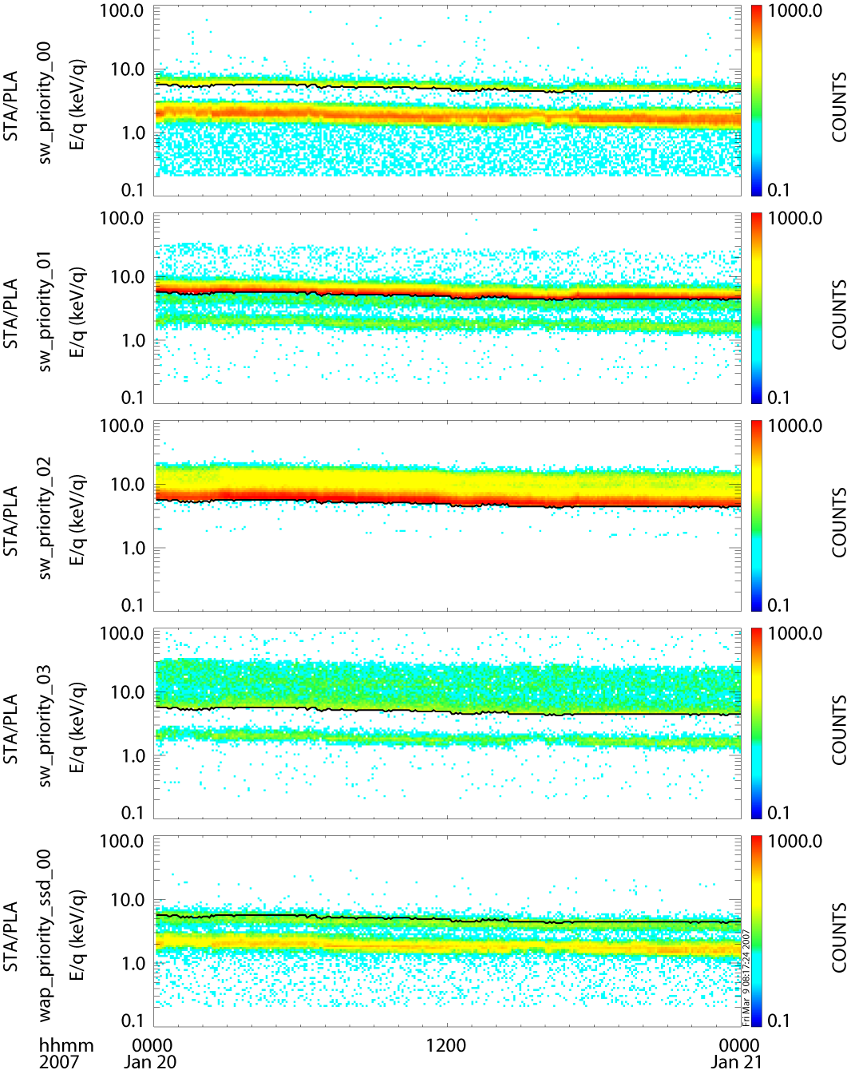

B.3.1.3. pla_en_spec_line_crib

To plot PLASTIC quantity vs. time line plots for a particular energy range.

INPUT PARAMETERS: product, time, timespan, units, energy

The inputs are the same as the ones described for the energy spectra (3.1.2). An additional input is the energy range (3.1.1) over which the energy spectrum is integrated.

KEYWORDS: diagn – it is not used yet.

B.3.1.4. pla_def_spec_crib

To plot PLASTIC deflection spectra (quantity vs. deflection angle vs. time)

INPUT PARAMETERS: product, time, timespan, units, energy, phi

The inputs are the same as the ones described for the energy spectra (3.1.2). An additional input is the energy range (3.1.1) over which the energy spectrum is integrated (and the phi range (3.1.1) which is not used yet).

KEYWORDS: diagn – It creates the corresponding average deflection plot (over-plotted line in following plots)

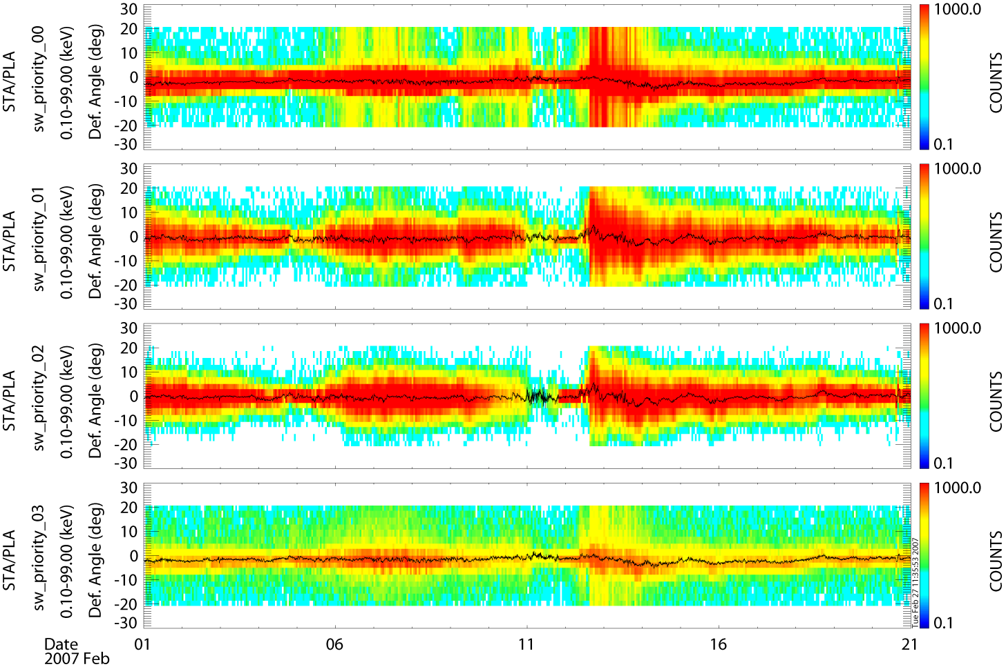

B.3.1.5. pla_pos_spec_crib

To plot PLASTIC position spectra (quantity vs. deflection angle vs. time)

INPUT PARAMETERS: product, time, timespan, units, energy, theta

The inputs are the same as the ones described for the energy spectra (3.1.2). An additional input is the energy range (3.1.1) over which the energy spectrum is integrated (and the theta range (3.1.1) which is not used yet).

KEYWORDS: diagn – It creates the corresponding average position plot (over-plotted line in following plots)

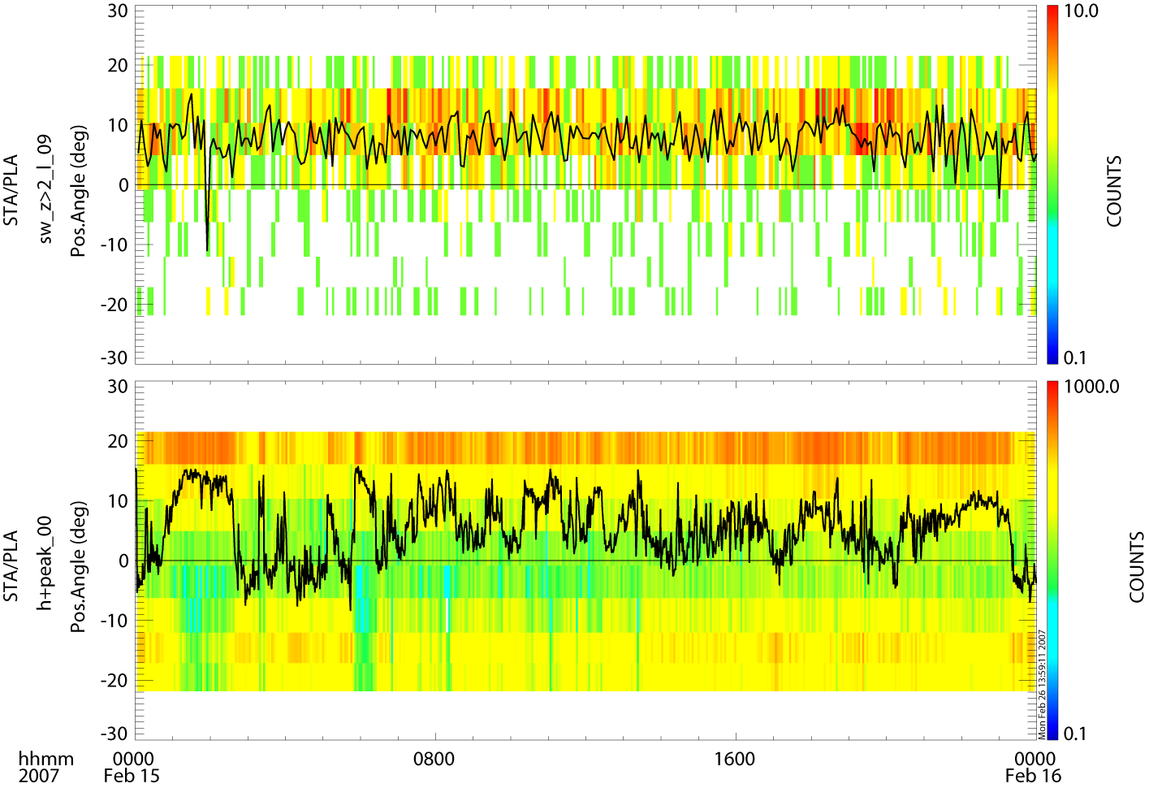

B.3.1.6. pla_obmom_crib

To plot PLASTIC on-board moments (quantity vs. time)

INPUT PARAMETERS: sat_moment, time, timespan

Possible moment products:

D: Density
VX: Velocity Vx component
VY: Velocity Vy component
VZ: Velocity Vz component
VXYZ: All three velocity components
VT: Velocity Vtotal component
TXX: Temperature xx
TYY: Temperature yy
TZZ: Temperature zz
TXXYYZZ: All three temperature components
PXX: Pressure xx
PYY: Pressure yy
PZZ: Pressure zz
PXXYYZZ: All three pressure components

sat_moment input examples:

sat_moment = [‘A_D’, ‘B-D’]
sat_moment = [‘A_D’, ‘A_VX’, ‘A_VY’, ‘A_TXXYYZZ’]

Note: For this version of the software one input per spacecraft will load all moments. Therefore the first example: sat_moment = [‘A_D’, ‘B-D’] will load all moments for both spacecraft. After the crib-sheet is executed using the tplot_names command will show the list of all the moments.

KEYWORDS: INST_COORD: moments are calculated in instrument coordinates

In the following figure on-board moments from STA (black) and STB (blue) are plotted.

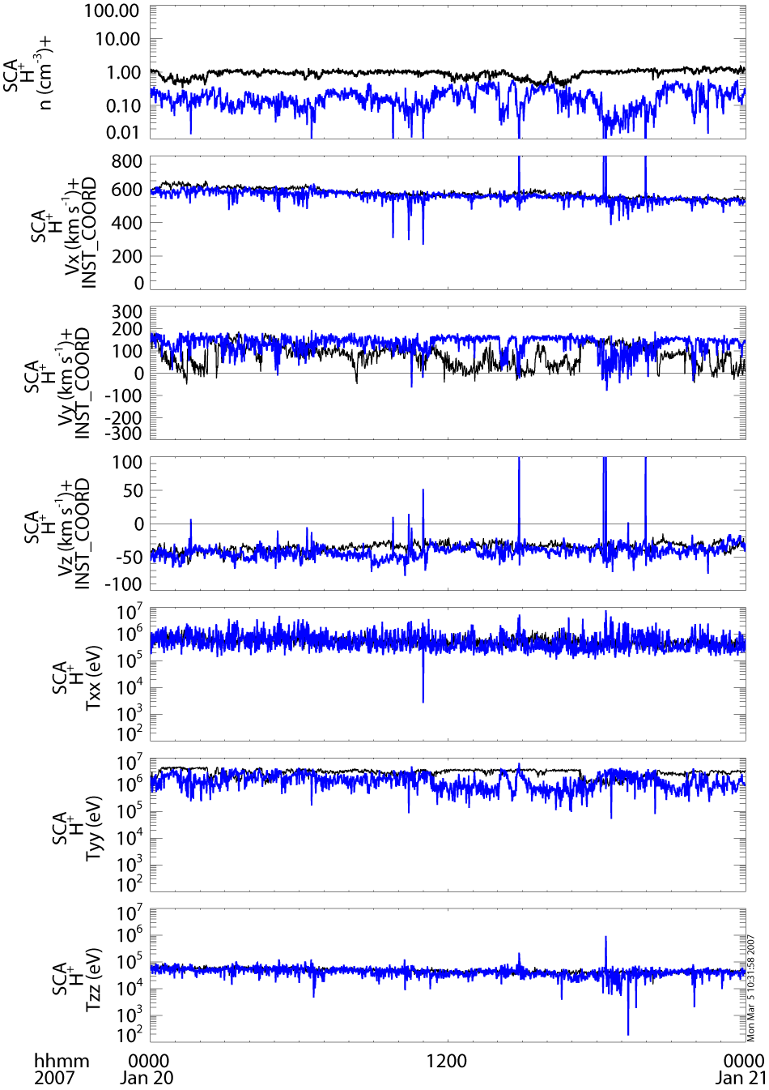

B.3.1.7. pla_mon_crib

To plot PLASTIC monitor rates (quantity vs. time)

INPUT PARAMETERS: sat, sat_mon, e_step, time, timespan, units, no_eng,

Possible sat_mon products:

‘s_valid’
‘s_e_not_req’
‘s_e_req’
‘s_no_pos’
‘s_mult_pos’
‘s_no_e’
‘s_mult_e’
‘ra_sat_a’
‘ra_sat_b’
‘ra_sat_both’
‘ssd_sw’
‘ssd_st’
‘sf0’
‘sfr0’
‘stp0’
‘ra_trig’
‘pos1_0’
‘pos1_1’
‘w_no_pos’
‘w_mult_pos’
‘w_valid’
‘sf2’
‘sfr2’
‘stp2’
‘pos2_0’
‘pos2_1’
‘pos2_2’
‘pos2_3’
‘pos3_0’
‘pos3_1’
‘pos3_2’
‘pos3_3’
‘stop0’ sfr0/sf0
‘start0’ sfr0/stp0
‘stop2’ sfr2/sf2
‘start2’ sfr2/stp2

sat_mon input examples:

sat_moment = [‘s_valid’, ‘ssd_sw’, ‘sf0’, ‘sfr0’, ‘ra_trig’] (following plot)

Possible e_step values:
are from 0 to 31. Each e_step value corresponds to 4 energy bins (from the 0-127 energy bins). e_step = 32 will return the whole energy range.

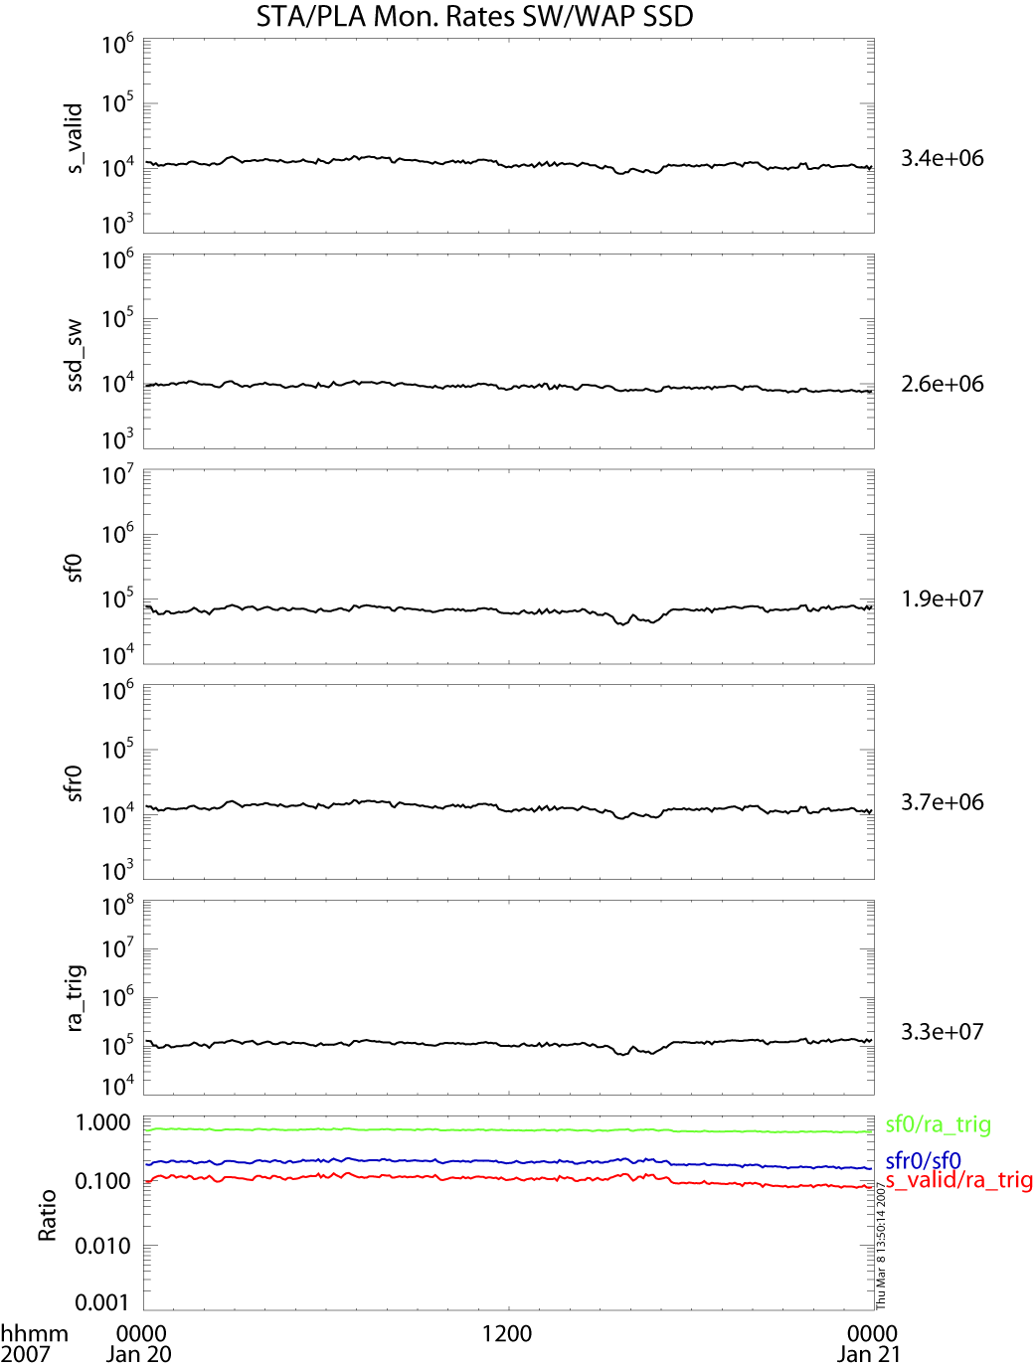

B.3.1.8. pla_mon_full_crib

To plot PLASTIC monitor rates for full energy range (quantity vs. time)

Same input parameters as above. The e_step takes values from 0 to 127.

B.3.1.9. pla_hk_crib

To plot analog housekeeping parameters (parameter vs. time)

INPUT PARAMETERS: sat, sat_hk

The list of the available analog housekeeping parameters is included in the crib-sheet

B.3.1.10. pla_dig_hk_crib

To plot digital housekeeping parameters (parameter vs. time)

INPUT PARAMETERS: sat, sat_dig_hk

The list of the available digital housekeeping parameters is included in the crib-sheet

B.3.1.11. pla_sc_hk_crib

To plot spacecraft housekeeping parameters (parameter vs. time)

INPUT PARAMETERS: sat, sat_sc_hk

The list of the available spacecraft housekeeping parameters is included in the crib-sheet

B.3.2 Level 2 and Level 3 Processing Programs

In the Public subfolder of the splat_user folder, there are also routines that are used for the creation of some Level 2 and Level 3 data products. These routines are often hard-coded for use at UNH, but they show the algorithms and code used to create some of the Level 2 and Level 3 data products. The following table lists the programs and a sample filename of the products they create.

Sample Filename | Program
STA_L2_PLA_1DMax_1min_20080101_V09.cdf | create_ra_mom_cdfs.pro
STA_L2_PLA_1DMax_10min_20080101_V09.cdf | create_ra_mom_cdfs.pro
STA_L2_PLA_1DMax_1hr_20080101_V09.cdf | create_ra_mom_cdfs.pro
STA_L2_PLA_OBMom_1min_20080101_V02.cdf | create_ob_mom_cdfs.pro
STA_L2_PLA_OBMom_10min_20080101_V02.cdf | create_ob_mom_cdfs.pro
STA_L2_PLA_OBMom_1hr_20080101_V02.cdf | create_ob_mom_cdfs.pro
STA_L2_PLA_Alpha_RA_1DMax_10min_200801_V02.cdf | create_alpha_ra_10min_cdfs_monthly.pro  and splat_core/calc_alpha_bulk.pro
STA_L2_PLA_Alpha_RA_1DMax_1hr_200801_V02.cdf | create_alpha_ra_1hr_cdfs_yearly.pro  and splat_core/calc_alpha_bulk.pro
Suprathermal_Event_Analysis_STA.txt | suprathermal_event_total_mod.pro

B.4. Trouble Shooting

If program execution stops with an error message, examine all the output message lines. In addition, an error log file is kept under splat_user/error_log. Quite often the error is related to missing data files or products. In some cases you might resume execution by returning from a subroutine: Type RETURN or RETURN,0 for that purpose, otherwise RETALL will bring you back to the main level, from where you can restart with corrected parameters.

PHA_PLAY Software

C.1. Introduction
Pha_play is a program designed to simulate the classification algorithm of PHA words into various rates. It is used for the creation of Level 2 and Level 3 data products that rely on the Level1 PHA. It does not alter the way in which PHA words are formed. However, the settings in the pha_play.settings file along with the associated input files will alter the way the PHA words are classified. More adventuresome users could also alter the classification algorithm itself, which is contained in the calculate_mass_mq_pp.pro file. It should be run in IDL. Some functionality, but not most, requires that it be run in SolarSoft.

C.2. Input Parameters and Associated Output
All input parameters are controlled through the pha_play.settings file.

C.2.1 Do you want to simulate the instrument’s bit shifting, etc.? (0=n0,1=yes)
If you choose yes here, the program will go through the process in the instrument logic of creating a bindatword and only incrementing rates based on the appropriate address in memory. This mandates limits on the number of bins in each category based on the number of bits given to each product in the bindatword. Limits on the number of bins are:
pha_pri 4
supra_no_e 7
supra_wide 15
sw Z>2 15
sw all 1
sw H alpha 3

C.2.2. Use “quad” style limits file? (0=no, 1=yes)
The limits file (see section 2.3 below) defines the “limit-boxes” for each of the classes for each of the rates. This file can be altered to change the minimum and maximum mass and mass/charge used for each species. There are two different formats for this file.
0) “Square” Format: Until September 2008, the format could only specify a minimum and maximum mass and mass/charge, which therefore made only rectangular boxes. For this format, the columns labeled “M/Q_low”, “M/Q_high”, “Mass_low”, “Mass_high” contain the information which should be changed to change box boundaries.
1) “Quad” Format: The second format allows each of four points to be specified so that other forms of quadrilateral boxes can be drawn in addition to rectangles. However, it is assumed that the boxes are convex. For this format, there are columns for the mass and for the mass/charge of each corner of the quadrilateral. The four corners should be specified in clockwise order starting with the top-most point (i.e. the point with the highest mass). If there are two points with equal mass/charge, the first point should be the top left point (i.e. the point with the highest mass and lowest mass/charge). This is important because the program relies on this ordering to determine what events fall in each box.

C.2.3. File name and path for limits file (ex. PLASTIC_Rate_Bins_20040811.txt)
Whichever format file is used to set the box limits (see 2.2 above), there are several ways to customize these files. The number of boxes in each category can be changed by adding or deleting rows. However, the categories themselves (eg. Pha_pri_rates SSD, Pha_pri_rates Non-SSD, etc.) may not be changed. The first white-space text in the “Species” column is used in filenames of ascii output of normalized data. Be sure that there is no white space in your label and that you do not use the same label in more than one bin of the same product, or your files will be overwritten! In the “square” format, the columns to the right of the “Species” column are not used by the program.
The classification algorithm works from highest “Number” box to lowest in each category. So, if there is overlap so that an event could fall in either box 2 or box 1 for the pha_pri_rates SSD, for example, the classification algorithm will put it in box 1.
A value of -1 in any of the columns means that the classification algorithm will accept any value into that bin (i.e. it is the default bin). A value of -2 in a column means that the classification algorithm will put values that fall into the lowest bin here. This is used for accepting events without a measurable mass.
Note: There must be a bin with -1 for all mass and m/q columns which will take all the events that don’t go in other bins.
To match the tables that were loaded on the spacecraft, for A, use PLASTIC_Rate_Bins_20040811.txt before September 09, 2007, and PLASTIC_Rate_Bins_20070813.txt starting on September 09, 2007. Note that the load took from 9/24 through 10/4; so there may be some difficulties during this time. Similarly, for B, use PLASTIC_Rate_Bins_20070811.txt before September 11, 2007, and then use PLASTIC_Rate_Bins_20070813.txt.

C.2.3.1 Checking box definitions with plot_bins keword
If you call the program with the plots bins keyword (i.e. pha_play, /plot_bins), the program will require some interaction. For each plot requested, it will create an onscreen plot. First it will plot the box definitions. Note that the axes are in bin-space (not physical units). The physical units (mass, m/q) for bin corners are also plotted. If you continue (.c), the program will then add points for places where events are classified. The colors should match the colors of the bin boxes! If they don’t, then this indicates there is a problem either with the program or with your bin definitions. To continue to the next plot, or the rest of the program, again type “.c”.

C.2.4 File name and path for constants file (ex. ClassConstants_20_2000228.txt)
This file defines the constants used by the classification algorithm. See the section on the classification algorithm, below.
To match the tables that were loaded on the spacecraft, for A, use ClassConstants_20_20050228.txt before September 09, 2007, and ClassConstants_20_20050422.txt starting on September 09, 2007. Note that the load took from 9/24 through 10/4; so there may be some difficulties during this time. Similarly, for B, use ClassConstants_20_20050228.txt before October 3, 2007, and then use ClassConstants_20_20050422.txt. Note that the load took from 10/01 through 10/03; so there may be some difficulties during this time.

C.2.5 File name and path for esa lookup (ex. sweep_table_info_EM_060803.txt)
This table is used for converting between an ESA step number and the corresponding keV/q value. It matches the “sweep table” used on the instrument. It is expected that this will go from 86.52 keV at ESA step 0 to 0.2 keV at ESA step 127.

C.2.6. PAC
Used in classification algorithm (see below).

C.2.7. Directory in which to put plot files
In addition to the files requested, the program automatically copies the settings file used to this file with a new name based on the settings (i.e. containing the date and CDF information and any suffix provided).

C.2.8. Read cdf from maui if nfs mounted? (0=no, 1=yes)
People who have maui nfs mounted on their Mac can have direct access to the data files there by indicating 1 here. If not, use a 0, and then specify the directory that has the data files below.

C.2.9. Add year to cdf directory
If you are reading the data from our central computers, and you plan to cross year boundaries, then you should set this flag so that the program will automatically add the year to the directory path.

C.2.10. If not reading from maui, directory in which to find cdfs

C.2.11. Which plot files do you want created?

C.2.11.1. classpoints
This file takes the pha events that are classified into the requested categories (see input parameter 9) of our 8 main categories (SwPha, WapPha_ssd, WapPha_nossd, SupraNoE_ssd, SupraNoE_nossd, SupraWide, SWZ2, Sw_H_alpha) and plots them on a Mass vs. Mass/Charge plot. They are color coded according to their PHA priority, and the new bin boundaries are overlaid on the plot. For events without mass, there is a histogram created for the number of events in each bin vs. Mass/Charge. If there are not any events with mass, then only the histogram is created.

C.2.11.2 classbins
This file takes the pha events that are classified into the requested categores (see input parameter 9) of our 8 main categories (SwPha, WapPha_ssd, WapPha_nossd, SupraNoE_ssd, SupraNoE_nossd, SupraWide, SWZ2, Sw_H_alpha) and sums them into the bins specified in the PLASTIC_Rate_Bins file. These bins are then plotted with the total number of counts in each bin. The color scale refers to the number of counts in each bin.

C.2.11.3 normbins
This file takes the pha events that are classified into the requested categories (see input parameter 9) of our 8 main categories (SwPha, WapPha_ssd, WapPha_nossd, SupraNoE_ssd, SupraNoE_nossd, SupraWide, SWZ2, Sw_H_alpha) and normalizes them. The basic normalization algorithm is:
for each esa step and time increment
for each bin
for each priority
norm = counts_in_bin_pri * rate /
count_in_pri
There are options for changing the time interval of the normalization and for deciding whether or not to include deflection in the normalization. (See below). The output plots look somewhat similar to those in “classbins”. The color scale refers to the number of normalized counts in each bin.

C.2.11.3.1 Normalization Errors
If you request normalized data (i.e. normbins), then error files will also be created which give you information about the quality of the statistics in the normalization process. For each file that you run, for each product you choose (SwPha, etc.), four error files will be created: one for each priority. Within each file, there are columns for the ESA step number, the number of cases where there are no pha events but there is a positive rate, the number of cases with both a pha event and a positive rate, the ratio between these two, the number of counts in the pha, the number of counts in the rate, and the ratio between these two. It is expected that this file will be important in two ways: 1) If the number of counts in the pha is the same as the number of counts in the rate (columns E and F) so the ratio in column G is 1, then it means that we are getting all the pha events that the instrument sends (i.e. there is no down-selection by the DPU). In these cases, normalization is not necessary. 2) When there are relatively many cases where we get no counts in the pha, but we do get counts in the rates, the statistics are poor, and the normalization cannot be trusted. So, if column D is large (>0.1), the statistics are suspect. Increasing the normalization interval can help in this case.

C.2.11.4 histograms
If you choose to get histograms, you will get 5 files:
a) hist_0-1_n0_ST…: This file contains pha events from sections 0 and 1 that have position greater than 0.
b) hist_0-1_ST...: This file contains all pha events from sections 0 and 1.
c) hist_0-1_y0_ST…: This file contains pha events from sections 0 and 1 that have position equal to 0.
d) hist_2_ST…: This file contains all pha events from section 2.
e) hist_3_ST…: This file contains all pha events from section 3.
In each of these files, there are 4 histograms:
a) count vs. tof
b) ssde vs. tof: This contains a scatter plot of ssde vs. tof, and also a histogram of ssde=0 vs. tof.
c) count vs. ssde
d) count vs. position

C.2.11.5 cumulative
This creates cumulative contour plots of all the PHA included. There are three panels: TOF bin vs. ESA step, NQ bin vs. ESA step, and total counts vs. ESA step.

C.2.12 For class points plots, do you want small circles or single points?
This selection makes a difference for how single points are plotted in these contour plots. If small circles are selected, you’ll be able to see individual points better, but it can cause smudging effects. If single points are selected, the overall distribution is clearer, but individual points are hard to see.

C.2.13. Which plots within the plot files do you want?
This selection can cut down on processing time. If you select only SwPha, for example, only pha events that fall into the SwPha category will be processed. In this case, the output file of “classpoints”, for example, would only have data in the SwPha plot, and the other 7 categories would have no data.

C.2.14 Do you want full-page classpoints plots? (0=no, 1=yes)
If selected, this creates full-page plot-files of each classpoints plot that you have requested (i.e. SwPha, WapPha_SSD…).

C.2.15 For full-page plot files, do you want the x-axis log or linear? (0=linear, 1=log)
This will affect full-page classpoints plot files, but not other plots.

C.2.16 For full-page plot files, do you want the y-axis log or linear? (0=linear, 1=log)
This will affect full-page classpoints plot files, but not other plots.

C.2.17 For full-page plot files, what limits to you want on the x-axis?
(put on one line, space delimited). You should have two values between .1 and 100 on this line. Values should only use one decimal place. These limits will affect full-page classpoints files, but not other plots.

C.2.18 For full-page plot files, what limits to you want on the y-axis?
(put on one line, space delimited). You should have two values between .1 and 100 on this line. Values should only use one decimal place. These limits will affect full-page classpoints files, but not other plots.

C.2.19 For full-page plot files, what limits do you want for the contour levels?
(put on one line, space delimited) (-1 means default) This allows you to set contour levels for the full-page classpoints plots. If you want the levels determined by idl, use -1.

C.2.20. How do you want the histograms colored?
This gives you the option of coloring the histograms either by the priority which is in the PHA word (which is determined by the on-board classification), or by the priority which this simulation assigns. Note that the color scheme in the classbins files will always be the priority in the PHA word. Only the histograms are effected by the input to this question.

C.2.21 Do you want ascii output of raw pha data (and nm, nq) for each product you selected? (0=no, 1=yes)
If you choose yes here, the program will create files that contain all the fields of each PHA event that falls into each category. It also includes the nm, nq, mass and m/q that are calculated using the on-board algorithm. If you ask for the program to use a different algorithm (see below), it will provide the nm, nq, mass, and m/q for both the original algorithm and the new one. If these files are too big, you can narrow down the number of PHA by either limiting the amount of time you run or the ESA steps you use.

C.2.22. Do you want ascii output of normalized counts?
If this option is selected, the program creates tab-delimited text files of the normalized counts. Depending on the following two pieces of input, this ascii output of normalized data can be in counts or in counts/sec, and it can be averaged over a specified number of hours, or output for each time record (i.e. every 5 or 10 minutes, depending on product). Separate ascii files are created for each of our 8 main categories (SwPha, WapPha_ssd, WapPha_nossd, SupraNoE_ssd, SupraNoE_nossd, SupraWide, SWZ2, Sw_H_alpha) unless you narrowed down your selection under “Which plots do you want”. Within each category, there is a file created for each bin specified in the “PLASTIC_Rate_Bins” file. So, for example, with the default bins, there are 4 files created for SwPha and 16 for Swz. The bin label, taken as the first white-space delimited text in the “Species” column in the “PLASTIC_Rate_Bins” file, is specified at the end of the file name. In each file, for each time record, there are columns for each esa step, for normalized counts (or count/sec) and for raw counts. If all esa steps are selected, the ascii output will start at esa 1 rather than esa 0 because otherwise the resulting file would have too many columns to be opened in Excel. If you want esa 0 in ascii output, you would need to reduce the number of esa steps requested (see below).

C.2.23. For ascii output, over how many hours do you want it averaged?
This offers the option of condensing the ascii output by the hour of the day. It is not the same thing as the normalization interval (see below). So, if you choose to normalize over 20 minutes, you can still ask for the ascii output to be averaged over an hour. This only affects the ascii output! Also note that the averaging takes place as near to across hours of the day as possible. That is, since the data only come out every 5 minutes, it may not be possible to have a 2 hour average that goes from 2-4 PM, for example. So, if the data is coming out at 2:04, a two hour average would include data from 2:04-4:04. If there is a data gap during that time so that the sequencing gets off, it is also possible that the average will only contain data from 2:04-4:02, or something else. The “start_time” column tells the beginning of each interval. The “min num cycles” and “max num cycles” columns tell the minimum and maximum number of cycles (i.e. minutes) are included in the average. The maximum is the number of minutes. The minimum can be smaller due to s-channel switching. For full information about the number of cycles, see C.2.30 below.

C.2.24. For ascii, do you want normalized data in counts or counts/sec?
In either case, there is a column of the raw counts to go with each column of normalized data.

C.2.25. Do you want data summed over deflection before or after normalization?
If you set this to 0, data will be summed over deflection before normalization. This is sufficient for most cases and will provide more counts and thus better statistics. If you set this to 1, deflection information will be maintained during normalization, which is important when looking at angular distribution. However, in some cases, you will need to increase the normalization interval to get enough counts to be statistically sound.

C.2.26. For normalization, do you want events separated into primary and secondary buffer for error log?
If you choose 1, then the program will keep track of which pha events were from the primary buffer in the DPU, and which were in the secondary buffer. This information will be included in the norm_error_ files. However, only do this if you really want this information, because it can slow down the program significantly. Also, be aware that in rare cases, there will be misleading information in one ESA step in a cycle. If the primary buffer ends on the same ESA step that the secondary buffer begins, there is no way to differentiate between the two buffers; so all the events from that ESA step will be assumed to be in the primary buffer.

C.2.27. Do you want the range of ESA steps combined into one data-set, or separate plots for each esa step?
If you choose to have data combined in one data-set, it will still be normalized by ESA step, but the final data will be combined into one set of files. Alternatively, you can select to have separate plots for each ESA step. If you choose this, and have normalization over 2 ESA steps, then the program will combine pairs of ESA steps. In any case, ascii output will be combined for all requested ESA steps.

C.2.28 Do you want to generate .tplot files?
If you use the SPLAT software, you may want to generate .tplot files of the normalized data. If you choose to do this, you must first source the splat.sh file before running pha_play. If you create .tplot files, you can use them by running the TPLOT_RESTORE command in SPLAT.

C.2.29 If you want .tplot files, directory in which to save them
The directory specified here is where the .tplot files will be saved. When you use the TPLOT_RESTORE command in SPLAT, you will need to look in this directory.

C.2.30 Which algorithm do you want to calculate mass and m/q?
0 means the original algorithm, which is used in flight. 1 means the algorithm which Andrew presented in 080304_agustafson.ppt.

C.2.31 Do you want full information on the number of cycles used in normalization to be printed?
This allows extra ascii output that gives an ESA-by-ESA accounting of the number of cycles used in normalization. The number of cycles included can vary by ESA step because the 5-minute rates only accumulate data that match the channel (small vs. main) of the first cycle of each five cycles.

C.2.32. List of specific file information
You can put as many lines here as you like, and the program will run through each configuration separately. (Actually, I’m sure there is a limit, but I haven’t yet found it).

C.2.32.1. satellite
A or B

C.2.32.2. start year
(ex. 2007)

C.2.32.3. start day-of-year

C.2.32.4. start_time
-1 means include data from the whole day. Otherwise, use a string of the format hh:mm:ss for the start time.

C.2.32.5. stop year
(ex. 2008)

C.2.32.6. stop day-of-year

C.2.32.7. stop_time
If the start_time is set to -1, then this value is ignored. If a specific start_time is entered, then enter your stop time here in the form hh:mm:ss.

C.2.32.8. esa step from which to take data
This should be two numbers, separated by a slash. 3/5 means combine the data from esa steps 3, 4, and 5. If you want to get data from esa steps 80-84, and 85-89 as two files, you will need to create two rows in your list of specific file information, one with esa step as 80/84 and one with esa step as 85/89. If you choose to normalize data over 2 esa steps, the program will automatically expand your range of esa steps so that it goes from an even esa to an odd esa (eg, if you put 3/5, it will treat this as 2/6 in order to get the necessary pairs of esa steps).

C.2.32.9. section
-2 means combine data from all the sections. -1 means combine data from the solar wind side (sections 0 & 1). Specifying 0, 1, 2, or 3 will select data that is only from that one section. Section 2 is WAP_SSD, and section 3 is WAP_noSSD.

C.2.32.10. normalization interval
This is the amount of time over which you want the data normalized. (Note: it is not the same as the ascii averaging interval – see above). This value is in minutes, and must be a multiple of 5 minutes (because the rates have a 5 minute time cadence). (Note: at times of low-telemetry, this might be increased.)

C.2.32.11. For normalization, number of ESAs to sum over
This should be either 1 or 2. The reason for this option is that the algorithm for PHA selection alternates between a cycle of starting at ESA 0 and a cycle of starting at ESA 1. In order to adjust for this, you can set the number of ESAs to sum over to 2. If you set it to 2, and ask for individual esa steps in the output, you will automatically get two at a time.

C.2.32.12. select PHA to include
This is an important setting which depends on what you are trying to accomplish with this program. The reason we need this setting is that the PHA events come in every minute while the rates data only comes every 5 minutes. Therefore, at the beginning and end of days, and when there are data gaps, it is possible for us to get PHA events for cycles that are not included in any of the rate data. Obviously, this can effect normalization. If you are interested in normalization, you should set this value to 1. If you are more interested in seeing all the pha data (for example, if you are looking at classification algorithms and how they effect the “classpoints” and “classbins” plots, you should set this value to 3. Setting the value to 2 is an option purely to be as complete as we can. It is primarily used for debugging.

C.2.32.13. Suffix for filename
This value is not useful to the program itself. It is put on the end of all file names. Some pieces of information are already included in file names (satellite, year, doy, esa steps used, start_time, stop_time). But others are not (section, normalization interval, pha events included). So, if you want to run the same file with different normalization intervals, you could put a different suffix here so that the output files are not overwritten.

C.3. Classification
C.3.1. Overview of Classification on the Instrument
The classifier receives the 48 bit PHA word. It then does the following:
It first compresses the 10-bit Energy to 8 bits using the following scheme:

If Ed < 96, Ecompressed = Edigital
Else Ec = INT[ Ed / 2L ] + 48*L,
where L = INT[ log2(Ed / 48)]

Measured Energy E_{m}  [keV] | 10-BIT ENERGY  (Event Word Ed) |  | 8-BIT ENERGY  (Mass Classification Ec)
Measured Energy E_{m}  [keV] | Linear Channel | Number of Channels | Compressed  Channel | Linear chn per Compr. chn | keV per Compr. chn | Chn Resolution at lower to upper measured energy
0-191 | 0-95 | 96 | 0-95 | 1 | 2 keV/Chn | 8% (25keV) to 1%
191-383 | 96-191 | 96 | 96-143 | 2 | 4 keV/Chn | 2.1% to 1%
383-767 | 192-383 | 192 | 144-191 | 4 | 8 keV/Chn | 2.1% to 1%
767-1535 | 384-767 | 384 | 192-239 | 8 | 16 keV/Chn | 2.1% to 1%
1535-2047 | 768-1023 | 256 | 240-255 | 16 | 32 keV/Chn | 2.1% to 1.6%

The 8-bit energy, 10 bit TOF, and 7-bit sweep-step then feed into 2 look-up tables to generate a 7-bit “mass” bin, NM, and am 8-bit “mass-per-charge” bin, NQ. One bit is added to the NM to reflect which half of the instrument (SSD side vs non-SSD side) the event came from, and this info is then fed into another lookup table which generates a 16 bit “Bins_dat word, which is used for classification. This is illustrated below:

Mass Tables
2x
128k x 8

tof (10 bits) Nm(7 bits)
ssde(8 bits)

Bins Tables
128k x 8

&
section(1) & Nm(7 bits) bins_dat word
section(1) (16 bits)
M/Q Tables
128k x 8
tof (10 bits) Nq(8 bits)
swpe(7 bits)

The 16-bit bins_dat word is defined below:
Bins_Dat Word

one set for SECTONS 0,1, 2 (SSD-side) & one set for SECTION 3 (no-SSD-side)
Pha pri rates | Supra no E | Supra wide | Sw Z>2 | Sw-all | Sw H/alpha
00 | 000 | 0000 | 0000 | 0 | 00

NOTE: only LSB of pha pri rates is used for WAP_PHA_Priority_rates

For each NM, NQ and Section input, each of the rate-types are classified into a bin, or given the “do not bin” code. The bin-types and codes are given below:

Type | Total Bins | Range | Do Not Bin Code
sw H alpha | 3 | 00 - 10 | 11
Sw-all | 1 | 0 only | 1 only
sw Z > 2 | 15 | 0000 - 1110 | 1111
supra wide | 15 | 0000 - 1110 | 1111
supra no E | 7 | 000 - 110 | 111
pha pri rates | 4 | 00 - 11 | always bin*

Finally, the bins_dat word (which gives the classification bin) is combined with the section, the position, and the deflection to determine which final bin should be incremented.

The position bin for each of the data types is determined by a combination of the section, the quadrant, and the 6-bit position within a quadrant. Figures following the table below illustrate the positions in the different instrument sections. Table below explicitly lists how the positions should be determined for each of the instrument sections and data types.

Table. Calculation of position bins
Quadrant | Incoming position in quadrant(Pos) | Section | Data Types | Position Bin
0 | 16-47 | 0 or 1 | sw H alpha  Sw-all | Pos -16
0 | 16-47 | 0 or 1 | sw Z > 2 | (Pos –16)/2
0 | 0 -7 | 2 | supra wide  supra no E | 0
0 | 8-15 | 2 | supra wide  supra no E | 1
0 | 48-55 | 2 | supra wide  supra no E | 3
0 | 56-63 | 2 | supra wide  supra no E | 4
1 | 0-32 | 2 | supra wide  supra no E | Pos/8 + 4
2 | 0-64 | 3 | supra no E | Pos/16
3 | 0-64 | 3 | supra no E | Pos/16+4
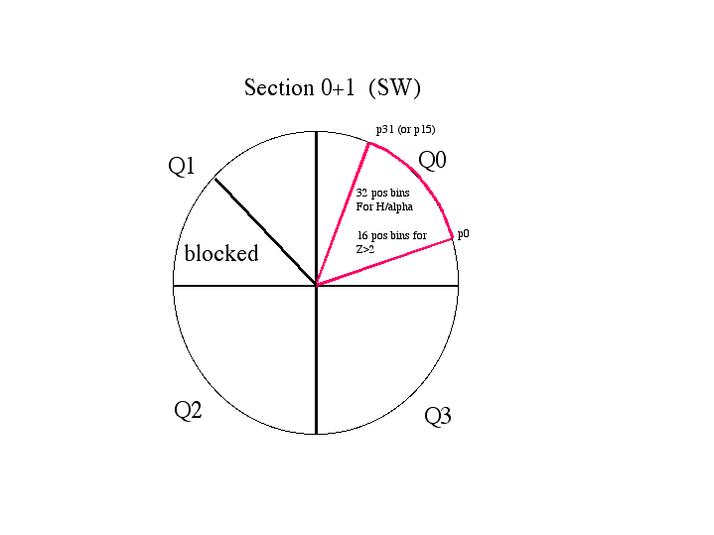 Positions in the Solar Wind Sector (Sections 0 and 1)

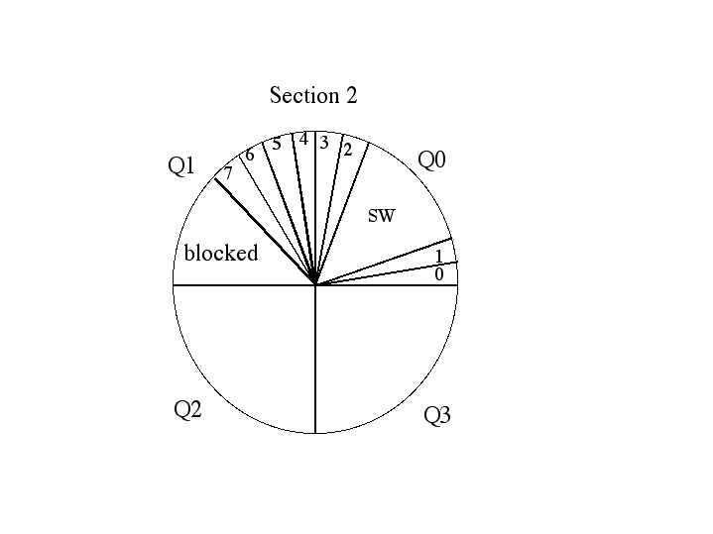 Positions in the WAP with SSD’s (Section 2).

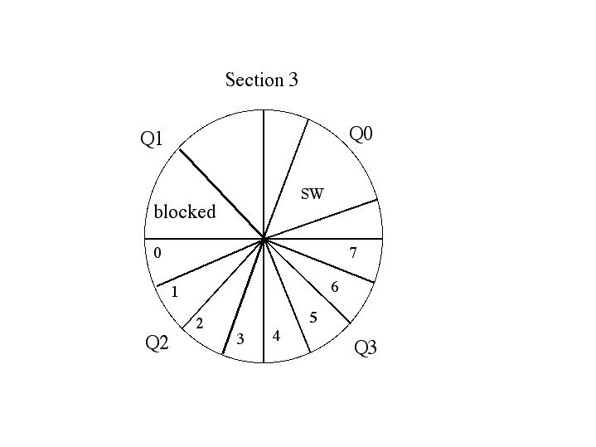 Positions in the WAP without SSD’s (Section 3).

Table. Accumulated products on Classification board.
Name | Bin_dat type | Class bins | Pos. bins | Def. bins | Energy steps | # of sections | SECTION* | Total bins | bits/item | Total Bytes | NQ | NM
SW-all | Sw no tof/E | 1 | 32 | 32 | 1 | 1 | 0 or 1 | 1024 | 16 | 2048 | all | all
SW-H/alpha-Doubles | sw H alpha | 2 | 32 | 32 | 1 | 1 | 0 or 1 | 2048 | 16 | 4096 | >0 | 0
SW_alpha_Triples | sw H alpha | 1 | 32 | 32 | 1 | 1 | 0 or 1 | 1024 | 16 | 2048 | >0 | >0
SW Z>2 | sw Z>2 | 15 | 16 | 8 | 1 | 1 | 0 or 1 | 1920 | 16 | 3840 | >0 | all
Wide-angle, Triples | Supra  wide | 15 | 8 | 1 | 1 | 1 | 2 | 120 | 16 | 240 | >0 | >0
Wide-angle, Double | Supra no E | 7 | 8 | 1 | 1 | 2 | 2,3 | 112 | 16 | 224 | >0 | 0
SW_PHA_Priority_rates | Pha pri rates | 4 | 1 | 32 | 1 | 1 | 0 or 1 | 128 | 16 | 256 | >0 | all
WAP_PHA_Priority_rates | Pha pri rates | 2 | 1 | 1 | 1 | 2 | 2,3 | 4 | 16 | 8 | >0 | all
PHA Data |  |  |  |  |  |  |  | 512 | 48 | 3072
Total |  |  |  |  |  |  |  |  |  | 15832
*0-SW-main channel,
1-SW-S channel,
2-WAPwSSD
3-WAP_no_SSD

Notes:
- SW Z>2 contains both double and triple coincidence rates
- Events with no TOF and no Energy are included in the priority rates, and will go into the PHA. If they end up being a lot of events, they may need to be a separate priority.
- The packet header must have a flag which tells what the energy step for the data is, and if the SW main channel or the S-channel is used for this energy step.

C.3.2. Classification Algorithm in this Program
In order to simulate the above process, this program goes through the following steps for each PHA event:

C.3.2.1. Calculate NQ
(Done in calculate_mass_mq_pp.pro) Mass-per-charge bin is derived from an input TOF-channel (10 bit) and the input E/Q step (7 bit). The algorithms are the following:

- Convert time channels (Tch) to nanoseconds (Tmeas)
Tns = Tch * At + Bt
At and Bt are in Constants file.

- Convert E/Q step to keV
E/q = D1 * D2[S]
S = 0 to 127 is the ESA voltage step number
D1 and D2 are in the Constants file.

- Calculate Mass per charge
C1 = (4.38E7)^2 / (1e9)^2/d_nossd^2
M/q = C1 * [ PAC + (E/q) - C2 ] * Tmeas2
If in section 0,1,or 2 (i.e. in ssd side) then M/q = M/q * d_nossd² / d_ssd²
d_ssd, d_nossd and C2 are in the Constants file.
PAC is in the pha_play.settings file.

- Convert the mass-per-charge to a bin number. The mass-per-charge is mapped into 254 logarithmically spaced bins

Desired Mass/Charge Range = MQmin to MQmax
NQ Range = 1 to NQMAX
kQ = ( MQmax / MQmin ) 1/NQMAX
M/Q (lower bound of NQ) = MQmin * kQ(NQ -1)
If on ssd side, then M/Q_lowbound=M/Q_lowbound * d_nossd² / d_ssd ²
MQmin, MQmax, NQMAX, d_ssd, d_nossd are in the Constants file.

C.3.2.2. Calculate NM
(Done in calculate_mass_mq_pp.pro) Mass bin is calculated for an input time-of-flight channel (Tch) and an input uncompressed energy channel. The algorithms are as follows:

- Convert uncompressed the energy channel to keV
Emeas = Eun * Ae + Be
Ae and Be are in Constants file.

- Take natural log of Emeas and Tns
X = ln (Emeas)
Y = ln(Tns)

- Calculate mass.
ln(M) = A1 + A2*X + A3*Y + A4*X*Y + A5*X2 + A6*Y3
A1,A2,A3,A4,A5, and A6 are in Constants file.

- Convert the mass to a bin number.
The particle mass M is mapped onto the mass-class axis which is subdivided into 92 logarithmically spaced NM bins. The boundaries of the NM bins are defined by the following relations:

Desired Mass Range = Mmin to Mmax
NM Range = 1 to NMAX
M (lower bound of NM) = Mmin * kM(NM -1)
kM = ( Mmax / Mmin ) 1/NMAX
NMAX, Mmax, and Mmin are in the Constants file.
In addition to these 92 bins, there are also bins for several error conditions:
a) If Emeas <= Emin then bin = 0
b) If Emeas >= Emax then bin = 93
c) If Mass is undefinined (i.e. if e_meas or tns is 0) then bin = 94
d) If Tns >= Tmax then bin = 95
e) If Mass >= Mmax then bin = 91
f) If Mass <= Mmin then bin = 92

C.3.2.3. Find Bindatword
(Done in find_bindatword_pp.pro) Given the half (ssd side or non-ssd side), the M/Q bin, and Mass bin and the bin limits given in the PLASTIC_Rate_Bins file, determine which bits in the “bindatword” should be set.

C.3.2.4. Increment appropriate Rates
(Done in fill_bins_pp.pro). This simulates the final step of the classifier. Based on the Bindatword, rates are incremented.

C.4. Normalization Algorithm
The basic normalization algorithm is:
for each esa step and time increment
for each bin
for each priority
norm = counts_in_bin_pri * rate /
count_in_pri
For SwPha, the rate used is SwPri.
For WapPha_ssd, the rate used is WapPri_ssd.
For WapPha_nossd, the rate used is WapPri_nossd.
For SupraNoE_ssd, the rate used is WapPri_ssd.
For SupraNoE_nossd, the rate used is WapPri_nossd.
For SupraWide, the rate used is wapPri_ssd.
For SWZ2, the rate used is SwPri.
For Sw_H_alpha
There are several inputs in the settings file that will affect how the normalization is done:
C.4.1. Normalization interval
This will change the time increment. The normalization interval must be a multiple of 5 minutes.
C.4.2. Number of ESA steps to sum over
This can be 1 or 2. If set to 2, it will adjust for the fact that our PHA events are selected starting at esa 0 on every other cycle and at esa 1 on every other cycle.
C.4.3. Summing over deflection before or after normalization
If you set this option to 0, data will be summed over deflection before normalization. This is sufficient for most cases and will provide more counts and thus better statistics. If you set this to 1, deflection information will be maintained during normalization, which is important when looking at angular distribution. However, in some cases, you will need to increase the normalization interval to get enough counts to be statistically sound.
C.4.4. Select PHA to include
WARNING: This must be set to 1 for the normalization to make sense!
C.4.5. Explanation of S-Channel switch
It is important to understand how the S-Channel switch affects normalization. When rates are accumulated over 5 minutes, only the ESA steps that are in the same channel (Small or Main) as the first of the five minutes are accumulated, because counts are quite different in the different channels due to different geometric factors. This is taken into account in the normalization. Therefore, in the ascii file of normalized data, there are columns for the minimum and maximum number of cycles included in the normalization. So, for example, if you choose hourly averages, you are likely to see 60 as the maximum number of cycles. However, depending on the S-Channel switches, the minimum could easily be in the 40s or 50s. Most of the ESA steps will be near the maximum, but the few ESA steps around the S-Channel switch may be lower.

C.5. Conversion to Counts/Sec
The instrument is divided into 32 deflection steps. The accumulation time on the first deflection step is 0.0124 seconds, and the accumulation time on all subsequent deflection steps is 0.0128 seconds. Note that the deflections are read out in opposite orders on even and odd esa steps. So, the shorter time accumulation falls on deflection 0 on even esa steps, and deflection 31 on odd esa steps
Although the instrument is divided into 32 deflection steps, the rates are accumulated over 2 deflection steps at a time, for a total of 16.
The conversion of counts to counts/sec is different for the wap side and for the ssd side when deflection is maintained during normalization.
On the wap side, and on the ssd side when deflection has been summed before normalization, the counts are in an array of 128 esa steps x time. To determine counts/sec, the algorithm is:
For each ESA step:
Counts/sec = counts / (num_cycles * 0.0128 * 32)
On the ssd side, when deflection has not yet been summed, the counts are in an array of 128 esa steps x 16 deflection steps x time. To determine the counts/set, the algorithm is:

For each ESA step:
For each defl step:
Counts/sec = counts / (num_cycles * 0.0128 * 2) – except for the first ESA step which is counts/ (num_cycles * (0.0128 + 0.0124)
Within each ESA step, the counts/sec are then summed.
It is important to note that this really gives counts/second/esa step. When we sum over 2 ESA steps, we divide by the amount of time spent on the two esa steps. Therefore, for example, when summing over 2 ESA steps, the value given for the 2 steps is roughly equal the value given in each of these steps when not summing.

C.6. PHA Selection Scheme
On the classifier board, the data have already been sorted by priority. There are 6 priorities, 2 for the WAP section (WAP P0 and WAP P1) and 4 for the Solar Wind Section (SW P0, SW P1, SW P2, SW P3). The DPU is sent up to 512 PHA words for one energy step. These will be already divided as up to 32 WAP P0, 32 WAP P1, 64 SW P0, 64 SW P1 and 160 SW P2 and 160 SW P3. The DPU is responsible for down-selecting the data, but making sure we still emphasize the heavy ions in a full packet.

On average the DPU can send down 6 events per step. We handle the PHA data in sets of 2 E/Q steps. The DPU can send down 12 events every 2 steps. This data is divided into 6 priorities: 2 WAP priorities and 4 SW priorities. We specify, on average, how many of each priority we should collect every 2 steps, with the total adding up to 12. For example, the default is:

1 WAP P0 (H+ and He++)
1 WAP P1 (Heavies)
1 SW P0 (H+)
1 SW P1 (He++)
4 SW P2 (heavies)
4 SW P3 (heavies)

The DPU has a buffers of size 768*48 bits = 36864 bits. It is filled from the front with “primary” events – ie those specified above. The extra space is used to store extra “high priority” events on a first-come basis. In order to get events from all esa steps, the DPU alternates between starting a cycle on esa step 0 and starting on esa step 1.

Protons Data Derived from 1D Maxwellian
Proton bulk parameters (speed, density, thermal) are derived from a 1D Maxwellian fit to a single detector rate (no coincidence required), and are corrected for background and dead time. The N/S angle is derived from a peak fitting to the N/S (deflection) rate bins of the same rate. The E/W angle is derived from a separate double coincidence rate. The proton velocity components are corrected for spacecraft aberration and are derived using the N/S and E/W angles.

Extended analysis of in-flight data indicates a major variance in the performance of the Schannel instrumental response (geometrical factor, E/Q, and polar and azimuth angular response) from expectations based upon the pre-flight testing and calibrations. The effect is attributed to insufficient fringe-field control within the aperture section of the Entrance System. The results provided are based upon an extensive in-flight calibration of the S-channel response which has been performed by the PLASTIC team utilizing Main channel data (which is unaffected) and confirming results through cross-calibrations of early mission data with Wind SWE (courtesy K. Ogilvie and A. Lazarus) and SOHO PM (courtesy F. Ipavich). We extend special thanks to our Wind and SOHO colleagues for the use of their data.

The spacecraft were ‘flipped’ by 180-degree roll angle after solar conjunction. Different detectors or areas of detectors were then exposed in the instrument, resulting in different efficiencies. A new calibration function is incorporated in v10 onwards.

B.1 Data Format

The time variables in the Level 2 CDFs are:
‘epoch’ gives time for record – start of cycle
‘epoch_1kev’ Time within cycle corresponding to E/Q =1 keV/e (format yyyy-mm- dd/hh:mm:ss). This parameter is only provided for the 1-minute data sets.
The next set of parameters give the solar wind proton data:
‘proton_number_density’
[1/cc]: Solar wind proton number density (protons per cubic centimeter)
‘proton_bulk_speed’
[km/s]: Proton bulk speed (in the s/c frame)
‘proton_temperature’
[deg K]: Proton kinetic temperature
‘proton_thermal_speed’
[km/s]: Proton thermal speed, defined here as sqrt(2kT/m)
‘proton_n_s_flow_angle_inst’
[deg]: Proton North-South flow angle in the INSTRUMENT COORDINATE SYSTEM. This coordinate system does not compensate for aberration (spacecraft movement) nor for spacecraft attitude. This parameter is included for verification purposes, only. In v10 onwards, a three-period moving average is used to reduce ‘jitter’.
‘proton_e_w_flow_angle_inst’
[deg]: Proton East-West flow angle in the INSTRUMENT COORDINATE SYSTEM. This coordinate system does not compensate for aberration (spacecraft movement) nor for spacecraft attitude. This parameter is included for verification purposes, only. In v10 onwards, a boxcar moving accumulation is used to obtain sufficient statistics.
‘proton_Vr_HERTN’
[km/s]: Proton radial velocity component in the HERTN system. The effects of aberration and spacecraft attitude have been removed.
‘proton_Vt_HERTN’
[km/s]: Proton tangential velocity component in the HERTN system. The effects of aberration and spacecraft attitude have been removed.
‘proton_Vn_HERTN’
[km/s]: Proton normal velocity component in the HERTN system. The effects of aberration and spacecraft attitude have been removed.
‘proton_n_s_flow_angle_HERTN’
[deg]: Proton North-South flow direction in the HERTN system. The effects of aberration and spacecraft attitude have been removed.
‘proton_e_w_flow_angle_HERTN’
[deg]: Proton East-West flow direction in the HERTN system. The effects of aberration and spacecraft attitude have been removed.
‘proton_Vr_RTN’
[km/s]: Proton radial velocity component in the RTN system. The effects of aberration and spacecraft attitude have been removed.
‘proton_Vt_RTN’
[km/s]: Proton tangential velocity component in the RTN system. The effects of aberration and spacecraft attitude have been removed.
‘proton_Vn_RTN’
[km/s]: Proton normal velocity component in the RTN system. The effects of aberration and spacecraft attitude have been removed.
‘proton_n_s_flow_angle_RTN’
[deg]: Proton North-South flow direction in the RTN system. The effects of aberration and spacecraft attitude have been removed.
‘proton_e_w_flow_angle_RTN’
[deg]: Proton East-West flow direction in the RTN system. The effects of aberration and spacecraft attitude have been removed.
The next set of parameters is for data quality information:
‘error’
0 = No known issues
1 = Processing error, data removed
2 = Data Level 1 (input data) error
3 = Data overflow (rate compression code saturated)
4 = Data outside 3-sigma limit (1 hr window)
5 = Data gap (usually due to operations), data removed
6 = Jump in thermal speed, use caution on all parameters
8 = Removed through manual check
9 = Fitting to 1-D Maxwellian indicated one or more cautions
11 = Background levels (usually due to entrance system ops), data removed
‘caution’
The caution code is an indication of how sensitive the density value is to the method used for determining the background correction.
0 = no issues (<5% effect on density calculation)
1 = minor issues (5-10% effect on density calculation)
>1 = use with caution (>10% effect on density calculation)
5 = 5 minute cadence data, use with caution
‘attitude flag’: 3 dimensional array [roll, yaw, pitch]:
This flag indicates the s/c roll angle is not nominal, possibly due to a spacecraft maneuver. Although efforts are made to correct the data, use all data with caution, particularly component and density values.
‘ew_source_flag’
Indicates which solar wind sector channel (Main or
analysis. Main Channel = 0, S-channel = 1. (Main channel has better statistics, but may include additional species.)
‘Reduced_Chi2’
Reduced Chi-square of the 1D Maxwellian fit.
‘stat_uncertainty_angle’
(%): An indication of the relative uncertainty from the number of counts available in determining the E/W flow direction (sqrt(n)/n), where n is the number of counts in the peak of the position array. Higher % indicates higher statistical uncertainty.
The next set of parameters provide Carrington Rotation and spacecraft trajectory information:
‘carrington_rotation’
Carrington Rotation Number relative to the given spacecraft.
‘spcrft_lon_carr’
[Carr, degrees]: Carrington Longitude relative to the given spacecraft.
‘heliocentric_dist’
[km]: Distance of the spacecraft from the center of the Sun.
‘spcrft_lon_hee’
[HEE, degrees]: Spacecraft longitude in the HEE coordinate system.
‘spcrft_lat_hee’
[HEE, degrees]: Spacecraft latitude in the HEE coordinate system.
‘spcrft_lon_heeq’
[HEEQ, degrees]: Spacecraft longitude in the HEEQ coordinate system. ‘spcrft_lat_heeq’
[HEEQ, degrees]: Spacecraft latitude in the HEEQ coordinate system.
‘spcrft_lon_hci’
[HCI, degrees]: Spacecraft longitude in the HCI coordinate system.
‘spcrft_lat_hci’
[HCI, degrees]: Spacecraft latitude in the HCI coordinate system.
Coordinate Systems used here: HCI Heliocentric Inertial
HEE Heliocentric Earth Ecliptic
HEEQ Heliocentric Earth Equatorial (or HEQ) Carrington
RTN Radial-Tangential-Normal
R is the Sun to SC vector, T = (Omega x R)/|(Omega x R)|, where omega is the Sun's spin axis (in J2000 GCI), i.e., roughly the orbital direction; N is the right-handed normal to complete the triad, essentially "north". The RN plane contains the solar rotation axis.
HERTN Heliocentric Ecliptic RTN
The RT plane is parallel to the ecliptic plane.

Protons from on-board
The algorithm for creating the level 2 moments is complicated. For a scientific explanation, see Lynn Kistler’s Conversion of On-board Moments to Physical Units (9/28/2006) in Appendix.

Values that are taken from calibration files are:
1) Step_variable: This covers the constants associated with stepping the integral over v, dtheta (elevation) and dphi. They are the same for all moments and for both spacecraft. Step_variable = dtheta*dphi*dV/V / tacc, where
dtheta = 1.25 degrees = 0.0218 radians
dphi = 1.41 degress * 2 = 0.0246 * 2 radians = 0.0492 (the factor of 2 is
because we only use every other step)
dv/v = 0.049/2 = 0.0245
tacc = 12.8 ms
step_variable = 2.05E-3 ster/s
2) Normalization Constant, B: This parameter takes out the normalization factors from the onboard velocity tables, and includes any other necessary unit changes and mass functions. These are different for each moment, but should be the same for each spacecraft.
B_D: 4.335E-11 s/cm
B_V: 1.950E-08 km/cm
B_P: 2.939E-20 kg m/s (cm/m)^2
B_H: 1.324E-14 kg (m/s)^2 (cm/m)^2
3) Geometric factors: Each unit has two geometric factors for the Solar Wind sector: one for the S-channel and one for the main channel. Here, the geometric factor is given for one angle bin (1.41 degrees in position).
Geom_S: 1.850E-7 cm2-ster-dV/V
Geom_M: 2.219E-5 cm2-ster-dV/V
4) A set of ra_trig efficiencies, one for each ESA step (128 total). These efficiencies vary over time and by spacecraft.
5) Two velocity tables. For each ESA step, we have a table that gives the velocity that the DPU Moments calculation uses (based on a maximum of 100 keV), and a table of what we believe the actual velocities for each ESA step to be.
6) svalid_ratio. This is a daily ratio (for each spacecraft) of the svalid rate / ra_trig rate for each esa group. It is calculated daily for the ESA steps representing valid velocities for that day. If there is not a valid ratio for a given esa group, we use the nearest esa group that has a valid ratio. Because this derives from our normal monitor rates, which are summed over 4 ESA steps, there are 32 values per day, one for each group of 4 ESA steps.
7) pri0_ratio. This is a daily ratio (for each spacecraft) of the priority 0 events / (pri 0 + pri 1 + pri 2 + pri 3) events. It is calculated daily for the ESA steps representing valid velocities for that day. If there is not a valid ratio for a given esa step, we use the nearest esa step that has a valid ratio. There are 128 values per day. This value is only used when the moments calculation is using the SW-H array.

Bulk Velocity Calculation:
1) For each record, we calculate the velocity components, using the formula:

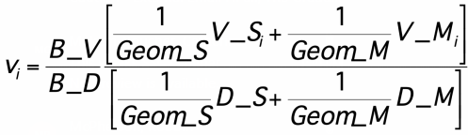

V_{i} is either the x, y, or z component of the velocity. B_V, B_D, Geom_S, and Geom_M are constants (see above). D_S and D_M are the Level 1 density values for the S-channel and the Main channel, respectively, and V_S and V_M are the Level 1 velocity values for the S and Main channels.
The total velocity is found by the equation:

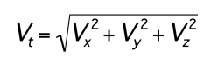

We then use linear interpolation to derive the bulk velocity (based on the velocity table of actual velocities) from the total velocity (based on the velocity table used by the DPU which starts at 100 keV).

Finding Efficiencies and Velocity Standard Deviation
Our efficiencies are based on velocity. In order to avoid sharp peaks, for each record, we determine an average velocity, which is used to find the efficiencies. This average velocity is based on the total velocity, not the interpolated bulk velocity. The average is taken over the 19 points closest to each given record. However, if a given velocity is below our lowest velocity step, it is removed from the average. Therefore, for a given record, the number of points averaged may be less than 19, if some are removed. We also find the standard deviation for the points included in the average. If this standard deviation divided by the total velocity for that point is less than 0.05, then the error_poor_stats flag is set. Efficiencies are then found for each record. Two efficiencies are found:
1) pri_efficiency: This is only used when the moments calculation uses the SW-H array. The pri0_ratio from the next lowest velocity is selected, checking the average velocity for each record against the DPU velocity table (100 keV).
2) general_efficiency: First, we find an interpolated svalid_ratrig ratio. To do this, we take the average velocity for a record and use linear interpolation based on the 4-ESA-step velocity groups (using the DPU velocity table), to find an appropriate svalid_ratrig ratio. Then, the ra_trig_efficiency from the next lowest velocity is selected, checking the average velocity against the DPU velocity table. These two values (interpolated svalid_ratrig_ratio and selected ra_trig_efficiency) are multiplied to create the general_efficiency.

Density Calculation
Density is then calculated for each record using the following equations:

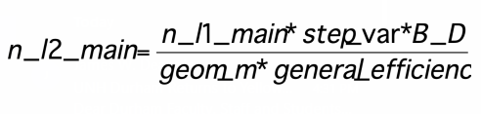

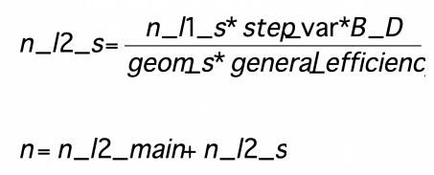

If the moments array being used for any record is SW-H, then the density for that record is then divided by the pri0_ratio for that record.

C.1 Data Format
The level 2 moments products that are valid so far are:
‘density’ calculated density
‘velocity_inst’ 4 element array: x,y,z,bulk in instrument coordinates
(only bulk valid so far)
‘velocity_spcrft’ 4 element array: x,y,z,bulk in spacecraft coordinates
(only bulk valid so far)
‘velocity_gse’ 4 element array: x,y,z,bulk in GSE coordinates
(only bulk valid so far)
‘velocity_hgrtn’ 4 element array: x,y,z,bulk in HGRTN coordinates
(only bulk valid so far)

The level 2 moments are tied to the following variables (i.e. the same record number will give you the appropriate data for any given value):
‘epoch’ gives time for record – start of cycle
‘cycle’ gives cycle number for record (for synchronization)
‘s_chan’ gives the step on which the s-channel switched for this
record (0 = didn’t switch)
‘moment_meta’ 4 elements:[Emin, Emax, Schan conversion factor,
Array (0:SW-All, 1:SW-H)]
‘error’ if 1, there was a possible error with this cycle’s data
‘error_poor_stats’ if 1, then poor statistics and data is suspect

Alphas
Alpha bulk parameters provided here are derived from a 1D Maxwellian fit to a single coincidence (the “RA”) rate that is measured in both the S-channel and Main Channel. Background and dead-time corrections are applied.

Data are processed at the ~1 minute instrument cadence and then averaged into 10 minute and 1 hour resolution products.

Alpha_RA versions 3 and below are limited to S-channel data. Versions 4 and above incorporate the Main channel.

Alpha data are available for both STA and STB 2007-2010.

D.1 Data Format
The Level 2 parameters are:
‘epoch’
Time for record – start of cycle
‘alpha_density’
[1/cc]: Solar wind alpha number density in [alphas per cubic centimeter]
‘alpha_bulk_speed’
[km/s]: Alpha bulk speed (s/c frame) in kilometers per second
‘alpha_thermal_speed’
[km/s]: Alpha thermal speed in kilometers per second, defined here as sqrt(2kT/m)
‘Na_Np’
Ratio of alpha to proton number densities (a unitless quantity)
Va_Vp’
[km/s]: The scalar difference between the alpha and proton bulk speeds in kilometers per second (s/c frame)
‘alpha_cycles’ (Version 3 and below)
The number of instrument cycles averaged together to create the alpha parameter records.
‘alpha_cycles_den_vth’ (Version 4 and above)
The number of instrument cycles averaged together to create Na and Vtha.
‘alpha_cycles_vel’ (Version 4 and above)
The number of instrument cycles averaged together to create Va and Va - Vp.
‘alpha_cycles_na_np’ (Version 4 and above)
The number of instrument cycles averaged together to create Na/Np.
‘alpha_caution’ (Version 3 and above)
0 – no known issues
1 – use with caution, Na/Np may be omitted
2 – alpha and/or proton density is suspect, Na/Np is omitted
3 – data removed after visual inspection, Na/Np is omitted -1 – no data

Iron Abundance and Kinetic Data
Due to unexpected issues involving the entrance system’s variable geometric factor (Opitz, 2007), an extensive in-flight calibration (Simunac, 2009) and post-launch determinations with the engineering model have been performed. Solar wind iron is typically contained fully within the main channel geometric factor, and only main channel data are provided here.

Matrix Rate (MR) data consist of count rates in pre-defined species (mass, mass/charge) ranges that are calculated by table look-up in the onboard processing. Full resolution matrix rates (5-minute, 10-minute) covering major solar wind elements are provided to the public domain through the STEREO Science Center as Level-1 data sets.

Iron kinetic properties provided here are derived from the matrix rates associated with iron, that is, MR08 through MR11. The raw rates are converted into densities using the geometrical factor determined in pre-launch calibrations (see Karrer 2007 and Galvin et al. 2008). Iron detection efficiencies are based on internal efficiency ratios and the start efficiency. As iron was not an available species at the calibration facility, the start efficiency used here is based on argon data (see Galvin et al., 2008 for argon curves). This may affect the absolute density determination.

The Fe speed and thermal speed are derived from a 1D Maxwellian fit to the dominant peak in the MR09 matrix rate. The charge state of the peak used in the fitting process is derived from the proton speed.

Time series monthly plots provided include the color contour of the scaled distribution function (directly from the matrix rate MR09) as a function of speed, the bulk speed derived for Fe (brown line) and the proton speed (black line), the thermal speed derived for Fe, the scalar bulk speed difference (vFe – vH), the number density ratio of Fe/H (scaled by 1E6), and the total density of iron (brown) and protons (black). The dashed lines in the Fe/H plot indicate the range of photospheric Fe/H cited by Howeger (2001, in Solar and Galactic Composition).

It has been found that the iron rates do contain remnants of the helium plus pick up ion trace and therefore some caution is needed in the density interpretation, particularly during He+ focus cones.

E.1 Data Format
The Level 2 parameters are:
‘epoch’
Time for record – start of cycle
‘iron_Q’
Iron charge state used in the v and vth fitting algorithm.
‘iron_bulk_speed’
Bulk speed for solar wind Fe, [km/s], spacecraft frame. Derived from a 1D Maxwellian fit to the distribution function.
‘iron_thermal_speed’
Thermal speed derived for solar wind Fe, [km/s]. Derived from a 1D Maxwellian fit to the distribution function.
‘iron_density’
Number density derived for solar wind Fe , [cm-3].
‘iron_density_ratio’
Number density ratio derived for solar wind Fe and protons, scaled to 1E6.
‘qf_iron_bulk_speed’
‘qf_iron_thermal_speed’
‘qf_iron_denisty’
‘qf_iron_density_ratio’
Quality flags:
0 = no identified issues
1 = caution: used second fit
2 = caution: low statistics
3 = caution: post acceleration less than nominal (efficiencies used for densities may be affected)
4 = wrong track selected, data deleted

Iron Charge State Data
Pulse height analysis (PHA) data consist of single event information, including the time of the event, the energy-per-charge (E/Q), the polar and azimuth position, the measured energy (Essd), and the measured time-of-flight (TOF). The Essd, TOF, and E/Q are used to identify the ion species, including the calculation of the ionic charge state for each ion. Charge state histograms are formed from these calculations.

Only a fraction of the PHA data for the heavy ions is brought to the ground because of telemetry limitations. However, all ions are counted and classified into four categories, known as priorities. In case of limited telemetry, the distribution of charge states for ions
entering the instrument may be recovered from the downloaded set by normalizing the downloaded set with these priority rates. This is done by multiplying the downloaded histograms of each priority by the ratio of the number of PHA events counted by the instrument in each priority, to the number of PHA events actually brought down.

The iron charge state distribution histograms are formed by binning the calculated charge states along the iron species track. Presently, the binning standard counts the integer value of a calculated charge state. For example, the histogram bin 10 includes all calculated charge states greater than or equal to 10.0, but less than 11.0. An average charge state may be calculated from the histogram by combining the counts at each bin with the bin value of bin+0.5. For example, the number 10.5 would best represent bin 10.

Iron charge state distributions and average charge state provided here are derived from the PHA data from the “main channel” accumulated over 2 hours. Data are acquired from ESA steps 2-100. This is approximately E/Q = 0.8-79 keV/e, which for Fe+10 is the velocity range 165 – 1670 km/s.

F.1 Data Format
The Level 2 parameters are:
‘epoch’
Time for record – start of cycle
‘Fe_aveQ’
Average charge state for iron calculated as described below. Typical uncertainty is half a charge unit.
‘Qty’
Normalized counts used in the fitting process. Provided as a measure of counting statistics.
‘Fe_Q’: 21 element array
Counts for each ionic charge state “Q” of iron, taken over the E/Q range.

Description of L3

He+ Phase Space Densities
STEREO pick up (He+) phase space densities (PSD) presented here are in the spacecraft frame of reference. The data sets provide 1hr and 24hr averages of He+ phase space density as a function of V/Vsw in 51 velocity ranges, where V and Vsw are the particle speed and bulk speed of solar wind protons, respectively.
He+ (PUI) phase space densities and total counts are provided in the spacecraft frame of reference as a function of w=V/Vsw, with particle speed V and solar wind speed Vsw. The phase space densities are computed from 10 minute averages of normalized counts and 10 min averages of the solar wind velocity for 51 bins (5% resolution) in the velocity range 8 > w > 0.66. Normalized counts are computed by summing over selected ranges in M/Q (double coincidences) and M/Q-M (triple coincidences), using the priority rates for normalization (s. a. Galvin et al., 2008). M and M/Q are the mass and mass per charge of the ions, respectively.
The phase space density F_Vsw is computed from
F_Vsw [s3/km6]= CTS / eff * K1 * K2 * 1 / (E/M)2, (1)
CTS are the normalized counts per second
eff is the efficiency of PLASTIC for He+ (energy and time dependent, derived from in-flight calibration)
- K1 is a constant, determined by the PLASTIC geometry and energy resolution
(= 317)
- K2 is a constant, determined by cross-calibration with ACE / SWICS in 2007 (=1.09, s. paragraph 5)
E/M is the energy per nucleon of the particle in units of keV/nucleon

A.1 File Format
The file names have the following format:
STx_L3_PLA_HePlus_F_Vsw_XXhr_YYYY_Vzz.TXT Where
"STx" is given as "STA" or "STB" for STEREO A and STEREO B, respectively. "L3" indicates Level 3 data in the STEREO PLASTIC convention.
"PLA" indicates Plasma and Suprathermal Ion Composition (PLASTIC) Investigation. "HePlus" indicates singly ionized helium (He+) as determined by PLASTIC.
"XXhr", indicates the time averaging interval of 01 or 24 hours (*) "YYYY" represents Year
“Vzz” represents the version number
The 3 file header lines provide information on the spacecraft, production date, software version number, in-flight calibration file name and column headers.
The files with 01hr and 24hr averages provide the data for 1 year. The data are organized in 113 columns, with
Column
- 1 year
- 2 month
- 3 day of month
- 4 day of year
- 5 hour (start time of time bin)
- 6 min (start time of time bin)
- 7 day of year (decimal)
- 8 maximum # of instrument cycles in time bin
- 9 solar wind proton speed (km/s)
- 10 solar wind proton thermal speed [km/s]
- 11 solar wind proton density [p/cm3]
- 12 phase space density [s3/km6], for mean V/Vsw= 7.80, s. a. column header
- 13 total counts for this V/Vsw bin
14-113 same as 12-13 for other V/Vsw bins
The proton bulk parameters Vsw, Vtherm and Density (Np) are derived from a 1D Maxwellian fit to a single detector rate (no coincidence required), and are corrected for background and dead time. The software version number used to derive the proton bulk parameters is shown in the file header (Version V06 and later).
Note of caution: At low V/Vsw (starting around 1.2 - 1.4, and certainly below 1), the fluxes are subject to background that needs to be evaluated on a case by case basis. Note also that for high solar wind speed, the measurement range in V/Vsw is limited, for example for He+ to V/Vsw < 3 for Vsw < 650 km/s.

A.2 Measurement range (V/Vsw) for He+ PUI
The figure below shows the range of maximum and minimum V/Vsw values for ESA step 2 (maximum energy 81 keV/q), and ESA step 91 (minimum energy 1.17 keV/q), selected for processing He+. The maximum value of V/Vsw for He2+ is shown for comparison.
Figure: V/Vsw range for He+ and He2+ as a function of maximum energy (81 keV/e) and minimum energy (ESA step 91, 1.17 keV/q) selected for processing He+.
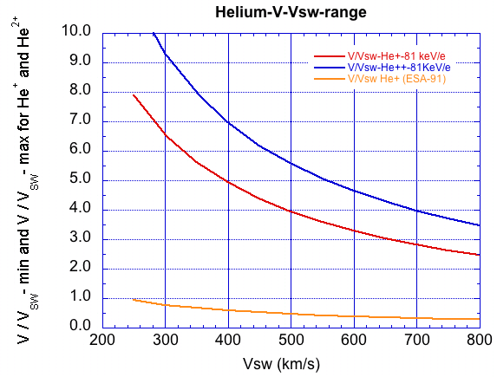

A.3 Comparison of STEREO PLASTIC PUI Spectra with ACE / SWICS
The in-flight calibration for PLASTIC / STEREO-A can be checked by a comparison with PUI data from ACE during times when both spacecraft are in the upwind region, i.e. when the He+ PUI intensities can be expected to be similar. In June 2007, both ACE and STEREO-A are in the upwind direction of the interstellar neutral flow with a separation distance of only 8.5° in ecliptic longitude. The He+ PUI spectra for June 2007 of ACE/SWICS (courtesy G. Gloeckler, s. a. ACE Science Center, http://www.srl.caltech.edu/ACE/ASC/DATA/level3/swics/He_plus.html, and Möbius, et al., 2010) and STEREO-A/PLASTIC show a very good overall agreement (see below). For the PLASTIC PUI spectrum shown below an energy- and time-independent intercalibration factor of 1.09 was applied (constant K2 in equation above).
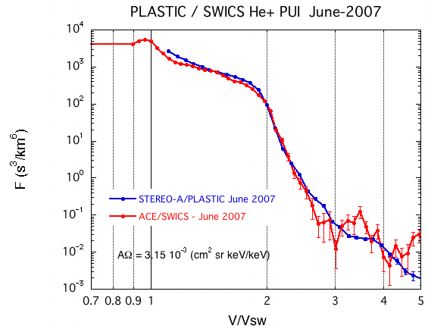
One month average He+ PUI spectra as observed in June 2007 on ACE and STEREO-A
In June 2008 the separation distance between ACE and STEREO-A is significantly larger (~30° in ecliptic longitude). However, the energy spectra in the plateau region of PUI intensities agree also very well (Figure below). At higher energies, in particular above the cut-off energy of 2 x V/Vsw, larger differences of the spectra due to local differences of the interplanetary conditions, resulting in differences in the acceleration, can be expected.
Figure: One month average He+ PUI spectra as observed in June 2008 on ACE and STEREO-A
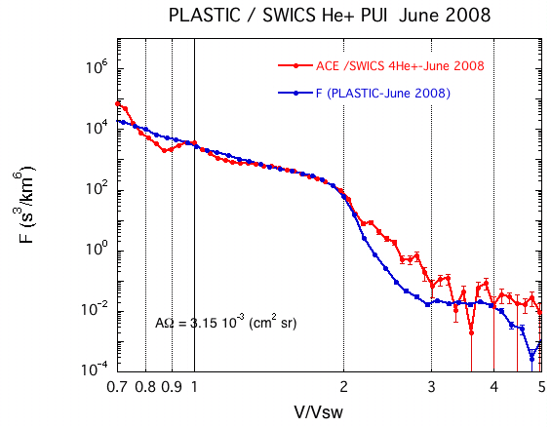

A.4 Long-term PUI Measurements
The figure below shows daily averages of efficiency corrected counts/s for the years 2007 to 2017. The vertical lines indicate the expected time of the passage through the neutral helium focusing cone in the downwind direction. The relative constant average fluxes in the upwind direction suggest a very stable performance of the sensor.
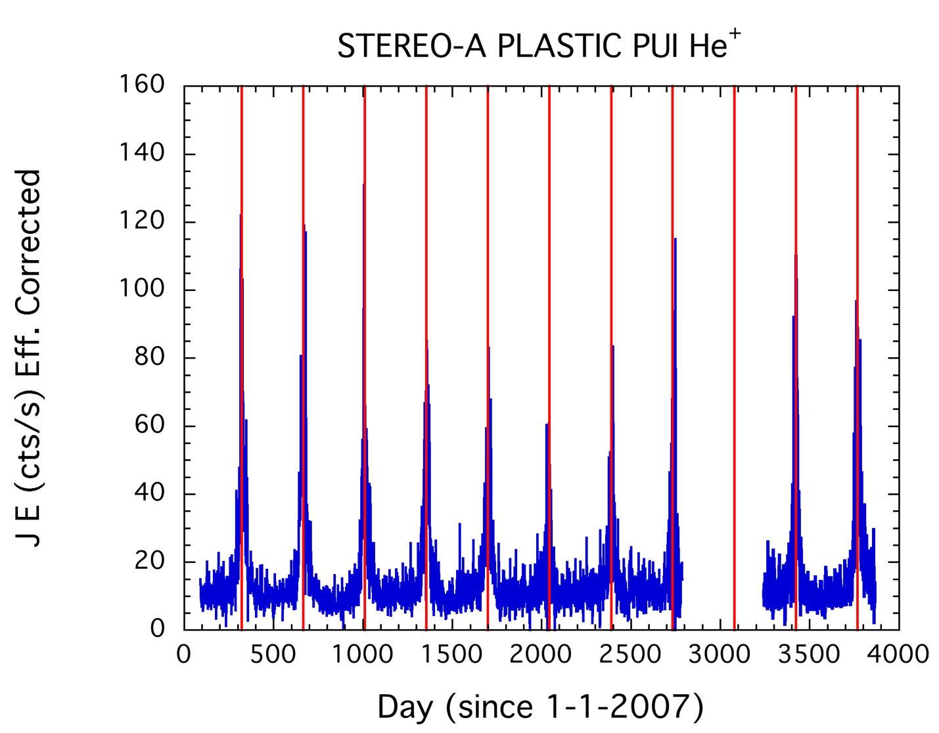
One day averages of relative differential energy flux in the velocity range 1.85>V/Vsw>1.44 for the years 2007 to 2017 as measured with PLASTIC onboard STEREO-A. The extended data gaps in 2014 and 2015 are due to the solar conjunction.

He+ Relative Fluxes, in four V/Vsw ranges
STEREO pick up (He+) data presented here are meant to provide an overview of the long-term behavior of He+ pickup ions and are useful for the selection of interesting event periods.
The data set provides 24h averages of efficiency corrected He+ counts per second in four ranges of V/Vsw. These values are proportional to the differential energy flux (J E) of pickup He+.
As an example, the relative differential energy flux in the velocity range 1.85 > V/Vsw >1.44, i.e. just below the expected He+ PUI cutoff at V/Vsw = 2, is shown for the time period 2007 to 2017 in the figure below. The pronounced peaks in the relative differential energy flux show the transition of STEREO-A through the neutral helium focusing cone. (c.f. Möbius et al., 2010, AIP Conf. Proc. 1216, pp 363-366) and the information on PUI He+ on the STEREO web pages at UNH (http://stereo.sr.unh.edu/data/PLASTIC_Resources/PickupIons_plots.htm).
The data set provides the relative differential energy flux (J*E) of He+ in 4 ranges of V/Vsw. The identification of He+ is based on the measurement of energy per charge (E/q), time-of-flight (TOF), and total energy (SSD) of ions with the PLASTIC sensor. These data include double (E/Q, TOF) and triple coincidences ((E/Q, TOF, SSD) (see e.g. Galvin et al., Space Sci. Rev. 136, p 437-468, 2008).
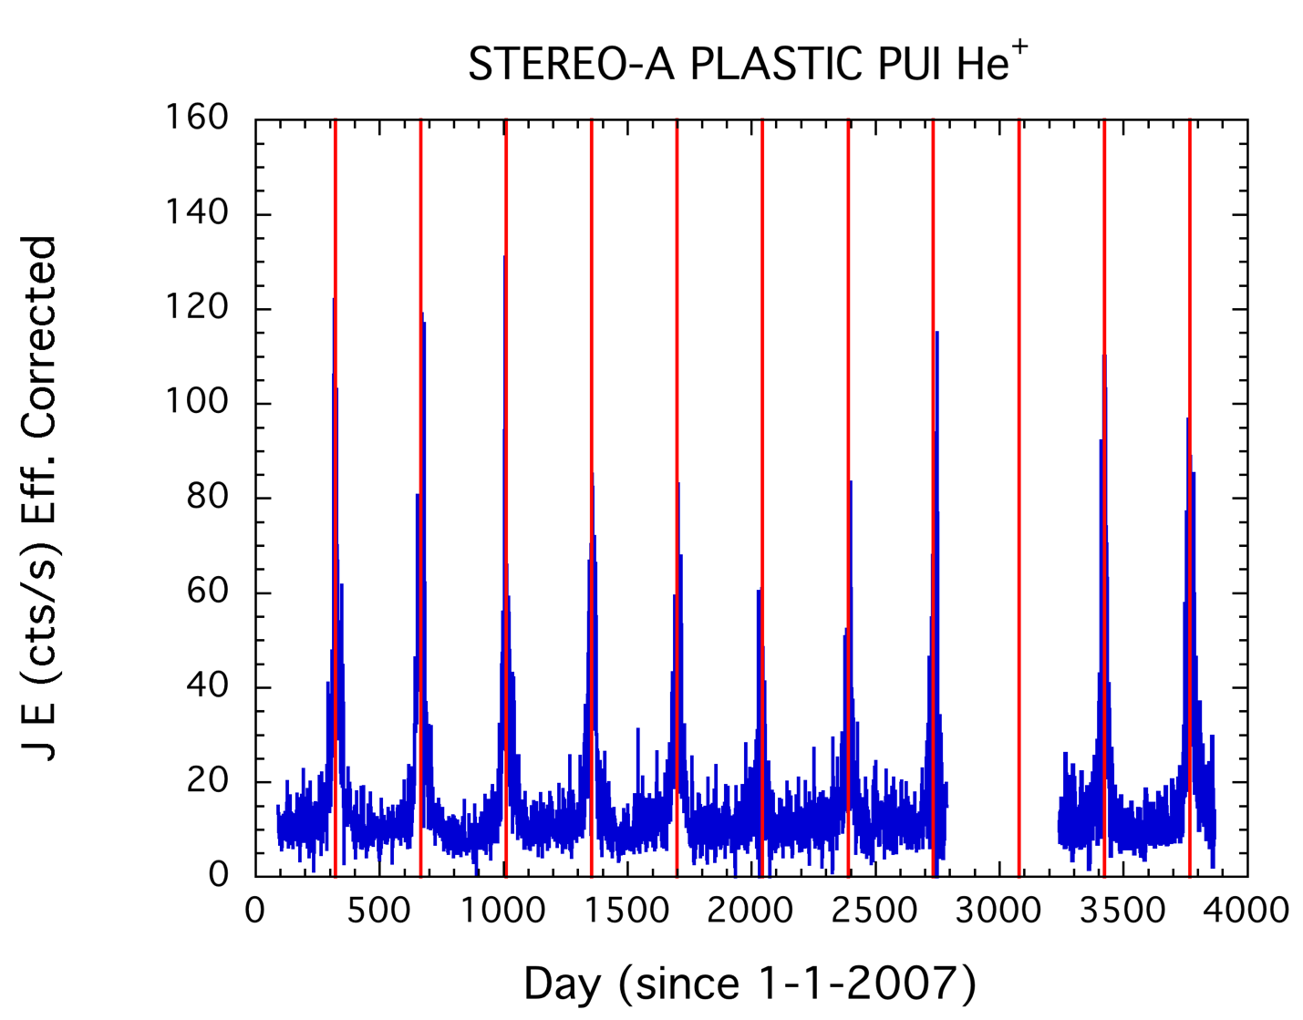
Pickup He+ relative differential energy flux in the velocity range 1.85 > V/Vsw > 1.44, i.e. just below the expected He+ PUI cutoff at V/Vsw = 2, is shown for the time period 2007 to 2017. The pronounced peaks in the relative differential energy flux show the transition of STEREO-A through the neutral helium focusing cone. The extended data gaps during 2014 and 2015 are due to the solar conjunction.

B.1 Data Format
File Naming convention:
STx_L3_PLA_HePlus_24hr_YYYY_Vyy.txt
Where:
"STx" is given as "STA" or "STB" for STEREO A and STEREO B, respectively. "L3" indicates Level 3 data in the STEREO PLASTIC convention.
"PLA" indicates Plasma and Suprathermal Ion Composition (PLASTIC) Investigation. "HePlus" indicates singly ionized helium (He+) as determined by PLASTIC.
"24hr", indicates the time averaging interval of 24 hours. "YYYY" represents Year
Note: Higher time resolutions (e.g. 1 hour, minimum: 10 minutes) are also available on request. Please contact the PI.
The ASCII data with 24 hour averages are provided in yearly "24hr" files. "Vyy", indicates Version number, with the processing version given by "yy." "txt" indicates ASCII file.
STEREO PLASTIC DAILY SUPRATHERMAL HE+ RELATIVE FLUXES
File Format
1. Header Lines
The 3 header lines of the yearly files include information on spacecraft (A or B), production date, calibration file version, proton bulk parameter version number, PUI production version number, and the range of V/Vsw covered.
The parameters provided in the 24-hour data sets are indicated in line 3 of the File Header:
The first set of 7 parameters gives the time the data were acquired:
1. YY: Year of start time of averaging period
2. MM: Month of start time of averaging period
3. DD: Day of start time of averaging period
4. doy: Day of year of start time of averaging period (Jan-1 = 1)
5. HH: Hour of start time of averaging period
6. Min: Minute of start time of averaging period
7. doy: Day of year of start time of averaging period (Jan-1 = 1, decimal).
The next set of 3 parameters provide average solar wind proton bulk parameters. The version number of proton bulk parameters is shown in line 1 of the file header (version V06 and later).
8. Vsw [km|s]: Proton bulk speed (s/c frame)
9. Vtherm [km/s]: Proton thermal speed, defined here as sqrt(2kT/m), with T proton kinetic temperature.
10. Np [1/cc]: Solar wind proton number density (protons per cm3)
The next set of 8 parameters provide the He+ relative energy flux and the number of counts in 4 ranges of V/Vsw (s/c-frame) as indicated in line 3 of the File Header.
11. Relative He+ energy flux in the velocity range 8.00>V/Vsw>3.50
12. Total counts for 8.00>V/Vsw>3.50
13. Same as 11 for 3.50>V/Vsw>2.50
14. Total counts for 3.50>V/Vsw>2.50
15. Same as 11 for 2.50>V/Vsw>1.85
16. Total counts for 2.50>V/Vsw>1.85
17. Same as 11 for 1.85>V/Vsw>1.44
18. Total counts for 1.85>V/Vsw>1.44
Note: the energy cutoff of the PUI He+ flux in the spacecraft frame is expected at V/Vsw=2.

B.2 Modification History
For the extraction of He+ data from PLASTIC raw data files the program pha_play is used (c.f. http://stereo-ssc.nascom.nasa.gov/software.shtml). The different versions of the data files have been generated with different versions of pha_play. Other differences are the energy per charge range used and the maximum range of V/Vsw. The modification history is summarized in the following Table.

Version Number | pha_play | ESA STEPS | Max V/Vsw | Minimum Averaging Time (min) | Date
01 | pha_play_20080922 | 00-71 | 10.0 | 60 | March 2008
02 | pha_play_20120228 | 00-71 | 10.0 | 60 | March 2012
03 | pha_play_20120402 | 00-91 | 8.0 | 10 | April 2012
04 | pha_play_20120402 | 00-91 | 8.0 | 10 | April 2012
05 | This version number is not used for HePlus
06 | pha_play_20120402* | 00-91 | 8.0 | 10 | April 2014
(*) Using also 2013 and 2014 updates of pha_play (does not affect PUI He+).

He+ SW Frame Velocity Count Distributions
This data set presents STEREO-A pickup-ion (PUI) He+ velocity distributions defined at a 5 min time resolution in the solar wind (SW) frame of reference. The velocity distributions are defined as a function of |v⃗′He+ |/|vsw in 69 velocity bins, where v⃗′He+ is the PUI speed in the SW frame and vsw is the SW speed.
This data set is not efficiency corrected, which has been shown to cause an increased relative count rate in the suprathermal tail region. Observation using this data set should be limited to the core PUI distribution.
Preprocessing of raw STEREO-A PLASTIC SW sector data has been performed at the University of Kiel, Gemany to consolidate the measurements to a workable format. Pulse height analysis, described in Drews et al. (2010), is used to identify ion type and to measure the PUI velocity vector. The PLASTIC SW sector provides the unique capability to measure an incoming ion’s incident angle in both the polar, θ (angle out of the ecliptic plane), and azimuthal, φ (angle in ecliptic to sun-spacecraft line) directions (Drews et al., 2015). The SW sector has a total azimuthal Field of View (FoV) of φ ± 22.5◦, divided into 32 angular bins of width ∆φ = 1.4◦. In polar angle, the SW sector has a total FoV of θ ± 20.0◦ which is also divided into 32 bins, resulting in an angular resolution of ∆θ = 1.3◦.
The He+ PUIs are identified in the raw ESA and ToF data through pulse height analysis (Drews et al., 2010), resulting in a measurement of the PUI speed (vhe+ ) and incident angles (φ, θ), for each incident He+. A scientific analysis of the pulse height analysis data is completed on a 5 minute time base, defining the time resolution. He+ PUI, speeds are expressed in the SW frame by subtracting ⃗vsw from the PLASTIC He+ PUI measurements using their velocity vectors. The PUI speed in the solar wind frame, normalized to the local SW speed (w′) is derived in Drews et al. (2012):
w′ = |⃗vsw −⃗vHe+| =􏰀w2 −2∗w∗cos(φ)cos(θ)+1

C.1 Data Format
The file names have the following format:
STx_L3_PLA_HePlus_SW_VelCtDist_5min_20XX_VXX.txt
Where:
"STx" is given as "STA" or "STB" for STEREO A and STEREO B, respectively.
"L3" indicates Level 3 data in the STEREO PLASTIC convention.
"PLA" indicates Plasma and Suprathermal Ion Composition (PLASTIC) Investigation.
"HePlus" indicates singly ionized helium (He+) as determined by PLASTIC.
"SW" indicates the counts are in the SW frame of reference.
"VelCtDist" indicates that this data set is made up of count distributions as opposed to phase space densities.
"5min" indicates the time averaging interval of 5mins. "20XX" represents the year.
"VXX" represents the version number.
The 1 file header line describes each of the columns in the data set. Columns 1-9 are described below, columns 9-77 of the header give the center bin speed, in w′, for the He+ velocity count distributions.
PUI speeds in the SW frame, and SW parameters, measured by PLASTIC and IMPACT, have been consolidated and averaged to meet PUI measurement cadence. All individual PUI counts are binned in w′ to produce an easily manipulatable VDF for every measurement period. This results in a consolidated data set comprised of averaged SW parameter measurements and He+ count distributions determined at a 5min time resolution, spanning STEREO-A’s operation from 2007-2013. Additional years are available to add to the consolidated data set, and are undergoing preprocessing. The data are organized in 77 columns with :
Column
- time: (in days from 2007)
- lon: Spacecraft longitude (in Ecliptic longitude defined from the Sun-Earth line at the spring equinox)
- vsw: solar wind speed proton speed [km/s]
- n: solar wind number density [p/cm3]
- b: Interplanetary Magnetic field (IMF) strength [nT ]
- theta: IMF angle out of the ecliptic [◦]. Defined between[0,180]
- phi: IMF angle out of the ecliptic [◦]. Defined between [-180,180]
- cone_ang: IMF cone angle [◦] (described below). Defined between [0,180].
- - 77. PUI velocity count density measured in w′, binned in 69 sectors in the range [.5 < w′ < 1.5]. The center bin speed is defined on row 1 (the header).

C.2 IMF Angles
The IMF angles (theta,phi,cone_ang) are all defined from the radial sun spacecraft line. The magnetic field cone angle is defined as the total angle between the IMF vector (B⃗) and the sun spacecraft line, and simply calculated using the IMF component angles theta (θB) and phi (φB).
Φcone =arccos(cos(|φB|)cos(π/2−θB)) (2)
The cone angle is useful in identifying times when the PUI torus is visible in the PLASTIC SW sector. The torus distribution forms perpendicular to the IMF, and as such is visible to PLASTIC when the IMF is quasi-perpendicular to the sun spacecraft line, 70◦ < Φcone < 110◦. During these times, PUIs that have been freshly injected into the torus dominate the shape of the count distribution, which results in a reduction of the impact of SW compressions and acceleration (Taut et al., 2018; Bower et al., 2019). The impact of this selection criteria is shown in the figure below.
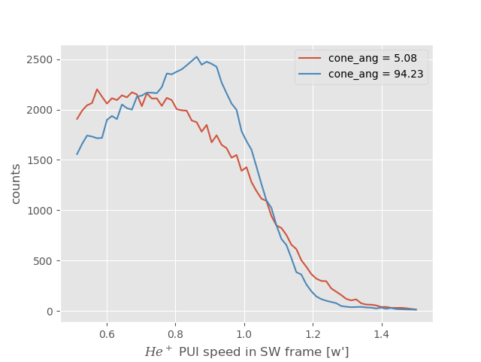
PUI count distribution for a parallel IMF orientation (red) and a quasi-perpendicular orientation (blue). When the IMF is quasi perpendicular the PUI count distribution is less processed by the SW, having a steeper cutoff and reduced suprathermal tail.

C.3 SW Frame PUI Measurements
As an example, we provide two plots generated from this data set. The figure below shows the velocity count distributions accumulated in one day bins spanning the range of the data set (2007-2013). Here one can see that the PUI cutoff speed varies yearly with the spacecraft orbit. This effect is driven by a change in the radial neutral injection speed, brought about by gravitational deflection of the Interstellar neutrals (ISN) around the SUN (Möbius et al., 1999).
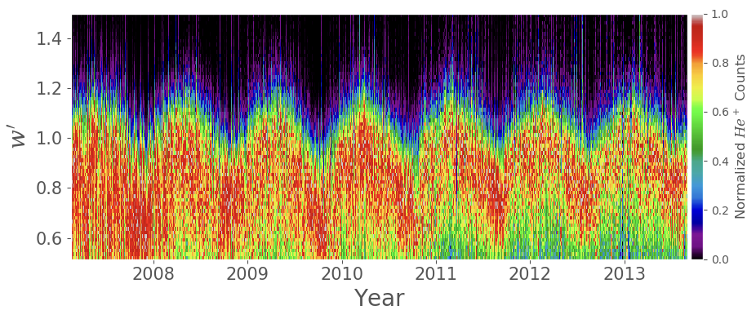
PUI velocity count distributions accumulated in one day bins between 2007 and 2013. Here, one can see the sinusoidal like fluctuations of the PUI cutoff speed (driven by changes in the PUI injection speed) as STEREO-A orbits the sun.

The figure below shows daily averages of the PUI counts between 2007-2013. The peaks here are associated with the spacecraft passing through the ISN focusing cone. Additionally, because this data set has not been efficiency corrected, the overall PUI count rate decreases through the PLASTIC operational time. In effect this means that measurements from the first years of operation will be weighted more heavily for any super-posed epoch analysis. An effort to provide an efficiency corrected data set will be made in the near future.
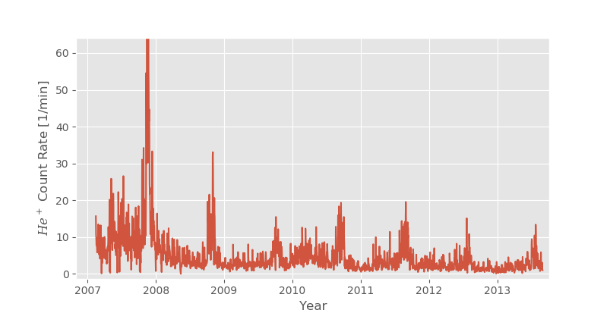
One day averages of STEREO-A PLASTIC He+ PUI counts in the velocity range .5 < w′ < 1.5 from 2007 to 2013. Peaks in the count rate are associated with STEREO passing through the ISN focusing cone.

C.4. References
[1] J S Bower et al. “Effect of Rapid Changes of Solar Wind Conditions on the Pickup Ion Velocity Distribution”. In: JGR-Space Physics Submitted (2019), pp. 1–28.
[2] C. Drews et al. “2D He+ pickup ion velocity distribution functions: STEREO PLASTIC ob- servations.” In: Astronomy and Astrophysics 575.A97 (2015). doi: 10.1051/0004-6361/ 201425271.
[3] C. Drews et al. “Inflow direction of interstellar neutrals deduced from pickup ion measurements at 1 AU”. In: JOURNAL OF GEOPHYSICAL RESEARCH 117 (2012).
[4] C. Drews et al. “Observations of interstellar neon in the helium focusing cone,” in: J. Geophys. Res 115.A10108 (2010). doi: 10.1029/2010JA015585.
[5] E. Möbius et al. “Direct evidence of the interstellar gas flow velocity in the pickup ion cut-off as observed with SOHO CELIAS CTOF”. In: GEOPHYSICAL RESEARCH LETTERS 26.20 (1999), pp. 3181–3184. doi: 10.1029/1999GL003644.
[6] A Taut et al. “Challenges in the determination of the interstellar flow longitude from the pickup ion cutoff”. In: Astronomy & Astrophysics 611 (2018), A61. issn: 0004-6361. doi: 10. 1051/0004-6361/201731796. url: https://doi.org/10.1051/0004-6361/201731796https: //www.aanda.org/10.1051/0004-6361/201731796.

He++ Phase Space Densities
STEREO alpha particle (He2+) phase space densities (PSD) presented here are in the spacecraft frame of reference. The data sets provide 1hr averages of He+ phase space density as a function of V/Vsw in 51 velocity ranges, where V and Vsw are the particle speed and bulk speed of solar wind protons, respectively.
Alpha particle (He2+) phase space densities and total counts are provided in the spacecraft frame of reference as a function of w=V/Vsw, with particle speed V and solar wind speed Vsw. The phase space densities are computed from 10 minute averages of normalized counts and 10 min averages of the solar wind velocity for 51 bins (5% resolution) in the velocity range 8 > w > 0.66. Normalized counts are computed by summing over selected ranges in M/Q (double coincidences) and M/Q-M (triple coincidences), using the priority rates for normalization (s. a. Galvin et al., 2008). M and M/Q are the mass and mass per charge of the ions, respectively.
The phase space density F_Vsw is computed from
F_Vsw [s3/km6]= CTS / eff * K1 * K2 * 1 / (E/M)2, (1)
CTS are the normalized counts per second
eff is the efficiency of PLASTIC for He (energy and time dependent, derived from in-flight calibration)
K1 is a constant, determined by the PLASTIC geometry and energy resolution
(= 317)
K2 is a constant, determined by cross-calibration with ACE / SWICS in 2007 (=1.09, s. paragraph 5)
E/M is the energy per nucleon of the particle in units of keV/nucleon

D1. Data Format
The file names have the following format:
STx_L3_PLA_He2Pl_F_Vsw_XXhr_YYYY_Vzz.TXT
Where "STx" is given as "STA" or "STB" for STEREO A and STEREO B, respectively. "L3" indicates Level 3 data in the STEREO PLASTIC convention.
"PLA" indicates Plasma and Suprathermal Ion Composition (PLASTIC) Investigation. "He2Pl" indicates doubly ionized helium (He2+) as determined by PLASTIC.
"XXhr", indicates the time averaging interval (01 hour). (*) "YYYY" represents Year
“Vzz” represents the version number.
The 3 file header lines provide information on the spacecraft, production date, software version number, in-flight calibration file name and column headers.
The files with 01hr averages provide the data for 1 year. The data are organized in 113 columns, with
Column
- year
- month
- day of month
- day of year
- hour (start time of time bin)
- min (start time of time bin)
- day of year (decimal)
- maximum # of instrument cycles in time bin
- solar wind proton speed (km/s)
- solar wind proton thermal speed [km/s]
- solar wind proton density [p/cm3]
- phase space density [s3/km6], for mean V/Vsw= 7.80, s. a. column header
- total counts for this V/Vsw bin
14-113 same as 12-13 for other V/Vsw bins
Note of caution: Helium fluxes are calculated with the geometric factor of the main sensor. At low V/VSW (typically for V/VSW < 1.2), depending on the switch from main sensor to solar wind sensor, the fluxes may be affected by the switch and need to be evaluated on a case by case basis. Note also that for high solar wind speed, the measurement range in V/Vsw is limited, for example for He2+ to V/Vsw < 4.3 for Vsw = 650 km/s (see figure below).

D.2 Measurement range (V/Vsw) for He+ PUI and He2+
The figure below shows the range of maximum and minimum V/Vsw values for ESA step 2 (maximum energy 81 keV/q), and ESA step 91 (minimum energy 1.17 keV/q), selected for processing He+. The maximum value of V/Vsw for He2+ is shown for comparison.

V/Vsw range for He+ and He2+ as a function of maximum energy (81 keV/e) and minimum energy (ESA step 91, 1.17 keV/q) selected for processing He+.

D.3 PLASTIC Inflight Calibration - Efficiency for Helium
The detection efficiency of the PLASTIC sensor system for ions is subject to time variations, because of a slow degradation of the MCPs during flight. This degradation can be partly compensated by an increase of the MCP HV supply voltage. Therefore, in order to obtain absolute fluxes, the efficiency needs to be continuously monitored during flight. To obtain this efficiency for He+, the ratio of single and coincidence rates in the SW main channel of the PLASTIC time-of-flight system are used, at an energy just below the He+ cutoff energy. Thus, the variation of the He+ cutoff energy with solar wind speed provides the energy dependence of the He+ efficiency. For details of the sensor system, see Galvin, et al., 2007.
The efficiency for He is provided as function of total energy/nuc Etot in the energy range 6 to 20 keV/nuc, where Etot is defined as
Etot = (E/Q + PAC) *Q/M,
with post acceleration voltage PAC (usually 20kV), M=4 for He and Q=1 and Q=2 for He+ and He2+, respectively.
The PLASTIC He efficiencies and details of the evaluation of the in-flight efficiency can be found in the Appendices STA_L3_PLA_HEEFF_Rev15 and READ_ME_PLASTIC_He_Efficiency_Rev15.

Alfven Wave Lists
The table lists some Alfvén waves observed by the STEREO spacecraft from year 2007 to year 2014. They are identified while searching for small solar wind transients (STs).
STs were observed frequently in the solar wind (Yu et al., 2014, 2016). However, as pointed out by Marubashi et al. [2010] and Cartwright and Moldwin [2010], some solar wind Alfvénic structures can be mistaken for STs. For this reason, we need to identify Aflvénic structures. We
classify as Aflvénic fluctuations those structures which satisfy the relation $ΔV_{⊥}=\frac{ΔB_{⊥}}{\sqrt{μ_{0}ρ}}$ Here ∆𝑉⊥ and ∆𝐵⊥ represent the velocity and magnetic field perturbations perpendicular to the background field. The latter is obtained by smoothing. (R_{X}, R_{Y}, R_{Z}) are three correlation
coefficients between ∆𝐵⊥ and ∆𝐴⊥ = $\sqrt{μ_{0}ρ}$ ∗ ∆𝑉⊥. We used CORRELATE function in IDL to get the three correlations between ∆𝐵# and ∆𝐴# (an example picture has been attached, see figure below).
We require all three correlations (R_{X}, R_{Y}, R_{Z}) to be greater than 0.5, or two greater than 0.6 and the other greater than 0.3, which is similar to the criterion in Cartwright and Moldwin [2008].

E.1. Data Format
File Naming convention:
STx_L3_PLA_AlfWaves_ Vyy.txt Where:
"STx" is given as "STA" or "STB" for STEREO A and STEREO B, respectively. "L3" indicates Level 3 data in the STEREO PLASTIC convention.
"PLA" indicates Plasma and Suprathermal Ion Composition (PLASTIC) Investigation. "AlfWaves" indicates the Alfvén waves data product.
"Vyy", indicates Version number, with the processing version given by the "yy." "pdf" indicates a portable document file.
Explanation of Columns in Alfvén Wave List
Column 1 – Event number
Column 2 – Start Time
Column 3 – End Time
Column 4 – R_{x} coefficient
Column 5 – R_{y} coefficient
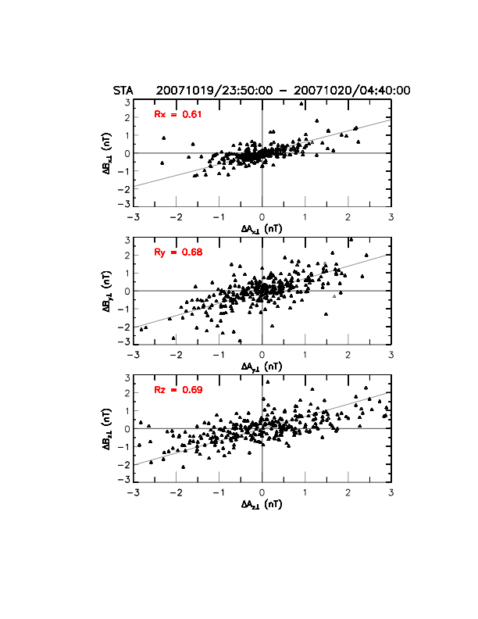
Column 6 – R_{z} coefficient
The clear correlations between ∆𝐵⊥ and ∆𝐴⊥ in an Alfvénic structure.

E.2 References
M.L. Cartwright and M.B. Moldwin, Comparison of small-scale flux rope magnetic properties to large-scale magnetic clouds: Evidence for reconnection across the hcs? Journal of Geophysical Research: Space Physics, 113 (A9), 2008.
M.L. Cartwright and M.B. Moldwin, Heliospheric evolution of solar wind small-scale magnetic flux ropes. Journal of Geophysical Research: Space Physics, 115(A8), 2010.
K. Marubashi, K.S. Cho, Y.D. Park, M. Maksimovic, K. Issautier, N. Meyer-Vernet, M. Moncuquet, and F. Pantellini, Torsional Alfvén waves as pseudo-magnetic flux ropes. In Aip Conference Proceedings, volume 1216, page 240, 2010.
B. U. Ö Sonnerup and M. Scheible, Minimum and maximum variance analysis. Analysis methods for multi-spacecraft data, pages 185 – 220, 1998.
B.U.Ö. Sonnerup and L.J. Cahill Jr., Magnetopause structure and attitude from explorer 12 observations. Journal of Geophysical Research, 72(1): 171-183, 1967.
W. Yu, C.J. Farrugia, N. Lugaz, A.B. Galvin, E.K.J. Kilpua, H. Kucharek, C. Möstl, M. Leitner, R.B. Torbert, K.D.C. Simunac, et al., A statistical analysis of properties of small transients in the solar wind 2007 – 2009: Stereo and wind observations. Journal of Geophysical Research: Space Physics, 119(2): 689 – 708, 2014.
W. Yu, C.J. Farrugia, A.B. Galvin, N. Lugaz, J.G. Luhmann, K.D.C. Simunac, and E. Kilpua, Small solar wind transients at 1 AU: STEREO observations (2007 - 2014) and comparison with near-earth wind results (1995-2014). Journal of Geophysical Research: Space Physics, 2016.

Small Transients Lists
The table lists some STs observed by the STEREO spacecraft from year 2007 to year 2014 (Yu et al., [2014], [2016]). They are identified by the following criteria.
1. The STs have durations between 0.5 and 12 hours.
2. Magnetic field strength is higher than the yearly average (> 1.3 times yearly average).
3. Low proton beta (less than 0.7 times yearly average) or low proton temperature (Tp/Texp < 0.7).
4. Low Alfvén Mach Number (less than 0.7 yearly average), or large rotations of magnetic field components (we used the minimum variance analysis on the magnetic field, Sonnerup and Cahill Jr. [1967], Sonnerup and Scheible [1998]; and we require that the intermediate-to-minimum eigenvalue ratio be > 5).
5. Checking the Aflvénic fluctuations.
We remove the events which satisfy the relation $ΔV_{⊥}=\frac{ΔB_{⊥}}{\sqrt{μ_{0}ρ}}$ We remove all three correlations (Rx, Ry, Rz) greater than 0.5, or two greater than 0.6 and the other greater than 0.3 from our list, which is similar to the criterion in Cartwright and Moldwin [2008].
Note: The asterisk (*) in the ST lists mean this ST was in the time ranges which ICMEs have been observed. We call them “ICME-like STs”. (The lists of the ICMEs observed by STEREO which have been used are got from: Jian et al., 2006, www- ssc.igpp.ucla.edu/~jlan/STEREO/Level3/STEREO_Level3_ICME.pdf.)

F.1 Data Format
File Naming convention:
STx_L3_PLA_SmallTrans_ Vyy.txt Where:
"STx" is given as "STA" or "STB" for STEREO A and STEREO B, respectively. "L3" indicates Level 3 data in the STEREO PLASTIC convention.
"PLA" indicates Plasma and Suprathermal Ion Composition (PLASTIC) Investigation. "SmallTrans" indicates the Small Transient data product.
"Vyy", indicates Version number, with the processing version given by the "yy." "pdf" indicates a portable document file.
Explanation of Columns in STs list:
Column 1 – Event number
Column 2 – Start time
Column 3 – End time

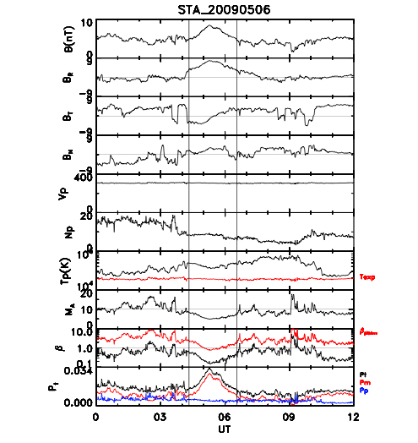
An example of a ST observed on May 6, 2009 from STA.
F.2 References
M.L. Cartwright and M.B. Moldwin, Comparison of small-scale flux rope magnetic properties to large-scale magnetic clouds: Evidence for reconnection across the hcs? Journal of Geophysical Research: Space Physics, 113 (A9), 2008.
B.U.Ö. Sonnerup and L.J. Cahill Jr., Magnetopause structure and attitude from explorer 12 observations. Journal of Geophysical Research, 72(1): 171-183, 1967.
B. U. Ö Sonnerup and M. Scheible, Minimum and maximum variance analysis. Analysis methods for multi-spacecraft data, pages 185 – 220, 1998.
W. Yu, C.J. Farrugia, N. Lugaz, A.B. Galvin, E.K.J. Kilpua, H. Kucharek, C. Möstl, M. Leitner, R.B. Torbert, K.D.C. Simunac, et al., A statistical analysis of properties of small transients in the solar wind 2007 – 2009: Stereo and wind observations. Journal of Geophysical Research: Space Physics, 119(2): 689 – 708, 2014.
W. Yu, C.J. Farrugia, A.B. Galvin, N. Lugaz, J.G. Luhmann, K.D.C. Simunac, and E. Kilpua, Small solar wind transients at 1 AU: STEREO observations (2007 - 2014) and comparison with near-earth wind results (1995-2014). Journal of Geophysical Research: Space Physics, 2016.

Suprathermal Event Lists
This data product contains a list of automatically identified suprathermal proton events measured on the Wide Angle Partition without a Solid State Detector (WAP non-SSD) portion of the STEREO/PLASTIC instrument. This list in conjunction with the IMPACT magnetic field information and PLASTIC solar wind data can aid a user in identifying energetic proton events related to Stream Interaction Regions (SIRs), shocks, upstream events, magnetospheric events, etc. For information on the WAP non-SSD portion of PLASTIC see below. A thorough explanation of both PLASTIC and IMPACT can be found in [Galvin et al., 2008] and [Luhmann et al., 2007], respectively.
Events are triggered if the rate-averaged flux of high energy protons accumulated over 10 min exceeds a threshold to match manual definitions. The program then compiles Event Lists for ICME, SEP, SIR, and Shock data to compute overlap with the suprathermal event and within +/- 1 day of these Event Lists.

G.1 Instrument Details
The WAP non-SSD portion of the PLASTIC instrument is utilized in creating these event lists. This non-sunward facing section has an 180º in- ecliptic view and covers an energy range from 0.2 keV/q to 80keV/q, Electro Static Analyzer (ESA) step 128 to 0. Early in the mission the WAP non-SSD portion of both spacecraft, STEREO-Ahead (STA) and STEREO-Behind (STB), are ideal for detecting bow shock/magnetospheric ion events.

G.2 Suprathermal Event Definition
The energy spectrogram produced by summing the 10 min resolution Supra_no_E_Non-SSD_class_0 and Supra_no_E_Non-SSD_class_1 matrix rate data (there are two classes allocated for protons on the WAP non-SSD so we sum them together) allows for quick manual identification of suprathermal proton events. The top panel in the figure below is an example of an energy spectrogram showing suprathermal proton signatures (the sum of Supra_no_E_Non-SSD_class_0 and Supra_no_E_Non-SSD_class_1 matrix rate data), while the lower panel shows |B|. Plots similar to those shown in Figure 1 can be created using the PLASTIC public domain routine SPLAT (IDL). Daily plots similar to those in the figure below can be found at http://fiji.sr.unh.edu/wap_bfield_public.html.
In the automated process to define events, we first define 3 bands in Energy/Charge (E/Q) covering the same number of ESA steps (8 ESA Steps). The red horizontal bands in the top panel of the figure below depict these energy bands. The upper, middle, and lower energy bands cover the E/Q range 59.0- 42.2keV/q, 19.7-14.1keV/q, and 5.95-4.26keV/Q, respectively.
If the average of the number of events in a 10 min increment in any one of the three energy bands exceeds a trigger value, the program identifies the start of an event period. The end of an event occurs when none of the three E/Q bands are triggered. The triggering of events was adjusted as to match those defined by eye.
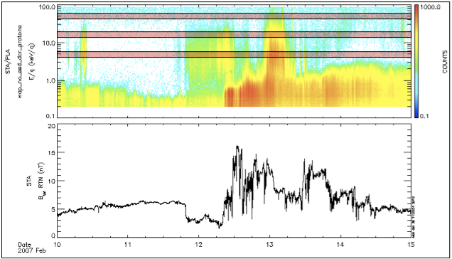
The top panel shows an energy spectrogram of suprathermal protons detected on the WAP Non-SSD while the bottom panel shows the magnitude of the magnetic field on STA. The red horizontal bands indicate the energy bands used to define suprathermal proton events.

G.3 Event List Criteria
Event criteria for ICMEs, SEPs, SIRs, and Shocks have changed for the start of the 2012 year. Most noticeable impact this has is on the SEP events. Event List Criteria used by Lan Jian:
ICME: The criteria of event classification are published in the following papers:
L.K. Jian, C.T. Russell, J.G. Luhmann, and A.B. Galvin, STEREO Observations of Interplanetary Coronal Mass Ejections in 2007 - 2016, The Astrophys. J., 885, 114, doi: 10.3847/1538-4357/aab189, 2018.
L.K. Jian, C.T. Russell, J.G. Luhmann, A.B. Galvin, K.D.C. Simunac, Solar Wind Observations at STEREO: 2007 – 2011, Amer. Inst. Phys. Proceedings of Solar Wind 13, 1539, 191-194, doi: 10.1063/1.4811020, 2013.
L. Jian, C.T. Russell, J.G. Luhmann, and R.M. Skoug, Properties of Interplanetary Coronal Mass Ejections at One AU during 1995 – 2004, Solar Phys., 239, 393-436, 2006.
SIR: The criteria of event classification are published in the following papers:
L.K. Jian, J.G. Luhmann, C.T. Russell, A.B. Galvin, Solar-Terrestrial Relations Observatory (STEREO) Observations of Stream Interaction Regions in 2007 - 2016: Relationship with Heliospheric Current Sheets, Solar Cycle Variations, and Dual Observations, Solar Phys., 294, 31, doi: 10.1007/s11207-019-1416-8, 2019.
L.K. Jian, C.T. Russell, J.G. Luhmann, A.B. Galvin, K.D.C. Simunac, Solar Wind Observations at STEREO: 2007 - 2011, Amer. Inst. Phys. Proceedings of Solar Wind 13, 1539, 191-194, doi: 10.1063/1.4811020, 2013. L. Jian, C.T. Russell, J.G. Luhmann, and R.M. Skoug, Properties of Stream Interactions at One AU during 1995 2004, Solar Phys., 239, 337-392, 2006.
SEP: Prior to 2012, SEP definitions are defined by the UCLA team: where the 3-hour time-averaged flux of 1.8 − 3.6 𝑀𝑒𝑉 protons exceed 5 x 10⁻⁴ $\frac{p f u}{MeV}$ (where 1 p f u = 1 p cm ⁻² sr ⁻¹ s⁻¹) as measured by the LET onboard STEREO A(B).
Beyond 2011: The list is compiled by Dr. Lan Jian (lan.jian@nasa.gov) using the criterion that the flux of 13 − 100 𝑀𝑒𝑉 protons from hourly High Energy Telescope (HET) measurements > 10 pfu, to mimic the list of Solar Proton Events provided by NOAA Space Weather Prediction Center using the GOES spacecraft data (http://www.swpc.noaa.gov/ftpdir/indices/SPE.txt).
Shock: The criteria of event classification are published in the following paper:
L.K. Jian, C.T. Russell, J.G. Luhmann, A.B. Galvin, K.D.C. Simunac, Solar Wind Observations at STEREO: 2007 - 2011, Amer. Inst. Phys. Proceedings of Solar Wind 13, 1539, 191-194, doi: 10.1063/1.4811020, 2013.

G.4 Data Format
Explanation of Columns in the STEREO Suprathermal Proton Lists
Column1- Event Number
This is the number of the event in the time period investigated. The investigation period of each list can be found in the 1st row of the suprathermal event lists header.
Column2&3- StartDate/Time & Stop Date/Time
These two columns indicate the start and stop of each event. The date/time format is YYYY:MM:DD/HH:MM:SS.
Column 4 – Duration (min)
This column gives the duration of the event in minutes. Equivalent to Stop Date minus Start Date.
Column 5 & 6 – Event Averaged SW @ STA(B) (km/s) & Event STDEV of SW @ STA(B) (km/s)
The first of these columns is the average solar wind speed measured by PLASTIC-A(B) over the duration of an event. The second column is the STandard DEViation (STDEV) of the solar wind speed measured by PLASTIC-A(B) over the duration of an event. If no solar wind velocity data is available then the average and STDEV solar wind velocity are filled with NAN.
Column 7 – STA(B)-Earth Separation (Re)
This column gives the event average separation distance between the center of the Earth and the spacecraft in Earth radii.
Column 8 & 9 – Event Averaged Linear Miss (Re) & Event STDEV Linear Miss (Re)
We define the linear miss-distance as the distance that a straight line extrapolated along the locally measured interplanetary magnetic field vector misses an intersection with the planet.
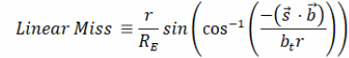
with r = GSE radial distance from STEREO A to Earth (km)
𝑅E Earth radius (km)
𝑏_{t} = magnitude of b field in GSE (nT)
$\vec{s}$ = STEREO position in GSE
$\vec{a}$ = Magnetometer data in GSE
$\vec{b}$ = $\vec{a}$ − $\vec{s}$
The result gives the average Linear Miss to the Earth’s center (a term introduced in [Desai et al., 2000]) of an event.
To produce the Linear Miss, the 1 min magnetic field data is analyzed to determine the direction of the field during an event. A straight line is then extended from the spacecraft in the direction of the measured magnetic field. The shortest distance between the extension of the magnetic field and the Earth is then the Linear Miss. The Linear Miss of all 1 min magnetic field vectors within an event are averaged to give the value in column 8. The next column is the STDEV of the Linear Miss of events in an event time period. If no magnetic field data is available, then the average and STDEV Linear Miss are filled with NAN.
Column 10 & 11 – Overlap SIR & Overlap +/- 1 Day of SIR
The SIR event list provided at https://stereo-ssc.nascom.nasa.gov/data/ins_data/impact/level3/ by Lan Jian is used.
Using the criteria outlined in [Jian et al., 2006], we place the number of SIR time periods the event overlaps in column 10. In column 11, we place the number of SIR time periods with a day added to the end time and a day subtracted from the start time an event overlaps. If the suprathermal proton event time occurred outside the time range inspected for SIRs then N/A is inserted in these two columns. The time range inspected for SIRs is located in the 4th row of the suprathermal event lists header. This row also contains the date the SIR list, used in the program, was last updated.
Column 12 & 13 – Overlap ICME & Overlap +/- 1 Day of ICME
The ICME event list provided at https://stereo-ssc.nascom.nasa.gov/data/ins_data/impact/level3/ by Lan Jian is used.
We place the number of ICME time periods the event overlaps in column 12. In column 13, we place the number of ICME time periods with a day added to the end time and a day subtracted from the start time an event overlaps. If the suprathermal proton event time occurred outside the time range inspected for ICMEs then N/A is inserted in these two columns. The time range inspected for ICMEs is located in the 6th row of the suprathermal event lists header. Row 7 contains the date the ICME list, used in the program, was last updated.
Column 14 & 15 – Overlap +/- 1 Day of Shock & Overlap +/- 1 Day of Shock
The Shock list provided at https://stereo-ssc.nascom.nasa.gov/data/ins_data/impact/level3/ by Lan Jian is used.
We place the number of shocks time’s ± 1 hour an event overlaps in column 14. In column 15, we place the number of shock times ±1 day an event overlaps. If the suprathermal proton event time occurred outside the time range inspected for shocks then N/A is inserted in these two columns. The time range inspected for shocks is located in the 6th row of the suprathermal event lists header. Row 7 contains the date the shock list, used in the program, was last updated.
Column 16 & 17 – Overlap SEP & Overlap +/- 1 Day of SEP
The SEP event list provided at https://stereo-ssc.nascom.nasa.gov/data/ins_data/impact/level3/ by Lan Jian is used.
We place the number of SEP time periods the event overlaps in column 12. In column 13, we place the number of SEP time periods with a day added to the end time and a day subtracted from the start time an event overlaps. If the suprathermal proton event time occurred outside the time range inspected for SEPs then N/A is inserted in these two columns. The time range inspected for SEPs is located in the 6th row of the suprathermal event lists header. Row 7 contains the date the SEP list, used in the program, was last updated.
Column 18, 19, & 20 – Hi Bin Triggered, Med Bin Triggered & Low Bin Triggered
These columns represent how many times each of the three E/Q bands is triggered within an event. The ‘Hi Bin Triggered’ column indicates how many times the 59.0-42.2keV/q band is triggered, ‘Med Bin Triggered’ column indicates how many times the 19.7-14.1 keV/q band is triggered, and ‘Low Bin Triggered’ column indicates how many times the 5.95-4.26keV/q band is triggered within an event. The 59.0-42.2keV/q band is excluded as a possible event trigger on STB before 10-21-2007 due to high background.

G.5 References
M. I. Desai, G. M. Mason, J. R. Dwyer, J. E. Mazur, T. T. von Rosenvinge, R. P. Leppin, Characteristics of energetic (≳30 keV/nucleon) ions observed by the Wind/STEP instrument upstream of the Earth's bow shock, Journal of Geophysical Research, VOL. 105, NO. A1, PP. 61- 78, doi:10.1029/1999JA900406, 2000.
A. B. Galvin, L. M. Kistler, M. A. Popecki, C. J. Farrugia , K.D.C. Simunac, L. Ellis, E. Moebius, , M. A. Lee , M. Boehm, J. Carroll, A. Crawshaw, M. Conti, P. Demaine, S. Ellis, J.A. Gaidos, J. Googins, M. Granoff, A. Gustafson, D. Heirtzler, B. King, U. Knauss, J. Lavasseur, S. Longworth, K. Singer, S. Turco, P. Vachon, M. Vosbury, M. Widholm, L. M. Blush, R. Karrer, P. Bochsler, H. Daoudi, A. Etter, J. Fischer, J. Jost, A. Opitz, M. Sigrist, P. Wurz, B. Klecker, R. F. Wimmer- Schweingruber, M. Koeten, B. Thompson, and D. Steinfeld, The Plasma and Suprathermal Ion Composition (PLASTIC) Investigation on the STEREO Observatories, Space Science Reviews, vol. 136, Numbers 1-4, pages 437-486, doi: 10.1007/s11214-007-9296-x, 2008.
L. Jian, C.T. Russell, J.G. Luhmann, and R.M. Skoug, Properties of stream interaction at one AU during 1995 - 2004, Solar Physics, 239, 337, doi: 10.1007/s11207-006-0132-3, 2006.
J. G. Luhmann, D. W. Curtis, P. Schroeder, J. McCauley, R. P. Lin, D. E. Larson, S. D. Bale, J.-A. Sauvaud, C. Aoustin, R. A. Mewaldt, A. C. Cummings, E. C. Stone, A. J. Davis, W. R. Cook, B. Kecman, M. E. Wiedenbeck, T. von Rosenvinge, M. H. Acuna, L. S. Reichenthal, S. Shuman, K. A. Wortman, D. V. Reames, R. Mueller-Mellin, H. Kunow, G. M. Mason, P. Walpole, A. Korth, T. R. Sanderson, C. T. Russell, and J. T. Gosling, STEREO IMPACT Investigation Goals, Measurements, and Data Products Overview, Space Science Reviews, 136, 117–184, doi: 10.1007/s11214-007-9170-x, 2008.
L.K. Jian, C.T. Russell, J.G. Luhmann, and A.B. Galvin, STEREO Observations of Interplanetary Coronal Mass Ejections in 2007-2016, The Astrophys. J., 885, 114, doi: 10.3847/1538-4357/aab189, 2018.
L.K. Jian, C.T. Russell, J.G. Luhmann, A.B. Galvin, K.D.C. Simunac, Solar Wind Observations at STEREO: 2007 – 2011, Amer. Inst. Phys. Proceedings of Solar Wind 13, 1539, 191-194, doi: 10.1063/1.4811020, 2013.
L.K. Jian, J.G. Luhmann, C.T. Russell, A.B. Galvin, Solar-Terrestrial Relations Observatory (STEREO) Observations of Stream Interaction Regions in 2007-2016: Relationship with Heliospheric Current Sheets, Solar Cycle Variations, and Dual Observations, Solar Phys., 294, 31, doi: 10.1007/s11207-019-1416-8, 2019.

Appendices

Appendix A: Apids with PLASTIC Data

- Analog Housekeeping (also includes IMPACT data)
- Digital Housekeeping
- PHA Data
- Normal Monitor Rates
- Full Resolution Monitor Rates
- ‘Trickle-Down’ Memory Dump
- Meta-data for Heavy Ions (number of packets summed)
31A SW Z>2 – High: Class 0
31B SW Z>2 – High: Class 1
31C SW Z>2 – Low: Classes 2-9
31D SW Z>2 – Low: Classes 10-14
31E WAP-SSD-TCR
31F WAP-SSD-DCR
- WAP-noSSD-DCR
- SW Priority Rates
- WAP Priority SSD
- WAP Priority no-SSD
- SW-All H-Alpha Reduced Distribution
- SW-H(Doubles) H+Peak Reduced Distribution & Proton Moments
- SW-Alpha(Doubles) He++ Peak Reduced Distribution
- SW-Alpha(Triples) He++ TCR Reduced Distribution
- Compressed Classifier Data (Proton Mode)
- Uncompressed Classifier Data (Proton Mode)
370 Beacon Data (not in Level 0 or Level 1)

Appendix B: Compression Algorithms

Compression from 16 bits to 8 bits:
 | Input Count Range, N, decimal |  | Input Count Range, N, Hex |  | Output Code
 | 0 - 31 |  | 0 - 1Fh |  | N
 | 32 - 63 |  | 20h - 3Fh |  | 20h+(N-20h)/2
 | 63 - 127 |  | 40h - 7Fh |  | 30h+(N-40h)/4
 | 128 - 255 |  | 80h - FFh |  | 40h+(N-80h)/8
 | 256 - 511 |  | 100h - 1FFh |  | 50h+(N-100h)/10h
 | 512 - 1,023 |  | 200h - 3FFh |  | 60h+(N-200h)/20h
 | 1,024 - 2,047 |  | 400h - 7FFh |  | 70h+(N-400h)/40h
 | 2,048 - 4,095 |  | 800h - FFFh |  | 80h+(N-800h)/80h
 | 4,096 - 8,191 |  | 1000h - 1FFFh |  | 90h+(N-1000h)/100h
 | 8,192 - 16,383 |  | 2000h - 3FFFh |  | A0h+(N-2000h)/200h
 | 16,384 - 32,767 |  | 4000h - 7FFFh |  | B0h+(N-4000h)/400h
 | 32,768 - 65,535 |  | 8000H - FFFFh |  | C0h+(N-8000h)/800h
 | 65,536 - 131,071 |  | 10000h - 1FFFFh |  | D0h+(N-10000h)/1000h
 | 131,072 - 262,143 |  | 20000h - 3FFFFh |  | E0h+(N-20000h)/2000h
 | 262,144 - 524,287 |  | 40000h - 7FFFFh |  | F0h+(N-40000h)/4000h
 | > 524,287 |  | > 7FFFFh |  | FFh
STEREO Moment Compression
 | Data has 1 sign bit, 6 exponent bits, and 9 mantissa bits:
 | MSB |  |  | LSB
 | S E E E E E E M M M M M M M M M
 | A compressed value of zero represents a zero data value.
 | Otherwise Value = (-1)^S * (512+M) * 2^(E-10)

Appendix C: Analog Housekeeping Products

Abbreviation | Name/Description | Sample Value | Units
'lrnm_spare', | spare monitor channel (negative)
'lvc_-12v', | low voltage converter -12 V | -12.27 | Volts
'lvc_-5v', | low voltage converter -5 V | -4.88 | Volts
'esa_vm_pos', | Electrostatic Analyzer Positive Voltage Monitor | 35.65 | Volts
'dfl_1_vm', | Deflection 1 Voltage Monitor | 15.45 | Volts
'dfl_1_tap', | Deflection 1 Tap | 17.39 | Volts
'dfl_2_vm', | Deflection 2 Voltage Monitor | 17.21 | Volts
'dfl_2_tap', | Deflection 2 Tap | 17.74 | Volts
'lvc_+2.5v_b', | low voltage converter +2.5 V b | 2.43 | Volts
'pac_cm_dc', | Post-Acceleration Voltage DC Current Monitor | 19.79 | mA
'lvc_+12v', | low voltage converter +12 V | 12.18 | Volts
'lrpm_spare', | spare monitor channel (positive) | 0 | Volts
'lvc_+2.5v_a', | low voltage converter +2.5 V a | 2.43 | Volts
'lvc_+5v', | low voltage converter +5 V | 4.97 | Volts
'adc_avdd', | Analog to Digital Converter Voltage (Analog) | 5.07 | Volts
'adc_dvdd', | Analog to Digital Converter Voltage (Digital) | 5.07 | Volts
'pac_vm', | Post-Acceleration Voltage Monitor | -144404.26 | Volts
'cal_vref', | Calibration Refernce Voltage | 5 | Volts
'pac_cm_ac', | Post-Acceleration AC Current Monitor -- not in use
'mcp_vm', | Micro-channel Plate Voltage Monitor | 2333.72 | Volts
'mcp_cm_dc', | Micro-channel Plate DC Current Monitor | 36.71 | mA
'mcp_cm_ac', | Micro-channel Plate AC Current Monitor -- not in use
'ssd_cm_dc', | Solid State Detector DC Current Monitor | 143.8 | mA
's_ch_vm', | S-Channel Voltage Monitor | -4.49 | Volts
's_ch_vm_tap', | S-Channel Voltage Monitor Tap | 1.7 | Volts
's_ch_cm_dc', | S-Channel DC Current Monitor | 3.64 | mA
'esa_vm_neg', | Electrostatic Analyzer Negative Voltage Monitor | -14.94 | Volts
'esa_cm_dc', | Electrostatic Analyzer DC Current Monitor | 3.96 | mA
'dfl_1_cm_dc', | Deflection 1 DC Current Monitor | 3.18 | mA
'dfl_2_cm_dc', | Deflection 2 DC Current Monitor | 3.34 | mA
'lvc_+2.5v_b_imon | low voltage converter +2.5 V b Current Monitor | 300.63 | mA
'lvc_+12v_imon', | low voltage converter +12 V Current Monitor | 377.51 | mA
'lvc_-12v_imon', | low voltage converter -12 V Current Monitor | 64.63 | mA
'lvc_+5v_imon', | low voltage converter +5 V Current Monitor | 219.98 | mA
'lvc_-5v_imon', | low voltage converter -5 V Current Monitor | 88.67 | mA
'lvc_+2.5v_a_imon | low voltage converter +2.5 V a Current Monitor | 287.59 | mA
'ssd_vm', | Solid State Detector Voltage Monitor -- conversion factor is incorrect | 66.8 | V
'adc_lu_flag', | DAC Boards Analog to Digital Converter latchup flag | 0
'plug_id', | high voltage limit plug (none-- fully enabled) | FullEnable
'adc_lu_ctr', | DAC Boards Analog to Digital Converter latchup counter | 0
'dac_status', | DAC Boards Status | 0
'adc0_agnd', | Analog to Digital Converter 0 Analog Ground
'adc1_agnd', | Analog to Digital Converter 1 Analog Ground
'ra_e0', | Resistive Anode Charge Amplifier Output 0
'ra_e1', | Resistive Anode Charge Amplifier Output 1
'tac0_tsp', | Time Amplitude Converter 0 temperature | 11.75 | deg C
'tac2_tsp', | Time Amplitude Converter 2 temperature | 15.11 | deg C
'sb0_tsp', | Signal Board 0 temperature -- not in use | none
'sb1_tsp', | Signal Board 1 temperature -- not in use | none
'tof_hv0_tsp', | Time-of-Flight High Voltage 0 temperature | 8.4 | deg C
'tof_hv1_tsp', | Time-of-Flight High Voltage 1 temperature | 10.08 | deg C
's_c_0_tsp', | Space-Craft/Instrument Case temperature 0 | -3.35 | deg C
's_c_1_tsp', | Space-Craft/Instrument Case temperature 1 | 5.04 | deg C
'lvc0_tsp', | low voltage converter 0 temperature | 3.36 | deg C
'lvc1_tsp', | low voltage converter 1 temperature | 6.72 | deg C
'adc0_vref', | Analog to Digital Converter 0 reference voltage | 1.33 | Volts
'adc1_vref', | Analog to Digital Converter 1 reference voltage | 1.33 | Volts
'ssd_status', | Solid State Detector Status
'ssd_v_pos_analog | Solid State Detector Positive Voltage (Analog) | 6.7 | Volts
'ssd_v_neg_analog | Solid State Detector Negative Voltage (Analog) | -6.76 | Volts
'ssd_hv_bias', | Solid State Detector High Voltage Bias | 98.91 | Volts
'ssd_tc0', | Solid State Detector 0 Temperature | 6.26 | deg C
'ssd_tc1', | Solid State Detector 1 Temperature | 6.26 | deg C
'ssd_tc2', | Solid State Detector 2 Temperature | 5.49 | deg C
'ssd_v_pos_dig' | Solid State Detector Positive Voltage (Digital) | 5.68 | Volts

Appendix D: Classification Bins

Note: In each category, row 0 overwrites row1 overwrites row2, etc
Note: -1 value means bin all; -2 means bin 0
Rate Name | Class | M/Q_low | M/Q_high | Mass_low | Mass_high | Species
Pha_pri_rates
SSD | 0 | 0.5 | 1.3 | -2 | 3 | H+
 | 1 | 1.3 | 3 | -2 | 8 | He++
 | 2 | 1.5 | 10 | 8 | 95 | Heavies
 | 3 | -1 | -1 | -1 | -1 | The rest
Pha_pri_rates
Non-SSD | 0 | 0.5 | 3 | -2 | -2 | H+, He++
 | 3 | -1 | -1 | -1 | -1 | Heavies & The Rest
Supra_no_E
SSD | 0 | 0.5 | 0.8 | -2 | -2 | <H+
 | 1 | 0.8 | 1.5 | -2 | -2 | H+
 | 2 | 1.5 | 2.2 | -2 | -2 | He++
 | 3 | 2.2 | 3 | -2 | -2 | O+6/O+7
 | 4 | 3 | 10 | -2 | -2 | He+, Fe
 | 5 | 10 | 25 | -2 | -2 | O+
 | 6 | 25 | 30 | -2 | -2 | Overflow
 | 7 | -1 | -1 | -1 | -1 | The Rest - Thrown away
Supra_no_E
Non-SSD | 0 | 0.5 | 0.8 | -2 | -2 | <H+
 | 1 | 0.8 | 1.5 | -2 | -2 | H+
 | 2 | 1.5 | 2.2 | -2 | -2 | He++
 | 3 | 2.2 | 3 | -2 | -2 | O+6/O+7
 | 4 | 3 | 10 | -2 | -2 | He+, Fe
 | 5 | 10 | 25 | -2 | -2 | O+
 | 6 | 25 | 60 | -2 | -2 | Molecules
 | 7 | -1 | -1 | -1 | -1 | The Rest - Thrown away
Supra_wide (triples)
SSD | 0 | 0.8 | 1.3 | 0.5 | 2 | H+
 | 1 | 1.7 | 2.5 | 1.5 | 8 | He++
 | 2 | 1.7 | 2.2 | 8 | 20 | C+6,O+8
 | 3 | 2.2 | 3 | 10 | 20 | O+6,O+7
 | 4 | 3 | 4.5 | 10 | 20 | O+4,O+5
 | 5 | 2.2 | 2.7 | 20 | 40 | Mg,Si
 | 6 | 2.7 | 3.7 | 20 | 40 | Mg,Si
 | 7 | 3.7 | 5 | 20 | 40 | Mg,Si
 | 8 | 3 | 4.2 | 40 | 95 | Fe+17,Fe+14
 | 9 | 4.2 | 5.8 | 40 | 95 | Fe+13,Fe+10
 | 10 | 5.8 | 9 | 40 | 95 | Fe+9,Fe+7
 | 11 | 9 | 15 | 40 | 95 | Fe<7
 | 12 | 3.5 | 5 | 2 | 8 | He+
 | 13 | 1.3 | 1.7 | 2 | 5 | 3He
 | 14 | 0.5 | 30 | 0.5 | 95 | The rest
 | 15 | -1 | -1 | -1 | -1 | The Rest - Thrown away
Supra_wide
Non-SSD | 15 | -1 | -1 | -1 | -1 | All is not binned
SW Z>2
SSD | 0 | 2.2 | 3 | -2 | -2 | O+6/O+7 Doubles
 | 1 | 3 | 5 | -2 | -2 | He+, O+4 Doubles
 | 2 | 1.7 | 2.2 | 8 | 20 | C+6,O+8
 | 3 | 2.2 | 3 | 10 | 20 | O+6,O+7
 | 4 | 3 | 4.5 | 10 | 20 | O+4,O+5
 | 5 | 2.2 | 2.7 | 20 | 40 | Mg,Si
 | 6 | 2.7 | 3.7 | 20 | 40 | Mg,Si
 | 7 | 3.7 | 5 | 20 | 40 | Mg,Si
 | 8 | 3 | 4.2 | 40 | 95 | Fe+17,Fe+14
 | 9 | 4.2 | 5.8 | 40 | 95 | Fe+13,Fe+10
 | 10 | 5.8 | 9 | 40 | 95 | Fe+9,Fe+7
 | 11 | 9 | 15 | 40 | 95 | Fe<7
 | 12 | 3.5 | 5 | 2 | 8 | He+
 | 13 | 5 | 14 | -2 | -2 | Fe Doubles
 | 14 | 14 | 30 | -2 | -2 | O+ Doubles
 | 15 | -1 | -1 | -1 | -1 | The Rest - Thrown away
SW Z>2
Non-SSD | 15 | -1 | -1 | -1 | -1 | All is not binned
Sw all
SSD | 0 | -1 | -1 | -1 | -1 | (bins even invalid TOF)
Sw all
Non-SSD | 1 | -1 | -1 | -1 | -1 | (do not bin)
SW_H_alpha
SSD | 0 | 0.5 | 1.3 | -2 | 3 | H+ doubles & triples
 | 1 | 1.3 | 3 | -2 | -2 | He++ doubles
 | 2 | 1.3 | 3 | 1.5 | 8 | He++ triples
 | 3 | -1 | -1 | -1 | -1 | The Rest - Thrown away
SW_H_alpha
Non-SSD | 3 | -1 | -1 | -1 | -1 | All is not binned

Appendix E: PHA_PLAY: Sample PLASTIC_Rate_Bins File “Square” Format

Note: In each category, row 0 overwrites row1 overwrites row2, etc
Note: -1 value means bin all
-2 means bin 0
Rate Name | Side | Number | M/Q_low | M/Q_high | Mass_low | Mass_high | Species
Pha_pri_rates | SSD
 |  | 0 | 0.5 | 1.3 | -2 | 3 | H+
 |  | 1 | 1.3 | 3 | -2 | 8 | He++
 |  | 2 | 1.5 | 10 | 8 | 95 | Heavies
 |  | 3 | -1 | -1 | -1 | -1 | The rest
Pha_pri_rates | Non-SSD
 |  | 0 | 0.5 | 3 | -2 | -2 | H+, He++
 |  | 3 | -1 | -1 | -1 | -1 | Heavies and The Rest
Supra_no_E | SSD
 |  | 0 | 0.5 | 0.8 | -2 | -2 | <H+
 |  | 1 | 0.8 | 1.5 | -2 | -2 | H+
 |  | 2 | 1.5 | 2.2 | -2 | -2 | He++
 |  | 3 | 2.2 | 3 | -2 | -2 | O+6/O+7
 |  | 4 | 3 | 10 | -2 | -2 | He+, Fe
 |  | 5 | 10 | 25 | -2 | -2 | O+
 |  | 6 | 25 | 30 | -2 | -2 | Overflow
 |  | 7 | -1 | -1 | -1 | -1 | The Rest - Thrown away
Supra_no_E | Non-SSD
 |  | 0 | 0.5 | 0.8 | -2 | -2 | <H+
 |  | 1 | 0.8 | 1.5 | -2 | -2 | H+
 |  | 2 | 1.5 | 2.2 | -2 | -2 | He++
 |  | 3 | 2.2 | 3 | -2 | -2 | O+6/O+7
 |  | 4 | 3 | 10 | -2 | -2 | He+, Fe
 |  | 5 | 10 | 25 | -2 | -2 | O+
 |  | 6 | 25 | 60 | -2 | -2 | Molecules
 |  | 7 | -1 | -1 | -1 | -1 | The Rest - Thrown away

Supra_wide (triples) | SSD
 |  | 0 | 0.8 | 1.3 | 0.5 | 2 | H+
 |  | 1 | 1.7 | 2.5 | 1.5 | 8 | He++
 |  | 2 | 1.7 | 2.2 | 8 | 20 | C+6,O+8
 |  | 3 | 2.2 | 3 | 10 | 20 | O+6,O+7
 |  | 4 | 3 | 4.5 | 10 | 20 | O+4,O+5
 |  | 5 | 2.2 | 2.7 | 20 | 40 | Mg,Si
 |  | 6 | 2.7 | 3.7 | 20 | 40 | Mg,Si
 |  | 7 | 3.7 | 5 | 20 | 40 | Mg,Si
 |  | 8 | 3 | 4.2 | 40 | 95 | Fe+17,Fe+14
 |  | 9 | 4.2 | 5.8 | 40 | 95 | Fe+13,Fe+10
 |  | 10 | 5.8 | 9 | 40 | 95 | Fe+9,Fe+7
 |  | 11 | 9 | 15 | 40 | 95 | Fe<7
 |  | 12 | 3.5 | 5 | 2 | 8 | He+
 |  | 13 | 1.3 | 1.7 | 2 | 5 | 3He
 |  | 14 | 0.5 | 30 | 0.5 | 95 | The rest
 |  | 15 | -1 | -1 | -1 | -1 | The Rest - Thrown away
Supra_wide | Non-SSD
 |  | 15 | -1 | -1 | -1 | -1 | All is not binned
SW Z>2 | SSD
 |  | 0 | 2.2 | 3 | -2 | -2 | O+6/O+7
 |  | 1 | 3 | 5 | -2 | -2 | He+, O+4
 |  | 2 | 1.7 | 2.2 | 8 | 20 | C+6,O+8
 |  | 3 | 2.2 | 3 | 10 | 20 | O+6,O+7
 |  | 4 | 3 | 4.5 | 10 | 20 | O+4,O+5
 |  | 5 | 2.2 | 2.7 | 20 | 40 | Mg,Si
 |  | 6 | 2.7 | 3.7 | 20 | 40 | Mg,Si
 |  | 7 | 3.7 | 5 | 20 | 40 | Mg,Si
 |  | 8 | 3 | 4.2 | 40 | 95 | Fe+17,Fe+14
 |  | 9 | 4.2 | 5.8 | 40 | 95 | Fe+13,Fe+10
 |  | 10 | 5.8 | 9 | 40 | 95 | Fe+9,Fe+7
 |  | 11 | 9 | 15 | 40 | 95 | Fe<7
 |  | 12 | 3.5 | 5 | 2 | 8 | He+
 |  | 13 | 5 | 14 | -2 | -2 | Fe
 |  | 14 | 14 | 30 | -2 | -2 | O+
 |  | 15 | -1 | -1 | -1 | -1 | The Rest - Thrown away
SW Z>2 | Non-SSD
 |  | 15 | -1 | -1 | -1 | -1 | All is not binned
Sw all | SSD
 |  | 0 | -1 | -1 | -1 | -1 | (bins even invalid TOF)
Sw all | Non-SSD
 |  | 1 | -1 | -1 | -1 | -1 | (do not bin)
SW_H_alpha | SSD
 |  | 0 | 0.5 | 1.3 | 0.2 | 3 | H+ doubles (and triples)
 |  | 1 | 1.3 | 3 | -2 | -2 | He++ doubles
 |  | 2 | 1.3 | 3 | 1.5 | 8 | He++ triples
 |  | 3 | -1 | -1 | -1 | -1 | The Rest - Thrown away
SW_H_alpha | Non-SSD
 |  | 3 | -1 | -1 | -1 | -1 | All is not binned

Appendix F: PHA_PLAY: Sample PLASTIC_Rate_Bins File “Quad” Format

Note: In each category, row 0 overwrites row1 overwrites row2, etc. When defining boxes, begin with left-most (or upper-left-most) point, and move clockwise.
Note: -1 value means bin all, -2 means bin 0
Rate Name | Side | Species label | Box Number | Left-most_M/Q | Left-most_Mass | Second_M/Q | Second_Mass | Third_M/Q | Third_Mass | Fourth_M/Q | Fourth_mass
Pha_pri_rates | SSD
 |  | H+ | 0 | 0.5 | 3 | 1.3 | 3 | 1.3 | -2 | 0.5 | -2
 |  | He++ | 1 | 1.3 | 8 | 3 | 8 | 3 | -2 | 1.3 | -2
 |  | Heavies | 2 | 1.5 | 95 | 10 | 95 | 10 | 8 | 1.5 | 8
 |  | The_rest | 3 | -1 | -1 | -1 | -1 | -1 | -1 | -1 | -1
Pha_pri_rates | Non-SSD
 |  | H+_He++ | 0 | 0.5 | -2 | 3 | -2 | 3 | -2 | 0.5 | -2
 |  | Heavies_and_The_Rest | 3 | -1 | -1 | -1 | -1 | -1 | -1 | -1 | -1
Supra_no_E | SSD
 |  | <H+ | 0 | 0.5 | -2 | 0.8 | -2 | 0.8 | -2 | 0.5 | -2
 |  | H+ | 1 | 0.8 | -2 | 1.5 | -2 | 1.5 | -2 | 0.8 | -2
 |  | He++ | 2 | 1.5 | -2 | 2.2 | -2 | 2.2 | -2 | 1.5 | -2
 |  | O+6_O+7 | 3 | 2.2 | -2 | 3 | -2 | 3 | -2 | 2.2 | -2
 |  | He+_Fe | 4 | 3 | -2 | 10 | -2 | 10 | -2 | 3 | -2
 |  | O+ | 5 | 10 | -2 | 25 | -2 | 25 | -2 | 10 | -2
 |  | Overflow | 6 | 25 | -2 | 30 | -2 | 30 | -2 | 25 | -2
 |  | TheRest-Thrown_away | 7 | -1 | -1 | -1 | -1 | -1 | -1 | -1 | -1
Supra_no_E | Non-SSD
 |  | <H+ | 0 | 0.5 | -2 | 0.8 | -2 | 0.8 | -2 | 0.5 | -2
 |  | H+ | 1 | 0.8 | -2 | 1.5 | -2 | 1.5 | -2 | 0.8 | -2
 |  | He++ | 2 | 1.5 | -2 | 2.2 | -2 | 2.2 | -2 | 1.5 | -2
 |  | O+6_O+7 | 3 | 2.2 | -2 | 3 | -2 | 3 | -2 | 2.2 | -2
 |  | He+_Fe | 4 | 3 | -2 | 10 | -2 | 10 | -2 | 3 | -2
 |  | O+ | 5 | 10 | -2 | 25 | -2 | 25 | -2 | 10 | -2
 |  | Molecules | 6 | 25 | -2 | 60 | -2 | 60 | -2 | 25 | -2
 |  | TheRest-Thrown_away | 7 | -1 | -1 | -1 | -1 | -1 | -1 | -1 | -1
Supra_wide_(triples) | SSD
 |  | H+ | 0 | 0.8 | 2 | 1.3 | 2 | 1.3 | 0.5 | 0.8 | 0.5
 |  | He++ | 1 | 1.7 | 8 | 2.5 | 8 | 2.5 | 1.5 | 1.7 | 1.5
 |  | C+6_O+8 | 2 | 1.7 | 20 | 2.2 | 20 | 2.2 | 8 | 1.7 | 8
 |  | O+6_O+7 | 3 | 2.2 | 20 | 3 | 20 | 3 | 10 | 2.2 | 10
 |  | O+4_O+5 | 4 | 3 | 20 | 4.5 | 20 | 4.5 | 10 | 3 | 10
 |  | Mg_Si_a | 5 | 2.2 | 40 | 2.7 | 40 | 2.7 | 20 | 2.2 | 20
 |  | Mg_Si_b | 6 | 2.7 | 40 | 3.7 | 40 | 3.7 | 20 | 2.7 | 20
 |  | Mg_Si_c | 7 | 3.7 | 40 | 5 | 40 | 5 | 20 | 3.7 | 20
 |  | Fe+17_Fe+14 | 8 | 3 | 95 | 4.2 | 95 | 4.2 | 40 | 3 | 40
 |  | Fe+13_Fe+10 | 9 | 4.2 | 95 | 5.8 | 95 | 5.8 | 40 | 4.2 | 40
 |  | Fe+9_Fe+7 | 10 | 5.8 | 95 | 9 | 95 | 9 | 40 | 5.8 | 40
 |  | Fe<7 | 11 | 9 | 95 | 15 | 95 | 15 | 40 | 9 | 40
 |  | He+ | 12 | 3.5 | 8 | 5 | 8 | 5 | 2 | 3.5 | 2
 |  | 3He | 13 | 1.3 | 5 | 1.7 | 5 | 1.7 | 2 | 1.3 | 2
 |  | TheRest | 14 | 0.5 | 95 | 30 | 95 | 30 | 0.5 | 0.5 | 0.5
 |  | Thrown_away | 15 | -1 | -1 | -1 | -1 | -1 | -1 | -1 | -1
Supra_wide | Non-SSD
 |  | All_is_not_binned | 15 | -1 | -1 | -1 | -1 | -1 | -1 | -1 | -1
SW Z>2 | SSD
 |  | O+6_O+7_a | 0 | 2.2 | -2 | 3 | -2 | 3 | -2 | 2.2 | -2
 |  | He+_O+4 | 1 | 3 | -2 | 5 | -2 | 5 | -2 | 3 | -2
 |  | C+6_O+8 | 2 | 1.7 | 20 | 2.2 | 20 | 2.2 | 8 | 1.7 | 8
 |  | O+6_O+7_b | 3 | 2.2 | 20 | 3 | 20 | 3 | 10 | 2.2 | 10
 |  | O+4_O+5 | 4 | 3 | 20 | 4.5 | 20 | 4.5 | 10 | 3 | 10
 |  | Mg_Si_a | 5 | 2.2 | 40 | 2.7 | 40 | 2.7 | 20 | 2.2 | 20
 |  | Mg_Si_b | 6 | 2.7 | 40 | 3.7 | 40 | 3.7 | 20 | 2.7 | 20
 |  | Mg_Si_c | 7 | 3.7 | 40 | 5 | 40 | 5 | 20 | 3.7 | 20
 |  | Fe+17_Fe+14 | 8 | 3 | 95 | 4.2 | 95 | 4.2 | 40 | 3 | 40
 |  | Fe+13_Fe+10 | 9 | 4.2 | 95 | 5.8 | 95 | 5.8 | 40 | 4.2 | 40
 |  | Fe+9_Fe+7 | 10 | 5.8 | 95 | 9 | 95 | 9 | 40 | 5.8 | 40
 |  | Fe<7 | 11 | 9 | 95 | 15 | 95 | 15 | 40 | 9 | 40
 |  | He+ | 12 | 3.5 | 8 | 5 | 8 | 5 | 2 | 3.5 | 2
 |  | Fe | 13 | 5 | -2 | 14 | -2 | 14 | -2 | 5 | -2
 |  | O+ | 14 | 14 | -2 | 30 | -2 | 30 | -2 | 14 | -2
 |  | TheRest-Thrown_away | 15 | -1 | -1 | -1 | -1 | -1 | -1 | -1 | -1
SW Z>2 | Non-SSD
 |  | All_is_not_binned | 15 | -1 | -1 | -1 | -1 | -1 | -1 | -1 | -1
Sw all | SSD
 |  | (bins_even_invalid_TOF) | 0 | -1 | -1 | -1 | -1 | -1 | -1 | -1 | -1
Sw all | Non-SSD
 |  | (do_not_bin) | 1 | -1 | -1 | -1 | -1 | -1 | -1 | -1 | -1
SW_H_alpha | SSD
 |  | H+doubles_(and_triples) | 0 | 0.5 | 3 | 1.3 | 3 | 1.3 | 0.2 | 0.5 | 0.2
 |  | He++doubles | 1 | 1.3 | -2 | 3 | -2 | 3 | -2 | 1.3 | -2
 |  | He++triples | 2 | 1.3 | 8 | 3 | 8 | 3 | 1.5 | 1.3 | 1.5
 |  | TheRest-Thrown_away | 3 | -1 | -1 | -1 | -1 | -1 | -1 | -1 | -1
SW_H_alpha | Non-SSD
 |  | All_is_not_binned | 3 | -1 | -1 | -1 | -1 | -1 | -1 | -1 | -1

Appendix G: PHA_PLAY: Sample Constants File

# These constants are taken from "DPU Table Generation tasks in "PLASTIC IDPU Software Requirements"
A1 4.91159 # used for finding ln(M)
A2 -1.40138 # used for finding ln(M)
A3 -2.81478 # used for finding ln(M)
A4 0.472268 # used for finding ln(M)
A5 0.080699 # used for finding ln(M)
A6 0.077267 # used for finding ln(M)
Ae 2 # Emeas = Eun * A + B
At 0.25 # Tns = Tch * A + B
Be 0 # Emeas = Eun * A + B
Bt 0 # Tns = Tch * A + B
C2 2 # M/q = C1 * [PAC + (E/q)-C2]*Tns^2
d 5.8 # C1 = f(d) -- d = flight path in cm (but not in SSD)
D1 0.2 # E/q = D1 * D2^S
D2 1.048954346 # E/q = D1 * D2^S
Emax 2010 # keV -- for binning Nm
Emin 15 # keV -- for binning Nm
Mmax 95 # for finding the bins for Mass
Mmin 0.5 # for finding the bins for Mass
MQmax 60 # for finding the bins for Mass/Charge
MQmin 0.5 # for finding the bins for Mass/Charge
NMAX 90 # for finding the bins for Mass
NQMAX 254 # for finding the bins for Mass/Charge
Tmax 250.5 # nsec -- for binning Nm
Tmin 6 # nsec -- for binning Nm

Appendix H: PHA_PLAY: Sample Classpoints PlotFile

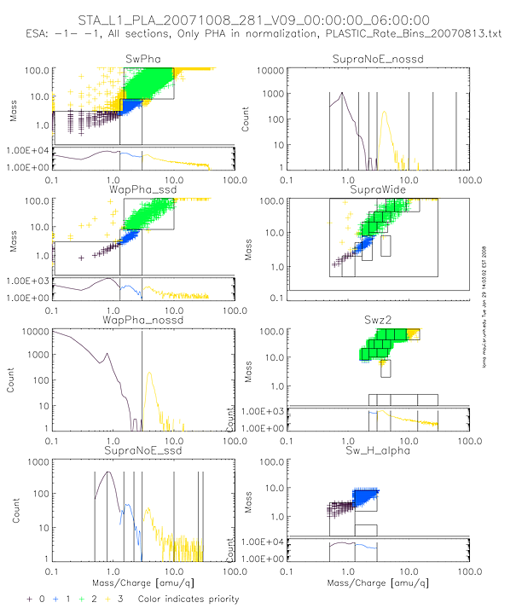

Appendix I: PHA_PLAY: Sample Classbins PlotFile

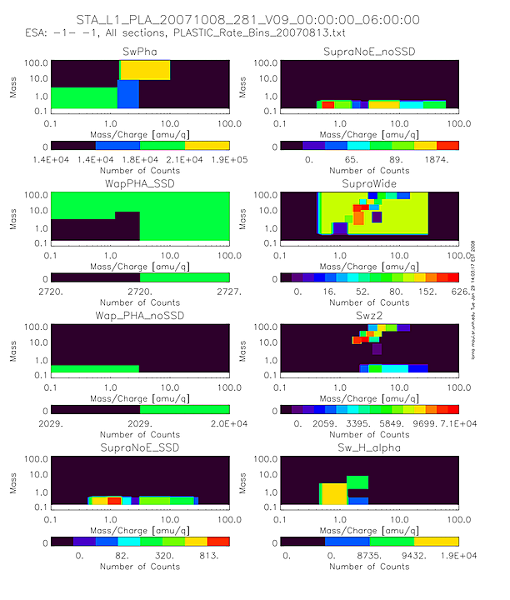

Appendix J: PHA_PLAY: Sample Normbins PlotFile

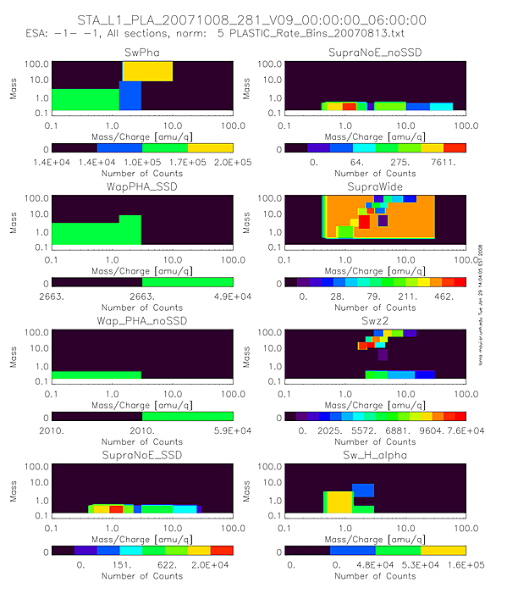

Appendix K: PHA_PLAY: Sample Histogram PlotFile

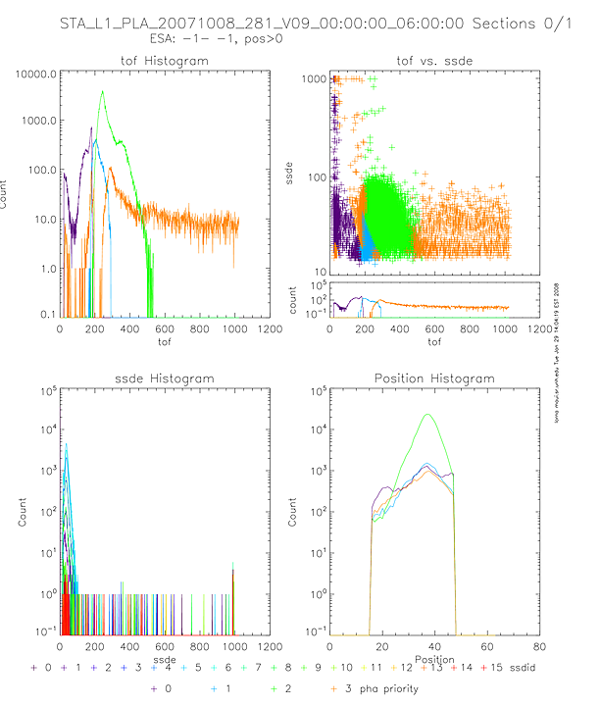

Appendix L: PHA_PLAY: Sample Cumulative Plot

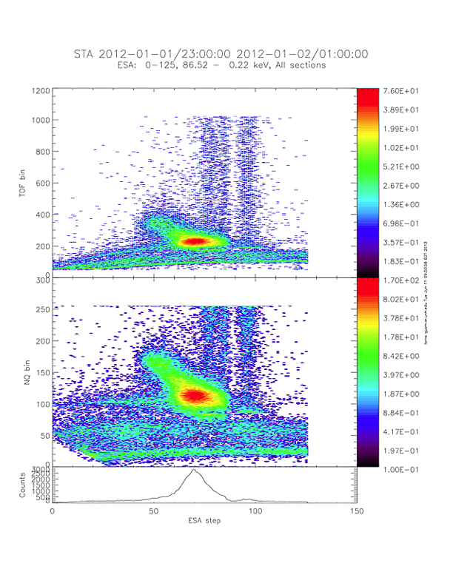

Appendix M: PHA_PLAY: Sample Normalization Error File

Statistical data for Plots/norm_error_supranoe_nossd_STB_L1_PLA_20070129_029_V09_00:00:00_06:00:00a_ for priority 0
Normalization interval: 5 Results summed over time.
ESA step | num (pha=0 rate>0) | num (pha>0 rate>0) | ratio | counts in pha | counts in rate | ratio
000/001 | 0 | 71 | 0 | 354 | 3626 | 0.09762824
002/003 | 0 | 71 | 0 | 351 | 2947 | 0.11910417
004/005 | 0 | 71 | 0 | 357 | 2659 | 0.134261
006/007 | 0 | 71 | 0 | 345 | 2206 | 0.15639166
008/009 | 0 | 71 | 0 | 350 | 1956 | 0.17893661
010/011 | 0 | 71 | 0 | 347 | 1646 | 0.21081409
012/013 | 0 | 71 | 0 | 344 | 1488 | 0.2311828
014/015 | 0 | 71 | 0 | 338 | 1267 | 0.2667719
016/017 | 0 | 71 | 0 | 330 | 1155 | 0.28571429
018/019 | 0 | 71 | 0 | 334 | 1170 | 0.28547009
020/021 | 0 | 71 | 0 | 332 | 1049 | 0.3164919
022/023 | 0 | 71 | 0 | 347 | 1179 | 0.29431722
024/025 | 0 | 71 | 0 | 307 | 1161 | 0.26442722
026/027 | 0 | 71 | 0 | 311 | 1276 | 0.24373041
028/029 | 0 | 71 | 0 | 329 | 1350 | 0.2437037
030/031 | 0 | 70 | 0 | 309 | 1595 | 0.19373041
032/033 | 0 | 70 | 0 | 311 | 1938 | 0.16047472
034/035 | 0 | 71 | 0 | 326 | 2332 | 0.13979417
036/037 | 0 | 71 | 0 | 320 | 2938 | 0.10891763
038/039 | 0 | 70 | 0 | 322 | 3736 | 0.086188437
040/041 | 0 | 70 | 0 | 314 | 4725 | 0.066455026
042/043 | 0 | 71 | 0 | 339 | 5945 | 0.057022708
044/045 | 0 | 71 | 0 | 324 | 7363 | 0.044003803
046/047 | 0 | 71 | 0 | 332 | 9436 | 0.0351844
048/049 | 1 | 70 | 0.014285714 | 309 | 11382 | 0.027148129
050/051 | 0 | 71 | 0 | 331 | 13938 | 0.023748027
052/053 | 1 | 70 | 0.014285714 | 329 | 16297 | 0.020187765
054/055 | 0 | 71 | 0 | 334 | 19692 | 0.016961203
056/057 | 0 | 71 | 0 | 318 | 22746 | 0.01398048
058/059 | 0 | 71 | 0 | 340 | 26726 | 0.012721694
060/061 | 0 | 71 | 0 | 340 | 30581 | 0.011118014
062/063 | 0 | 71 | 0 | 304 | 35489 | 0.008566035
064/065 | 0 | 71 | 0 | 330 | 39304 | 0.008396092
066/067 | 0 | 71 | 0 | 311 | 43274 | 0.007186763
068/069 | 1 | 70 | 0.014285714 | 303 | 45650 | 0.006637459
070/071 | 0 | 71 | 0 | 302 | 47530 | 0.006353882
072/073 | 1 | 70 | 0.014285714 | 302 | 49214 | 0.006136465
074/075 | 0 | 71 | 0 | 282 | 47598 | 0.005924619
076/077 | 1 | 70 | 0.014285714 | 277 | 48675 | 0.005690806
078/079 | 0 | 71 | 0 | 255 | 45840 | 0.005562827
080/081 | 2 | 69 | 0.028985507 | 238 | 43643 | 0.005453337
082/083 | 3 | 68 | 0.044117647 | 246 | 35004 | 0.007027768
084/085 | 0 | 71 | 0 | 267 | 44118 | 0.006051952
086/087 | 1 | 70 | 0.014285714 | 260 | 50490 | 0.005149535
088/089 | 1 | 70 | 0.014285714 | 267 | 45556 | 0.005860918
090/091 | 0 | 71 | 0 | 264 | 45880 | 0.005754141
092/093 | 3 | 68 | 0.044117647 | 260 | 40487 | 0.006421814
094/095 | 1 | 70 | 0.014285714 | 249 | 33789 | 0.007369262
096/097 | 0 | 71 | 0 | 247 | 28153 | 0.008773488
098/099 | 5 | 66 | 0.075757576 | 194 | 25760 | 0.007531056
100/101 | 26 | 45 | 0.57777778 | 121 | 24243 | 0.004991132
102/103 | 30 | 41 | 0.73170732 | 104 | 23451 | 0.004434779
104/105 | 18 | 53 | 0.33962264 | 122 | 27821 | 0.004385177
106/107 | 8 | 63 | 0.12698413 | 178 | 33668 | 0.005286919
108/109 | 1 | 70 | 0.014285714 | 323 | 83760 | 0.003856256
110/111 | 0 | 71 | 0 | 336 | 121840 | 0.002757715
112/113 | 0 | 71 | 0 | 353 | 218784 | 0.001613464
114/115 | 0 | 71 | 0 | 352 | 328256 | 0.001072334
116/117 | 0 | 71 | 0 | 353 | 483200 | 0.000730546
118/119 | 0 | 71 | 0 | 353 | 610240 | 0.000578461
120/121 | 0 | 71 | 0 | 355 | 684928 | 0.000518303
122/123 | 0 | 71 | 0 | 355 | 761984 | 0.000465889
124/125 | 0 | 71 | 0 | 355 | 754816 | 0.000470313
126/127 | 0 | 71 | 0 | 355 | 739456 | 0.000480083

Appendix N: PHA_PLAY: Sample Use of .tplot Files in SPLAT
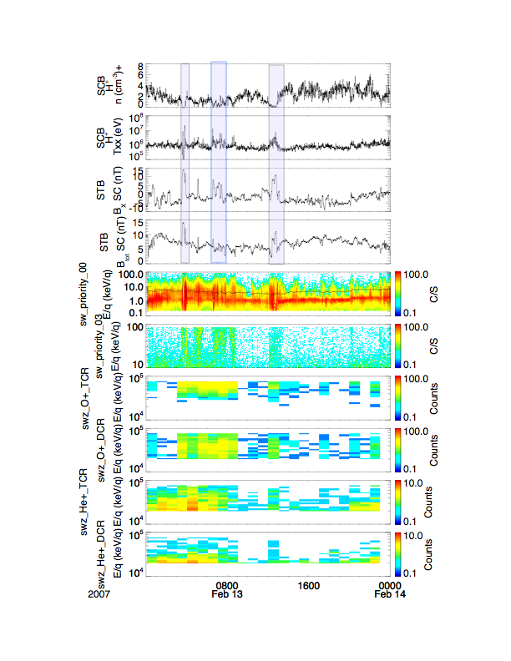

Appendix O: Conversion of On-board Moments to Physical Units
Lynn Kistler
9/28/2006

Density

The density computed onboard is converted to physical units using the following equation:

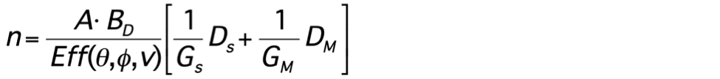

A is a constant which takes into account the stepping variables and accumulation time, and is the same for all moments. B_{D} is a constant which converts the onboard velocity tables to physical units for the particular moment, and includes any other constants specific to the particular moment required to put the moment into the desired physical units. G_{S} and G_{M} are the geometric factors of the S-channel and Main-Channel, respectively, and D_{S} and D_{M} are the uncompressed results of the on-board calculation. The derivation of the constants is given below.

The density is defined by the integration

where θ is the polar angle (deflector angle) and ϕ is the azimuthal angle (position), v is the velocity and f is the distribution function.

The distribution function at a particular point is related to the counts at that location by the equation:

where t_{acc} is the accumulation time and G_{i} is the geometric factor
where Δα, Δβ, and Δs/s (or ΔΕ/Ε) are the FWHM of the angular and velocity (or energy) transmission functions of the analyzer. The actual counts, , is related to the measured counts, , by

The density expression can then be written as:

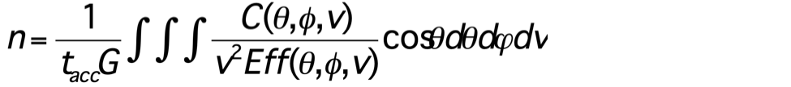

For STEREO/PLASTIC, two geometric factors are used. At high energies, the ions come through the main channel, with geometric factor Gm, while at low energies they come through the S-channel, with geometric factor Gs. Thus the integration over velocity is done in two parts, and the total density is the sum of the two parts:

where (now expressing the integral as a sum)

and

However, Δθ, Δϕ, and Δv/v, which are the size of each step, in angle and velocity, (not the intrinsic angular response of the instrument) are constant. So they can be pulled out of the sums. Ideally, the efficiency term, Eff, should be carried inside the sums. However, because the solar wind is beam-like, and focused at one velocity and angle, we can pull it out of the sum and apply it as a constant after the incoming velocity has been determined. The resulting equation (using n_{M} as the example) becomes:

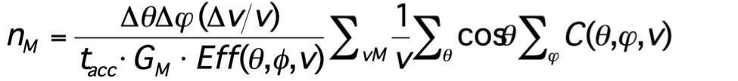

Finally, we pull out the conversion factor, B_{D}, which puts the velocity tables back into physical units.

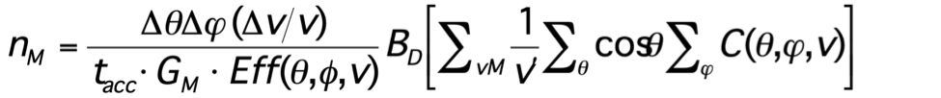

Now the quantity in brackets is the quantity, D_{M}, calculated onboard, and the rest are numbers applied on the ground.

Referring to our initial equation, we define

so the total equation is:

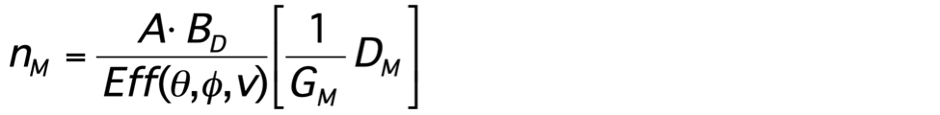

For these stepping variables:

Δθ = (20/16) =1.25 º = 0.0218 radians
Δϕ = 1.41 º=0.0246 radians
and
Δv/v = 0.049/2 = 0.0245

The moments are calculated from data products with full deflection resolution, so the accumulation time for one measurement is the time of one deflection step. This time is 12.8 ms = 12.8 E-3 s

Giving

A = ΔθΔϕ(Δv/v)/t = (0.0218)(0.0246)(0.025)/12.8E-3 = 2.46E-3 1/s

The constants for determining G for the two instruments for one position bin are given below. These constants are based on measurements of the electrostatic analyzer only over the full energy-elevation angle range. The numbers given are for the full 45 degree azimuthal angle of the solar wind sector. We then scale them to the geometric factor of one angular bin, and finally convert from differential energy, to differential velocity, Δv/v = 0.5 ΔE/E. The factors are different for the 2 instruments, and for the S-channel and Main channel

 | G ( cm2-ster-dE/E) full SW sector | G (cm2-ster-dE/E)  1 position bin 1.41 degree | G (cm2-ster-dV/V)  1 position bin  1.41 degrees
FM1 - Schannel | 6.00E-07 | 1.88E-08 | 9.40E-09
FM1 - Main Channel | 3.15E-03 | 9.87E-05 | 4.94E-05
FM2 - Schannel | 6.31E-07 | 1.98E-08 | 9.89E-09
FM2 - Main Channel | 2.52E-03 | 7.90E-05 | 3.95E-05

The on-board velocity tables need to be scaled back to physical units.

To determine the constant, B, to scale the velocity tables, the tables are based on energy, in keV, and we then take the square root to get a value proportional to velocity (column H of Plastic_Moments_Tables.xls). Thus to convert that column to km/s
V(km/s) = H*440

The value in H is then multiplied by 4000 to get the “pseudo dac” column covering a 16 bit range (column K)
V(km/s) = K*440/4000

Finally, to get the 1/V table, column K is inverted, and then shifted by 2^N0 to again put the column into a 16 bit range. Currently, N0=21. The result is in column L.

So, L = 2²¹ /K

So finally, to put the 1/V table back into s/km units, from the table (L) we get

1/V (s/km) = (L*4000/2²¹)/440.

Finally, to convert to cm, so that the density is in 1/cm^3), we need to multiply by 1E-5 km/cm. We divide the final constant into two parts so the final constant is:
B = (4000/2^21)*(1e-5/440) = 4.335E-11 (s/cm)

To just do the units conversion, without the bit shifting and normalizing
B’ = 1e-5/440 = 2.273E-8

To determine the density, the S-channel and Main channel sums need to be combined.

The efficiency is given as a function of velocity. To get a final value for the density, first calculate the velocity, as given below. Then look up the efficiency for that velocity and apply to the density.

Velocity

The velocity computed onboard is converted to physical units using the following equation:

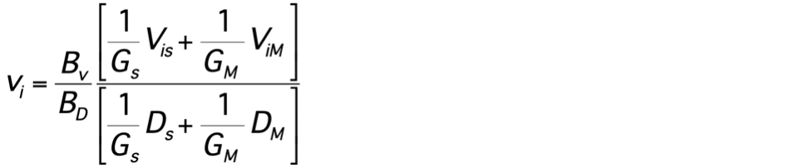

where v_{i} is either the x, y, or z components of the velocity, B_{D} is a constant which converts the onboard velocity table for density to physical units, B_{V} converts the onboard table for velocity to physical units, G_{S} and G_{M} are the geometric factors of the S-channel and Main-Channel, respectively, and V_{iS} and V_{iM} are the uncompressed results of the x, y, and z components of the on-board summations. The derivation of this expression and the constants is given below.

To convert velocity, we will use the example of Vx

where for each energy step, at a particular angle, the vx component is

The same constants pull out for n, and the v integral, so we are left with:

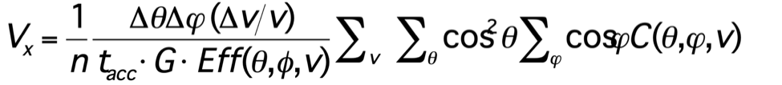

Again we define the constant A, as above to include the stepping variables and integration time. The velocity tables are just “1” in this case, bit shifted by 2^9 . Then a factor of 10e-5 is needed to convert the cm/s to km/s. So finally
B_{V} = 10e-5/2^9.

If not using the bit shifted tables, only the conversion is needed

B_{V}’ = 10e-5

We divide the expression into accumulation in the S-channel and the main channel, with V_{M} being the onboard accumulation in the main channel and V_{S} being the onboard accumulation in the S-channel. So our expression becomes:

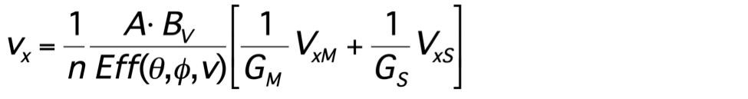

Substituting in our expression for n, the efficiency and A constants cancel, and we are left with:

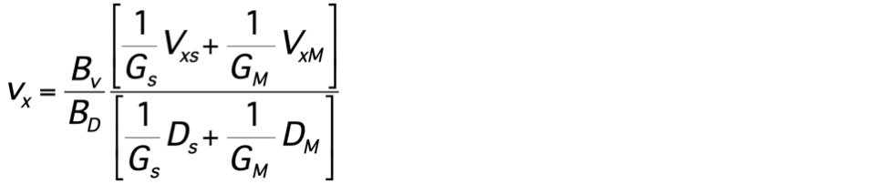

Pressure and Temperature

The pressure and temperature are derived from the momentum flux tensor which is computed onboard. To convert this tensor to physical units, we use the following equation:

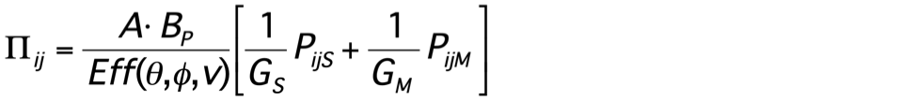

To convert the momentum flux density, Π, into pressure, P, we need to transform to the bulk velocity frame

We can then convert to temperature, using

P = nkT, where k is the Boltzmann constant, k = 1.38E-23 J/deg

This will give the temperature in degrees, K.

To convert the momentum flux tensor into physical units, we use the following equation
The formula for the momentum flux density tensor is derived as follows. As with the velocity, we will use an example of one component

and plugging in for vx, we get

Making the same substitutions for f, and converting the integral to sums gives:

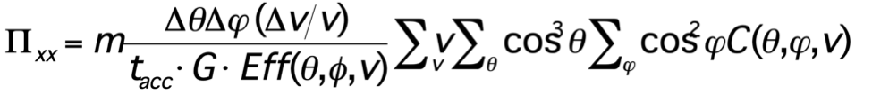
and substituting the constant A for the stepping and accumulation time variables, we get:
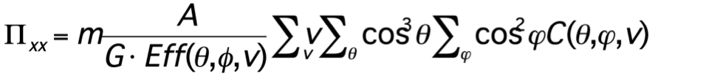

The second constant, B_{P} , contains the conversions to put the velocity tables into physical units, the mass, and the constants to convert everything to MKS units.

As discussed, the “pseudo dac” column covering a 16 bit range (column K) is related to the velocity by:

V(km/s) = K*440/4000

To get the onboard v table, column K is shifted by 2^N2. Currently, N2=-4. The result, in column N, is the velocity term used on board, v’:

So, v’ = 2⁻⁴ /K

So, to get velocity back from the table column N,

V (km/s) = v’/2⁻⁴ (440)/4000

And to put it in MKS units

V (m/s) = v’/2⁻⁴ (440km/s)/4000 *(1e3m/km)

The constant B is thus

B = [m (440km/s) *(1e3m/km)*(1E2cm/m)^2]/4000/2⁻⁴

The final conversion is to convert the cm^2 in the geometric factor constant to m^2.

Plugging in m = 1.67E-27 kg (mass of the proton), we get

B = 2.939e-20 kg m/s (cm/m)^2

The constant without the table normalization and bit shifting is:

B’ = 7.348E-18 kg m/s (cm/m)^2

Again dividing the sum into S-channel and main channel parts, we get

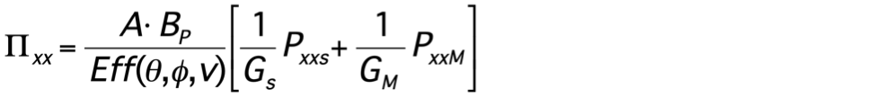

To convert the momentum flux density, Π, into pressure, P, we need to transform to the bulk velocity frame

where ρ is the mass density, ρ = mn. So, for for a particular component

making sure everything is in MKS units

Energy Flux Density and Heat Flux

The heat flux is derived from the energy flux density vector that is calculated on board. The equation for determining the energy flux density vector is

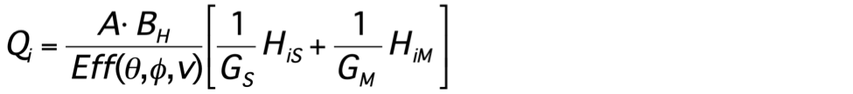

where A, Eff, G_{S} and G_{M} are defined as before, B_{H} is the specific constant for converting heat flux to physical units, and H_{iS} and H_{iM} are the results of the on-board summation. To convert this momentum flux to heat flux, the following equation is used:

Again we will use an example of one component of the vector. The x-component of the energy flux density vector is given by:

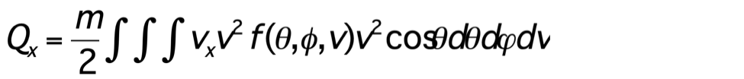
substituting in for Vx gives:
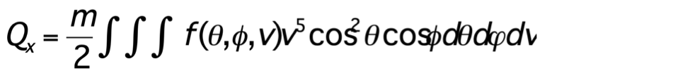

Making the usual substitutions for f, converting the integral to a sum, and pulling out the stepping constants, we get

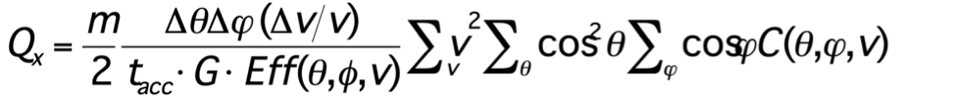

Using the constant A, as before, and defining the constant B_{H} to include the constant to convert the onboard velocity tables and the m/2 factor,

As discussed, the “pseudo dac” column covering a 16 bit range (column K) is related to the velocity by:

V(km/s) = K*440/4000

To get the onboard v table, column K is shifted by 2^N3. Currently, N3=-17. The result, in column O, is the velocity term used on board, v’:

So, v’ = 2⁻¹⁷ /K²

So, to get velocity back from the table column O,

V² (km/s) ² = v’²/2⁻¹⁷ [(440)/4000]²

And to put it in MKS units

V² (m/s) ² = v’/2⁻¹⁷ [(440km/s)/4000 *(1e3m/km)]²

The constant B is thus

B = m/2 [(440km/s) *(1e3m/km)]]² (1e2 cm/m)^2 [1/2⁻¹⁷ /4000²]
Plugging in m = 1.67E-27 kg (mass of the proton), we get

B = 1.324e-14 kg (m/s)² (cm/m)^2

The same constant without the table normalization and bit shifting is
B’ = 1.616E-12 kg (m/s)² (cm/m)^2
Letting H_{S} and H_{M} be the on-board sums over the S-channel and the main channel, we now get:

Appendix P: READ_ME_PLASTIC_He_Efficiency_Rev15

STEREO PLASTIC DAILY SUPRATHERMAL HE+ Efficiency
The detection efficiency of the PLASTIC sensor system for ions is subject to time variations, because of a slow degradation of the microchannel plates (MCP) during flight. This degradation can be partly compensated by an increase of the MCP HV supply voltage. Therefore, in order to obtain absolute fluxes, the efficiency needs to be continuously monitored during flight. To obtain this efficiency for He+ on a daily basis, the ratio of single and coincidence rates in the solar wind (SW) main channel of the PLASTIC time-of-flight system are used, at an energy just below the He+ cutoff energy. Thus, the variation of the He+ cutoff energy with solar wind speed provides the energy dependence of the He+ efficiency. For details of the sensor system, see Galvin, et al., Space Sci. Rev. 136, 2008.
The time variation and energy dependence of the efficiency, eps(t, Etot), is reconstructed using one hour averages of single and coincidence rates for 7 energy bands in total energy between 7 and 13 keV/nuc with a bandwidth of 1 keV/nuc (i.e. 7±0.5, 8±0.5, ... 13±0.5 keV/nuc). The energy Etot is computed from the post-acceleration voltage (PAC, nominally 20 KV) and for an energy of He+ corresponding to 1.8 x Vsw, where Vsw is the solar wind proton bulk velocity (i.e. an energy just below the cutoff energy of pickup He+ at 2 x V/Vsw). Thus, the variation of the He+ cutoff energy with solar wind speed provides the energy dependence of the He+ efficiency. With mass M and charge Q and energy per charge (E/Q) the total energy Etot is given by
Etot = (E/Q + PAC) *Q/M, with M=4 and Q=1 for He+.
In a first step of the procedure eps(t, Etot) is obtained on a daily basis by 11-day boxcar averages of the relevant one hour average rates. In a second step data gaps in time are interpolated by assuming an exponential decrease of the efficiency with time. The energy dependence is fitted by a 3-parameter non-linear fit with fit function
Eps(Etot) = A * (1 - exp (-B * Etot))C
that is based on pre-flight calibration measurements. The energy range of the fit is 7 to 13 keV/nuc, the efficiencies at 15 and 20 keV/nuc are obtained by extrapolation. In order to avoid unrealistically high efficiency at high energies, the extrapolation is limited to an increase of 5% between 13 and 15 keV/nuc and 15 and 20 keV/nuc, respectively.
Note: On August 19, 2014 the PLASTIC data on STEREO-A were turned off. The extended data gap in the years 2014 and 2015 (days 2788 - 3242; 2014-08-019 - 2015-11-016) is due to the solar conjunction.
File Naming convention:
STx_L3_PLA_HEEFF_RevYY .txt
Where
"STx" is given as "STA" or "STB" for STEREO A and STEREO B, respectively.
"YY" indicates the Revision number.
File Format
File Header
Line 1: processing information
Line 2: Header for 12 data columns
Line 3: energy unit (keV/nuc)
Columns:
1 Year: year of data set
2 Day: day count since January 1 2007 (=1)
3 Date: DD-MON-YY
4 - 12 Efficiency for He+, 7 - 20 keV/nuc total energy

