The STEREO / IMPACT / SEP Suprathermal Ion Telescope (SIT) CMAD
Version: 2021-05-13

Overview
The Suprathermal-Ion-Telescope (SIT) is part of the In-Situ-Measurements-of-Particles-and-CME-Transients (IMPACT) investigation on board the STEREO spacecraft. Each SIT sensor is a time-of-flight (TOF) mass spectrometer, designed to measure the ions, protons though iron, from ~20 keV/nucleon up to several MeV/nucleon in energy.
In-situ observations of solar and interplanetary energetic particles help us understand the important processes involved in the acceleration and transport of energetic particles. Since energetic particles are produced throughout the universe, these processes are relevant not only in the heliosphere but also in more exotic, astrophysical sites, where in-situ measurements are not possible.
SIT is designed to measure energetic particles produced by a wide variety of phenomena, including particles accelerated by CME driven shocks in the solar corona and in interplanetary space, solar flares, and corotating interaction regions (CIRS). Because the shocks associated with CMEs are often quite weak at 1 AU, the energy spectra produced by these shocks are usually soft and do not extend into the MeV energy range. The large geometry factor (0.29 cm2 sr) and low energy response of SIT, therefore, makes it well suited for observing energetic particles produced locally by these events.

Heritage
SIT has good mass resolution which allows the composition of the particles to be measured, thus helping to determine the source population of the particles. Composition measurements, for instance, are useful in distinguishing particles that are accelerated in the corona, in interplanetary space, or at the site of solar flares. The SIT sensor is nearly identical to the Supra-Thermal-through-Energetic-Particle (STEP) sensors on board the WIND spacecraft (von Rosenvinge et al., Space. Sci. Rev., 71, 155, 1995); however, the electronics and on-board data processing design were redone for SIT to make full use of the capabilities of the STEREO mission.
The SIT instrument is described in detail in a Space Science Reviews paper by Mason et al. (2008).

Product Description
The SIT instrument produces four types of data packets: (1) rate packets, (2) PHA packets, (3) Beacon packets, and (4) Housekeeping. The packets are telemetered once per 60 s.
The SIT Level 1 and Level 2 data are energetic particle intensities [1/(cm^2 s sr MeV/nucleon)] for 4 species (H, 4He, O, and Fe), in ~10 energy-bins per species.
The highest time-resolution data provided by SIT is 1 minute. The 1-minute data (Level 1 data) are in ASCII text files, with each file containing one day of data, for one species, for one spacecraft (ahead or behind). The 10-minute data (Level 2) are also in ASCII text files, with each file containing one month of data, and hourly-averaged and daily-averaged files with each file containing one calendar year of data. Each ASCII file begins with a header that provides version and other provenance information, and describes each data field. The ASCII files can be found on the Caltech website: http://www.srl.caltech.edu/STEREO/Public/SIT_public.html
The SIT 1-minute data are also available in CDF format, from the STEREO IMPACT Data portal at Berkeley: http://stereo.ssl.berkeley.edu/L1_data.html and from CDAWeb.
The Berkeley CDF files are generated using on-board lookup tables. For the periods through 4/20/2011 for SIT-A, and 5/5/2011 for SIT-B, the files at the Caltech site use pulse-height data and therefore have a more accurate calibration but sometimes lower statistical accuracy; after these dates the Caltech site also uses on-board lookup tables.
The SIT design, calibration and operation are described in detail in the Space Science Reviews paper by Mason et al. (2008).
Other potentially useful SIT and SEP-suite docs can be found at:
http://www.srl.caltech.edu/STEREO/docs/index.html

Theoretical Description

Instrument overview
Figure 1 shows a schematic diagram of a SIT sensor. There is one SIT sensor on board each of the two STEREO spacecraft. A Valid Event is produced when an energetic ion passes through the front foil of the telescope. Secondary electrons, produced by the foil, are electrostatically directed into the “Start” multi-channel plate (MCP). The signal from the Start MCP provides the trigger for the time-to-amplitude-converter (TAC) electronics. Meanwhile, the energetic ion traverses the telescope and hits the solid-state-detector (SSD) at the back. In the energy range measured by SIT, the ions are stopped by the SSD, and, consequently, the kinetic energy is completely absorbed in the detector. In addition, when the incident ion strikes the SSD, it liberates more secondary electrons, which are then electrostatically directed into the “Stop” MCP. The signal from the Stop MCP provides the necessary coincidence for the TAC to measure the time-of-flight (TOF) of the ion.
By measuring the TOF from the TAC and the total kinetic energy from the SSD, the atomic mass and kinetic energy per nucleon of the incident ion is then determined (after energy loss corrections in the front foil and the SSD detector window) using the familiar equation for the kinetic energy
(1)
Here E is the total kinetic energy from the SSD, m is the atomic mass of the ion, and v is the speed of the Ion. Solving equation (1) for m, and inserting constants including the 10 cm flight path, we have
(2)
where m is in AMU, E is the detector energy deposit in MeV, and T is the time-of-flight in ns. The constant 0.021 is based on a fits to a detailed (SITMR) calculation for Oxygen, and is approximately correct over a wide range of values but yields low masses for heavy ions and long times of flight.

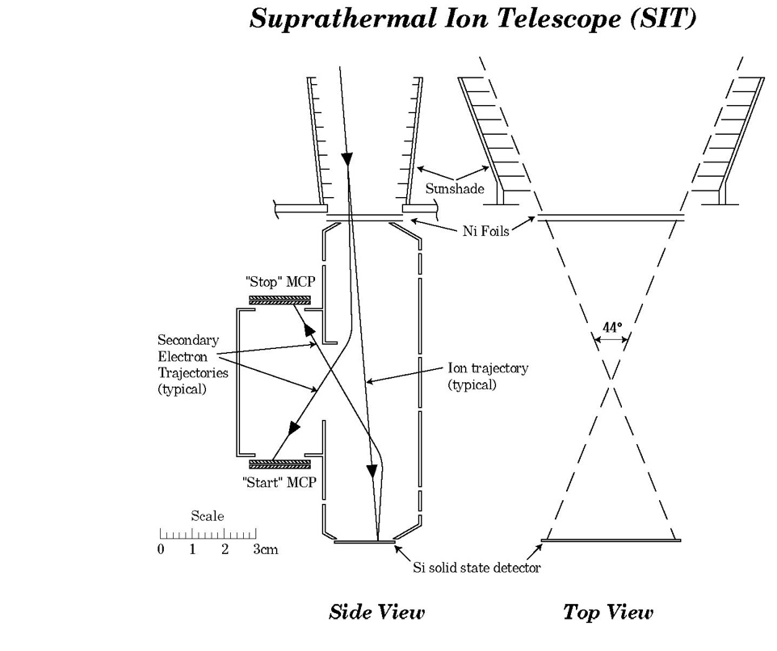
Figure 1. Schematic diagram of the Suprathermal-Ion-Telescope (SIT) sensor.

Instrument Performance
As can be seen in equation (2), when E is plotted versus T on a log-log scale, the various atomic species organize themselves along straight tracks with slopes of -2 and offsets given by the atomic masses. This can be seen in 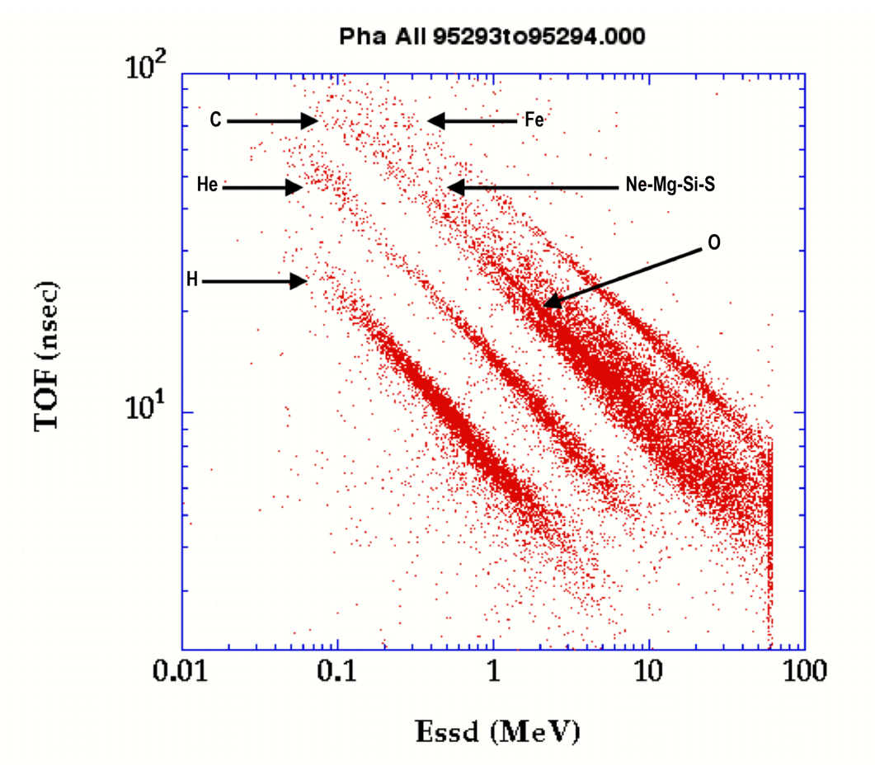Figure 2, which slows pulse height analysis (PHA) data from the WIND/STEP sensors. The figure shows the TOF, measured in nsec, versus the total kinetic energy, measured in MeV. Each point represents the measurement of one solar energetic particle ion during the October 1995 event. As can be seen in the figure, the major species, p, He, C, O and Fe form distinct and well resolved tracks. The species Ne is partially resolved, and Mg, Si and S cannot be completely resolved by the instrument and are measured together as a group.

Error Analysis and Corrections
Based upon over five years of interplanetary data from WIND/STEP, we have found that the Valid Event rate almost never rises above 1000 counts/second. Even large SEP events such as the November 1997 event only produce Valid Event rates of a few hundred per second. Furthermore, because of the geometry factor of the front foil and the low efficiency for measuring protons and helium, the Start MCP singles rate is typically about 300 times higher than Valid Event rate. We have found that with STEP, for Start rates higher than about 100,000 counts/second, the gain on the Start MCP drops, thus reducing the efficiency for measuring the low Z species. We, therefore, consider 1000 counts/second to be an upper limit on the Valid Event rate for SIT. Correspondingly, the Start MCP singles rate will be less than about 300,000 Hz. The other singles rates, e.g. the Stop MCP and SSD rates, will be less than the Start rate.
Figure 2. TOF versus the total kinetic energy for solar energetic particles, measured during the October 1995 event. The pulse height analysis (PHA) data are from the WIND/STEP sensors. The SIT Essd values will extend up to about 160 MeV, considerably higher than in this figure.

Species are identified on board the spacecraft using lookup tables. Over the course of the mission, the table accuracy has been improved, and new tables uploaded to the spacecraft. Knowledge of the instrument efficiencies (primarily for H and He) has improved, and is used in reprocessing data on the ground.
Some caveats about SIT data:
- 1-sigma errors for each rate due to counting statistics can be computed using the number of counts used for each rate bin, which are listed in the files. Counting statistics generally dominate the intensity uncertainties.
- In periods of very high intensity, e.g., comparable to the July 2000 “Bastille Day” event, or the 2003 “Halloween events”, saturation in instrument electronics may result in inaccurate intensities; these effects almost always result in producing intensities that are lower than the actual intensities.
- For H and He, the efficiency of detection is <100%, and may vary in time due to exposure of the instrument to radiation. If changes in the efficiency are detected, the intensities will be re-calculated and new Level 1 files posted. Since detection of efficiency changes requires detailed comparison with other instruments, these changes may be several months, or even longer, after the data are collected. When such updates are done, the data affected will be posted in future version of the data release notes.
- Because of SIT’s low and possibly varying detection efficiency for H, is recommended that users use SEPT level-1 data for H intensities.
- SIT-A intensities are calculated with pulse-height data through 4/20/2011; after this date, onboard lookup tables are used, which increases statistical accuracy in intense periods.
- SIT-B intensities are calculated with pulse-height data through 5/10/2011; after this date, onboard lookup tables are used, which increases statistical accuracy in intense periods.
- BACKGROUND DURING QUIET PERIODS:
  - Above ~1 MeV/nucleon all intensities are likely dominated by background during quiet periods. During modest intensity increases it is strongly recommended to see if hourly rates show an increase from background before including those rates in, e.g., spectral calculations.
  - Background events in the telescopes produce background counts in the following boxes during quiet periods:
Species | SIT-A energy ranges affected (MeV/nucleon) | SIT-B energy ranges affected (MeV/nucleon)
H | 0.91-1.81 | 0.64-1.81
4He | 0.16 - 0.226  0.64 - 1.81 | 0.64 - 1.81
O | 0.16 - 0.32  0.64 - 2.56 | 0.64 - 1.81
Fe | 0.16 - 0.32  0.64 - 2.56 | 0.45 - 2.56

Calibration and Validation
The SIT Level 1 and Level 2 data products are cross-checked among members of the instrument team for validity before posting for public consumption. The specifics of how the intensities are computed are given in the following subsections.

Computation with Matrix Rates
Particle intensities corresponding to individual Matrix Rate (MR) boxes are easily calculated from ground received data since the MISC processor is fast enough to process all events entering the telescope. For a single readout of Matrix Rate j (=MR_{j}), the particle intensity, I_{j}, is given by
(3)
where T is the collection time (60 s), AΩ is the geometry factor (0.29 cm² sr), ε is the efficiency for this species and energy, and ΔE is the energy interval covered by this MR box in MeV/nucleon. MR_corr_{j} is a correction factor (Table 1) for each box that takes account of the difference between boxes defined by the PHA data and by the on-board lookup processing; this correction arises due to the lower resolution of the on-board processing and is derived post-launch by comparing the pha-derived intensities with the rom-box derived intensities.
In equation (3) the ΔE is calculated for each box from the minimum and maximum energies in Table 1: ΔE = Emax - Emin. Efficiencies are determined post launch and change as the MCPs age, and so are not given here. For C and heavier elements, the efficiencies are usually ~1, but for H and He they can be small.
Table 1 lists the Matrix Rate boxes, showing the species and energy intervals available, and the correction factors MR_corr_{j}. Rates whose efficiencies are set < 0, or rates whose boxes have no counts, have their correction factor set = 1.0. These corrections are made only for dates after the lookup tables generated in the spring of 2011; the start dates for the correction are the first full days after the table loads:
SIT-A: April 21, 2011 0:00 (DOY = 111.0; MJD = 55672.0 and higher)
SIT-B: May 6, 2011 0:00 (DOY = 126.0; MJD = 55687.0 and higher)
Table 1 notes:
- 'Pri 0' = sum of all counts with priority 0
- 'Pri 1' = sum of all counts with priority 1
- 'Hi ramp' = count rate of particles in high gain (gain bit = 0) range
- 'Lo ramp' = count rate of particles in low gain (gain bit = 1) range
- 'discarded' = sum of counts discarded due to FIFO full + counts left in FIFO at end of 60s processing period (when interrupt occurs)
- 'out bnds' = events whose SSD or tof channel number is outside the low or high channel limits; OR whose computed f_e or f_m value is outside the limits of the input array (1-128 for both variables)
- 'Junk' = sum of all counts with ‘junk’ box (#7)
Table 1. Matrix rate assignments and correction factors
Matrix  Rate  Box  No. | sit_  lister  index  No. | UCB  L1  Flux  No. | title or element | Emin | Emax | Mass min | Mass max | SIT-A  M_corr | SIT-B  M_corr | Pri  (0 = low)
1 | 0 | -- | 'Pri 0' | 0 | 0 | 0 | 0 | -- | --
2 | 1 | -- | 'Pri 1' | 0 | 0 | 0 | 0 | -- | --
3 | 2 | -- | 'Hi ramp' | 0 | 0 | 0 | 0 | -- | --
4 | 3 | -- | 'Lo ramp' | 0 | 0 | 0 | 0 | -- | --
5 | 4 | -- | 'discard' | 0 | 0 | 0 | 0 | -- | --
6 | 5 | -- | 'out bnds' | 0 | 0 | 0 | 0 | -- | --
7 | 6 | -- | 'Junk' | 0 | 0 | 0 | 0 | -- | --
8 | 7 | 1 | 'H' | 0.1600 | 0.2263 | 0.5 | 2.3 | 1.0000 | 1.0000 | 0
9 | 8 | 2 | 'H' | 0.2263 | 0.3200 | 0.5 | 2.3 | 1.0000 | 1.0000 | 0
10 | 9 | 3 | 'H' | 0.3200 | 0.4525 | 0.5 | 2.3 | 1.0466 | 0.90980 | 0
11 | 10 | 4 | 'H' | 0.4525 | 0.6400 | 0.5 | 2.3 | 1.0386 | 1.1459 | 0
12 | 11 | 5 | 'H' | 0.6400 | 0.9051 | 0.5 | 2.3 | 0.90860 | 0.96630 | 0
13 | 12 | 6 | 'H' | 0.9051 | 1.2800 | 0.5 | 2.3 | 1.5181 | 1.1865 | 0
14 | 13 | 7 | 'H' | 1.2800 | 1.8102 | 0.5 | 2.3 | 0.79390 | 0.71210 | 0
15 | 14 | 8 | 'H' | 1.8102 | 2.5600 | 0.5 | 2.4 | 0.69100 | 0.92480 | 0
16 | 15 | 9 | 'H' | 2.5600 | 3.6204 | 0.5 | 2.8 | 1.5610 | 0.95120 | 0
17 | 16 | 10 | 'H' | 3.6204 | 5.1200 | 0.5 | 3.1 | 1.0097 | 0.69410 | 0
18 | 17 | 11 | 'H' | 5.1200 | 7.2408 | 0.5 | 2.5 | 0.79960 | 0.77250 | 0
19 | 18 | 12 | 'H' | 7.2408 | 10.2400 | 0.5 | 2.0 | 0.75400 | 0.74390 | 0
20 | 19 | 13 | '3He' | 0.1600 | 0.2263 | 2.3 | 3.0 | 1.6936 | 3.3004 | 0
21 | 20 | 14 | '3He' | 0.2263 | 0.3200 | 2.3 | 3.0 | 1.4716 | 3.1633 | 0
22 | 21 | 15 | '3He' | 0.3200 | 0.4525 | 2.3 | 3.0 | 1.6204 | 2.7040 | 0
23 | 22 | 16 | '3He' | 0.4525 | 0.6400 | 2.3 | 3.0 | 1.6085 | 2.7269 | 0
24 | 23 | 17 | '3He' | 0.6400 | 0.9051 | 2.3 | 3.0 | 1.6631 | 3.0154 | 0
25 | 24 | 18 | '3He' | 0.9051 | 1.2800 | 2.3 | 3.0 | 2.1640 | 3.8545 | 0
26 | 25 | 19 | '3He' | 1.2800 | 1.8102 | 2.3 | 2.3 | 1.0000 | 1.0000 | 0
27 | 26 | 20 | '3He' | 1.8102 | 2.5600 | 2.4 | 2.4 | 1.0000 | 1.0000 | 0
28 | 27 | 21 | '3He' | 2.5600 | 3.6204 | 2.8 | 2.8 | 1.0000 | 1.0000 | 0
29 | 28 | 22 | '3He' | 3.6204 | 5.1200 | 3.1 | 3.1 | 1.0000 | 1.0000 | 0
30 | 29 | 23 | '4He' | 0.0400 | 0.0566 | 3.0 | 8.0 | 1.0000 | 1.0000 | 0
31 | 30 | 24 | '4He' | 0.0566 | 0.0800 | 3.0 | 8.0 | 1.0000 | 1.0000 | 0
32 | 31 | 25 | '4He' | 0.0800 | 0.1131 | 3.0 | 8.0 | 1.0000 | 1.0523 | 0
33 | 32 | 26 | '4He' | 0.1131 | 0.1600 | 3.0 | 8.0 | 1.1719 | 0.81800 | 0
34 | 33 | 27 | '4He' | 0.1600 | 0.2263 | 3.0 | 8.0 | 0.93080 | 0.82470 | 0
35 | 34 | 28 | '4He' | 0.2263 | 0.3200 | 3.0 | 8.0 | 0.95700 | 0.77610 | 0
36 | 35 | 29 | '4He' | 0.3200 | 0.4525 | 3.0 | 8.0 | 0.98320 | 0.67490 | 0
37 | 36 | 30 | '4He' | 0.4525 | 0.6400 | 3.0 | 8.0 | 0.93800 | 0.85690 | 0
38 | 37 | 31 | '4He' | 0.6400 | 0.9051 | 3.0 | 8.0 | 0.80200 | 0.78480 | 0
39 | 38 | 32 | '4He' | 0.9051 | 1.2800 | 2.5 | 8.0 | 1.3675 | 1.0017 | 0
40 | 39 | 33 | '4He' | 1.2800 | 1.8102 | 2.3 | 8.0 | 0.82850 | 0.64690 | 0
41 | 40 | 34 | '4He' | 1.8102 | 2.5600 | 2.4 | 8.0 | 0.71980 | 0.80380 | 0
42 | 41 | 35 | '4He' | 2.5600 | 3.6204 | 2.8 | 8.0 | 1.5747 | 0.73480 | 0
43 | 42 | 36 | '4He' | 3.6204 | 5.1200 | 3.1 | 8.0 | 0.78520 | 0.69960 | 0
44 | 43 | 37 | '4He' | 5.1200 | 7.2408 | 2.5 | 8.0 | 0.88260 | 0.65780 | 0
45 | 44 | 38 | '4He' | 7.2408 | 10.2400 | 2.0 | 8.0 | 0.82920 | 0.45570 | 0
46 | 45 | 39 | 'C' | 0.0283 | 0.0400 | 10 | 13 | 1.0000 | 1.0000 | 1
47 | 46 | 40 | 'C' | 0.0400 | 0.0566 | 10 | 13 | 1.0000 | 1.0000 | 1
48 | 47 | 41 | 'C' | 0.0566 | 0.0800 | 10 | 13 | 0.97870 | 1.0000 | 1
49 | 48 | 42 | 'C' | 0.0800 | 0.1131 | 10 | 13 | 1.0475 | 1.0000 | 1
50 | 49 | 43 | 'C' | 0.1131 | 0.1600 | 10 | 13 | 1.0942 | 1.0000 | 1
51 | 50 | 44 | 'C' | 0.1600 | 0.2263 | 10 | 13 | 0.89160 | 1.0000 | 1
52 | 51 | 45 | 'C' | 0.2263 | 0.3200 | 10 | 13 | 0.97050 | 0.92270 | 1
53 | 52 | 46 | 'C' | 0.3200 | 0.4525 | 10 | 13 | 0.84970 | 0.76110 | 1
54 | 53 | 47 | 'C' | 0.4525 | 0.6400 | 10 | 13 | 0.92570 | 0.79950 | 1
55 | 54 | 48 | 'C' | 0.6400 | 0.9051 | 10 | 13 | 0.89910 | 0.84580 | 1
56 | 55 | 49 | 'C' | 0.9051 | 1.2800 | 10 | 14 | 0.85380 | 0.65760 | 1
57 | 56 | 50 | 'C' | 1.2800 | 1.8102 | 10 | 14 | 0.85420 | 0.62870 | 1
58 | 57 | 51 | 'C' | 1.8102 | 2.5600 | 10 | 14 | 0.58630 | 0.72440 | 1
59 | 58 | 52 | 'C' | 2.5600 | 3.6204 | 10 | 14 | 0.85120 | 0.67620 | 1
60 | 59 | 53 | 'C' | 3.6204 | 5.1200 | 10 | 13 | 0.97260 | 0.57060 | 1
61 | 60 | 54 | 'C' | 5.1200 | 7.2408 | 10 | 13 | 0.73650 | 1.3753 | 1
62 | 61 | 55 | 'C' | 7.2408 | 10.2400 | 10 | 13 | 0.62330 | 0.043300 | 1
63 | 62 | 56 | 'O' | 0.0400 | 0.0566 | 13 | 19 | 1.0000 | 1.0000 | 1
64 | 63 | 57 | 'O' | 0.0566 | 0.0800 | 13 | 19 | 0.98370 | 1.0431 | 1
65 | 64 | 58 | 'O' | 0.0800 | 0.1131 | 13 | 19 | 0.99920 | 1.0000 | 1
66 | 65 | 59 | 'O' | 0.1131 | 0.1600 | 13 | 19 | 1.1234 | 1.1579 | 1
67 | 66 | 60 | 'O' | 0.1600 | 0.2263 | 13 | 19 | 1.0453 | 1.1578 | 1
68 | 67 | 61 | 'O' | 0.2263 | 0.3200 | 13 | 20 | 1.0138 | 1.1401 | 1
69 | 68 | 62 | 'O' | 0.3200 | 0.4525 | 13 | 20 | 0.99030 | 1.0402 | 1
70 | 69 | 63 | 'O' | 0.4525 | 0.6400 | 13 | 20 | 1.0910 | 1.1320 | 1
71 | 70 | 64 | 'O' | 0.6400 | 0.9051 | 13 | 20 | 1.0563 | 0.99980 | 1
72 | 71 | 65 | 'O' | 0.9051 | 1.2800 | 14 | 21 | 1.2080 | 0.96460 | 1
73 | 72 | 66 | 'O' | 1.2800 | 1.8102 | 14 | 21 | 0.93850 | 0.94050 | 1
74 | 73 | 67 | 'O' | 1.8102 | 2.5600 | 14 | 21 | 0.95010 | 1.3626 | 1
75 | 74 | 68 | 'O' | 2.5600 | 3.6204 | 14 | 20 | 0.98000 | 0.80310 | 1
76 | 75 | 69 | 'O' | 3.6204 | 5.1200 | 13 | 20 | 0.93700 | 0.95720 | 1
77 | 76 | 70 | 'O' | 5.1200 | 7.2408 | 13 | 19 | 0.96790 | 1.0977 | 1
78 | 77 | 71 | 'O' | 7.2408 | 10.2400 | 13 | 19 | 0.92620 | 0.27000 | 1
79 | 78 | 72 | 'NeS' | 0.0400 | 0.0566 | 19 | 36 | 0.97950 | 1.0232 | 1
80 | 79 | 73 | 'NeS' | 0.0566 | 0.0800 | 19 | 36 | 0.99440 | 1.0537 | 1
81 | 80 | 74 | 'NeS' | 0.0800 | 0.1131 | 19 | 36 | 1.0452 | 1.1453 | 1
82 | 81 | 75 | 'NeS' | 0.1131 | 0.1600 | 19 | 36 | 1.0994 | 1.1549 | 1
83 | 82 | 76 | 'NeS' | 0.1600 | 0.2263 | 19 | 36 | 0.96500 | 1.2539 | 1
84 | 83 | 77 | 'NeS' | 0.2263 | 0.3200 | 20 | 36 | 1.0903 | 1.2928 | 1
85 | 84 | 78 | 'NeS' | 0.3200 | 0.4525 | 20 | 36 | 1.1164 | 1.1063 | 1
86 | 85 | 79 | 'NeS' | 0.4525 | 0.6400 | 20 | 36 | 1.3418 | 1.2057 | 1
87 | 86 | 80 | 'NeS' | 0.6400 | 0.9051 | 20 | 36 | 1.0212 | 1.3710 | 1
88 | 87 | 81 | 'NeS' | 0.9051 | 1.2800 | 21 | 36 | 1.5990 | 1.2786 | 1
89 | 88 | 82 | 'NeS' | 1.2800 | 1.8102 | 21 | 36 | 1.4020 | 1.3561 | 1
90 | 89 | 83 | 'NeS' | 1.8102 | 2.5600 | 21 | 36 | 1.3633 | 1.7529 | 1
91 | 90 | 84 | 'NeS' | 2.5600 | 3.6204 | 20 | 36 | 1.1961 | 0.96870 | 1
92 | 91 | 85 | 'NeS' | 3.6204 | 5.1200 | 20 | 36 | 1.2926 | 1.1125 | 1
93 | 92 | 86 | 'NeS' | 5.1200 | 7.2408 | 19 | 36 | 0.95080 | 1.7793 | 1
94 | 93 | 87 | 'NeS' | 7.2408 | 10.2400 | 19 | 36 | 1.3099 | 0.50780 | 1
95 | 94 | 88 | 'Fe' | 0.0283 | 0.0400 | 36 | 80 | 1.0526 | 0.96730 | 1
96 | 95 | 89 | 'Fe' | 0.0400 | 0.0566 | 36 | 80 | 1.0123 | 1.0200 | 1
97 | 96 | 90 | 'Fe' | 0.0566 | 0.0800 | 36 | 80 | 1.0370 | 1.1578 | 1
98 | 97 | 91 | 'Fe' | 0.0800 | 0.1131 | 36 | 80 | 1.0064 | 1.1376 | 1
99 | 98 | 92 | 'Fe' | 0.1131 | 0.1600 | 36 | 80 | 1.0991 | 1.0781 | 1
100 | 99 | 93 | 'Fe' | 0.1600 | 0.2263 | 36 | 80 | 1.0224 | 1.0993 | 1
101 | 100 | 94 | 'Fe' | 0.2263 | 0.3200 | 36 | 80 | 1.2038 | 1.1435 | 1
102 | 101 | 95 | 'Fe' | 0.3200 | 0.4525 | 36 | 80 | 1.1341 | 1.0727 | 1
103 | 102 | 96 | 'Fe' | 0.4525 | 0.6400 | 36 | 80 | 1.1813 | 1.1859 | 1
104 | 103 | 97 | 'Fe' | 0.6400 | 0.9051 | 36 | 80 | 1.0283 | 1.2135 | 1
105 | 104 | 98 | 'Fe' | 0.9051 | 1.2800 | 36 | 80 | 1.4655 | 1.2921 | 1
106 | 105 | 99 | 'Fe' | 1.2800 | 1.8102 | 36 | 80 | 1.1977 | 1.3582 | 1
107 | 106 | 100 | 'Fe' | 1.8102 | 2.5600 | 36 | 80 | 1.2602 | 1.7463 | 1
108 | 107 | 101 | 'Fe' | 2.5600 | 3.6204 | 36 | 80 | 1.3843 | 1.0551 | 1
109 | 108 | 102 | 'UH' | 0.04 | 0.0800 | 80 | 180 | 1.0600 | 1.1491 | 0
110 | 109 | 103 | 'UH' | 0.08 | 0.1600 | 80 | 180 | 1.1526 | 1.5352 | 0
111 | 110 | 104 | 'UH' | 0.16 | 0.3200 | 80 | 180 | 1.1142 | 1.4574 | 0
112 | 111 | 105 | 'UH' | 0.32 | 0.6400 | 80 | 180 | 1.6851 | 2.0170 | 0
113 | 112 | 106 | 'UH' | 0.64 | 1.2800 | 80 | 180 | 1.3259 | 1.7929 | 0
114 | 113 | 107 | 'UH' | 1.28 | 2.5600 | 80 | 180 | 1.0858 | 0.55780 | 0
115 | 114 | -- | 'bkgd' | 0.06 | 0.5000 | 180 | 400 | 1.2075 | 1.6326 | 0
116 | 115 | -- | 'bkgd' | 0.5 | 3.0000 | 180 | 400 | 2.6636 | 0.43770 | 0
Limitations on use of Matrix Rate data:
- The Matrix Rate binning algorithm loaded at launch had significant inaccuracies due to the switch out of solid state detectors late in the development of SIT. New tables were loaded 3/14/2007 which mostly corrected this problem. After that, the tables were updated several times with smaller changes. The higher energy calibration of the Matrix Rate tables was not completed until solar particle events occurred in 2010 and 2011 with sufficient high energy particles to identify track locations and compare with the STEREO/LET sensor. Tables based on these fully populated matrix tracks were uploaded to SIT-A on 4/20/2011 and SIT-B on 5/5/2011.
- The adjustment for matrix boxes with the MR_corr_{j} term in equation (3) was derived for the boxes in the 2011 table loads, and is applied only after that upload.

Computation with pulse-height data
In addition to intensities calculated using individual Matrix Rate boxes, particle intensities can be constructed with much greater energy and mass resolution (but also with smaller statistics) using the PHA event data. In this calculation, the Matrix Rate boxes are used to compute an overall normalization to take into account the effects of PHA sampling. Equation (4) gives the formula for calculating the particle intensity, I_{j} for a single 60 s interval corresponding to an arbitrary area of the time vs. energy matrix data from SIT (i.e. an area in the t vs E plane shown in Figure 2. The coefficient is the same as equation (3), N_{0j} is the number of PHA events with priority 0 in this area in the matrix, and N_{1j} is the number of PHA events with priority 1 in this area in the matrix. N₀ and N₁ are the number of PHA events of priority 0 and 1 in the entire matrix. For all events, whether they fall in rate boxes or not, it is critical to use the priority assigned by the on-board processor, since that determined how they were handled in the storage buffer. Finally, MR1 and MR2 are the total number of counts of priority 0 and 1, respectively (Table 1).
(4)
Note that in many cases, an intensity calculated with equation (4) will correspond to an area of the PHA matrix that has only priority 0 or priority 1 events – in this case only one term in the parenthesis in equation (4) will contribute. If the selected area in the t vs E crosses a priority boundary then both terms must be used.
Both equations (3) and (4) give the formulas for calculating intensities from a single 60 second period, with the Matrix Rate rates from that period’s rate packet, and the PHA summations taken from the PHA packets of the same period. Longer term averages are built up simply by averaging a succession of individual intensity calculations.
Limitations on Pulse-Height derived intensities:
- If the JUNK command bit is set = 1, PHA events whose look-up does not find a defined box are telemetered (otherwise they are not). These events have a ROM box = 0, as opposed to “junk” events (ROM box 7) which fall in the defined matrix but are not on a track. Most ROM box = 0 events have small time-of-flight channel number, and they are telemetered only for engineering purposes. If computing intensities with equation (4) it is important to skip events with ROM box = 0, since they are not counted in the matrix rates used to normalize the expression. Thus, only events with ROM box numbers 7-116 should be used in equation (4). So far in the mission, JUNK has been set = 1 for only a test period in Feb-March 2007.
(2) Equation (4) may be yield fluctuations due to small statistics in the various terms.

SIT Data Processing
The following is taken from the SIT Lister Description document which is time-stamped 09/08/2015. It describes the data processing for SIT.
FILE NAME: sit_lister_description_09_08_2015.docx

SIT_LISTER is started by compiling & running in the usual manner from the terminal application (see below)

SIT_LISTER uses 3 control files:

1) sit_lister_cfg.dat specifies the outputs
2) sit_lister_times.dat specifies the time periods to be analyzed
3) sit_lister_paths.dat specifies locations of input data files and paths

The first 2 are typically changed from one run to the next, and are read from the same input folder; the 3rd is usually left unchanged and is in a separately defined folder.

CONTROL FILE LOCATIONS:

The “cfg” and “times” file are read from the same folder. There are two ways of specifying this folder:

1) default location, which can be changed by modifying the appropriate line in the procedure SDF_LISTER.PRO

2) folder name passed to the program as a string when running it, e.g.,
IDL>sit_lister,'/Users/masongm1/Data/Production/STEREO/daily_a/'

3) The “path names” file contains the paths to the STEREO SIT and EPHEMERIS data folder, and the various calibration and specification files for SIT and the SEP BEACON data. Normally the contents of this file are not changed from run to run. In the current code, the “paths” file is located in the “PATHS” folder at the top level of the Mac hard drive; the address is
'/paths/sit_lister_paths.txt'
This location would be changed by modifying the appropriate line in the procedure READ_PATHS.PRO.
sit_lister_cfg.dat description
sit_lister reads the first 8 lines of this file -- others are ignored. The first, 3rd, 5th, and 7th lines are header cards that contain information about the parameters on the following line. The content of the header card lines is ignored by sit_lister.
1) header line (contents ignored)
2) output folder name:

Output_file_path | String containing the name of the folder or directory where the output files will be written

3) header line (contents ignored)
4) spacecraft_id, avg_int, type_out, run_checks, error_limit, bkgd_correction_on
spacecraft_id | 0: program analyzes SIT-A  1: program analyzes SIT-B
avg_int | Minutes of averaging interval (see notes)
type_out | 0 = output units are intensity (/s cm2 sr MeV/n)  1 = output units are fluence (/cm2 sr MeV/n)  2 = output units are counts
run_checks, | 0 = no checks run  1 = check following quantities: matrix box for each PHA event; packet checksums; flight software version number; flight lookup table checksum; will print out a message for each error encountered
error_limit | X: spectral points will be written out only if the point has a sigma/value of < X; to write out all points, set X>1
bkgd_correction_on | 0: no correction  1: spectra have background subtracted as specified in the files pointed to in sit_lister_paths.txt

notes:
avg_int: sit_lister averaging intervals begin at 0:00 UT each day. A result will be written out each avg_int minutes of clock time, and the intervals are fixed. Thus, for avg_int = 60, averages will be written out for 00:00-01:00, 01:00-02:00, etc.
- If the time intervals specified in the list of times do not coincide with the avg_int boundaries, the list of times will be followed but the first and last intervals may be short. E.g., for 60 min averaging, if the start time was 02:15, the first averaging interval would be 02:00-03:00 and would contain the 45 minutes of data from 02:15 to 03:00.
- If a 24 hour period is not an integer multiple of avg_int, the last interval will stop at 00:00. For example, if avg_int = 300 min, the last interval would be 20:00-24:00 each day.
- If avg_int > 1440, there will be no values written each day, and a value will be written only when the time interval specified in the sit_lister_times.dat file calls for output (see that file’s notes)
5) header line (contents ignored)
6) rate_out, pha_out, beacon_out, hk_out, spectra_out, pha_spectra_out, pha_rates_out, histogram_out, multi_panel_out

rate_out | 0: no rate output file  1: rate output file written using matrix rates
pha_out | 0: no PHA output file  1: writes a PHA file with one line per PHA event
beacon_out | 0: no beacon output file  1: writes a beacon output file with one line per averaging interval
hk_out | 0: no housekeeping output file  1: writes a housekeeping output file with one line per averaging interval
spectra_out | 0: no spectra output file  1: writes a spectra out file with one line per averaging interval with spectra computed using the matrix rate boxes
pha_spectra_out | 0: no pha_spectra output file  1: writes a pha_spectra output file with one line per averaging interval with spectra using matrix box definitions, but calculated using PHA events and normalizing rates. Intended for periods when flight boxes not accurate, eg before 3/14/07
pha_ratse_out | 0: no pha rate output file  1: rate output file written using matrix rates energy interval rates calculated using PHA data
histogram_out | 0: no histogram output file  1: write out a file of mass histograms as specified below with one histogram for each time interval specified in the time file
multi_panel_out | 0: no output file  X: produces a 3 files covering X days for use in Mihir’s multi-panel plotting routine

7) header line (contents ignored)
8) pha_mlo, pha_mhi, pha_elo, pha_ehi, bin_width
FOR PHA FILES or HISTOGRAM FILES (units are AMU or Energy/nuc)
pha_mlo | Minimum mass printed, or added to histogram
pha_mhi | Maximum mass printed, or added to histogram
pha_elo | Minimum energy/nuc printed or added to histogram
pha_ehi | Maximum energy/nuc printed or added to histogram
bin_width | Histogram bin width

note: lines 7 and 8 are read only if pha_out = 1 or histogram_out = 1

sit_lister_times.dat description
1) header line (contents ignored)
2...N) start_time(5), stop_time(5), control_flag
Start_year | 4 digit start year
Start_month | start month (1-12)
Start_day | Start day of month; NOTE if start month = 1, then start day can be day of year, e.g., start month = 1, start day = 127 will specify day 127 of the year  NOTE: if this is a floating point number (not an integer) then the hour, minute will be calculated using this value instead of the value in the next two items.
Start_hour | Start hour
Start_minute | Start minute
Stop_year | 4 digit Stop year
Stop_month | Stop month (1-12)
Stop_day | Stop day of month; NOTE if Stop month = 1, then Stop day can be day of year e.g., start month = 1, start day = 127 will specify day 127 of the year  NOTE: if this is a floating point number (not an integer) then the hour, minute will be calculated using this value instead of the value in the next two items.
Stop_hour | Stop hour
Stop_minute | Stop minute
Control_flag | = 1, another interval follows this interval and is added to it  = 2, process this interval write out result (and clear all sums)  = 3 , process this interval write out result and STOP  4, 5, or 6: same as 1, 2, or 3 EXCEPT that this is a SWOOSH interval (see notes)
Notes:
Lines after the first one with a control_flag of 3 or 6 are read, but not processed.
There is no restriction on time ordering in between lines; time stepbacks, or time overlaps will be processed as specified.
SWOOSH intervals: are specified by 2 lines with same format. The first line specifies the start and stop times at HIGH energy (ie injection time at the Sun); the second line specifies the start and stop times at LOW energy (0.0225 MeV/n) where the ion travel time to 1 AU is 20 hours. These energies are meant to be used with 1/ion speed spectrograms such as that shown below.
The 2 time lines for this selection are:
2000 5 1 6 0 2000 5 2 12 0 6 (high energy start/stop time)
2000 5 2 6 0 2000 5 2 8 0 6 (low energy start/stop time)
Note: the low energy start and top times may occur either before or after the high energy start and stop time -- there is no restriction. Usually the low energy times are later than the high energy times, but need not be (Figure 3).
Figure 3. Showing low and high energy times.
sit_lister_paths.txt description
This file contains pointers to the data and calibration files used by the program. Is it located in the paths folder in the top level directory above the /Users/ folder: /paths/sit_lister_paths.txt
Line | Contents | Notes
1 | File header line | Header line (contents ignored)
2 | Flight data: | Header line (contents ignored)
3 | /Users/masongm1/Data_L1_flight/STEREO/ | Folder containing flight data (.ptp or .fin) files. The two spacecraft data sets are in folders SIT_ahead/ and SIT_behind/
4 | ephemeris | Header line (contents ignored)
5 | /Users/masongm1/Data_L1_flight/STEREO/stereo_ephemeris/ | Folder containing folders with position data; files read in:  Ahead/position_ahead_2006_GSE.txt  Behind/position_ahead_2006_GSE.txt  For all years 2006-2020
6 | Calibration files: (restore files) | Header line (contents ignored)
7 | /Users/masongm1/Data/Instrument_cal_files/sit_cal/Energy_tof/ | Folder containing calibration data in sav files. The following files are read in:  amass_sav.dat  energy_sav.dat  einc_ssd_sav.dat  einc_tof_sav.dat  of_sav.dat
8 | Rate Box files: (restore files) | Header line (contents ignored)
9 | /Users/masongm1/Data/Instrument_cal_files/sit_cal/SIT_rate_boxes/ | Folder containing the current matrix boxes and energy ranges; file read in is:  sit_rate_box_ranges_082307_sav.dat  (082307 is the date of the current set of tables)
10 | efficiencies: | Header line (contents ignored)
11 | /Users/masongm1/Data/Instrument_cal_files/sit_cal/SIT_efficiencies/ | Folder containing efficiency file; file read in is:  sit_efficiencies_082307.dat
12 | flight hex tables | Header line (contents ignored)
13 | /Users/masongm1/Data/Instrument_cal_files/sit_cal/SIT_flight_hex_tables/ | Folder containing most recent flight hex tables. File read in:  sit_hex_tables_082307.dat  (082307 is the date of the current set of tables)
14 | SEP beacon tables: | Header line (contents ignored)
15 | /Users/masongm1/Data/Instrument_cal_files/sit_cal/SEP_beacon_tables/ | Folder containing files describing beacon data (from Andrew Davis); files read in:  SEP_Beacon_factors_ahead.txt  SEP_Beacon_factors_behind.txt
16 | background correction: | Header line (contents ignored)
17 | /users/masongm1/data/stereo_data/sit_calibration/sit_bkgd_corrections/ | Folder containing the background correction files for both units. Files read in:  SIT_Ahead_background_corr.txt  SIT_Behind_background_corr.txt
18 | rom box corrections: | Header line (contents ignored)
19 | /Users/masongm1/Data/Instrument_cal_files/sit_cal/SIT_rom_box_corrections/ | folder containing corrections to ROM boxes derived from comparison with PHA data
Notes:
- Each sdf_lister run processes data from either Ahead or Behind, never both.
- data file reading: for a given day the program will use the .fin file, and if that is not available will look for .ptp files starting at version 10 and moving down to version 0. A message is printed if no file is found. If the program encounters 10 missing files in a row, it stops.
- control files for batch jobs: if a parameter is passed when calling sit_lister either through IDLDE or using a command line (ie sit_lister, inpathname) the three control files are read from a folder /inpathname located in the sit_lister_control folder. This makes it possible to set up standard jobs (eg for batch processing) that use fixed data files that are separate from the regular control files. The folder setup in the box below shows an example of this for daily batch processing for both spacecraft. If a control parameter is passed to sit_lister the program runs in a “batch” mode where most of the output messages are written to a text file in the sit_lister_output folder described in the path_names file, instead of being printed to the screen.
running sit_lister_path from Mac terminal:
Example of how to do this:
in the .bash_profile file, define the alias:
alias runidl='/Users/masongm1/bin/runidl.bash'

the contents of the runidl.bash file are:
/Applications/exelis/idl84/bin/idl_setup.bash
export PATH=${PATH}:/Applications/exelis/idl84/bin/
idl -32

typing “runidl” in terminal results in the prompt:
IDL>

to change the default directory to a new folder, type
IDL> cd,’
then drag the folder into the terminal window, and close the quote to get something like this:
IDL> cd,'/Users/masongm1/Data/STEREO\ development/'
at this point the IDL default directory has been changed.

SAMPLE START OF A TERMINAL SESSION RUNNING IDL -- the control file folder address was obtained by dragging the folder into the terminal window:

masongm1-md4:~ masongm1$ runidl
IDL Version 8.4, Mac OS X (darwin x86_64 m64). (c) 2014, Exelis Visual Information Solutions, Inc.
Installation number: 1971-1.
Licensed for use by: APL Space Sciences Branch

IDL> .compile sit_lister
% Compiled module: SIT_LISTER.
IDL> sit_lister,'/Users/masongm1/Data/work_files_STEREO/sit_lister_control/'
% Compiled module: READ_PATHS.
opening: /paths/sit_lister_paths.txt
batch job from folder : /Users/masongm1/Data/work_files_STEREO/sit_lister_control/
opening cfg file: /Users/masongm1/Data/work_files_STEREO/sit_lister_control/sit_lister_cfg.dat
reading missing days list
% Compiled module: GET_SIT_MISSING_DAYS.
% Compiled module: DATE2MJD.
% Compiled module: DATATYPE.
reading calibration tables
% Compiled module: READ_CALIBRATION.
Reading in instrument calibration
Instrument calibration read in
restoring hex file: hex_table_file_name
Restoring: sit_rate_box_ranges_041811_sav.dat
% Compiled module: SIT_EFFICIENCIES.
opening: /Users/masongm1/Data/Instrument_cal_files/sit_cal/SIT_efficiencies/sit_efficiencies_2015_08_24.txt
% Compiled module: READ_BACKGROUND_CORRECTION.
opening: /Users/masongm1/Data/Instrument_cal_files/sit_cal/SIT_bkgd_corrections/SIT_Ahead_background_corr.txt
opening: /Users/masongm1/Data/Instrument_cal_files/sit_cal/SIT_bkgd_corrections/SIT_Behind_background_corr.txt
background corrections read in
Background correction files read in
restoring rom_box corrections file
% Compiled module: STEREO_EPHEMERIS.
% Compiled module: READ_POSITION.

.......etc

output data in finder:
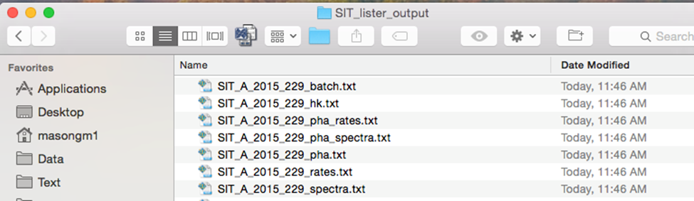

Reference

G. M. Mason, A. Korth, P. H. Walpole, M. I. Desai, T. T. Von Rosenvinge, and S. A. Shuman, “The Suprathermal Ion Telescope (SIT) for the IMPACT/SEP Investigation”, Space Science Reviews, Volume 136, 257-284, 2008 (DOI: 10.1007/s11214-006-9087-9)

