STEREO / IMPACT / MAG: The Magnetic Field Investigation CMAD

Revision | Effective Date | Description of Changes
Baseline | 05/13/2021 | First tracked version
Revision 1 | 03/16/2026 | Formatting and minor corrections

- Overview
The magnetometer flown on the two STEREO spacecraft were built by the Goddard Space Flight Center under the direction of Mario H. Acuna for the IMPACT investigation led by the Space Sciences Laboratory at Berkeley under the leadership of Janet G. Luhmann. The oversight of the operation of the magnetometer post launch was delegated to the University of California, Los Angeles under the oversight of C. T. Russell after STEREO’s successful launch in 2006.
On each spacecraft, a single, triaxial, wide-range, low-power and noise fluxgate magnetometer is mounted on the IMPACT telescoping boom at a distance of 3m from the spacecraft body. The electronics have been designed as an integral part of the IMPACT Data Processing Unit, sharing a common power converter and data/command interfaces.
  - Heritage
The STEREO IMPACT/magnetometer is a conventional three-axis fluxgate magnetometer design with extensive flight heritage derived from more than 50 space missions (Acuña 1974; Behannon et al. 1977; Potemra et al. 1985; Neubauer et al. 1987; Zanetti et al. 1994; Lohr et al. 1997; Acuña et al. 1992, 1997; Acuña 2002), implemented through a collaboration of NASA’s Goddard Space Flight Center and the Space Sciences Laboratory of the University of California Berkeley. It also benefits significantly from the relevant experience gained through previous collaborations including Firewheel, Giotto, WIND, Mars Global Surveyor and Lunar Prospector.
  - Product Description
The magnetometer produces two data streams: the scientific data product: a three-component measurement of the magnetic field sampled at rates up to 32 Hz and a Beacon measurement that is transmitted immediately to ground at a low data rate. The offset for the high rate data processed post transmission is calculated on the ground after receipt. The Beacon data used a projected zero-level for each sensor that may be in error.
At UCLA, the three data products (125 ms, 1 s, and 1 min) are produced in the original spacecraft coordinates and also rotated to RTN coordinates, which are archived in a Web-based data server for public access and also delivered monthly to UC Berkeley STEREO Science Center. These Level 1 data (in CDF format) contain columns of:
TIME, Bx, By, Bz, Bt, IMAGHKP, IMAGHKC
After the PLASTIC data is available, UCLA also produces an L2 dataset combining the 1-min resolution PLASTIC data and the 1-min MAG data, which is also archived in the UCLA STEREO web server for public access and delivered to SPDF website and UC Berkeley STEREO Science Center yearly cdf files.
https://stereo.epss.ucla.edu/l2_data
https://spdf.gsfc.nasa.gov/pub/data/stereo/ahead/l2/impact/magplasma/1min/;
https://spdf.gsfc.nasa.gov/pub/data/stereo/behind/l2/impact/magplasma/1min/
http://stereo.ssl.berkeley.edu/l2data/ahead/magplasma/
http://stereo.ssl.berkeley.edu/l2data/behind/magplasma/
This L2 merged data product includes the following columns:
TIME, BXSC, BYSC, BZSC, BTSC, BR, BT, BN, BT, X HAE, Y HAE, Z HAE, X HEE, Y HEE, Z HEE, X HEEQ, Y HEEQ, Z HEEQ, X CARR, Y CARR, Z CARR, X HCI, Y HCI, Z HCI, R, Np, Vp, Tp, Vth, Vr/V RTN, Vt/V RTN, Vn/V RTN, Vp RTN, Entropy, Beta, Total Pr, Cone Ang, Clock Ang, Mag Pr, Dyn Pr
The definitions of these coordinate systems are as following:
CARR: Carrington Heliographic coordinates. Z is along the Solar rotational axis, and X is along Carrington prime meridian.
HAE: Heliocentric Aries Ecliptic coordinates. X is the first point of Aries, and Z is along the ecliptic north pole.
HCI: Heliocentric Inertial coordinates. Z is the solar north rotational axis, and X is the solar ascending node on the J2000 ecliptic.
HEE: Heliocentric Earth Ecliptic coordinates. X is the Sun-Earth line, and Z is the north pole for the ecliptic of date.
HEEQ: Heliocentric Earth Equatorial coordinates. Z is the solar rotation axis, and X is in the plane containing the Z axis and Earth, at the intersection of the solar central meridian, and the heliographic equator. So, Y is along the cross product of Z and the Sun-to-Earth direction. When converted to longitude and latitude, this is known as Stonyhurst heliographic coordinates.
RTN: Radial-Tangential-Normal coordinates. X axis points from Sun center to the spacecraft, and the Y axis is the cross product of the solar rotational axis and X, and lies in the solar equatorial plane (towards the West limb). When the Sun is used as the origin, the designation is HGRTN; with the spacecraft as origin, it is simply RTN.
Spacecraft coordinates (SC): The +X axis points sunward; the X-Z plane and the ecliptic plane will generally be co-planar, such that the Y-axis points towards the north ecliptic pole for STEREO-A and points towards the south ecliptic pole for STEREO-B. The transformation matrices from SC to other coordinates (GEI, GSE, GSM, HCI, HEE, HEEQ, HAE) can be calculated from SPICE kernels or be found on the site: http://www.srl.caltech.edu/STEREO/docs/pointing.html
The definitions of the data columns are as following:
TIME: universal time.
BXSC, BYSC, BZSC, BTSC: the x, y, z component of magnetic field in the spacecraft coordinates, and the magnetic field strength.
BR, BT, BN, BT: the r, t, n component of magnetic field in the RTN coordinates, and the magnetic field strength. The averaged magnetic field magnitude is calculated from individual full resolution magnitudes.
X HAE, Y HAE, Z HAE, X HEE, Y HEE, Z HEE, X HEEQ, Y HEEQ, Z HEEQ, X CARR, Y CARR, Z CARR, X HCI, Y HCI, Z HCI: the x, y, z component of spacecraft position in the HAE, HEE, HEEQ, CARR and HCI coordinates.
R: the radial distance of the spacecraft position from the center of the Sun.
Vp: interpolated speed calculated from the three PLASTIC speed samples closest to the minute for one-minute data (These cover a two-minute span). Ten-minute data are averages over 20 one-minute interpolated values centered on the 10-minute mark. One-hour data are averages over 2 hours centered on each hour.
Np: interpolated proton number density.
Tp: interpolated proton temperature.
Vth: thermal speed of proton.
Vr/V, Vt/V, Vn/V: average direction cosines of the velocity of solar wind composited every minute and averaged over two minute intervals, using proton velocity data in the RTN coordinates.
Vp RTN: proton speed.
Entropy: logarithm of the 3/2 power over proton temperature to proton density.
Beta: ratio of the perpendicular plasma (ion plus electron) thermal pressure to the magnetic pressure (i.e. Np * 1e-5 * (487188 + 4.0252 * Tp) / (BT * BT)). A constant electron temperature of 130,000K is assumed. Due to the lack of alpha particle data, we assume its number density is 4% of proton's, and its temperature is 4 times of proton temperature.
Total Pr: sum of magnetic pressure and perpendicular plasma thermal pressure (i.e. Np * 1e-3 * (0.016016 * Tp + 1938.5) + BT * BT * 0.3979). See comments given for Beta calculation.
Mag Pr: magenetic pressure (i.e. BT * BT * 0.3979).
Dyn Pr: solar wind dynamic pressure (i.e. 9.701e-7 * Np * Vp_RTN * Vp_RTN).
Cone Ang: angle of the field with the R (antisunward) direction (i.e. acos(BR / BT)). Zero degrees is away from the Sun and 180 degrees is toward the Sun.
Clock Ang: angle of the magnetic field in the T-N plane (i.e. atan2(BT, BN). Zero degree aligned with T. Ninety degrees is aligned with N.

- Theoretical Description
The principle on which the fluxgate magnetometer is built is determining the strength of the current that flows in a three-axis Helmholtz configuration that is needed to produce zero field in the sensor’s center.
The STEREO IMPACT magnetometer has two gain states ± 65,536nT used only in Earth orbit and the ±572 nT range used after leaving Earth orbit. Table 1 from Acuña et al., (2008) gives the design goals for the magnetometer. Performance in flight is discussed in the next section.
Table 1 - IMPACT MAG performance characteristics
Description | Goal | Requirement
Noise level | 0.01nT | 0.05nT
Absolute accuracy | ±0.1nT | ±0.1nT
Range | ±512nT  ±65.536nT | ±512nT
Drift | ±0.2nT/yr | ±0.2nT/yr
Time resolution | 1/8 s (Normal)  1/32 s (Burst)  10 s (Beacon) | 0.01s accuracy

- Error Analysis and Corrections
A magnetic cleanliness program was implemented to minimize variable spacecraft fields and to ensure that the static spacecraft-generated magnetic field does not interfere with the measurements (with detail plan described in section 6 of Acuña et al., 2008).
- Calibration and Validation
The magnetometer electronics were initially adjusted for zero offset and approximate scale factor using a multilayer magnetic shield and calibration solenoids in the laboratory. These adjustments are generally sufficient to define these parameters to within ∼2% of their final values. The following sensor gains (i.e. scale factors) are used in data processing:
STEREO A - (0.0146328, 0.0144910, 0.0142581)
STEREO B - (0.0145346, 0.0144281, 0.0143076)
The sensor assembly uses three orthogonally mounted ring core fluxgate sensors to derive vector components of the ambient field along the three directions. Small mechanical deviations from true orthogonality are corrected in ground processing using an “alignment matrix” determined in preflight calibration.
The following rotation matrices are applied to measured component values in data processing:
STEREO A -
1.002243e+00 2.362464e-03 5.571466e-03
8.861673e-04 1.004338e+00 3.359097e-03
-1.372088e-03 -4.208385e-03 1.002837e+00
STEREO B –
1.001983e+00 -2.870098e-03 -6.032015e-04
6.622213e-03 1.007957e+00 -5.896024e-03
9.832735e-03 -2.593192e-03 1.002363e+00
The zero determination in each of the three orthogonal directions is based on the knowledge that the majority of the changes in the interplanetary magnetic field are rotations and not compressions. This retrospective calculation of the offset is computed under the assumption that the major contributor to the changing magnetic field is the rotation of the interplanetary field and not compressional waves (Leinweber et al. 2008). These time-varying offsets are calculated from the downlinked data and a running average is applied to the calculated offsets with a window of 29 days to minimize the daily variations and maintain the long-term level of the offsets. Figure 1 and 2 show the offsets on three sensors for STEREO A and B.
Please note: There is a jump in the STEREO-A offsets around June 2014 which is due to the spacecraft getting into side-lobe operations and then superior conjunction until near the end of 2015. And the data gap between March to July 2015 is due to solar conjunction as the spacecraft being behind the Sun. During this solar conjunction period, the normal science data have high time resolution but just a couple hours each day with many data gaps, while the beacon data have low time resolution but continuously 24-hour each day. So we also calculated the offsets of the beacon data (from August 2014 to November 2015) and provided the “calibrated beacon” data in RTN coordinates. Communications with STEREO-B were lost on Oct. 1, 2014, due to multiple hardware anomalies affecting control of spacecraft orientation.

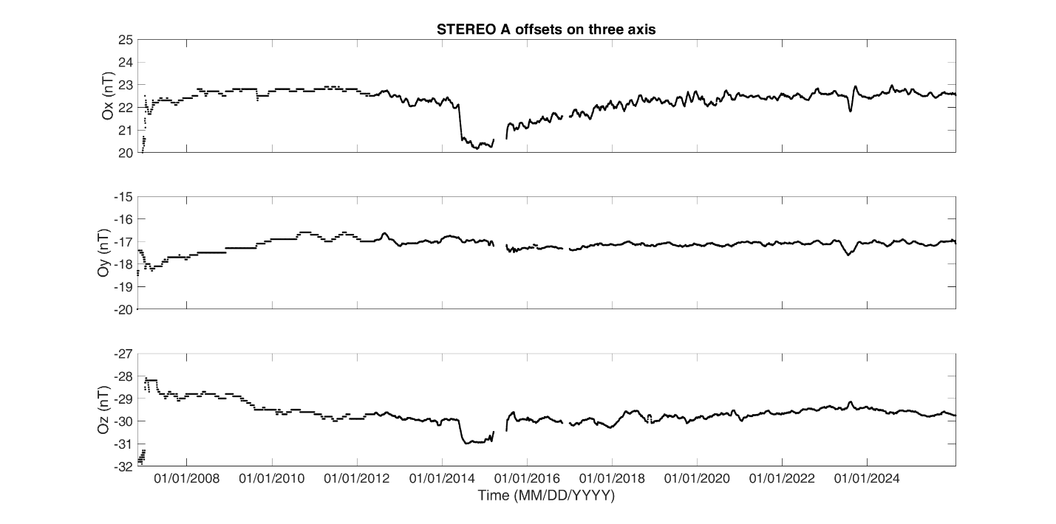
Figure 1. The offsets on three sensor axes of STEREO A.
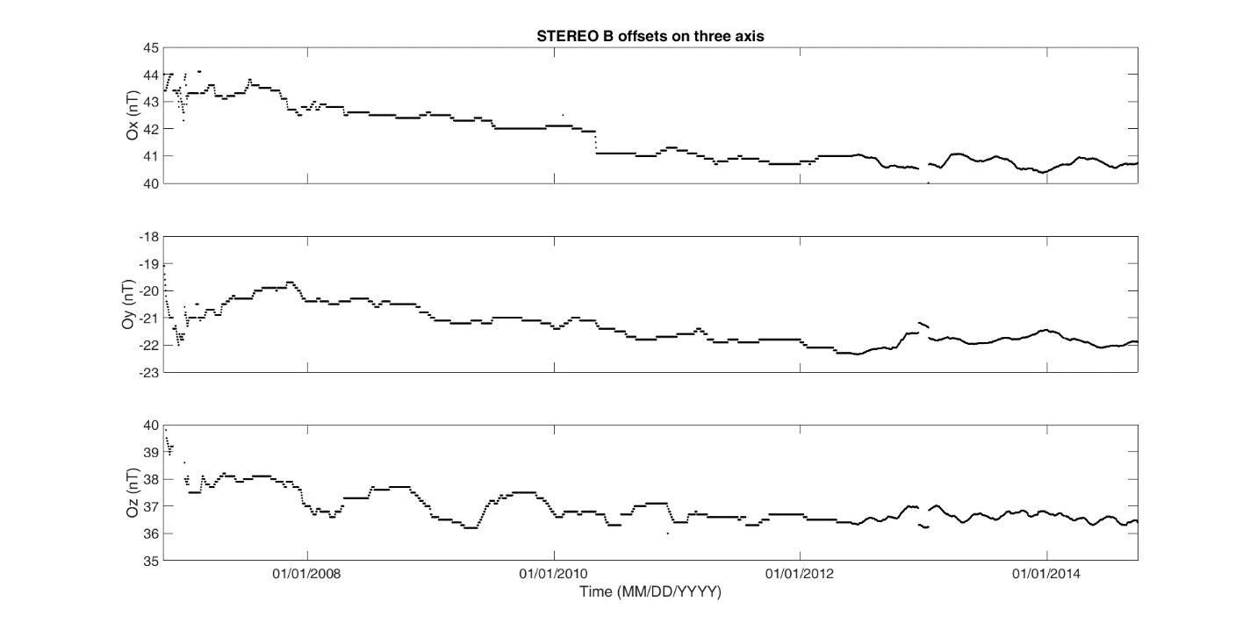
Figure 2. The offsets on three sensor axes of STEREO B.
After downlink to ground, the field data is converted to scientific units (nano Teslas, nT) by applying a temperature-dependent gain from ground calibration and a time-dependent offset/zero-level from in-flight calibration using solar wind Alfvenic perturbations (Leinweber, et al., 2008). The data are then transformed (rotated) in geophysical coordinates from the instrument system (using information from SPICE Kernels) and averaged to desirable cadences for use by the scientific community.
Data validation was done when the STEREO spacecraft was close to the Earth, by comparing with other near Earth spacecraft measurements.
- Reference
M.H. Acuña, IEEE Trans. Magnetics MAG-10, 519 (1974)
M.H. Acuña et al., J. Geophys. Res. 97(E5), 7799–7814 (1992)
M.H. Acuña, C.T. Russell, L.J. Zanetti, B.J. Anderson, J. Geophys. Res. 102(E10), 23,751–23,760 (1997)
M.H. Acuña, Space-based magnetometers. Rev. Sci. Instrum. 73(11), 3717–3736 (2002)
M.H. Acuna, D. Curtis, J.L. Scheifele, C.T. Russell, P. Schroeder, A. Szabo, J.G. Luhmann, The STEREO/IMPACT Magnetic Field Experiment, Space Sci. Rev., 136, 1-4, DOI 10.1007/s11214-007-9259-2, pp. 203-206, (2008)
K.W. Behannon, M.H. Acuña, L.F. Burlaga, R.P. Lepping, N.F. Ness, F.M. Neubauer, Space Sci. Rev. 21, 235–257 (1977)
H.K. Leinweber, C.T. Russell, K. Torkar, T.L. Zhang, V. Angelopoulos, An advanced approach to finding magnetometer zero levels in the interplanetary magnetic field, Meas. Sci. Technol., 19, doi:10.1088/0957-0233/19/055104, (2008)
D.A. Lohr, L.J. Zanetti, B.J. Anderson, T.A. Potemra, J.R. Hayes, R.E. Gold, R.M. Henshaw, F.F. Mobley, D.B. Holland, M.H. Acuña, J.L. Scheifele, Space Sci. Rev. 82(1,2), 255–281 (1997)
F.M. Neubauer, M.H. Acuña, L.F. Burlaga, B. Franke, B. Gramkow, J. Phys. E 20, 714–720 (1987). ISSN 0022-3735
T.A. Potemra, L.J. Zanetti, M.H. Acuña, IEEE Trans. Geosci. Remote Sens. GE-23, 246 (1985)
L.J. Zanetti, T.A. Potemra, R.E. Erlandson, P. Bythrow, B.J. Anderson, A.T.Y. Lui, S. Ohtani, G. Fountain, R. Henshaw, B. Ballard, D. Lohr, J. Hayes, D. Holland, M.H. Acuña, D. Farifield, J. Slavin, W. Baumjohann,
M. Engebretson, K.-H. Glassmeier, T. Iijima, H. Luehr, F. Primdahl, Space Sci. Rev. 70, 465–482 (1994)

