IMPACT HET: Solar Energetic Particle Intensities ERC 10/05/22

Overview
The High Energy Telescope (HET) is one of four sensors that make up the Solar Energetic Particle (SEP) instrument of the IMPACT investigation for NASA's STEREO mission. HET consists of a sensor system made up of a stack of 9 solid-state detectors (see Figure 1). The first detector, H1, is composed of two active regions, an inner circular region and an outer annulus, and the third through eighth detectors are combined into three pairs that act as thicker single detectors. That results in a total of seven active regions that are individually analyzed by custom Pulse Height Analysis System Integrated Circuits (PHASICs). The signals from two PHASIC chips in each HET are used by a Minimal Instruction Set Computer (MISC) to provide on-board particle identification of energetic particles from H through Fe, and electrons, at event rates of up to greater than 1000 events/sec.
The primary measurement goal of HET is to measure the energy spectra and time variations of solar energetic particles, including H and He ions, with 13 to 100 MeV/n and electrons with 0.7 to 6 MeV. In addition, HET will provide measurements of individual ions ranging from C to Fe with ∼30 to ∼150 MeV/n (depending on species). During solar quiet times HET will also measure the composition and energy spectra of anomalous cosmic ray (ACR) and galactic cosmic ray (GCR) nuclei. Detailed documentation of the instrument design and science goals may be found in the instrument paper published in Space Science Reviews (SSR): Space Sci Rev (2008) 136: 391-435 (https://doi.org/10.1007/s11214-007-9300-5 ).

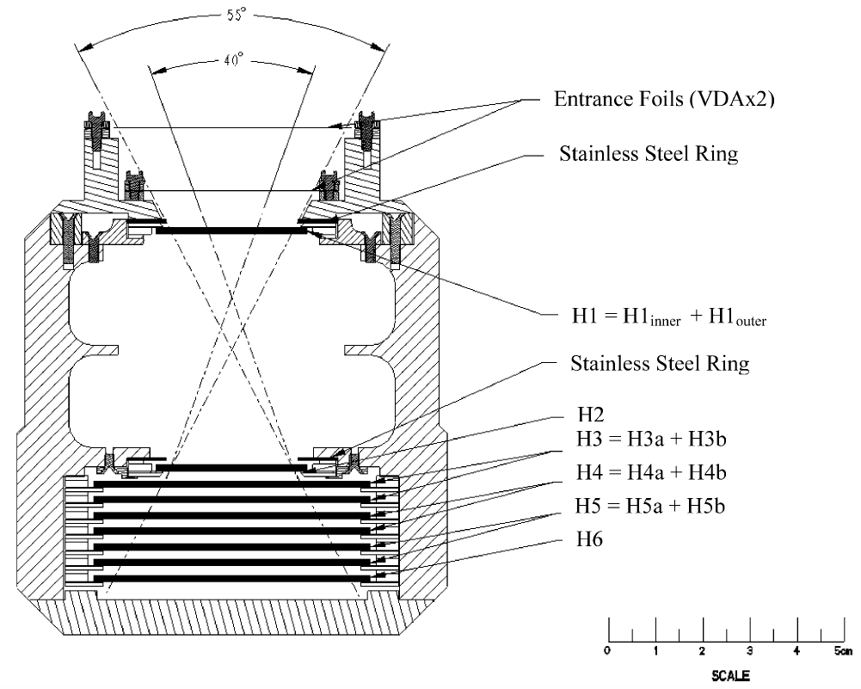
Figure 1: HET Instrument Cross-Section

Heritage
The HET instrument employs the well-established dE/dx vs. total energy technique to determine the nuclear charge, and in some cases the mass, of detected heavy ions. This particle identification technique uses the energy loss signal from a detector that the particle fully penetrates (ΔE) and the energy deposited in a following detector in which the particle stops (E'), together with the thickness penetrated in the ΔE detector (L) to obtain an estimate of the particle’s charge, Z. The technique has been used in many previous instruments, e.g. the SIS instrument on ACE, the CRS subsystem on Voyager, etc. The technique is described in detail in the SSR instrument paper, as is the implementation of this technique in the onboard particle identification system.

Instrument Data Acquisition and Onboard Data Processing Features

Onboard Particle Identification and Energy/Sector Binning
To transmit the pulse heights of a single HET particle event to the ground can require up to 16 bytes, whereas a count of tens of thousands of events can be transmitted using only two bytes. Due to the limited telemetry allocation for HET it is not possible to send a large number of pulse height events to the ground. For this reason, it is important to analyze individual particle events on board and bin the particles into software counters that count the numbers of particles of each type in different kinetic energy intervals. These different software counters for HET are listed in Table 1. Note that some of these counters are counting background events and events from the on-board pulser. The latter are intended to determine live times and will be discussed below. The primary purpose of transmitting any pulse height events to the ground is to verify that the on-board analysis is being done correctly. In addition, particle types without software counters can be studied to a limited degree.

Table 1 Software Counters (SW Ctr), Event Particle Types and Categories
SW  Ctr # | Z | A | KEmin  (MeV/n) | KEmax  (MeV/n) | Particle  Type | Category
Background Rates
0 | Background for stopping e +p |  |  |  | - | 1
1 | Background for stopping He |  |  |  | - | 2
2 | Background for stopping Z > 2 |  |  |  | - | 3
3 | Background for penetrating H |  |  |  | - | 4
4 | Background for penetrating He |  |  |  | - | 5
5 | Background for penetrating Z > 2 |  |  |  | - | 6
Range 2+ Stopping Particles
6 | -1 | - | 0.7 | 1.4 | 1 | 1
7 | -1 | - | 1.4 | 2.8 | 1 | 1
8 | -1 | - | 2.8 | ~6 | 1 | 1
9 | 1 | 1 | 13.3 | 15.0 | 2 | 1
10 | 1 | 1 | 15.0 | 17.0 | 2 | 1
11 | 1 | 1 | 17.0 | 19.0 | 2 | 1
12 | 1 | 1 | 19.0 | 21.0 | 2 | 1
13 | 1 | 1 | 21.0 | 24.0 | 2 | 1
14 | 1 | 1 | 24.0 | 27.0 | 2 | 1
15 | 1 | 1 | 27.0 | 30.0 | 2 | 1
16 | 1 | 1 | 30.0 | 33.0 | 2 | 1
17 | 1 | 1 | 33.0 | 36.0 | 2 | 1
18 | 1 | 1 | 36.0 | 40.0 | 2 | 1
19 | 2 | 3 | 17.0 | 21.0 | 3 | 2
20 | 2 | 3 | 21.0 | 27.0 | 3 | 2
21 | 2 | 3 | 27.0 | 33.0 | 3 | 2
22 | 2 | 3 | 33.0 | 40.0 | 3 | 2
23 | 2 | 3 | 40.0 | 47.0 | 3 | 2
24 | 2 | 4 | 13.3 | 15.0 | 4 | 2
25 | 2 | 4 | 15.0 | 17.0 | 4 | 2
26 | 2 | 4 | 17.0 | 19.0 | 4 | 2
27 | 2 | 4 | 19.0 | 21.0 | 4 | 2
28 | 2 | 4 | 21.0 | 24.0 | 4 | 2
29 | 2 | 4 | 24.0 | 27.0 | 4 | 2
30 | 2 | 4 | 27.0 | 30.0 | 4 | 2
31 | 2 | 4 | 30.0 | 33.0 | 4 | 2
32 | 2 | 4 | 33.0 | 36.0 | 4 | 2
33 | 2 | 4 | 36.0 | 40.0 | 4 | 2
34 | 6 | 12 | 26.4 | 30.0 | 6 | 3
35 | 6 | 12 | 30.0 | 33.0 | 6 | 3
36 | 6 | 12 | 33.0 | 36.0 | 6 | 3
37 | 6 | 12 | 36.0 | 40.0 | 6 | 3
38 | 6 | 12 | 40.0 | 45.0 | 6 | 3
39 | 6 | 12 | 45.0 | 52.0 | 6 | 3
40 | 6 | 12 | 52.0 | 62.0 | 6 | 3
41 | 6 | 12 | 62.0 | 74.0 | 6 | 3
42 | 8 | 16 | 30.0 | 33.0 | 8 | 3
43 | 8 | 16 | 33.0 | 36.0 | 8 | 3
44 | 8 | 16 | 36.0 | 40.0 | 8 | 3
45 | 8 | 16 | 40.0 | 45.0 | 8 | 3
46 | 8 | 16 | 45.0 | 52.0 | 8 | 3
47 | 8 | 16 | 52.0 | 62.0 | 8 | 3
48 | 8 | 16 | 62.0 | 74.0 | 8 | 3
49 | 8 | 16 | 74.0 | 87.0 | 8 | 3
50 | 10 | 20 | 33.0 | 36.0 | 10 | 3
51 | 10 | 20 | 36.0 | 40.0 | 10 | 3
52 | 10 | 20 | 40.0 | 45.0 | 10 | 3
53 | 10 | 20 | 45.0 | 52.0 | 10 | 3
54 | 10 | 20 | 52.0 | 62.0 | 10 | 3
55 | 10 | 20 | 62.0 | 74.0 | 10 | 3
56 | 10 | 20 | 74.0 | 87.0 | 10 | 3
57 | 10 | 20 | 87.0 | 98.0 | 10 | 3
58 | 12 | 24 | 40.0 | 45.0 | 12 | 3
59 | 12 | 24 | 45.0 | 52.0 | 12 | 3
60 | 12 | 24 | 52.0 | 62.0 | 12 | 3
61 | 12 | 24 | 62.0 | 74.0 | 12 | 3
62 | 12 | 24 | 74.0 | 87.0 | 12 | 3
63 | 12 | 24 | 87.0 | 98.0 | 12 | 3
64 | 12 | 24 | 98.0 | 109.0 | 12 | 3
65 | 14 | 28 | 40.0 | 45.0 | 14 | 3
66 | 14 | 28 | 45.0 | 52.0 | 14 | 3
67 | 14 | 28 | 52.0 | 62.0 | 14 | 3
68 | 14 | 28 | 62.0 | 74.0 | 14 | 3
69 | 14 | 28 | 74.0 | 87.0 | 14 | 3
70 | 14 | 28 | 87.0 | 98.0 | 14 | 3
71 | 14 | 28 | 98.0 | 109.0 | 14 | 3
72 | 14 | 28 | 109.0 | 119.0 | 14 | 3
73 | 26 | 56 | 52.0 | 62.0 | 26 | 3
74 | 26 | 56 | 62.0 | 74.0 | 26 | 3
75 | 26 | 56 | 74.0 | 87.0 | 26 | 3
76 | 26 | 56 | 87.0 | 98.0 | 26 | 3
77 | 26 | 56 | 98.0 | 109.0 | 26 | 3
78 | 26 | 56 | 109.0 | 119.0 | 26 | 3
79 | 26 | 56 | 119.0 | 140.0 | 26 | 3
80 | 26 | 56 | 140.0 | 163.0 | 26 | 3
Penetrating Particles
81 | 1 | 1 | 40.0 | 60.0 | 2 | 0
82 | 1 | 1 | 60.0 | 100.0 | 2 | 0
83 | 1 | 1 | 100.0 | 200.0 | 2 | 0
84 | 1 | 1 | 200.0 | 400.0 | 2 | 0
85 | 1 | 1 | 400.0 | 2000.0 | 2 | 0
86 | 2 | 4 | 40.0 | 60.0 | 4 | 0
87 | 2 | 4 | 60.0 | 100.0 | 4 | 0
88 | 2 | 4 | 100.0 | 200.0 | 4 | 0
H1-Stopping Particles
89 | 1 | 1 | 4.1 | 6.0 | 2 | 0
90 | 1 | 1 | 6.0 | 8.0 | 2 | 0
91 | 1 | 1 | 8.0 | 10.0 | 2 | 0
92 | 1 | 1 | 10.0 | 12.0 | 2 | 0
93 | 1 | 1 | 12.0 | 14.0 | 2 | 0
94 | 1 | 1 | 14.0 | 16.0 | 2 | 0
95 | 2 | 4 | 5.5 | 7.0 | 4 | 0
96 | 2 | 4 | 7.0 | 8.0 | 4 | 0
97 | 2 | 4 | 8.0 | 9.0 | 0 | 0
98 | 2 | 4 | 9.0 | 10.0 | 4 | 0
99 | 2 | 4 | 10.0 | 11.0 | 4 | 0
100 | 2 | 4 | 11.0 | 12.0 | 4 | 0
101 | 2 | 4 | 12.0 | 13.0 | 4 | 0
102 | - | - | >13.0 | - | - | 0
Livetime Counters
103 | “Stopping” Stim events in category 1 (stopping e + H)
104 | “Stopping” Stim events in category 2 (stopping He)
105 | “Stopping” Stim events in category 3 (stopping Z > 2)
106 | “Penetrating” Stim events in category 4 (penetrating H)
107 | “Penetrating” Stim events in category 5 (penetrating He)
108 | “H1 Only” Stim events in category 0 for H1only livetime

The on-board algorithm for stopping particles uses the classic dE/dx X E’ method of particle identification. Penetrating particles are also accepted and analyzed by a separate algorithm in order to extend the energy range. The expected locations of particle tracks were calculated by a Monte Carlo program that uses energy loss algorithms based on scaling proton range-energy formulae given by Andersen and Ziegler (1977). The category values correspond to different readout queues (see also Figs. 2, 3). Note that the coincidence logic can be set to accept H1 only events as well as events that require an H1 and H2 coincidence. To date, H1 only events have not been accepted on-board.

Figure 2 Shows the processing flow of the on-board particle identification algorithm (part a.)

Figure 3 Shows the processing flow of the on-board particle identification algorithm (part b.)
The overall on-board processing flow is illustrated in Figs.2 and 3. When the frontend logic issues a valid coincidence interrupt, the MISC reads the event from the PHASICs and the process queue_event() is initiated. The queue_event subroutine’s task is to queue the incoming event into one of 4 different input queues (FIFOs) as well as capture the value of the stim bit and the number of pulse heights in the event. Calstim events are calibration events that are generated at a low rate (<1/second) by triggering all 7 on-board pulsers simultaneously. For these events, the pulser DACs are increased by one step per minute during minutes 0–8 out of every 15 minutes. The resultant events are used to verify the linearity and overall performance of the PHASICs. These are placed in the Calstim event queue (256 3-byte words deep). If the event is not a Calstim event, then the pulse height index values are determined from the Chip Address and PHA Address values and examined. If there is an H6 pulse height it is checked for cross-talk and the event is correspondingly queued as a stopping event or as a penetrating event. Each queue slot holds the number of pulse heights in the event and the event itself in raw format. The H1 only queue, the stopping queue and the penetrating event queue can each hold 256 events. The Calstim event queue can hold up to 32 events. The next step in the event processing is to fetch an event from one of the input queues (other than the Calstim event queue) on a round-robin basis. The event is then handed to the routine preprocess_event(), which performs the sequence illustrated in Fig. 2. The event will be rejected if the pulse heights are not in H1 (either H1i, H1o, or possibly H1i followed by H1o), H2, H3, H4, H5, H6 order. This sequence check is intended to eliminate events for which there are more than two incident particles or possibly events with cross-talk. If accepted, the processing continues as shown in Fig. 3. The task of the blocks marked H1 only, Stopping, and Penetrating is to determine the proper software counter number, increment this counter by one, and add the event to one of 7 different output queues together with the software counter number. This is also shown in Fig. 3. The queues for categories 3–6 can each hold up to 64 events. The category 1 and 2 queues can each hold up to 128 events. At the end of the major frame, events will be selected from these queues on a roundrobin basis and read out into telemetry.

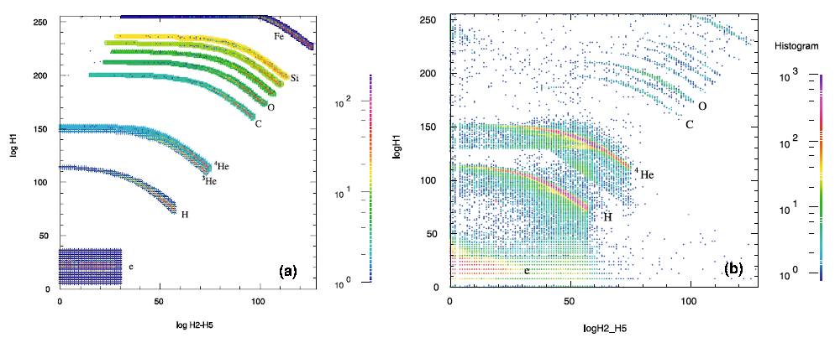
Figure 4 (a) A 2-D histogram of simulated stopping particles is shown overlaid on top of the stopping particle response table. (b) Shows a 2-D histogram of stopping particles during the event of 2006 December 13
Determination of the stopping software counter number is as follows. Up to 4 logarithmic indices are obtained from the pulse heights by table lookup: logH1 (0-255), logH2 (0-255), logH2_H5 (0-127), and logH3_H5 (0-127). Here logH2_H5 denotes the index for the logarithm of the sum of offset- and gain-corrected pulse heights H2 through H5. There are two corresponding response tables with dimensions 256 X 128. The first is for the software counter (SWCtr = stopSWCtr[logH1][logH2_H5]) and the second is for the stopping particle type (stopParticleType[logH1] [logH2_H5]). The table size is definitely sufficient for identifying particle types. Quantization of the residual E due to log conversion (logH2_H5) means that the energy intervals for each particle type are not optimum, but they are sufficient to meet Level 1 requirements.

If the software counter does not correspond to a particle track it is assigned a background counter number (0 for the category 1 output queue, i.e. for electrons and protons; 1 for the category 2 output queue, i.e. for He; and 2 for the category 3 output queue, i.e. for Z > 2) or a livetime stim pulser event counter number (103, 104, or 105). Otherwise, if there is an H3 pulse height then a consistency check can be made to see if stopParticleType[logH1][logH2_H5] is the same as stopParticleType[logH2][logH3_H5]. If not, the event software counter is assigned the appropriate background counter. This amounts to the dE/dx vs E’ method being applied first with H1 as the dE/dx detector and then with H2 as the dE/dx detector. The same table can be used for each since the _x detector is 1 mm thick Si in each case and because the gains have been matched.
The stopping response tables are illustrated in Figs. 4 and 5. Figure 4 shows a 2-D histogram derived from simulated particle events overlaid on top of a plot of the stopping particle response table stopPrtclType[logH1][logH2_H5]. Figure 5 shows a sample 2-D histogram of stopping particles from the SEP event of 13 December 2006.
Analysis of penetrating events is similar. This multi-dimensional problem has been reduced to two 2-dimensional response planes: the first of these is the logH1 versus logH6 plane (128 by 128 logarithmic channels for protons and He), and the second is the logH2 versus logH3_H5 plane (also 128 by 128 logarithmic channels). No accelerator tests were performed with penetrating protons and He, so the current tables are solely based upon the simulated response. An additional complication is that, due to the relatively shallow stack, the forward and backwards tracks merge at a fairly low energy.

Dynamic Thresholds
Historically speaking, particle telescopes have frequently saturated during the largest solar particle events. In order to increase HET’s capability to make measurements during intense events, the front detector on HET has been segmented into a small central detector (H1 inner, denoted as H1i) surrounded by a circular ring (H1 outer, denoted by H1o). The normal mode is the low-rates mode, where both H1i and H1o are fully enabled. In this mode, electrons, protons and He are detected and processed by either H1i or H1o through their high-gain PHA channels. When the H1i singles rate exceeds a (commandable) level, the MISC automatically switches the instrument to high-rates mode. This switching occurs at a major frame boundary and involves disabling the H1o high-gain PHA channel. Higher Z particles that pass through the H1o detector continue to trigger the H1o low-gain PHA channel. After launch we discovered that low energy stopping He, which normally is processed by the H1o high-gain PHA channel, will be accepted and processed by the low gain channel when the high-gain channel is disabled. High energy stopping He, however, is unable to trigger the low-gain channel. This complicates the He high-rates analysis, because He now has two different geometry factors, depending on the He energy. We could raise the H1o low-gain threshold and eliminate this effect, but so far we have elected to not do so. When the H1i singles rate falls below a certain (commandable) count rate, normally half the rate that causes HET to go into high-rate mode, the MISC re-enables the low-rate mode. To date the H1i rate at which the high-rate mode begins has been set at 400 counts per second, a rather low value.

There are some draw-backs to the high-rate mode, but we don’t consider them serious. One is that in low-rates mode, the H1i and H1o detectors act as guards for particles that pass through both detectors. In high-rate mode, the H1o threshold is raised too high to detect low-Z particles that intersect both H1i and H1o. In particular, ⁴He that passes through the H1i edge can fall down into the ³He region of the H1 versus H2_H5 SWCtr matrix. On the other hand, the stopping-particle consistency check described below can help to eliminate these ⁴He from being misidentified as ³He. One reason that this is not really a serious problem is that ³He-rich events are generally small events, ones that are too small to trigger the high-rate mode.

Level 1 and Level 2 Data Products Description
The current release of HET data consists of 1-minute, 15-minute, Hourly, 12-hour, and Daily averaged electron and proton intensities and the statistical uncertainty for each individual intensity. The intensity units are particles/(cm2-sr-sec-MeV), and intensities in the following energy ranges are provided:
- electrons: 0.7-1.4, 1.4-2.8, 2.8-4.0 MeV
- protons: 13.6-15.1, 14.9-17.1, 17.0-19.3, 20.8-23.8, 23.8-26.4, 26.3-29.7, 29.5-33.4, 33.4-35.8, 35.5-40.5, 40.0-60.0, 60.0-100.0 MeV
File Format Description
The ascii files have names like BeH07Dec.15m (which can be parsed as spacecraft B, electrons and protons, 2007 December, 15minute averages).

There is a header in each file which ends with the line '#End'. The header can be used to infer the data contained in the file; each subsequent line in the file, if it doesn't start with ';' , represents a date record; lines starting with a ';' are comment lines.

The information in the file header can be parsed as follows:

line 1 ASCII
line 2 comment (without ; )
line 3 start date/time for the data in the file
line 4 end date/time for the data in the file
line 5 ignore this line
line 6 #0 Rate - signifies the start of definition for verse 0; each data record starts with its verse number; in the present case the only verse which appears is verse 0
line 7 If "T2" is present in the 1st field of this line, then both a start and end time will be given for each record.
If "T1" is present in the 1st field, then only a start time will be given for each record.
After line 7, each header line defines a pair of intensity/uncertainty values that appears in each data record. For example:

line 8 "F2 1e-005 5e+005 0.7 1.4 e" Indicates that there will be a value given for electron intensity with energies between 0.7 and 1.4 MeV, followed by the uncertainty (1 sigma) for this intensity
...
...
line 11 "F2 1e-005 5e+005 13.6 15.1 H" similar to line 8 but for 13.6 to 15.1 MeV protons
Spelling this out in more detail...After the file header, the data records in the electron/proton files are defined as follows:

Column 1: Verse number (always '0')
Columns 2,3,4,5: Start date/time
Columns 6,7,8,9: End date/time NOTE: for the 1-minute data files, these End date/time columns ARE NOT PRESENT (T1 in line 7)
Column 10: Electron flux, 0.7 - 1.4 MeV, particles/(cm2-sr-sec-MeV)
Column 11: Uncertainty (sigma) for 0.7 - 1.4 MeV electron flux
Column 12: Electron flux, 1.4 - 2.8 MeV, particles/(cm2-sr-sec-MeV)
Column 13: Uncertainty (sigma) for 1.4 - 2.8 MeV electron flux
Column 14: Electron flux, 2.8 - 4.0 MeV, particles/(cm2-sr-sec-MeV)
Column 15: Uncertainty (sigma) for 2.8 - 4.0 MeV electron flux
Column 16: Proton flux, 13.6-15.1 MeV, particles/(cm2-sr-sec-MeV)
Column 17 Uncertainty (sigma) for 13.6-15.1 MeV proton flux
Column 18: Proton flux, 14.9-17.1 MeV, particles/(cm2-sr-sec-MeV)
Column 19: Uncertainty (sigma) for 14.9-17.1 MeV proton flux
and so on....

The identical data are also available in CDF format from the STEREO IMPACT Data portal at Berkeley, and from CDAWeb.

Theoretical Description
The conversion from raw counts to energetic particle intensities uses the following simple formula:
The raw data are counts (compressed), for N species, M energy bins.
The physical quantity is Flux(N,M) (also called Intensity),
Where Flux(N,M) = counts(N,M)/Z,
Where Z = Livetime * Ebin_width(N,M) * Geom(N,M) *Eff(N,M)
Ebin_width is the width of the energy bin, in MeV/nucleon.
Geom is the Geometry factor. During large SEP events, the geometry factors for H and He depend upon the dynamic-threshold state of the instrument. This dynamic-threshold state is included in each record in the HET data and is used in the Level 1 data processing to select the appropriate geometry factor when computing the intensities.
Appropriate geometry factors for each dynamic-threshold state are included in the calibration files.
Eff is an efficiency factor, which is usually 1.0.
The rates decompression is described below.
The geometry factors are essentially independent of kinetic energy and particle type. The geometry factor for particles that pass through H1o or H1i into detector H2 and don’t enter H6 is 0.61 cm2-steradian. The geometry factor for particles that pass through H1i into H2 and don’t enter H6 is 0.10 cm2-steradian. Note that during high-rates mode, particles with Z >2 that pass through either H1i or H1o are accepted for analysis, whereas particles with Z ≤ 2 are only accepted if they pass through H1i.
The geometry factor for penetrating particles that pass through H1i+H1o and exit through H6 is 0.61 cm2-steradian. The geometry factor for penetrating particles that pass through H1i and exit through H6 is 0.10 cm2-steradian. Similar to the stopping particles, penetrating particles with Z ≤ 2 in high-rates mode are only accepted if they pass through H1i.
The calibration data (Ebin_width, Geom, Eff arrays) are all stored in ascii tables that are in the include files that are included with the C code.
The C code and associated calibration files that implement the above algorithm are available online from the STEREO IMPACT website at https://sprg.ssl.berkeley.edu/impact/peters/level1_software/

Error Analysis and Corrections

Uncertainties due to Counting Statistics
The Level 1 and Level 2 data contain statistical errors on the intensities, calculated as $\sqrt{N}$, where N is the number of counts in that time period for that species and energy bin.

Systematic Uncertainties
Chance Coincidences
The segmentation of the H1 detector provides some protection against chance coincidences of two separate particles simulating a single event because it often will result in multiple hits in layer 1. Particle in Ranges 3-6 ions will produce multiple independent measurements of the charge and energy by using different combinations of detectors as the ΔE and E’ measurement, and these should agree. These checks can be made during ground processing. These issues are greater for electrons which often do not result in straight-line trajectories.
Live-time Effects
The front-end livetime is measured by counting pulses from a clock running at 2 X 10⁵ pulses per second in a counter that is gated off when the MISC is not available to accept new events. PHASIC calibration events, Calstim, are generated during minutes 0–8 out of every 15 minutes. During minutes 9–14, the pulsers are set to generate events that correspond in turn to each of the different event categories 0-5 (at a rate of 600 per minute. These events are processed on-board as if they were due to particles. They are counted in software counter numbers 103–108. These counters are located in low-background regions of their respective categories. The number that get counted in a given minute is a measure of the livetime for on-board processing events in the corresponding category. This overall sequence of pulsing (minutes 0–14) can be disabled by command. These events have been chosen so that their counting rate is unaffected by the high-rate mode. Category 6 does not have a livetime counter.
The livetime counters measure the total livetimes for categories 0-5. These livetimes are in general shorter than the front-end livetime because, at high rates, the MISC may not be able to obtain the software counter number for every pulse height event that it receives. Figure 5 shows the front-end livetime and the 3 stopping event category livetimes during the large event of 13 December 2006. It can be seen that the front-end livetime is only slightly longer than the other livetimes, and also that the livetimes were reasonably high, even at the peak of the event.
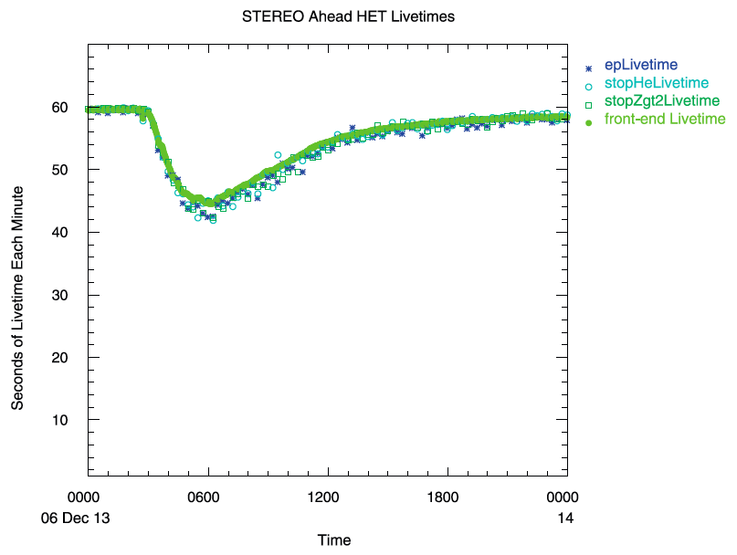
Figure 5 Front-end livetime and stim event livetimes versus time during the event that started on December 12, 2006. The livetimes measured by the stim pulser are slightly below the front-end livetime at its minimum.

Crosstalk
Cross-talk occurs when a large signal in one signal channel couples into another, producing an unintended signal in the second channel. During the first of two visits to the National Superconducting Cyclotron Laboratory at Michigan State University (July 2004) we exposed the two flight HETs to a 160 MeV/n Ni beam. Ni was not a particularly good choice for HET because Ni saturates at least one PHA channel, but a variable length water target/absorber was put in the beam to create lower Z fragments. The lower Z fragments produce smaller energy losses and hence smaller cross-talk signals. With the large signals from the Ni beam, we quickly discovered two different forms of crosstalk. The first of these was cross-talk between H1i and H1o that is due to stray capacitance between H1i and H1o. Normally, events with pulses in both H1i and H1o are rejected as events where the particle trajectory traversed both H1i and H1o. The cross-talk is only about one part in 400, so the key point is to not reject events in which one of two H1 pulse heights is due to cross-talk.
The second type of cross-talk occurs between channels inside of PHASIC 1. Cross-talk in PHASIC 1 is negligible with regard to obtaining residual energy losses in the stack (H2– H5 or H3–H5). The critical part is to determine whether a signal in H6 is due to cross-talk or not so that stopping particles with large energy losses in the stack don’t get erroneously put in the penetrating particle queue. If the H6 pulse height is small, one must unpack the raw pulse heights and gain bits of H2–H5 in order to determine whether the H6 pulse height is real or is just due to cross-talk. It is to be emphasized that the on-board software identifies both types of cross-talk and eliminates their effects.

Calibration and Validation
Accelerator calibrations and performance tests were performed on the HET flight units and subsequently on the HET engineering test unit at the National Superconducting Cyclotron Laboratory (NSCL) at Michigan State University in East Lansing, Michigan.
Pre-flight calibrations included:
Electronic Pulser Calibrations
Accelerator End-to-end Tests and Calibrations
Radioactive Source Tests

Cross Calibration of the HET and LET Sensors with GOES and IMP-8
During December 2006 there was a series of large SEP events shortly after the launch of STEREO A&B. This period provided a rare opportunity to cross calibrate the STEREO LET & HET sensors with GOES. The first results of this cross calibration were presented in Mewaldt et al. (2015). They showed reasonable agreement for >10 MeV peak intensities and fluences. Subsequently Rodriguiz et al. (2017) cross-calibrated the proton response of GOES xx with both IMP-8 and STEREO A&B. The comparison showed that the GOES-15 was systematically overestimating proton intensities at higher energies (e.g., by x1.7 for >30 MeV; x2.1 for >60 MeV and x2.7 for >100 MeV protons. The results of this study also demonstrate good consistency between the two long-term IMP-8 GME and STEREO LET and HET solar proton data sets.

Caveats and Warnings
These data do not have any background corrections applied. There may be significant background contributions during solar quiet times, but it is not expected that these contributions are important during periods when the count rates are well above their minimum levels.
Data gaps in these HET files are not filled.
Pointing and Orbit Data for the SEP Instruments on the STEREO Spacecraft
This document provides information about orientation of the HET instrument on the STEREO Ahead and Behind spacecraft, and instructions for calculating pointing (attitude) and position vectors for any SEP instrument from the spacecraft ancillary data.
Sections 1 and 2 deal with defining a HET coordinate system, and provide a recipe for converting vectors in the HET system to the spacecraft coordinate system. No recipe is provided for the other SEP instruments – this is left to the respective instrument teams.

HET Orientation with Respect to the Spacecraft Coordinate System

Both Spacecraft
For both spacecraft:
HET is mounted on the S/C +Y panel.
The S/C +X axis points sunward.
During normal flight operations, the S/C X-Z plane and the ecliptic plane will generally be co-planar, approximately.

For both spacecraft, we define a HET coordinate system as follows:
X: center of HET forward Field of View (FOV).
Y: outward from spacecraft (same as S/C +Y axis).
Z: completes the right-hand orthogonal set.

For the purposes of this discussion, we may ignore the fact that the origins of the HET and S/C origins are not co-located.

Ahead Spacecraft
The Ahead S/C Y-axis points towards the north ecliptic pole. The HET X-Z plane is rotated θ = -135° (note the negative angle) about the S/C Y-axis (see Figure 1). To transform a vector v in the HET_{a} system to a vector v′ in the S/C_{a} system,

v′ = T_{a} v

where T_{a} =

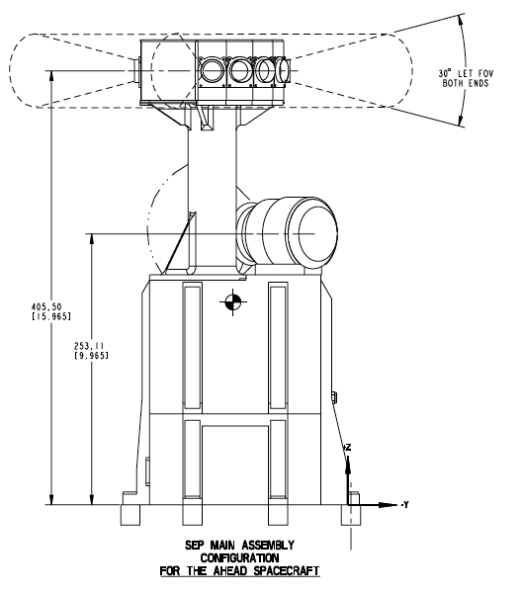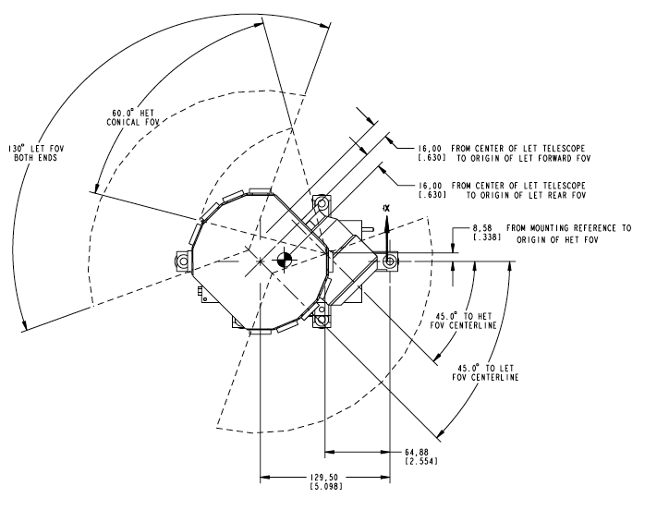
Figure 6: HET mounting and orientation on the Ahead Spacecraft, showing S/C X, Y, and Z axes. For illustration purposes only, positions and dimensions not exact.
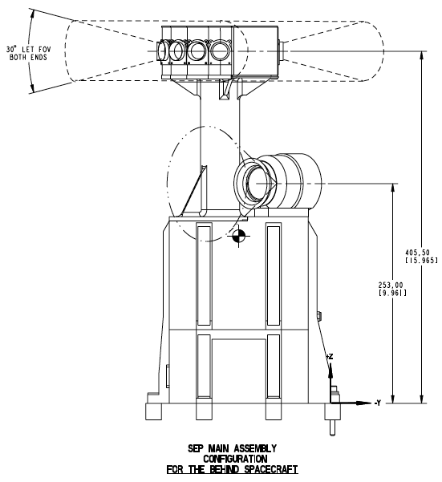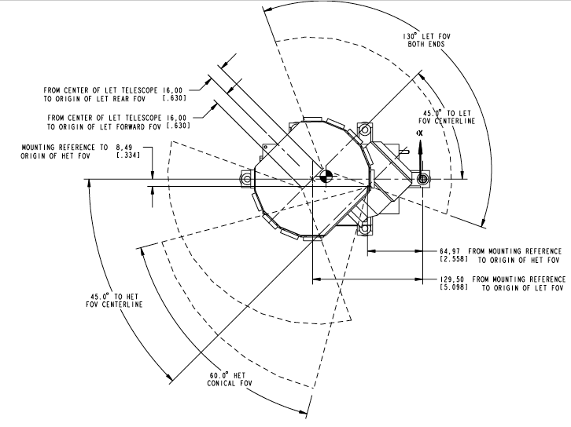
Figure 7: HET mounting and orientation on the Behind Spacecraft, showing S/C X, Y, and Z axes. For illustration purposes only, positions and dimensions not exact.

Behind Spacecraft
The Behind S/C Y-axis points towards the south ecliptic pole. A diagram of the HET mounting on the Behind spacecraft is Figure 7. The HET is mounted in a different position on the S/C +Y panel, and the HET X-Z plane is rotated θ = +135° about the S/C Y-axis. The transformation matrix to transform a vector v in the HET_{b} system to a vector v′ in the S/C_{b} system is the same as for the Ahead S/C: just be sure to use the correct sign for the angle θ.

Transformations from Spacecraft to Other Coordinate Systems
We have described the transformation of vectors from the HET to the S/C coordinate system. The LET section of this CMAD shows the procedures for transforming vectors in the S/C coordinate system to other useful coordinate systems.

References
Andersen, H.H., and J.F. Ziegler, 1977, Hydrogen Stopping Powers and Ranges in All Elements (Pergamon, New York).
Mewaldt et al, 2015, “A 360° survey of solar energetic particle events and one extreme event”. Proceedings of 704 Science. PoS(ICRC2015)139. 34th International Cosmic Ray Conference, The Hague. (2015)
Rodriguiz, J.V. et al, 2017, “Validation of the Effect of Cross-Calibrated GOES Solar Proton Effective Energies on Derived Integral Fluxes by Comparison with STEREO Observations, J. V. Rodriguez, Space Weather
von Rosenvinge, T. T. et al, 2008, The High Energy Telescope for STEREO: Space Science Reviews 136: 391-435 ( https://doi.org/10.1007/s11214-007-9300-5 ).
Appendix A HET Telemetry Data Format
The science data telemetry format document is included below as a reference (starting next page),
The telemetry output of the STEREO IMPACT HET telescope contains CCSDS packets in 7 different data formats:
- Rate packets
- Status and single PH packets
- Stopping particle PH packets
- Penetrating particle PH packets
- Table status dump
- Beacon packets
- Housekeeping data packets
- Raw event packets (non-flight)

Each CCSDS packet is 272 bytes long and begins with an 11-byte CCSDS header. The quantities of primary interest in the CCSDS header are the ApID, which identifies the specific packet type, and Universal Time in seconds since January 1, 1958 00:00:00. Each of the packet types A. – G. corresponds to a specific ApID.
After individual particle pulse height (PH) events are recorded by HET, the onboard processing algorithm identifies particle species and energies and bins the particles in “software rate counters,” as distinguished from hardware counters in the front-end electronics. The identification of these counters is given in Appendix A. In addition to binning all the particles, samples of the raw PH events are selected in 8 categories (see Appendix B) for inclusion in the telemetry stream. The format of the PH events themselves is given in B.2. Note that PH events can vary in length from 2 to 16 bytes (always even). All rates are log compressed from 24-bit to 16-bit quantities for telemetry according to the algorithm given in Appendix C. Quantities longer than one byte are written into the packets least-significant byte first.
The following sections describe the formats of individual packet types. In normal operation, HET generates 6 primary packets during a one-minute frame; these might be formatted as follows: 1 A, 1 B, 3 Cs and 1 D. E packets are multiplexed out at a rate that can be selected by command. In flight, typically, E packets replace a PH packet once every 15 minutes to produce a complete dump every ~7 days. F and G packets contribute the HET portions of the SEP beacon and housekeeping data, respectively, i.e. they are sent to SEP Central, which in turn combines them with data from other IMPACT SEP instruments to create combined beacon (ApID 624) and housekeeping packets (ApID 577). Section 9 discusses the algorithm for selection of sample PHs to fill the PH packets.

Each HET packet ends with a checksum as the last byte. The checksum is calculated such that if all 272 bytes of the packet are added together the lowest order byte is 0x00.

1. CCSDS Headers:

The quantities in the CCSDS header are most-significant byte first. Let byte[0] be the first byte and byte[10] be the last. Then

ApID = ((byte[0] << 8) + byte[1]) & 0x07ff

UT as seconds since Jan1, 1958 00:00:00 =
(byte[6] << 24) + (byte[7] << 16) + (byte[8] << 8) + byte[9]

Fractions of a second in units of 1/256th of a second are also available in byte[10].

For further details, see the STEREO MOC to POC Interface Control Document.

2. ‘A’ or Rate packets (ApID: 590 (dec) 24e (hex)):

Rate packets are formatted as follows (all quantities are log-compressed from Livetime on down):
Offset | Bytes | A-packet contents
0 | 11 | CCSDS header
11 | 1 | HET mode byte
12 | 2 | Spare
14 | 2 | Major frame number
16 | 2 | Livetime
18 | 2 | Trigger rate
20 | 2 | Coincidence rate
22 | 2 | Total number of events (excludes stimulus events)
24 | 2 | N singles queued
26 | 2 | N stopping events queued
28 | 2 | N penetrating events queued
30 | 2 | N stopping H
32 | 2 | N stopping He
34 | 2 | N stopping heavies
36 | 2 | N penetrating H
38 | 2 | N penetrating He
40 | 2 | N penetrating heavies
42 | 2 | N invalid events – out of sequence (reg and stim events )
44 | 2 | N invalid events – H1i & H1o, but not stimulus events
46 | 2 | N invalid events – inconsistent dE/dx (reg and stim events)
48 | 2 | N invalid events – H1 not first ph (reg and stim events)
50 | 2 | N stimulus events (all types of stimulus events)
52 | 12 | 6 background event bins 0-5
64 | 150 | 75 stopping event bins 6-80
214 | 16 | 8 penetrating event bins 81-88
230 | 26 | 13 single event bins 89-101
256 | 14 | 7 stimulus event bins 102-108
270 | 1 | Spare
271 | 1 | Checksum

(HET_mode & 16)>>4 is 1 when the HET is in high rate mode and 0 if HET is in low rate mode.

3. ‘B’ or Status and Single PH Packets (ApID: 591 (dec) 24f (hex)):
B packets are somewhat of a catchall. They contain instrument status and health bytes, H1 single PH events, stimulator calibration event PHs (7 PHs in each event) and a few extra rates. They are formatted as follows:
Offset | Bytes | B-packet contents
0 | 11 | CCSDS header
11 | 1 | HET mode byte
12 | 2 | Spare
14 | 2 | Major frame number
16 | 28 | 14 Single detector rates (log-compressed)
44 | 1 | number of commands received in previous major frame
45 | 1 | zero
46 | 2 | command errors (bit N = 1 if command N had an execution error, N=0-15)
48 | 2 | background idle counts (compressed)
50 | 14 | Offsets for current channels (H1i lowgain=0, H1i lowgain=1, H1o lowgain=0, H1o lowgain=1, ..., H6 lowgain =0, H6 lowgain=1)
64 | 7 | H1i chip=0 addr, H1o chip=0 addr, H2 chip=1 addr, ... H6 chip=1 addr (chip # is most significant bit)
71  74 | 3  100 | Status Bytes (Spare)  50 sample H1-only PHs
174 | 96 | STIM PH events (7 pulse heights each, compressed format)
270 | 1 | N stimulus events in packet (not compressed)
271 | 1 | Checksum

4. ‘C’ or Stopping-Particle PH Packets (ApID: 592 (dec) 250 (hex)):
C packets contain PH events for stopping particles. They are formatted as follows:
Offset | Bytes | C-packet contents
0 | 11 | CCSDS header
11 | 1 | HET mode byte
12 | 2 | Spare
14 | 2 | Major frame number
16 | 2 | N stopping events in this packet
18 | 252 | Stopping event PHs
270 | 1 | Spare
271 | 1 | Checksum

Stopping particles produce PHs in from 2 to 7 detectors (including possible cross-talk pulse heights), so their description contains from 6 to 16 bytes (appendix B). This means that a packet can contain a maximum of 42 events, but contains at least 15 events if they are available. Since event lengths are variable, extra space may exist at the end of the PH region that is too small for another event. Any such bytes following the last PH event must be 0 filled.

5. ‘D’ or Penetrating-Particle PH Packets (ApID: 593 (dec) 251 (hex)):
D packets contain PH events for penetrating particles. They are formatted as follows:
Offset | Bytes | D-packet contents
0 | 11 | CCSDS header
11 | 1 | HET mode byte
12 | 2 | Spare
14 | 2 | Major frame number
16 | 2 | N penetrating events in this packet
18 | 252 | 0-18 Penetrating event PHs
270 | 1 | Spare
271 | 1 | Checksum

Penetrating particles produce PHs in 6 detectors, so their description contains 14 bytes (appendix B).

6. ‘E’ or Table Listing Packets (ApID: 594 (dec) 252 (hex)):
E packets contain a listing of a segment of the table and constant region of the MISC-24 processor’s memory. They are formatted as follows:
Offset | Bytes | E-packet contents
0 | 11 | CCSDS header
11 | 1 | HET mode byte
12 | 2 | Spare
14 | 2 | Major frame number
16 | 3 | Beginning address
19 | 252 | Data
271 | 1 | Checksum

Generally, “Data” will consist of the next 84 24-bit words of memory beyond the beginning address. These packets are designed to slowly multiplex the contents of large sections of memory into the telemetry stream. Typically, one E-packet will be written every 15 major frames (minutes) in place of a PH packet.

7. ‘F’ or Beacon Packets (ApID: 599 (dec) 257 (hex)
Beacon packets transmit HET’s share of the SEP beacon packet.
Offset | Bytes | F-packet contents
0 | 11 | CCSDS header
2 | 2 | Electrons 0.7-4 MeV - sum of sw bins 6-8
4 | 2 | Protons 13-21 MeV – sum of sw bins 9-12
6 | 2 | Protons 21-40 MeV – sum of sw bins 13-18
8 | 2 | Protons 40-100 MeV – sum of sw bins 81-82
10 | 2 | He 13-21 MeV/n – sum of sw bins 24-27
12 | 2 | He 21-40 MeV/n – sum of sw bins 20-22
14 | 2 | He 40-100 MeV/n – sum of sw bins 86-87
 | 2 | C+O 30-52 MeV/n - sum of sw bins 35-39, 42-46
 | 2 | C+O 52-74 MeV/n - sum of sw bins 40-41, 47-48
 | 2 | Fe 52-74 MeV/n - sum of sw bins 73-74
 | 2 | Livetime (log compressed)
 | 2 | Stop. efficiency (Spare)
 | 2 | Pen. efficiency (Spare)
 | 2 | HET status (Spare)
270 | 1 | Spare
271 | 1 | Checksum

The rate quantities in the beacon data packet are derived by summing software rates described in Appendix A. Regions in the packet other than the header and defined HET data block are filled with 0. The HET MISC sends 599 packets to SEP Central, which in turn puts out packet 624 which combines the HET beacon data with beacon data from other SEP instruments. The HET data begins in packet 624 at an offset of 126 bytes from the start of the packet.

8. ‘G’ or Housekeeping Packets (ApID: 598 (dec) 256 (hex))
G packets contain the HET contribution to the housekeeping data packet. Regions other than those defined are 0 filled.
Offset | Bytes | G-packet contents
0 | 11 | CCSDS header
11 | 1 | ADC Temp 1
12 | 1 | ADC Temp 2
13 | 1 | PHASIC 0 PH channel ID
14 | 1 | PHASIC 0 ADC Preamp
15 | 2 | PHASIC 0 high gain threshold
17 | 2 | PHASIC 0 low gain threshold
19 | 2 | PHASIC 0 leakage current DAC setting
20 | 1 | PHASIC 1 PH channel ID
21 | 1 | PHASIC 1 ADC Preamp
23 | 2 | PHASIC 1 high gain threshold
25 | 2 | PHASIC 1 low gain threshold
27 | 2 | PHASIC 1 leakage current DAC setting
29 | 2 | Error Flags (16 bits)
31 | 2 | Software version ID (16 bits)
33 | 2 | N invalid token
35 | 2 | N invalid trigger
37 | 2 | N lost raw events
39 | 2 | Major frame number
41 | 3 | Table checksum
44 | 1 | 24-bit DAC value, bits 0:7 (PHASIC 0 DAC)
45 | 1 | 24-bit DAC value, bits 8:15 (PHASIC 1 DAC)
46 | 1 | 24-bit DAC value, bits 16:23 (un:4, mux:2, rng1:1, rng0:1)
47 | 5 | Available (Spare)
52 | 219 | Not available for use
271 | 1 | Checksum

The HET housekeeping data is transmitted to SEP Central using the packet defined above. SEP Central combines the housekeeping data from the different SEP instruments and transmits this information to the IDPU in a packet with ApID 577 (packet 577). The HET housekeeping bytes starting at offset 11 in packet 598 start at offset 37 in packet 577. The PHASIC 0 values cycle through H1i and H1o, taking one step each minute. The PHASIC 1 values cycle through H2 to H6, taking one step each minute.

9. Raw Event Packet (ApID: 597 (dec) 255 (hex))
This packet is a diagnostics packet and should not normally be generated in flight mode. The raw event packet is generated when the FSW has been configured to tmode 3 when connected to SEP Central, and tmode 1 when not connected to SEP Central. This packet replaces the packets with ApId 592 and 593 in tmode 3, and is generated in addition to the other packets at every unused second in tmode 1. This packet should generally be used when analysis requires reviewing the raw (24 bit) events before particle processing or to achieve a high rate of event collection during accelerator calibrations.

Offset | Bytes | 597-packet contents
0 | 11 | CCSDS header
11 | 1 | HET mode byte
12 | 2 | Spare
14 | 2 | Major frame number
16 | 255 | 85 24-bit raw events
271 | 1 | Checksum

10. PH Event Selection
In large solar energetic-particle events, the number of particles collected by HET will exceed by far the space available for PH events in the PH packets. Since most of these particles are protons, intelligent sampling is required to insure that other species are sampled. As a part of the onboard processing and binning of each particle, sampled PH events for stopping and penetrating particles are queued as protons, helium, or heavy ions. Approximately 1/3 of the telemetry space will be reserved for each species, but vacant space will be filled. That is, if there are 3 C packets being sent per frame, one will be dedicated to each species. However, if the “heavies” packet is not full, the space will be filled by any left over He. Then, if the Heavy and He packets have space, it will be filled with H PH events. A similar process will be used to fill the 18 slots in the D packet with penetrating-ion events (6 each).
If all stopping PH events fit in 3 C packets, all will be sent; if all fit in 1 or 2 C packets only, those will be sent, leaving room for extra D packets. In quiet times, 1 D packet should contain all Galactic Cosmic Ray events, but additional D packets might be useful very early in a large SEP event, before many stopping ions arrive. When all pulse-heights fit in a 1 C packet and 1 D packet, 2 E packets may be sent to fill the 6 packet/min frame. This is the minimum quiet-time set of packets.
Note that the queues for the 8 categories of sample PH events (see B.1) will have to be long enough to accommodate the maximum “backfill” of the packets. For example the stopping proton queue must fill 3 C packets (max. 126 events) in case there are no stopping He & heavies; He must fill 2 C packets (max. 84 events), and heavies 1 (max 42 events). Similarly, penetrating H events must fill as many as 3 D packets (54 events) and pen. He must fill 2 D packet (36 events) and heavies 1 (18 events). Note that only those PHs to be actually transmitted need to be converted to compressed PH format.
Frame rates higher than one per minute may be required for accelerator calibrations.

Appendix B. Pulse-Height Selection and Formatting

B.1 Pulse-Height Categories
In the process of the onboard identification and binning of particle pulse-height (PH) events, sample events are selected and formatted for telemetry. To prevent PH events of a given type (e.g. protons) from dominating the telemetry stream, events are grouped in the following categories:
0 - H1 singles
1 - Stopping protons
2 - Stopping He
3 - Stopping heavies
4 - Penetrating protons
5 - Penetrating He
6 - Penetrating heavies
7 - PH stimulator events
Singles events consist of a single PH in the H1 (H1i or H1i) detector. Stopping events consist of PHs from 2 to 5 detectors, H1, H2, (…H5). Penetrating events consist of 6 detectors H1 through H6. PH stimulator events consist of up to 7 PHs: H1i, H1o, H2, …H6. All events are presumed to be valid events, in that the PHs are ordered consistently, since invalid events (e.g. H1H2H5) have been weeded out early during PH interrupt service. Each event has been tallied in an onboard particle species and energy “software” bin, although that bin may be a “background” bin between actual particle tracks.
Each event category is allocated a fixed basic amount of space in the output data packets. This insures adequate representation of the categories in a large solar particle event. However, if there are not enough events in a given category to fill the allotted space at the end of each one-minute “frame,” events from another category are allowed to occupy that space, in a priority order, until all available PH telemetry space in the packets is filled or all events are telemetered. This means that more PH events in each category should be queued than can fit in the basic allocation for that category.

B.2 PH Event Format
With the exception of the H1 singles events, discussed below, all PH events consist of a 16-bit header followed by the appropriate number of 16-bit packed pulse heights. The bit pattern of the 16-bit header is as follows (listed in lsb to msb order):
3-bits Count of PHs in this event
8-bits Onboard SW bin this event was assigned to
1-bit Stimulator event flag
1-bit Current rate mode of the HET
3-bits PH category
Each individual PH is compressed from the 24-bit value read from the ASIC to a 16-bit value with the following bit pattern (lsb to msb)
11-bits PH value
1-bit Overflow bit
1-bit High/low gain
3-bit PH number (H1i, H1o, H2, …H6)
To save space, H1 singles are treated differently from other events in that they have no header but consist only of a single 16-bit PH event as defined above. Because of this, they occupy a fixed space in the telemetry packets that cannot be shared with events in other PH categories.
Note that stopping and penetrating events can be mixed arbitrarily. Using the PH-counts in the PH-header it is possible to traverse logically from event to event throughout a list of events.
In the process of storing PH events in a 272-byte packet buffer, one may arrive at a place where an event is too large to fit in the remaining space. In this case, the remaining space in the packet is zeroed and the event is stored elsewhere or omitted. This will result in a PH-count of 0 when an attempt is made to read this event on the ground.
Appendix C: Rates Compression/Decompression Algorithm

The following algorithms are a modification of the standard “biased-exponent, hidden-one” float-point algorithm. In the standard version, with an 11-bit mantissa (M) and 5-bit exponent (E), N = (2048+M) * 2^(E-12). This maximizes precision for large numbers, but requires compression for all number, even small counts, and is also designed to handle fractional values, which never occur in the rates HET compresses. The modification was suggested by Don Reames (private communication). This algorithm is a modified biased exponent, hidden one algorithm with a 12 bit mantissa and a 4 bit exponent. Numbers up to 2¹² are uncompressed, and numbers up to 2¹³ decompress with no “error”.

/* Rewrite to allow flexible arrangements of bits. AWL 030909 */
unsigned int num_bits=16, num_mantissa_bits=12, num_exponent_bits=4;
unsigned long output_mask=0xffff; /* 0xffff 16 bit */

/* 32-bit -> 16-bit compression for SW and HW rates */
/* usage: rateout=pack_rate(ratein); */

unsigned int pack_rate(ratein)
long ratein;
{
unsigned int rateout, power=0;
unsigned long mask;

/* Right shift the input, bit-by-bit, to get up to the
12 (num_mantissa_bits) most significant bits of ratein. The
number of shifts gives the exponent (power) of the compression
output, shifted so that the exponent is at the most-significant-bit
end of the output. */

mask = (0xffffffff<<(num_mantissa_bits+1));
while (ratein&mask) /* true if ratein (shifted) has bits needing to be compressed */
{
power += (0x0001<<num_mantissa_bits); /* add 1 to the exponent (E) if shift occurs */
ratein>>=1; /* shift one bit */
}

/* Save the remaining, right-shifted bits. If the exponent
(power) is zero (or ratein up to 2^(num_mantissa_bits+1), then
rateout later returns ratein uncompressed. Otherwise, the most
significant bits (num_exponent_bits) are set to the exponent,
and the remaining lower bits (num_mantissa_bits) are set to
the mantissa. */

rateout=ratein; /* mantissa */
if (power)
{
rateout = power + (0x0001<<num_mantissa_bits) /* exponent */
| (rateout & (output_mask>>num_exponent_bits)); /* mantissa */
}

rateout = (rateout & output_mask); /* guarantee 16-bit unsigned */

return rateout;
}

/* Uncompression is straightforward: The num_exponent_bits most
significant bits are extracted as the exponent (power), and the
remaining less significant bits are the mantissa. If power=0,
the rate is returned not-uncompressed. Otherwise the rate
is returned as mantissa*2^(exponent-1) . */

double dbl_rate(packed) /* Unpack to double */
unsigned packed;
{
int power;
double out;

power = packed>>num_mantissa_bits; /* exponent */
if (power>1)
{
out = ( (packed & (output_mask>>num_exponent_bits))
| (0x0001<<num_mantissa_bits) ); /* mantissa including hidden bit */
out = out * pow(2.,(double)(power-1)); /* mantiss * 2^exponent */
}
else
out = packed; /* if packed rate < 2^(num_mantissa_bits+1), it is already uncompressed */
return out;
}

