STEREO IMPACT SWEA DAC COLD START REWORK INSTRUCTIONS

Unit_______________________

The SWEA load (Actel) has an in-rush transient at cold temperatures. It is found that this can be mitigated by changing the threshold on the 2.5V supply at which the 5V Actel supply comes on. To do this, we will change R504 from 300Kohms to 69.8K.

- Replace R504 on the SWEA DAC board with a D55342K07B69E8R chip resistor from STEREO flight stock.
LDC & MFG:________________
- Touch up the conformal coat using Uralane 5750 A/B
Uralane batch & expiration________________
Mix Ratio__________________
- Cure at +60C for 12 hours. Record duration________________

COMPLETED BY ______________________________ DATE ______________________

APPROVED BY: __________________________ DATE: __________________

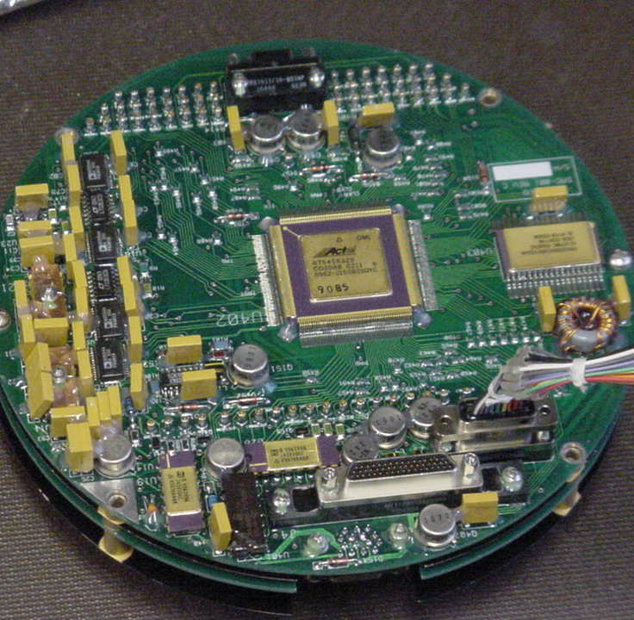
+
R504

