IMPACT STE Door Review CLOSURE STATUS (8/9/02)

Action No. | Action Item TITLE | ORIGINATOR | STATUS | DATE CLOSED
1 | DAG 213 meets Contamination Requirements | Harry Culver
2 | STE Thermal Conduction of Wires | Mike Delmont
3 | STE Bearing Friction | Shane Hynes
4 | Add Purge Port | Dave Curtis

 | Action Item |  |  |  | Number: 1
 | Project: | STP
 | Spacecraft (SC/GS/LV): | STEREO
 | System/Instrument: | IMPACT
 | Review: | PDR
 | Date: | September 11-September 13, 2001
Originator: | Harry Culver | Phone: | 301-286-5874 | Organization: | GSFC/460
Category: | STE contamination
Title: | DAG 213 meets Contamination Requirements
Date Closed:
Residual Risk:
Action Requested: | Verify DAG 213 coating meets the STEREO contamination requirements
Supporting Rationale:
Response: | No longer planning to use DAG – now using Z307 black conductive paint (approved for STEREO) as recommended by Bob Eby.

 | Action Item |  |  |  | Number: 2
 | Project: | STP
 | Spacecraft (SC/GS/LV): | STEREO
 | System/Instrument: | IMPACT
 | Review: | PDR
 | Date: | September 11-September 13, 2001
Originator: | Mike Delmont | Phone: | 301-286-1228 | Organization: | GSFC/460
Category: | STE Thermal
Title: | STE Thermal Conduction of Wires
Date Closed:
Residual Risk:
Action Requested: | 1) Verify that the thermal conduction through the wires does not transfer excessive heat to the STE detector (I assume that this refers to the wires connecting the cold STE detector to its higher temp preamp). 2) This question was also re-posed as "How do you verify that you have sufficient current for all possible operating environments? (I assume this refers to heating of the SMA wires)"
Supporting Rationale:
Response: | - The total heat transfer through 34 30ga. manganin wires is 82mW for the predicted STE-D temp of 187K. This has been incorporated into the STE thermal model, and is small compared to total conduction of 410mW. Have verified that this wire size is adequate for the largest current seen.  - I analyzed the time to reach T_{f} (the temp at which the SMA wire activation is complete) for three cases: Room Temp (293K), predicted On Orbit Temp(187K), and a low temp with an arbitrary margin of 37K (150K). The actuation times were 0.29s, 0.61s, and 0.73s, respectively. These times are well within requirements. In all cases, the equilibrium temp was at least 150K above the activation temperature. I ignored heat loss to the Vespel idler pulleys based on tests performed on actuation times with and without pulleys, showing no difference due to heat loss at the short length line-contact touch points with the poorly conductive Vespel. See the attached plots.
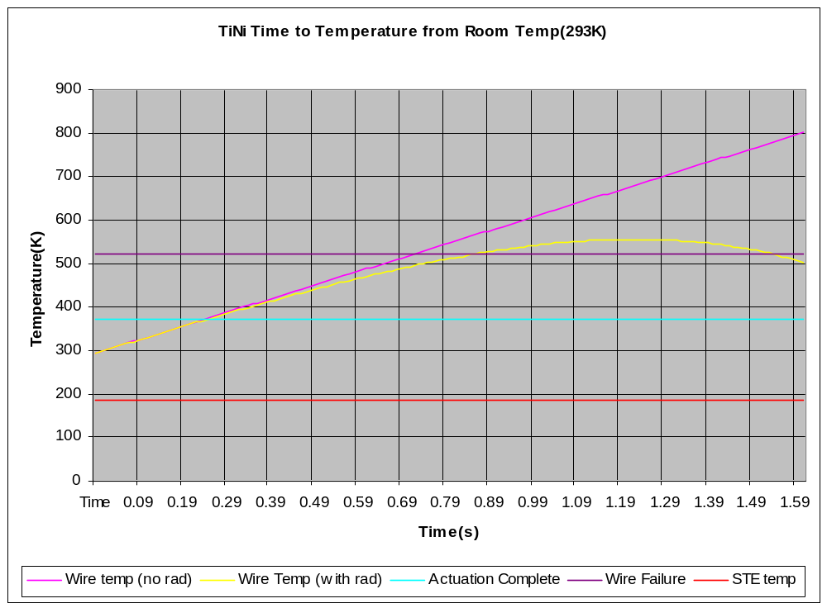

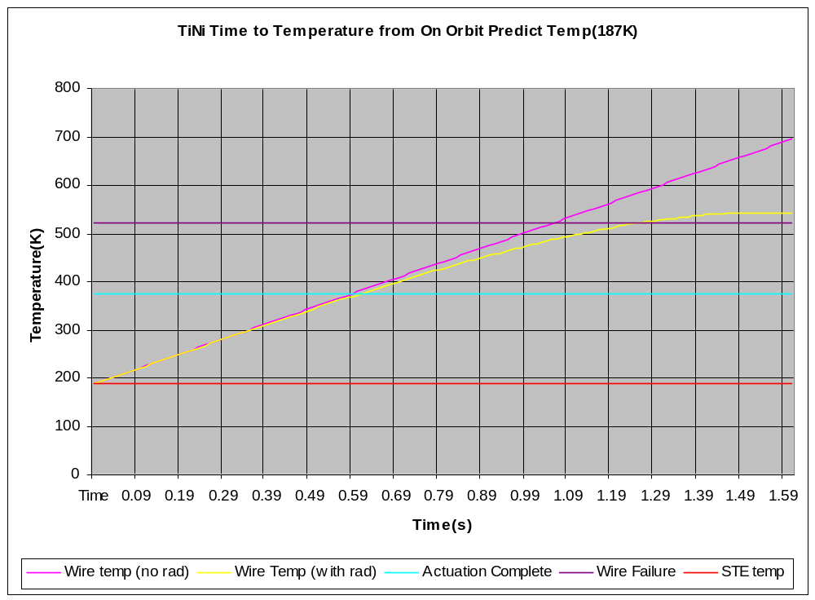
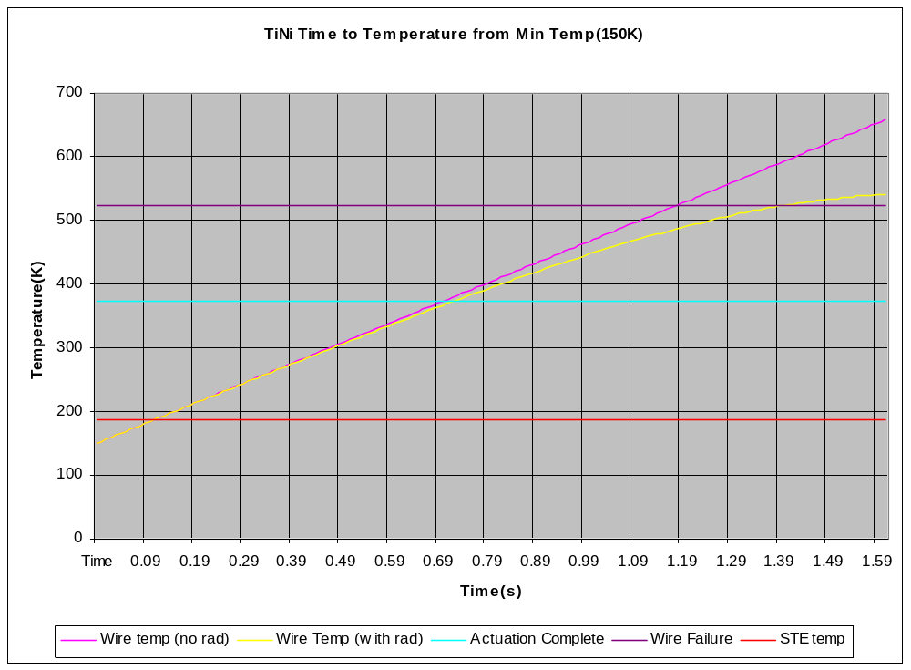

 | Action Item |  |  |  | Number: 3
 | Project: | STP
 | Spacecraft (SC/GS/LV): | STEREO
 | System/Instrument: | IMPACT
 | Review: | PDR
 | Date: | September 11-September 13, 2001
Originator: | Shane Hynes | Phone: | 301-286-1016 | Organization: | GSFC/460
Category: | STE Door
Title: | STE Bearing Friction
Date Closed:
Residual Risk:
Action Requested: | Measure friction in the bearings and pulleys to verify 22.42 grams will overcome friction of the bearing with at least 3X margin.
Supporting Rationale:
Project Response: | Have switched to 70μm NiTi wire, which has a pull force of 80g. The force to overcome the overcenter plunger at each end of travel is 20g. The force to stretch the opposing (unheated) SMA wire is 18g.These forces plus friction in system = total force need to be provided by NiTi wire. I measured the friction in system by pulling a wire attached to drive pulley and wrapped around all idler pulleys with force gauge. The over-center plunger was installed on cam (0-rise section), and drive pulley shaft was running in its sapphire bearings, accounting for all friction sources. Measured 7 grams of friction, giving a margin of (80-20-18)/7=6.

 | Action Item |  |  |  | Number: 4
 | Project: | STP
 | Spacecraft (SC/GS/LV): | STEREO
 | System/Instrument: | IMPACT
 | Review: | PDR
 | Date: | September 11-September 13, 2001
Originator: | Dave Curtis | Phone: | 510-642-5998 | Organization: | UCB
Category: | STE
Title: | Add Purge Port
Date Closed:
Residual Risk:
Action Requested: | Add purge input port to STE.
Supporting Rationale: | .
Project Response: | Purge ports added to both STE-U and STE-D. Both purge systems are now RBF items

